V₂O₅-ZrO₂ catalyst for selective oxidation of o-xylene to phthalic anhydride:
II. Physicochemical characterisation of the catalyst
Bulgarian Chemical Communications, Volume 41, Number 3 (pp. 313–322) 2009
© 2009 Bulgarian Academy of Sciences, Union of Chemists in Bulgaria
L. Makedonski*
* E-mail: lubomir60@yahoo.comm
© 2009 Bulgarian Academy of Sciences, Union of Chemists in Bulgaria
Medical University, 55 Marin Drinov St., 9002 Varna, Bulgaria
Received May 15, 2008; Revised January 15, 2009
Vanadium oxide-zirconia catalysts were prepared by impregnation of ZrO₂ powder with an aqueous solution of NH₄VO₃. The thermal stability, activity and selectivity of a series of V₂O₅-ZrO₂ catalyst samples towards o-xylene oxidation to phthalic anhydride have been investigated. It has been established that the phthalic anhydride content reaches about 55 mol% in samples containing 7 and 10 wt% V₂O₅. The physicochemical characterisation of the catalysts prepared was performed using IR spectroscopy, XPS analysis, X-ray spectroscopy, derivatograph analysis, EPR spectroscopy and temperature - programmed reduction.
Key words: V₂O₅-ZrO₂ catalysts, o-xylene oxidation, surface characterisation, physicochemical characterization.

INTRODUCTION
Vanadium oxide-based catalysts are well known and extensively employed in industry for hetero-geneous oxidation and ammoxidation of aromatic hydrocarbons [1−7]. Generally these catalysts are supported on oxides such as Al₂O₃, SiO₂ and TiO₂. Supports are often found to modify the physico-chemical properties of vanadia catalysts. The supported oxides do not form three-dimensional crystal phases, but rather a patchy or continuous ‘monolayer’ covering the support [8, 9]. Recently, ZrO₂-supported catalysts were found to exhibit better catalytic properties than the catalysts supported on other oxides [10].
During the past years some patents have reported the use of ZrO₂ as a support of V₂O₅ [11]. Systems of V₂O₅-ZrO₂ in combination with various promoters are widely used for several reactions including o-xylene oxidation [12], ammoxidation of aromatics and methylaromatics [13], oxidation of toluene [14, 15], decomposition of propan-2-ol [16, 17], oxidative dehydrogenation of propane [18, 19], oxidation of naphthalene [21, 23], partial oxidation of methanol and selective catalytic reduction of NO_{x} by C₃H₆ [20]. The utilisation of ZrO₂ is based on the fact that it is stable at very high temperatures [21] and its acid-basic characteristics are very close to those of TiO₂ .
Interesting studies [21−29] have reported the use of zirconia as a support of vanadium oxide catalysts. The valuable zirconia properties in this respect are its high thermal stability and acid-basic character-istics which are close to those of titania (anatase) [22−25].
The activity of supported vanadia catalysts depends mainly on the method of preparation, the nature of the support and the dispersion of the active component on the support surface. Considerable efforts have been made to develop surface char-acterisation of the active component in supported catalysts. These include specific surface area, IR spectroscopy, XPS analysis, X-ray spectroscopy, derivatograph analysis, EPR spectroscopy and temperature - programmed reduction.
EXPERIMENTAL
Synthesis of the catalyst
Supported V₂O₅-ZrO₂ catalyst samples were obtained by a method based on the preparation of an industrial BASF catalyst, V⁵⁺-V₂O₅ (specific surface area 6 m²/g), NH₄VO₃ (AG-Fluka) and ZrO₂ (AG-Fluka; monoclinic [6], specific surface area 26 m²/g) being used.
The catalyst samples were prepared by reducing V⁵⁺ of V₂O₅ (V₂O₅:H₂C₂O₄ = 1:2.5−3.0) in an aqueous solution of oxalic acid at 60-80°C. Zirconia was introduced simultaneously. Surfactants (form-amide or diphenylformamide) in an aqueous solu-tion: surfactants ratio = 3.5−5.0:1.0 were used as binding substances. The suspension obtained was subjected to ultrasonic treatment with a view to homogenisation, dispersion and additional activa-tion of the catalyst mass. The active catalyst mass was applied on an inert support of steatite spheres, 6 mm in diameter, by pulverising the suspension on the spheres pre-heated up to 200–250°C. The catalyst samples thus obtained had a coverage thickness of 1 mm of the total catalyst mass. They were dried at 110°C and calcined for 2−10 h at 450°C (a temperature corresponding to the calcina-tion temperature of the industrial catalyst in air flow).
Apparatus for investigating the catalytic activity and selectivity of the samples, under study
The activity and selectivity of the catalyst samples towards the vapour phase partial oxidation of o-xylene to phthalic anhydride were investigated with a flow-type installation functioning at a pressure of 1 atm. The laboratory flow reactor had a length of 450 mm and contained 250 cm³ catalysts. It was immersed in a salt bath containing a KNO₂ :NaNO₂ (1:1) salt melt, the temperature being maintained with an accuracy of up to 1°C. The temperature of the catalyst grains along the catalyst layer was measured by thermocouples. A minipump achieved the exact dosage of o-xylene. Along with the air introduced by a compressor, o-xylene came to a mixer with a filling where the temperature of the air-xylene mixture was maintained at 180°C.
Condensers up took the vapour phase oxidation products and the gas phase was conducted to the gas chromatograph.
Methods and apparatus for characterisation of catalyst samples and products of o-xylene oxidation
The analysis of the oxidation products was performed on-line by a gas chromatograph. The contents of phthalic anhydride (PhA), phthalide (Pht), benzoic acid (BA), maleic anhydride (MA) and CO₂ + CO were determined. The gas chromato-graph was connected on-line with the flow installa-tion for o-xylene oxidation. The catalyst samples were activated by air for 48 h, while the selectivity measurements were done 2 h after fixing the corres-ponding regime.
The final reaction mixture was subjected to gas-chromatographic analysis in a Perkin Elmer 850 apparatus (capillary column OV-101, 1 = 25 m, inner diameter = 0.25 mm, carrier gas = H₂,
T = 90−120°C, detector PID). The reaction products found were o-toluyl aldehyde, benzoic acid, phthalide, maleic anhydride, phthalic anhydride and unreacted xylene. The products of fragmentary oxidation (CO and CO₂) were determined chromato-graphically in a steel column (l = 4 m, inner diameter = 0.25 mm, catarometer as a detector).
The catalyst samples were activated in an air flow at the corresponding temperature and volume rate for 48 h. The kinetic measurements were performed two hours after establishing the corres-ponding regime.
The samples were characterised by a series of physicochemical methods.
L. Makedonski: Physicochemical characterisation of V₂O₅-ZrO₂ catalyst
The specific surface area was measured with a Klyachko-Gurvich apparatus by the BET method.
The IR spectra were recorded by a Nicolet Avatar 320 FIIR spectrometer using KBr tablets.
The XPS analysis of V₂O₅-ZrO₂ was carried out with an Escalab II electron spectrometer at a pressure of about 10⁻⁸ Pa. The samples were stored in stainless steel vessels. The photoelectron spectra were excited by MgKα radiation.
The X-ray spectra were recorded with a DRON-3 apparatus using CuKα radiation.
The EPR spectra of the samples at room temperature were obtained by an ERS 220/Q electron resonance spectrometer system at 100 kHz modulation of the magnetic field.
Temperature-programmed reduction (TPR) was carried out on a standard laboratory apparatus using a quartz thermometer. The weight of the sample was 0.1 g. The temperature was raised linearly from 30 to 800°C at a constant heating rate of 10°/min. The samples were reduced in a 10% hydrogen + 90% argon mixture (flow-rate of 30 ml/min).
Derivatograph analysis was made with a Paulik Erdey derivatograph apparatus. This permitted simultaneous registration of the temperature curve (T), the enthalpy curve (DTA), the mass change (TG curve) and the DTG curve. The analysis was performed with a TG sensitivity of 200 mg, a sample weight of 0.5 g, a heating rate of 10°C/min, technically pure alumina as an inert substance, turbulence air in the furnace and heating up to 1000°C.
RESULTS AND DISCUSSION
In order to elucidate the behaviour of the zirconium cations in the catalyst samples, we performed the following experiment. The catalytic activity and selectivity of a 7% V₂O₅-ZrO₂ sample, 1:1 mechanic (physical) mixture of the same catalyst sample with pure ZrO₂, and a sample of pure zirconia were investigated and compared.
The experimental results in Fig. 1 show that pure zirconia oxide has very low catalytic selectivity in vapour phase oxidation of o-xylene to phthalic anhydride. The coordinatively unsaturated cations initiate processes of complete oxidation. On this basis it can be expected that the pure zirconia surface would lead to complete o-xylene oxidation. At first sight the relatively low activity of pure zirconia seems to be an indication of its inertness towards the complete o-xylene oxidation to phthalic anhydride. From the scientific literature it is known that coordinatively unsaturated titanium cations also have a low activity with respect to the oxidation of o-xylene oxidation to phthalic anhydride. However, they favour the complete oxidation of the inter-mediate products of partial oxidation.
Fig. 1. Selectivity of pure ZrO₂ and a physical mixture of pure ZrO₂ and catalyst sample 7% V₂O₅-93% ZiO₂ (1:1) at a different temperature oxidation of o-xylene. C_{o-xylene} = 42 g/nm³, w = 1500 h⁻¹, time of exploitation τ = 10 h.
Let us study the behavior of the zirconium species. If they are completely inert, a drop in catalyst activity should be observed due to the lower (50%) relative content of the active V₂O₅ phase.
The experimental results (Fig. 1) obtained at different (330, 370 and 410°C) temperatures reveal a significant drop (by about 10%) in activity of the 7% V₂O₅-ZrO₂ sample when it is mixed mecha-nically with pure zirconia in a 1:1 ratio. Simulta-neously, the amount of CO_{x} in the products increases. The content of o-toluyl anhydride and phthalide in the oxidation products increases several times. This is also an indication of a reaction proceeding towards complete oxidation.
The experimental results permit the important, with respect to the catalyst structure, conclusion that high catalyst selectivity towards the oxidation reac-tion can be achieved when the zirconia surface is completely covered by VO_{x}. It should also be noted that the amount of the VO_{x} surface phase needed for monolayer coverage would not necessarily ensure the absence of a bare zirconia surface. It is known that in many cases the VO_{x} surface phase forms the so-called islands. A suitable method is needed for the synthesis of surface phase VO_{x} coverage.
L. Makedonski: Physicochemical characterisation of V₂O₅-ZrO₂ catalyst
Determination of specific surface
The specific surface areas are: 26 m²/g for the initial monoclinic ZrO₂, 28 m²/g for the obtained fresh catalyst of 7% V₂O₅-ZrO₂, 22 m²/g for the catalyst 10 h at 450°C, and 7 m²/g for the heated in air at 800°C for 3 h (Table 1). These data show that during the exploitation of the 7% V₂O₅-ZrO₂ catalyst at 450°C no intense sintering proceeds since the specific surface area does not change substantially. The sintering occurring at 800°C leads to a strong decrease of the specific surface area.
It should be noted that according to [30] the conventional V₂O₅-TiO₂ (anatase) catalyst is strongly sintered (deactivated) at this temperature. However, considerable sintering of the 7% V₂O₅-ZrO₂ catalyst resulting in a specific surface area drop has been observed at 800°C.
Derivatograph analysis (DTA, DTG, TG)
The DTA curve of the synthesised catalyst sample (7% V₂O₅-93% ZrO₂) exhibits a double exothermic effect beginning above 100°C and showing a maximum at about 260°C, then a second maximum at 365°C. The latter is visible within the same temperature range on the TG curve (Fig. 2) and is produced by a two-stage decomposition process. According to our opinion this may be due to further decomposition of the vanadium-oxalate complex used as a precursor in preparation of catalysts samples. The supposition is confirmed by IR and X-ray phase analyses of the catalyst samples. The total weight drop of the sample indicates about 93% of undecomposed oxalate complex.
The DTA curve (Fig. 3) of the same catalyst sample (7% V₂O₅-93% ZrO₂) after 100 h exploita-tion in o-xylene oxidation to phthalic anhydride at 450°C displays one barely visible exothermic effect at 230−290°C with a maximum at 260°C. It is probably a result of additional decomposition, which is indicated by the DTG and TG curves within the same temperature range.
XP spectroscopy
The XPS studies of the catalyst samples have registered Ti 2p^{3/2} and Zr 3d^{3/2} lines. On the surface
there are only ZrO₂ and TiO₂ in the 4⁺ oxidation state. This is evident from Figs. 4 and 5 presenting the XPS spectra of Ti2p and Zr3d. The chemical shift of the above lines is characteristic of TiO₂ and ZrO₂. In both substrates (Figs. 4 and 5) vanadium is in the same oxidation state as V₂O₅, which is proved by the shift of the V 2p^{3/2} lines.
L. Makedonski: Physicochemical characterisation of V₂O₅-ZrO₂ catalyst

Fig.2. Derivatograph analysis (DTA, DTG, TG) of fresh 7% V₂O₅-93% ZiO₂ catalyst sample. | Fig. 3. Derivatograph analysis (DTA, DTG, TG) of catalysts samples 7% V₂O₅-93% ZiO₂ tested in o-xylene oxidation, T=370°C, C_{o-xylene} = 42 g/nm³, w = 1500 h⁻¹, time of exploitation τ = 10 h.

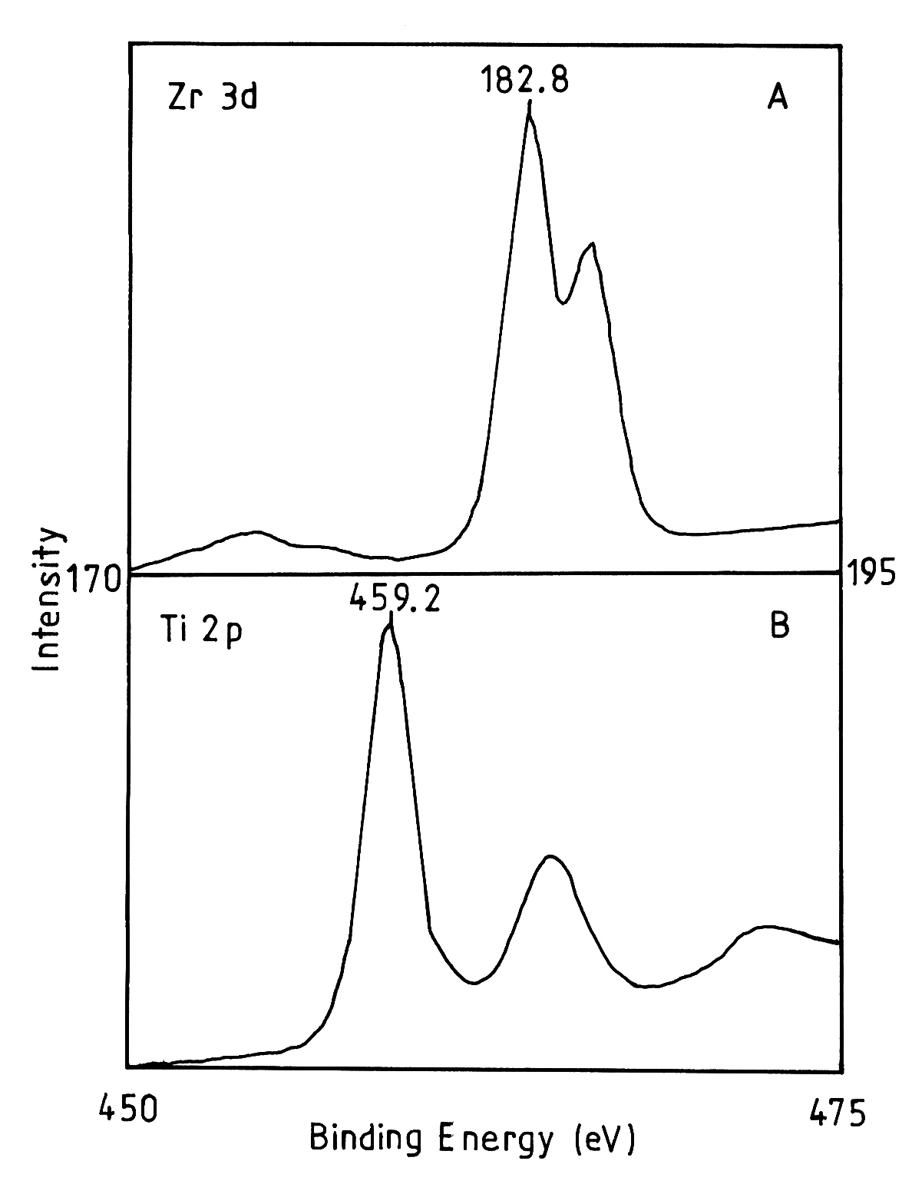
Fig. 4. Photoelectron spectra of pure ZrO₂ (curve A) and pure TiO₂ (anatase) (curve B).
The Ti:V:O or Zr:V:O concentration ratio (at.%) calculated on the basis of XPS experiments (Table 1) is, after correcting the free path of photoemitted electrons, in a very good agreement with the above considerations.
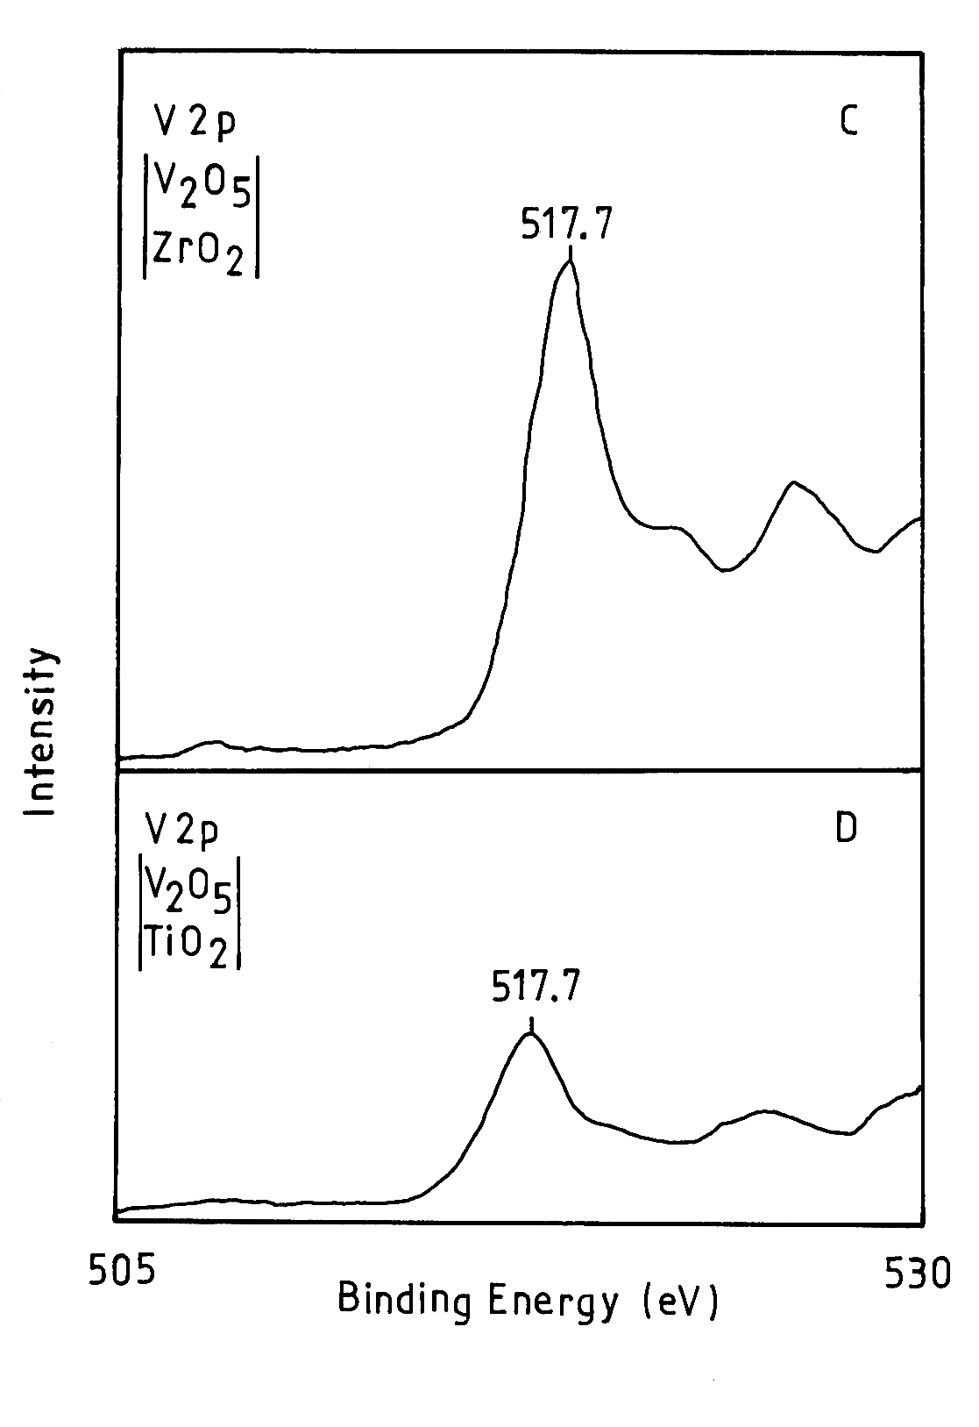
Fig. 5. Photoelectron spectra of catalyst sample
7% V₂O₅-93% ZiO₂ (curve C) and catalyst sample
7% V₂O₅-93% TiO₂ (anatase) (curve D), tested in
o-xylene oxidation (curve B), T = 370°C, C_{o-xylene} = 42 g/nm³, w = 1500 h⁻¹, time of exploitation τ = 10 h.
Thermoprogrammed reduction
The catalyst samples were subjected to temperature programmed reduction. Figures 6 and 7 present results from TPR of fresh V₂O₅-ZrO₂ samples containing different V₂O₅ concentrations (from 4 to about 10%). The peaks observed up to 300°C with samples a, b and c are probably due to desorption of water from the samples. Two more groups of peaks are observed: low-temperature peaks at 340−360°C and high-temperature ones at 460−480°C. According to literature [49, 50], the low-temperature peaks are characteristic of the reduction of V₂O₅ crystals, while the high-tempe-rature ones are produced by reduction of surface vanadium. The areas of the low-temperature peaks (a-c) show an obvious trend to increase with the V₂O₅ content. The same trend, although much less pronounced, is observed with the areas of the high-temperature peaks.
L. Makedonski: Physicochemical characterisation of V₂O₅-ZrO₂ catalyst
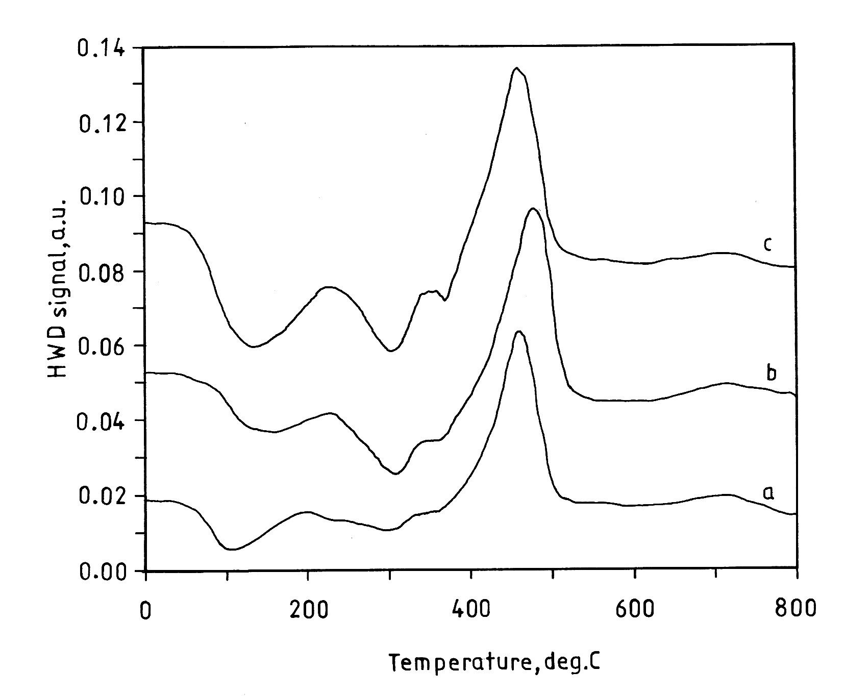
Fig. 6. Temperature-programmed reduction of fresh catalysts systems V₂O₅-ZiO₂ at different contents of
V₂O₅ (wt.%): a. catalyst sample 4% V₂O₅-96% ZiO₂;
b. catalyst sample 7% V₂O₅-93% ZiO₂;
c. catalyst sample 10% V₂O₅-90% ZiO₂.
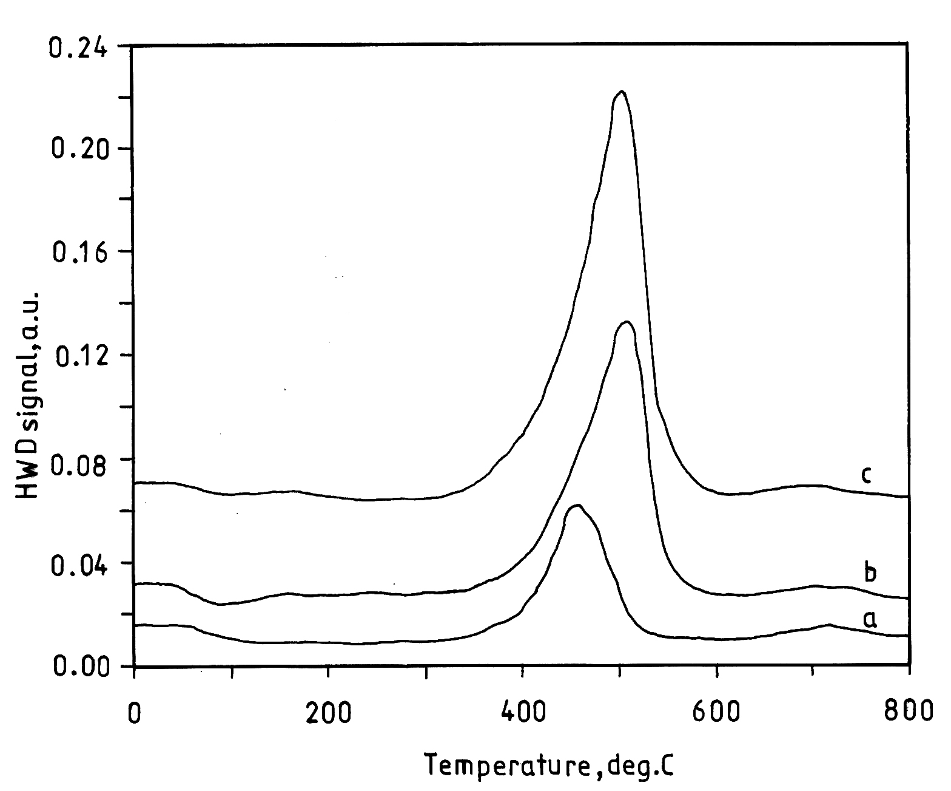
Fig. 7. Temperature-programmed reduction of tested
in o-xylene oxidation catalysts systems V₂O₅-ZiO₂,
T = 450°C, C_{o-xylene} = 42 g/nm³, w = 1500 h⁻¹, time of exploitation τ = 10 h at different contents of V₂O₅ (wt.%): a. catalyst sample 4% V₂O₅-96% ZiO₂;
b. catalyst sample 7% V₂O₅-93% ZiO₂;
c. catalyst sample 10% V₂O₅-90% ZiO_{2.}
Comparison of the data from TPR of a conven-tional V₂O₅-TiO₂ (anatase) catalyst [31, 32] with those on V₂O₅-ZrO₂ shows a low-temperature peak much smaller than the high-temperature one in the first case. This is attributed to the fact that the V₂O₅-TiO₂ (anatase) catalyst samples contain a much larger amount of surface vanadium. On the zirconia substrate, vanadium is coordinated much more easily and is more difficult to remove than in the case of the titania (anatase) support. Taking into account that V₂O₅ is the active phase, the V₂O₅-ZrO₂ catalyst should have a good catalytic activity.
The spectra of used in process of oxidation of o-xylene V₂O₅-ZrO₂ catalyst samples (Fig.7) show a single peak at 450−510°C, which is probably due to the reduction of surface vanadium. With increasing V₂O₅ amount in samples a-c, the peak areas in-crease. The ratio between the areas of the peaks for fresh and used samples also increases with the ac-tive phase (V₂O₅) concentration in the direction a-c.
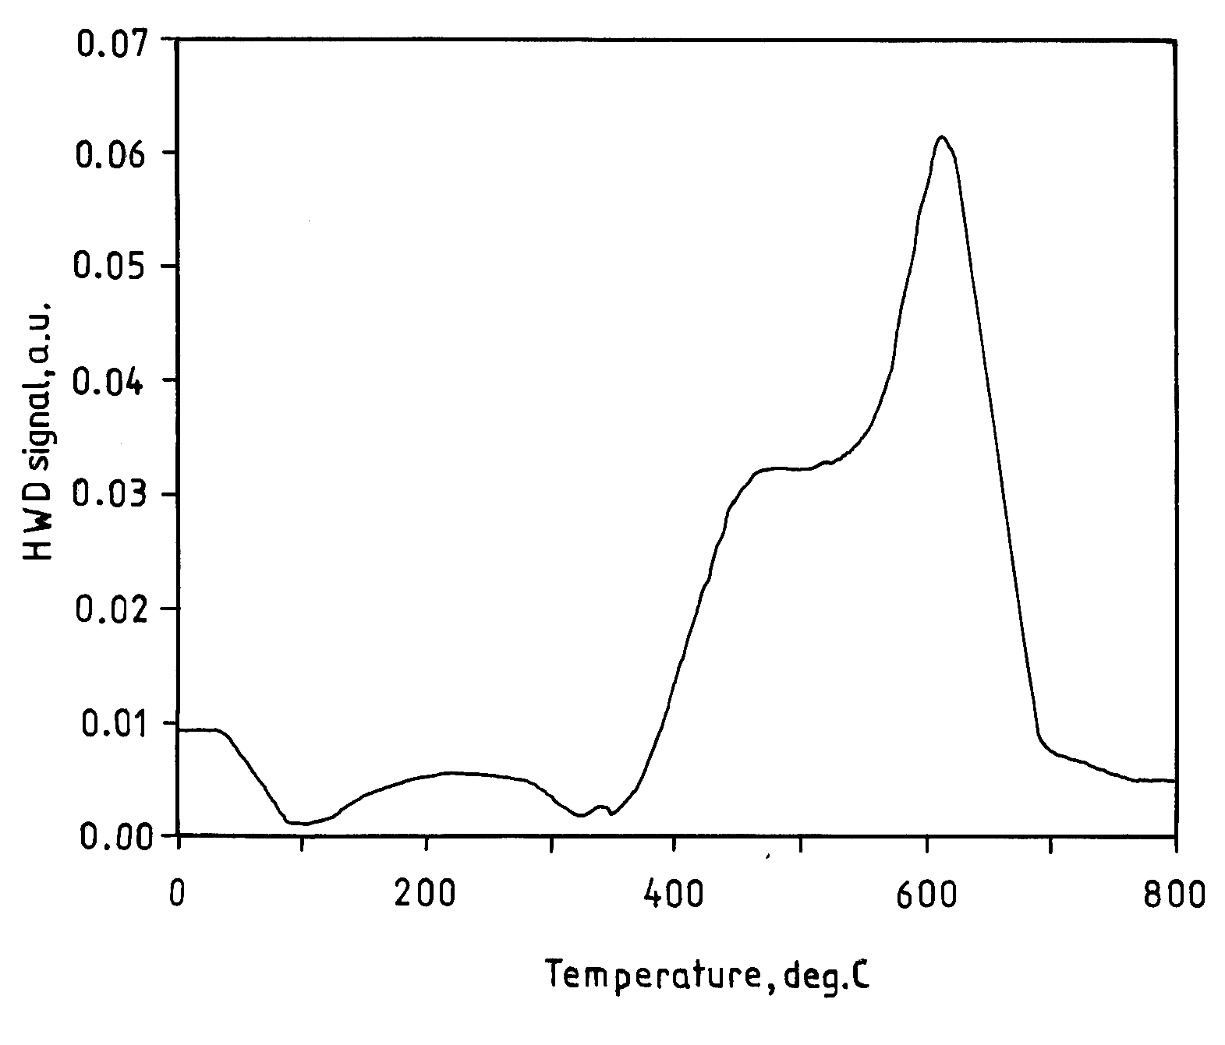
Fig. 8. Temperature-programmed reduction of tested in
o-xylene oxidation catalysts sample 7% V₂O₅-93% TiO₂ (anatase), T = 450°C, C_{o-xylene} = 42 g/nm³, w = 1500 h⁻¹, time of exploitation τ = 10 h.
For the sake of comparison, a 7% V₂O₅-TiO₂ (anatase) sample was also subjected to TPR. Figure 8 shows the spectrum, which is very close to that of the conventional V₂O₅-TiO₂ (anatase), described in literature [30]. The low-temperature peak is observed at about 460°C. It is due to reduction of surface vanadium. A high-temperature peak, much more intense than the low-temperature one, is observed at 600°C. No such peak has been established with V₂O₅-ZrO₂ samples. According to Wachs et al. [30], this peak is due to the partial reduction of V₂O₅ probably to V₂O₄ during the catalytic reaction. A low-intensity peak is observed at 340−350°C. Its presence indicates that not completely reduced crystallites of V₂O₅ have remained in the used catalyst sample.
Previous studies on the catalytic activity of the V₂O₅-ZrO₂ system [33] have shown values commensurable with those for the system V₂O₅-TiO₂. Taking into account this and the experimental results of TPR one may draw some conclusions on the role of the V₂O₅ active phase with respect to the catalytic properties of the samples.
The relatively high catalytic activity of samples of the V₂O₅-ZrO₂ system may be due to distribution of the active sites on the surface of the vanadium support. This assumption is based on the fact that the peak area of 7% V₂O₅-ZrO₂ – used in oxidation of o-xylene (Fig. 7) is much larger that the area of the low-temperature peak in the spectrum of using V₂O₅-TiO₂ (anatase) sample (Fig. 8).
The high catalytic activity of the catalyst sample from the V₂O₅-TiO₂ (anatase) system shows that the partial reduction of V₂O₅ to V₂O₄ is also of importance for the catalytic reaction.
L. Makedonski: Physicochemical characterisation of V₂O₅-ZrO₂ catalyst
EPR spectroscopy
Figure 9 shows the EPR spectra of fresh V₂O₅-ZrO₂ catalyst samples as well as of samples used in o-xylene oxidation to phthalic anhydride.
Fig. 9. EPR spectra of the catalyst system V₂O₅-ZiO₂:
1. pure V₂O₅; 2. fresh catalyst sample 4% V₂O₅-96% ZiO₂; 3. tested in o-xylene oxidation catalyst 4% V₂O₅-96% ZiO₂, T = 450°C, C_{o-xylene} = 42 g/nm³, w = 1500 h⁻¹, time of exploitation τ = 10 h; 4. fresh catalyst sample 7% V₂O₅-93% ZiO₂; 5. tested in o-xylene oxidation catalyst 7% V₂O₅-93% ZiO₂, T = 450°C, C_{o-xylene} = 42 g/nm³, w = 1500 h⁻¹, time of exploitation τ = 10 h;
6. fresh catalyst sample 10% V₂O₅-90% ZiO₂; 7. tested
in o-xylene oxidation catalyst 10% V₂O₅-90% ZiO₂,
T = 450°C, C_{o-xylene} = 42 g/nm³, w = 1500 h⁻¹, time of exploitation τ = 10 h.
In the same figure a comparison with the EPR spectrum of a sample of V₂O₅ is made. Evidently, the EPR spectrum of V₂O₅ (curve 1) consists of a single line on which an unresolved fine structure is visible. According to the data from literature [34, 35], this signal may be ascribed to exchange-associated VO²⁺complexes. The spectra (2, 4 and 6) of fresh catalyst samples exhibit a single line with a Lorentzian shape whose width slightly decreases with increasing the amount of supported V₂O₅ (from curve 2 to curve 6): curve 2: 4% V₂O₅-96% ZrO₂ – ΔH_{pp} = 115 ± 1G; curve 4: 7% V₂O₅-93% ZrO₂ – ΔH_{pp} = 104 ± 1G; curve 6: 10% V₂O₅-90% ZrO₂ – ΔH_{pp} = 100 ± 1G.
The model V₂O₅ used as a standard has about 200 times lower intensity as compared to the EPR signal of the sample where V₂O₅ is the active phase.
With the catalyst samples used in o-xylene oxidation to phthalic anhydride (Fig.9, curves 3, 5 and 7), the intensity of the EPR signal sharply drops and the EPR spectra (Fig. 9, curves 3, 5 and 7) contain an asymmetric signal of isolated VO²⁺ complex group.
In these catalyst samples the amount of exchange-associated VO²⁺ groups decreases. The appearance of isolated VO²⁺ groups (having not changed during the catalytic reaction) can be attributed to that part of the active V₂O₅ phase, which has partly interacted with zirconia support.
The period of exploitation of catalyst depends significantly on their thermal stability. The EPR spectra of a fresh 7% V₂O₅-ZrO₂ catalyst and catalysts samples calcined at 450°C and 800°C for 10 h are show in Fig. 10.
The EPR spectrum of a fresh 7% V₂O₅-ZrO₂ catalyst (Fig. 10, curves 1a–1c) shows two signals: a singlet signal being 11 mT wide (curve 1a) and an octet signal, which is not well solved (curve 1b). The combination of both signals (curve 1a and 1b) leads to the registration of a total signal presented in Fig. 5 by a thick line (curve 1c). According to the authors [34, 36], these two signals are due to clustering V⁴⁺ (with respect to the singlet signal) and to a VO²⁺ complex (for the octet signal).
The form and the view of EPR spectrum of a catalyst sample calcined at 450°C for 10 h (curve 2a–2b) do not differ practically from that of a fresh catalyst (Fig. 10, curves 1a–1c). This means that there is no significant change of the fine structure of the active phase (V₂O₅) of the catalyst calcined at 450°C. The thermal treating of the catalyst under this temperature has practically no influence on its thermal stability. On the contrary, a V₂O₅-TiO₂ (anatase) catalyst undergoes consider-able structural changes under such conditions of calcination.
An appreciable variation of the shape of the EPR spectrum of a sample calcined at 800°C for 10 h is observed (Fig. 10, curve 3). The singlet signal (clustering V⁴⁺) disappears and is completely compensated by the octet signal due to the VO²⁺ complex. The last one is presented in Fig.10 by a thick line (curve 3).
Fig. 10. EPR spectra of 7% V₂O₅-93% ZiO₂ catalyst sample. curves 1a-1c – fresh catalyst; curves 2a-2c − catalyst calcined at 450°C for 10h; curves 3a-3c − catalyst calcined at 800°C for 10h
X-ray phase analysis
The X-ray phase analysis of catalyst samples used in the o-xylene oxidation to phthalic anhydride shows the presence of a crystalline phase of mono-clinic zirconia with all catalysis samples (Fig. 11). Peaks of the supported V₂O₅ phase are not visible, which indicates that at the working temperature of the catalyst samples (450°C) it is amorphous or clusters of V₂O₅ particles have been formed. Well shaped V₂O₅ crystals have not been observed.
L. Makedonski: Physicochemical characterisation of V₂O₅-ZrO₂ catalyst
The intensity of the zirconia peaks decreases with the increase in V₂O₅ concentration (from 3 to 1 in Fig. 11). The mean thickness of the V₂O₅ coverage in the whole bulk surface of the zirconia support was estimated from the decrease in integral intensities of the zirconia peaks due to absorption of the X-rays by the catalyst layer.
The calculations were performed according to the formula [37]:
$$I=I_{0}e^{\frac{−μ}{ρ}}ρ\frac{2t}{\text{sin}θ}$$
$$\frac{μ}{ρ}=\frac{1}{M}\sum{{\left(\frac{μ}{ρ}\right)}_{i}}m_{i}$$
$t=−\frac{1}{2}\text{ln}\frac{I}{I_{0}}\text{sin}\frac{Θ}{μ}$,
where I denotes the integral intensity of the of 7% V₂O₅-93% ZrO₂ sample, Io − the integral intensity of the peak of zirconia, μ − absorption coefficient, ρ − the density (g∙cm3), t − the density of the coverage and θ is the angle for which the intensities I and Io are calculated. According to the cal-culations, the mean thickness of the V₂O₅ coverage in the whole bulk surface of the zirconia support of the 7% V₂O₅-93% ZrO₂ catalyst is 375 nm.
Fig. 11. X-ray spectra of the catalyst system V₂O₅-ZiO₂: 1. tested in o-xylene oxidation catalyst 10% V₂O₅-90% ZiO₂, T = 450°C, C_{o-xylene} = 42 g/nm³, w = 1500 h⁻¹, time of exploitation τ = 10 h; 2. tested in o-xylene oxidation catalyst 7% V₂O₅-93% ZiO₂, T = 450°C, C_{o-xylene} = 42 g/nm³, w = 1500 h⁻¹, time of exploitation τ = 10 h;
3. tested in o-xylene oxidation catalyst 4% V₂O₅-
96% ZiO₂, T = 450°C, C_{o-xylene} = 42 g/nm³, w = 1500 h⁻¹,
time of exploitation τ = 10 h; 4. pure ZrO_{2.}
IR Spectroscopy
Figure 12 shows the IR spectra of the fresh synthesised sample (with 4 and 7% V₂O₅) and catalysts samples tested in o-xylene oxidation.
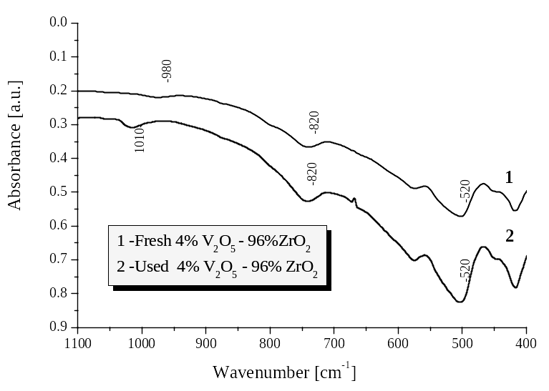
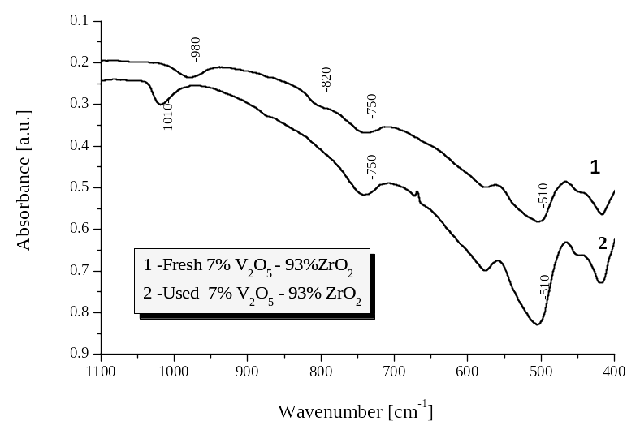
Fig. 12. IR spectra of catalysts samples 4% V₂O₅-
96% ZiO₂ and 7% V₂O₅-93% ZiO₂: 1 - fresh catalysts samples; 2 - tested in o-xylene oxidation catalysts samples, T = 450°C, C_{o-xylene} = 42 g/nm³, w = 1500 h⁻¹, time of exploitation τ = 10 h.
The IR spectra of use catalyst samples contain absorption bands at 1010, 820 and 520 cm⁻¹, which are characteristic of pure V₂O₅. The high-frequency band at 1010 cm⁻¹ is assigned to vibration of isola-ted V=O non-bridge bonds in the [VO₅] trigonal bipyramids [38, 39]. The broad absorption band at 810 cm⁻¹ is due to stretching modes of V–O–V chains, while the bands at 500 and 430 cm⁻¹ are associated with bending modes of the V₂O₅ network consisting of [VO₅]. The intensity of these absorp-tion bands is higher than that of the band of fresh catalyst samples. This may be a result of crystalli-sation processes initiated by the temperature of o-xylene oxidation.
L. Makedonski: Physicochemical characterisation of V₂O₅-ZrO₂ catalyst
A characteristic feature of the IR spectra of fresh catalyst samples is the shift of the absorption lines of [VO₅] groups to lower frequencies, which is probably due to lengthening of the V–O bonds.
The IR spectra of 7% V₂O₅-93% ZrO₂ system treated at 450 and 800°C (normalised with respect to the most intensive peak at 501 cm⁻¹) are presented in Fig. 13. The spectra of both samples (curve 1 - 450°C and curve 2 - 800°C) in the region of 1100−400 cm⁻¹ do not show significant variations in the structure of the active phase. The reason for such a statement is the fact that the positions of the peaks (characteristic for the system V₂O₅-ZrO₂) of the absorption band coincide. On the other side, it can be seen that the intensity of the peak at 1020 cm⁻¹ for the catalyst sample calcined under 800°C (curve 2) increases significantly. Most probably this is due to crystallisation processes taking place at this high temperature. In our point of view, they lead to an intensive sintering of the catalyst sample and as a result the adsorption characteristics of the support decline and the thermal stability of the catalyst being worsened, respectively. This is in accordance with the specific surface data (Table 1). It is worth noting that in the interval 450−800°C a separation of the water occurs and the peak observed at 1633 cm⁻¹ for a sample calcined at 450°C (curve 1) disappears (curve 2) (deformation fluctuation of the water). The peaks observed in the spectrogram 1 at 1384 and 1458 cm⁻¹ are very likely due to the thermal decomposition of the binding agent that is used in the synthesis of the catalyst.
Fig. 13. IR spectra of 7% V₂O₅-93% ZiO₂ catalyst
sample: 1 - catalyst samples calcined at 450°C for 10 h;
2 - catalyst samples calcined at 800°C for 10 h.
Conclusions
The physicochemical characterisation of prepared V₂O₅-ZrO₂ catalyst samples was performed using IR spectroscopy, XPS analysis, X-ray spectroscopy, derivatograph analysis, EPR spectroscopy and temperature-programmed reduction.
A high catalyst selectivity towards the oxidation reaction can be achieved when the zirconia surface is completely covered by VO_{x.} The amount of the VO_{x} surface phase needed for monolayer coverage would not necessarily ensure the absence of a bare zirconia surface.
In the synthesised V₂O₅-ZrO₂ and V₂O₅-TiO₂ catalyst samples vanadium is in the same oxidation state as V₂O₅, which is proved by the shift of the V 2p^{3/2} lines.
The relatively high catalytic activity of samples of the V₂O₅-ZrO₂ system may be due to distribution of the active sites on the surface of the vanadium support. The high catalytic activity of the catalyst sample on the base of V₂O₅-TiO₂ (anatase) system shows that the partial reduction of V₂O₅ to V₂O₄ is also of importance for the catalytic reaction.
L. Makedonski: Physicochemical characterisation of V₂O₅-ZrO₂ catalyst
The EPR analyses of fresh V₂O₅-ZrO₂ catalyst samples expose the presence of exchange-associated VO²⁺complexes and isolated VO²⁺complex groups. The appearance of isolated VO²⁺ groups (having not changed during the catalytic reaction) can be attri-buted to that part of the active V₂O₅ phase which has partly interacted with zirconia support.
The thermal treating of the catalyst has practically no influence on its thermal stability. On the contrary, a V₂O₅-TiO₂ (anatase) catalyst under-goes considerable structural changes under such conditions of calcinations.
References
- L. Makedonski, V. Nikolov, Bulg. Chem. Commun., 28, 27 (1995).
- G. Deo, I. Wachs, J. Haber, Crit. Rev. Surf. Chem., 4, 141 (1994).
- V. Escribano, G. Busca, V. Lorenzelli, J. Phys. Chem., 95, 5541 (1991).
- G. Deo, I. Wachs, J. Catal., 146, 323 (1994).
- N. Y. Topsoe, H. Topsoe, A. Dumesic, J. Catal., 151, 226 (1995).
- I. Wachs, G. Deo, B. Weckhuysen, A. Andreini, M. Vuurman, M. de Boer, M. Amiridis, J. Catal., 161, 211 (1996).
- M. Galantowicz, in: 12th Int. Conf. Chem. Proc. Eng., Praha, 1996, Mapret lecture, Prague, 1996.
- G. Bergeret, K. V. Chary, B. Rama Rao, V. S. Subrahmanyam, N. K. Nag, Appl. Catal., 40, 191 (1988).
- K. V. Chaty, K. Narsimha, K. S. Rama Rao, P. Kanta Rao, J. Mol. Catal., 58, 13 (1990).
- T. Ono, H. Miyata, Y. Kubokawa, J. Chem. Soc., Faraday Trans. I., 83, 1761 (1987).
- R. Saleh, I. Wachs, USA Patent 4728744 (1988).
- C. L. Pieck, S. Del Val, M. L. Grandos, M. A. Banares, J. L. G. Fierro, Langmuir, 18, 2642 (2002).
- R. Y. Saleh, I. E. Wachs, Eur. Patent 21325-A (1987).
- M. Sanati, A. Andersson, L. R. Wallenberg, B. Rebenstorf, Appl. Catal. A., 106, 51 (1993).
- H. Miyata, T. Ohno, F. Hatayama, J. Chem. Soc.-Faraday Trans., 91, 3505 (1995).
- Y. Toda, T. Ohno, F. Hatayama, H. Miyata, Appl. Catal. A., 207, 273 (2001).
- Y. Toda, T. Ohno, F. Hatayama, H. Miyata, Phys. Chem. Chem. Phys., 1, 1615 (1999).
- A. Adamski, Z. Sojka, K. Dyrek, M. Che, G. Wendt, S. Albrecht, Langmuir., 15, 5733 (1999).
- A. Khodakov, J. Yang, S. Su, E. Iglesia, A. T. Bell, J. Catal., 177, 343 (1998).
- T. Ohno, E. Tanaka, F. Hatayama, Y. Toda, H. Miyata, Catal. Lett., 77, 183 (2001).
- J. Sohn, S. Cho, Y. Pac, S. Hayashi, J. Catal., 159, 170 (1996).
- I. Wang, Y. Cai, I. Wachs, Langmuir, 15, 1233 (1999).
- B. Olthof, A. Khodakov, A. Bell, J. Phys. Chem. B., 104, 1516 (2000).
- S. Su, A. Bell, Phys. Chem. B., 102, 7000 (1998).
- E. Reddy, T. Rojas, A. Fernandez, B. Chowdhury, B. Reddy, Langmuir, 16, 4217 (2000).
- I. Wachs, G. Deo, B. Weckhuysen, J. Catal., 170, 75 (1997).
- A. Khodakov, B. Olthof, J. Catal., 181, 205 (1999).
- J. Miller, L. Jhanski Lakshmi, J. Catal., 184, 183 (1999).
- X. Gao, J. L. Fierro, I. Wachs, Langmuir, 15, 3169 (1999).
- M. Galantowicz, W. Krajewski, S. Karpinski, B. Wielowinska, in: Catalyst Deactivation, (Stud. Surf. Sci. Catal., vol. 88), Elsevier Science B.V., 1994.
L. Makedonski: Physicochemical characterisation of V₂O₅-ZrO₂ catalyst
- C. G. Bond, S. Flamerz, Appl. Catal., 46, 89 (1989).
- H. Bosch, B. Kip, J. Vanommen, P. Gellings, J. Chem. Soc. Faraday Trans. I., 80, 2479 (1984).
- V. Nikolov, L. Makedonski, A. Anastasov, Hung. J. Ind. Chem., 28, 93 (2000).
- S. Masters, A. Chrissanthopouls, K. Eriksen, S. Boghosian, R. Fermann, J. Catal., 166, 16 (1997).
- K. Dyrek, A. Adamski, Z. Sojka, Spectrochim. Acta, Part A., 54, 2337 (1998).
- K. Eriksen, D. Karydis, S. Boghosian, R. Fehrman, J. Catal., 155, 32 (1995).
- International Tables for X-ray Crystalography, vol. III, Kynoch Press, Birmingham, 1968, p.157.
- J. Sohn, S. Cho, Y. Pae, S. Hayashi, J. Catal., 159, 170 (1996).
- C. Pieck, M. Banares, M. Vicente, J. Fierro, Chem. Mater., 13, 1174 (2001).

V₂O₅-ZrO₂ катализатор за селективно окисление на о-ксилол
до фталов анхидрид: II. Физикохимично охарактеризиране
Л. Македонски
Медицински университет, ул. „Марин Дринов“ № 55, 9002 Варна
Постъпила на 15 май 2008; Преработена на 15 януари 2009
(Резюме)
V₂O₅-ZrO₂ катализатор е синтезиран чрез нанасяне на прах от ZrO₂ с воден разтвор NH₄VO₃. Изследвана е термичната устойчивост, каталитичната активност и селективност на серия от V₂O₅-ZrO₂ катализаторни образци спрямо окислението на о-ксилол до фталов анхидрид. Установена е селективност около 55 мол.% за образци съдържащи 7 и 10% V₂O₅. Направена е физикохимична характеристика на катализаторните образци с помощта на инфрачервена спектроскопия, рентгенофазов анализ, ЕПР анализ, деритографски анализ и термопрограмирана редукция.

