Potentiodynamic and galvanostatic investigations of copper deposition from sulphate electrolytes containing large amount of zinc
Bulgarian Chemical Communications, Volume 41, Number 3 (pp. 330–335) 2009
G. A. Hodjaoglu, A. T. Hrussanova, I. S. Ivanov*
* To whom all correspondence should be sent:
E-mail: isivanov@ipc.bas.bg
© 2009 Bulgarian Academy of Sciences, Union of Chemists in Bulgaria
Institute of Physical Chemistry, Bulgarian Academy of Sciences, Acad. G. Bonchev St., Block 11, 1113 Sofia, Bulgaria
Received May 23, 2008; Revised February 25, 2009
The electroextraction of copper was studied on platinum cathode from sulphate electrolytes containing large amount of zinc. It was established that in electrolytes, containing 50 g∙dm⁻³ Zn²⁺ and 1 or 5 g∙dm⁻³ Cu²⁺ at potentials more negative than –1.6 V vs. SSE both copper and zinc deposition takes place. At concentration higher than 5 g∙dm⁻³ Cu²⁺ and in the presence of 130 g∙dm⁻³ H₂SO₄ (independently of Cu²⁺ concentration) only copper is deposited. The addition of H₂SO₄ to the electrolyte leads to abrupt increase in cathodic current but it decreases the current efficiency of both copper and zinc deposition, which means that the current increase is a result of enhanced hydrogen evolution. The additive hydroxyethylated-2-butyne-l,4-diol (Ferasine) decreases the areas of Cu and Zn dissolution peaks, showing that the deposition process is inhibited. Dense, smooth and bright coatings of pure copper are deposited at current densities 0.5−2 A∙dm⁻² in electrolytes with Cu²⁺ concentration higher than 5 g∙dm⁻³ in the presence of Ferasine. Non-adherent, dark-red slime of copper is obtained at lower Cu²⁺ concentrations.
Key words: copper, cyclic voltammograms, deposition, electroextraction, zinc.

Introduction
Metallurgy is a branch of the industry that affects very strongly the environment. After a number of pyro- or hydrometallurgical ores treating processes, large amount of wastes with high metal content remain. For example, the waste product known as “blue powder” that results by condensing furnace gases during the thermometallurgical processing of non-ferrous ores contains: Zn (25−41%), Pb (20−25%), Fe (3−5%), Cu (0.5−1%), Cd (0.5−1%), etc. [1, 2]. The purification of the electrolytes for Zn electrowinning by cementation is another process that produces wastes containing large amount of different metals such as: copper cake(containing 36−54% Cu, 5−10% Zn and 0.08−0.16% Cd), copper-cadmium cake (containing 10% Cu, 30% Zn, 12% Cd), collective cake (containing 5.8% Cu, 35.9% Zn, 7.2% Cd), copper-nickel cake (con-taining 25% Cu, 20% Zn, 3% Cd, 0.75% Co, 0.05% Ni). [3]. Cementates of the zinc industry, obtained during the hydrometallurgical zinc winning process, where the sulphate leach liquor is treated with arsenic trioxide and zinc powder for the removal of Cu, Ni, Co, Cd and other impurities before electro-winning, contain: Cu (28.6%), Zn (22.4%), Cd (6.7%), Co (1.32) and Ni (0.16%) [4]. Flue dusts in a secondary copper smelter treated in the electro-winning zinc plant contain: Zn (40−65%), Cu (1−6%), (Pb 6−20%), Cd (0.5−0.8%), Ni (0.1−1%), Sn (1−2%), etc. [5]. Muresan et al. [2, 6] studied the process of Cu electrowinning from sulphate acidic electrolytes and observed that the addition of small amounts of Zn²⁺ had no effect on the composition of the Cu deposits, but it increased their microscopic roughness. The effect of horse-chestnut extract (HCE) and IT-85, representing a mixture of triethyl-benzyl-ammonium chloride (TEBA) and hydroxy-ethylated-2-butyne-l,4-diol (Ferasine) upon the morphology and structure of Cu deposits was studied. The cathodic polarization was also investi-gated and compared to the effect exerted by thiourea and animal glue. The additive IT-85 was found to be an efficient inhibitor of the Cu electrocrystallization process, leading to levelled, fine-grained cathodic deposits. The effect of HCE was similar to the effect exerted by animal glue, leading to deposits consisting of rounded nodules, reflecting a smaller levelling effect. Varvara et al. [7−10] studied the influence of TEBA, Ferasine and IT-85 on the kinetics of Cu electrodeposition from such elec-trolytes and on the morphology and structure of Cu deposits. TEBA acts as an inhibitor of the electro-deposition process only as a blocking agent com-peting with cuprous ions for the adsorption sites of the cathodic surface. Due to its adsorption on the electrode surface, Ferasine inhibits the charge transfer and thus affects the electrocrystallization step, impeding the crystal growth process and promoting the nucleation of Cu. In spite of their different chemical nature, both additives were found to be efficient as levelling agents, leading to fine-grained cathodic deposits. Comparison of the inhibiting effects exerted by IT-85 and its com-ponents on the electrodeposition process pointed out to the existence of a beneficial complementarity of TEBA and Ferasine when they are used in mixture.
The aim of this paper was to study the influence of Zn²⁺ ions, Ferasine and some experimental conditions on the process of Cu electroextraction from sulphuric acid electrolytes.
Experimental
The experiments were carried out in a thermo-stated (37 ± 1°C), three-electrode glass cell without stirring of the electrolyte.
G. A. Hodjaoglu et al.: Copper deposition from sulphate electrolytes
The cathode (2.0 cm²) and both anodes (4.0 cm² total area), used in the potentiodinamic studies, were Pt plates. The reference electrode was a mercury/mercurous sulphate electrode in 0.5 M H₂SO₄ (SSE), its potential vs. NHE being +0.720 V. The studies were carried out using a cyclic potentiodynamic technique. The potential scanning at a rate of 30 mV∙sec⁻¹ in the potential range from +1.000 to −1.800 V vs SSE was performed by means of computerized PAR 263A potentiostat/gal-vanostat using Soft Corr II software. The current efficiency of deposition process was obtained by integration of cathodic part and anodic peaks on the cyclic voltammograms (CV curves). The potential range and scanning rate were chosen experimentally as the most suitable.
Galvanostatic deposition was carried out using copper cathodes (4.0 cm²) and two Pt anodes (4.0 cm² total area) at current densities in the range of 0.5−2 A∙dm⁻².
All electrodes were degreased in an ultrasound bath and then only Cu cathodes were etched in HNO₃ (1:1).
Cu²⁺ ions (1, 5 or 10 g∙dm⁻³) were added to elec-trolytes, containing from 14 to 50 g∙dm⁻³ Zn²⁺ ions (as ZnSO₄.5H₂O) and from 0 to 130 g∙dm⁻³ H₂SO₄. The organic additive was 30% solution of hydroxy-ethylated-butyne-2-diol-1,4 (Ferasine).
Results and discussion
Potentiodinamic studies
Influence of the vertex potential on CV curves. Figure 1 shows CV curves obtained in an electro-lyte, containing 50 g∙dm⁻³ Zn²⁺ and 1 g·dm^{–3} Cu²⁺. The potential scan direction is changed at cathodic potentials (vertex potentials) −0.8, −1.2 or −1.6 V. When the change of scan direction is made
at −0.8 or −1.2 V (curves 1 and 2) one little cathodic peak at −0.265 V and one higher cathodic peak at −0.455 V due to Cu deposition on the Pt surface are observed on the cathodic part of the curves. At more negative potentials simultaneous Cu deposition and hydrogen evolution is occuring. On the anodic part of each CV curve one high peak at −0.275 V (curve 1) and at −0.250 V (curve 2), due to the dissolution of the larger amount of the deposited Cu, and much lower one at 0.035 V (curve 1) and 0.130 V (curve 2), due to the dissolution of the Cu layer deposited on the Pt surface, are observed. When the vertex potential is −1.6 V (curve 3) on the cathodic part of the CV curve the two peaks due to Cu deposition are followed by sharp rise of the current due to codeposition of Cu and Zn as well as to hydrogen evolution. On the anodic part of the curve at −1.260 V peak of Zn dissolution appears, followed by the peaks of Cu dissolution at −0.210 V and 0.135 V, respectively. CV curves obtained in the presence of 1 cm³∙dm⁻³ of the organic additive Ferasine in the electrolyte are similar.
Fig. 1. Cyclic voltammograms, obtained on Pt cathode in an electrolyte, containing 50 g∙dm⁻³ Zn²⁺ and 1 g∙dm⁻³ Cu²⁺. Vertex potentials vs. SSE (V): 1) −0.8; 2) −1.2;
3) −1.6. Scan rate 30 mV∙sec⁻¹.
Figure 2 shows the CV curves obtained in an electrolyte, containing 50 g∙dm⁻³ Zn²⁺, 1 g∙dm⁻³ Cu²⁺ and 130 g∙dm⁻³ H₂SO₄. The change of the scan direction is made at the same potentials as in the absence of acid. The peaks of Cu deposition are similar to those shown in Fig. 1. When the vertex potential is −1.6 V or more negative on the anodic part of the curves only peaks of Cu dissolution are observed. This shows that in the presence of H₂SO₄ Zn is not deposited. The addition of 1 cm³∙dm⁻³ Ferasine to the electrolyte does not change the CV curves.
Fig. 2. Cyclic voltammograms, obtained on Pt cathode in an electrolyte, containing 50 g∙dm⁻³ Zn²⁺, 1 g∙dm⁻³ Cu²⁺ and 130 g∙dm⁻³ H₂SO₄. Vertex potentials vs. SSE (V):
1) −0.8; 2) −1.2; 3) −1.6. Scan rate 30 mV∙sec⁻¹.
CV curves obtained in an electrolyte, containing 50 g∙dm⁻³ Zn²⁺ and 10 g∙dm⁻³ Cu²⁺ are shown in Fig. 3. The change of the scan direction is made at the same potentials as in Figures 1 and 2. The cathodic part of the curves is similar to those obtained in the electrolyte, containing 1 g∙dm⁻³ Cu²⁺. The peaks of Cu deposition are higher, as it could be expected. Only peaks of Cu dissolution are observed on the anodic part of the curves showing that Zn deposition does not take place. The CV curves, obtained in the presence of Ferasine, H₂SO₄ or both H₂SO₄ and Ferasine are similar. In all cases Zn deposition does not take place, even if the vertex potential is −1.8 V.
Fig. 3. Cyclic voltammograms, obtained on Pt cathode in an electrolyte, containing 50 g∙dm−⁻³ Zn²⁺ and 10 g∙dm⁻³ Cu²⁺. Vertex potentials vs. SSE (V): 1) −0.8; 2) −1.2;
3) −1.6. Scan rate 30 mV sec⁻¹.
Influence of the Cu²⁺ concentration and the vertex potential on the current efficiency of Cu and Zn deposition. Integration of the cathodic part of CV curves as well as of the anodic peaks of Zn and Cu dissolution is used to determine the current efficiency of Zn and Cu deposition according to the following formulae:
CE_{Zn} [%] = q^{anode}_{Zn} /q^{cathode}.100
CE_{Cu} [%] = q^{anode}_{Cu} /q^{cathode}.100
Figure 4 shows the dependence of the current efficiency of Cu and Zn deposition on the vertex potential in electrolytes, containing 50 g∙dm^{–3} Zn²⁺ and 1, 5 or 10 g∙dm⁻³ Cu²⁺, respectively. It can be seen that in the electrolyte, containing 1 g∙dm⁻³ Cu²⁺, when the change of scan direction is made at −1.4 V, the current efficiency of Cu deposition is 70−72% and it decreases to about 20 %, when the vertex potential is −1.8 V (curve 1а). In the same electrolyte the current efficiency of Zn deposition rises from 0% at vertex potential −1.4 V to about 75% at vertex potential −1.8 V (curve 1b). At Cu²⁺ concentration 5 g∙dm⁻³ the current efficiency of Cu deposition is higher than 85% when the vertex potential is −1.6 V and it decreases to 75% at vertex potential −1.8 V (curve 2а). In the same electrolyte the current efficiency of Zn deposition rises from 0% at vertex potential −1.6 V to 15% at vertex potential −1.8 V (curve 2b). At Cu²⁺ concentration 10 g∙dm⁻³ the current efficiency of Cu is in the range 80−95% at all vertex potentials (curve 3). In this case, Zn is not deposited at all. The results obtained in electrolytes, containing Zn²⁺ 50 g∙dm⁻³, Cu²⁺ (1, 5 or 10 g∙dm⁻³) and 1 cm³∙dm^{–3} Ferasine are similar.
G. A. Hodjaoglu et al.: Copper deposition from sulphate electrolytes
Fig. 4. Current efficiency (CE) of Cu and Zn deposition on Pt cathode vs. vertex potential (E_{vertex}). Electrolyte, containing 50 g∙dm⁻³ Zn²⁺ and 1 g∙dm⁻³ Cu²⁺; 1a) CE of Cu; 1b) CE of Zn. Electrolyte, containing 50 g∙dm⁻³ Zn²⁺ and 5 g∙dm⁻³ Cu²⁺: 2a) CE of Cu; 2b) CE of Zn. Electrolyte, containing 50 g∙dm⁻³ Zn²⁺ and 10 g∙dm⁻³ Cu²⁺: 3) CE of Cu.
In Figure 5 the dependence of current efficiency on vertex potential in electrolytes, containing 50 g∙dm⁻³ Zn²⁺, 130 g∙dm⁻³ H₂SO₄ and 1, 5 or 10 g∙dm⁻³ Cu²⁺, respectively, is represented. The current effi-ciency of Cu decreases with the shift of vertex potential in negative direction, which is an indica-tion of enhanced hydrogen evolution. As it could be expected, the increase in Cu²⁺ concentration leads to increase in the current efficiency. CV curves show that in the presence of H₂SO₄ at all Cu²⁺ concen-trations Zn is not deposited. The addition of 1 cm³∙dm^{–3} Ferasine in these electrolytes does not lead to any significant changes in the CV curves.
Fig. 5. Current efficiency (CE) of Cu deposition on Pt cathode vs. vertex potential (E_{vertex}). Electrolytes, containing 50 g∙dm⁻³ Zn²⁺, 130 g∙dm⁻³ H₂SO₄ and:
1) 1 g∙dm⁻³ Cu²⁺; 2) 5 g∙dm⁻³ Cu²⁺; 3) 10 g∙dm⁻³ Cu²⁺.

Influence of H₂SO₄ and the organic additive Ferasine on the current efficiency of Cu and Zn deposition. Figure 6 shows the influence of the vertex potential on the current efficiency of Cu in electrolytes, containing 50 g∙dm⁻³ Zn²⁺ and 1 or 10 g∙dm⁻³ Cu²⁺ in presence or in absence of 130 g∙dm⁻³ H₂SO₄. The current efficiency of Cu decreases in the presence of H₂SO₄, (curves 2 and 4) compared to the current efficiency in absence of H₂SO₄ (curves 1а and 3). Zn is deposited in electrolytes containing 50 g∙dm⁻³ Zn²⁺ and only 1 g∙dm⁻³ Cu²⁺ (curve 1b).
The CV curves show that Ferasine decreases the cathodic current and the anodic peaks of metal deposition, which means that the organic additive inhibits the process. The influence of Ferasine is more pronounced in electrolytes without H₂SO₄. The additive decreases the current efficiency of both metals, especially the current efficiency of Cu. In the presence of H₂SO₄ in the electrolyte Zn is not deposited at all vertex potentials.
Fig. 6. Current efficiency (CE) of Cu and Zn deposition on Pt cathode versus vertex potential (E_{vertex}).
Electrolyte, containing 50 g∙dm⁻³ Zn²⁺ and 1 g∙dm⁻³ Cu²⁺: 1a) CE of Cu; 1b) CE of Zn. Electrolyte, containing
50 g∙dm⁻³ Zn²⁺, 1 g∙dm⁻³ Cu²⁺ and 130 g∙dm⁻³ H₂SO₄:
2) CE of Cu. Electrolyte, containing 50 g∙dm⁻³ Zn²⁺ and 10 g∙dm⁻³ Cu²⁺: 3) CE of Cu. Electrolyte, containing
50 g∙dm⁻³ Zn²⁺, 10 g∙dm⁻³ Cu²⁺ and 130 g∙dm⁻³ H₂SO₄:
4) CE of Cu.
Galvanostatic studies
The effects of current density and electrolyte composition on the surface morphology and compo-sition of galvanostatically deposited coatings on Cu substrates were also studied. In all cases only copper is detected by microprobe analysis.
G. A. Hodjaoglu et al.: Copper deposition from sulphate electrolytes
It has been established that dense and smooth Cu coatings are deposited when the Cu²⁺ concentration is higher than 5 g∙dm⁻³ and the current density is in the range 0.5 ÷ 2 A∙dm⁻². At density of 1 A∙dm⁻² the deposition potential is −0.500 ÷ –0.600 V. In all cases the current efficiency of Cu deposition is higher than 95%. Figure 7 shows SEM micrograph of Cu coatings obtained after 3 h deposition at density of 1 A∙dm⁻² in an electrolyte, containing 50 g∙dm⁻³ Zn²⁺, 10 g∙dm⁻³ Cu²⁺ and 130 g∙dm⁻³ H₂SO₄. The coating is light-red, smooth and semi-bright. The addition of Ferasine (1 cm³∙dm^{–3}) leads to more fine-grained surface morphology of the coatings (Fig. 8). The additive effect is more strongly expressed at Ferasine concentration 5 cm³∙dm⁻³. In the presence of Ferasine the coatings are light-red, smooth and bright. Coatings obtained in electrolytes containing 20 g∙dm⁻³ Cu²⁺ and, respectively 50 and 100 g∙dm⁻³ Zn²⁺ are more coarse-grained but in the first case they are bright, while in the second – dark-red and rough.
The grain size of all coatings is presented in Table 1.

Table 1. Grain size of Cu coatings obtained in different electrolytes (in μm).
Electrolyte | Grain size, μm
50 g∙dm⁻³ Zn²⁺ + 10 g∙dm⁻³ Cu²⁺ | 25−30
50 g∙dm⁻³ Zn²⁺ + 10 g∙dm⁻³ Cu²⁺ + 1 ml∙dm⁻³ Ferasine | 15−18
50 g∙dm⁻³ Zn²⁺ + 10 g∙dm⁻³ Cu²⁺ + 130 g∙dm⁻³ H₂SO₄ | 12−18
50 g∙dm⁻³ Zn²⁺ + 10 g∙dm⁻³ Cu²⁺ + 130 g∙dm⁻³ H₂SO₄ + 1 cm³∙dm⁻³ Ferasine | 10−12
50 g∙dm⁻³ Zn²⁺ + 10 g∙dm⁻³ Cu²⁺ + 130 g∙dm⁻³ H₂SO₄ + 5 cm³∙dm⁻³ Ferasine | < 3
50 g∙dm⁻³ Zn²⁺ + 20 g∙dm⁻³ Cu²⁺ + 130 g∙dm⁻³ H₂SO₄ + 5 cm³∙dm⁻³ Ferasine | 9−12
100 g∙dm⁻³ Zn²⁺ + 20 g∙dm⁻³ Cu²⁺ + 130 g∙dm⁻³ H₂SO₄ + 5 cm³∙dm⁻³ Ferasine | 15−20
50 g∙dm⁻³ Zn²⁺ + 5 g g∙dm⁻³ Cu²⁺ + 130 g∙dm⁻³ H₂SO₄ + 5 cm³∙dm⁻³ Ferasine | < 6
14 g∙dm⁻³ Zn²⁺ + 1.25 g∙dm⁻³ Cu²⁺ + 16.5 g∙dm⁻³ H₂SO₄ + 0.6 cm³∙dm⁻³ Ferasine | < 1−2

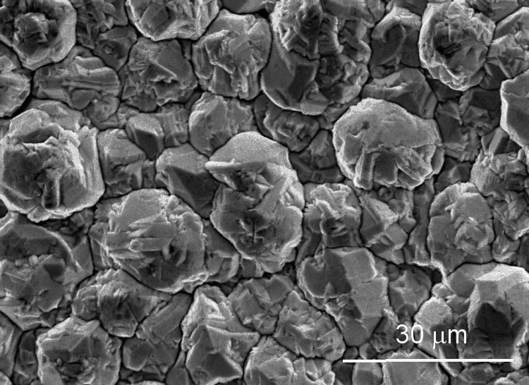
Fig. 7. SEM micrograph of Cu coating, obtained after 3 h deposition at density 1 A∙dm⁻² in an electrolyte, containing 50 g∙dm⁻³ Zn²⁺, 10 g∙dm⁻³ Cu²⁺ and
130 g∙dm⁻³ H₂SO₄. Magnification ×1000.

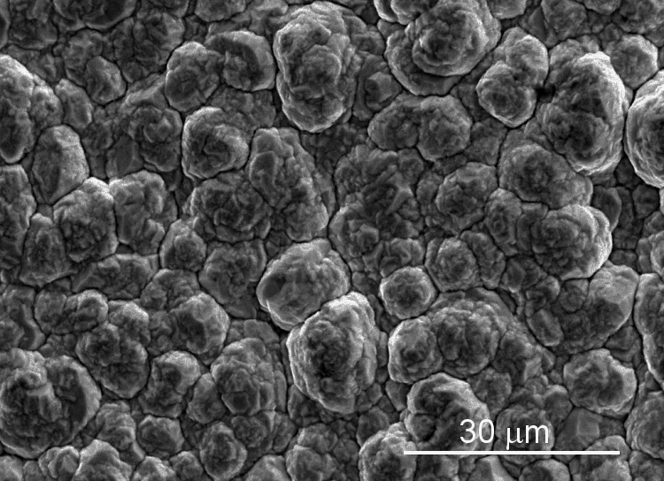
Fig. 8. SEM micrograph of Cu coating, obtained after 2 h deposition at density 1 A∙dm⁻² in an electrolyte, containing 50 g∙dm⁻³ Zn²⁺, 10 g∙dm⁻³ Cu²⁺, 130 g∙dm⁻³ H₂SO₄ and 1 cm³∙dm⁻³ Ferasine. Magnification ×1000.
It was established that non-adherent, dark-red Cu slime is deposited on Cu substrate at Cu²⁺ concen-tration lower than 5 g∙dm⁻³. In the case of low Cu²⁺ concentration the deposition potential is more negative (between –1.000 and –1.100 V) due to the concentration polarization. Figure 9 shows the morphology of Cu slime obtained after 30 min deposition at density 0.5 A∙dm⁻² and potential –1.05 V in an electrolyte, containing 1.25 g∙dm⁻³ Cu²⁺,
14 g∙dm⁻³ Zn²⁺, 16.5 g∙dm⁻³ H₂SO₄ and 0.6 cm³∙dm⁻³ Ferasine. In this case the current efficiency is less than 75%.
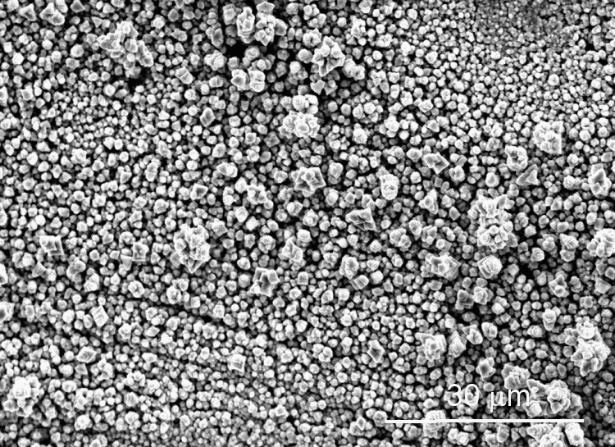
Fig. 9. SEM micrograph of Cu coating, obtained after 30 min deposition at density 0.5 A∙dm⁻² in an electrolyte, containing 14 g∙dm⁻³ Zn^{2+,} 1.25 g∙dm⁻³ Cu^{2+,} 16.5 g∙dm⁻³ H₂SO₄ and 0.6 cm³∙dm⁻³ Ferasine. Magnification ×1000.
Conclusions
In electrolytes, containing 50 g∙dm⁻³ Zn²⁺ and 1 or 5 g∙dm⁻³ Cu²⁺ at potentials more negative than
–1.6 V vs. SSE simultaneous deposition of Cu and Zn on Pt cathode is taking place. With the increase in Cu²⁺ concentration, the anodic peaks of Zn dis-solution decrease. At Cu²⁺ concentration 10 g∙dm⁻³ only Cu deposition takes place. In electrolytes, containing 50 g∙dm⁻³ Zn²⁺ and 130 g∙dm⁻³ H₂SO₄ at all studied Cu²⁺ concentrations and vertex potentials only Cu deposition takes place.
G. A. Hodjaoglu et al.: Copper deposition from sulphate electrolytes
In electrolytes, containing 50 g∙dm⁻³ Zn²⁺ current efficiency of Cu deposition at vertex potentials more negative than –1.6 V vs. SSE decreases from 70% to 20% (at Cu²⁺ concentration 1 g∙dm⁻³) and from 85−90% to 75–80% (at Cu²⁺ concentration 5 or 10 g∙dm⁻³). As it is expected current efficiency of Cu increases with the increase in Cu²⁺ concentration. Current efficiency of Zn deposition increases at vertex potentials more negative than –1.6 V vs. SSE from 0 to 75% and 15% (at Cu²⁺ concentrations of 1 and 5 g∙dm⁻³, respectively). At Cu²⁺ concentration of 10 g∙dm⁻³ Zn deposition does not take place.
In electrolytes containing 50 g∙dm⁻³ Zn²⁺ and 130 g∙dm⁻³ H₂SO₄ the current efficiency of Cu deposition increases with the increase in Cu²⁺ concentration and decreases with the increase in the vertex potential. In all cases Zn deposition does not take place. The current efficiency of Cu deposition in the presence of 130 g∙dm⁻³ H₂SO₄ is lower than the current efficiency in its absence.
Dense and smooth copper coatings on Cu cathode with current efficiency higher than 95% are deposited when Cu²⁺ concentration is higher than 5 g∙dm⁻³ and the current density is in the range 0.5−2 A∙dm⁻². More fine-grained coatings are obtained in the presence of H₂SO₄ and the organic additive hydroxyethylated-2-butyne-l,4-diol (Ferasine). At lower Cu²⁺ concentration, non-adherent dark-red slime of copper is deposited with current efficiency less than 75%.
G. A. Hodjaoglu et al.: Copper deposition from sulphate electrolytes
References
- L. Muresan, A. Nicoara, S. Varvara, G. Maurin, J. Appl. Electrochem., 29, 719 (1999).
- L. Muresan, S. Varvara, G. Maurin, S. Dorneanu, Hydrometallurgy, 54, 161 (2000).
- V. D. Кaroleva, Metallurgy of Heavy Non-ferrous Metals, Part II, c/o Jusautor, Sofia, 1986.
- D. Melzner, J. Tilkowski, A. Mohrmann, W. Poppe, W. Halwachs, K. Schogerl, Hydrometallurgy, 13, 105 (1984).
- R. Kammel, M. Goktepe, H. Oelmann, Hydrometal-lurgy, 19, 11 (1987).
- L. Muresan, A. Nicoara, S. Varvara, G. Maurin, J. Appl. Electrochem., 29, 719 (1999).
- S. Varvara, L. Muresan, I. C. Popescu, G. Maurin, J. Appl. Electrochem., 33, 685 (2003).
- S. Varvara, L. Muresan, I. C. Popescu, G. Maurin, Hydrometallurgy, 75, 147 (2004).
- S. Varvara, L. Muresan, A. Nicoara, G. Maurin, I. C. Popescu, Mater. Chem. Phys. 72, 332 (2001).
- S. Varvara, L. Muresan, I. C. Popescu, G. Maurin, J. Appl. Electrochem. 35, 69 (2005).

Потенциодинамични и галваностатични изследвания на отлагане на мед от сулфатни електролити съдържащи големи количества цинк
Г. А. Ходжаоглу, А. Т. Хрусанова, И. С. Иванов*
Институт по физикохимия, Българска академия на науките, ул. „Акад. Г. Бончев“, бл. 11, 1113 София
Постъпила на 23 май 2008 г.; Преработена на 25 февруари 2009 г.
(Резюме)
Изследвана е електроекстракцията на мед върху платинов катод от сулфатни електролити, съдържащи голями количества цинк. Установено е, че в електролити, съдържащи 50 g·dm⁻³ Zn²⁺ и 1 или 5 g·dm⁻³ Cu²⁺, при потенциали по-отрицателни от –1.6 V vs. SSE се отлагат едновременно мед и цинк. При концентрация на Cu²⁺ по-висока от 5 g·dm⁻³ и в присъствие на 130 g·dm⁻³ H₂SO₄ (независимо от концентрацията на Cu²⁺) се отлага само мед. Прибавянето към електролита на H₂SO₄ води до рязко нарастване на катодния ток, но същевременно понижава добива по ток, както на отлагането на мед, така и на цинк, което означава, че нарастването на тока е резултат от засиленото отделяне на водород. Добавката хидроксиетилиран-2-бутин-1,4-диол (Ферасин) намалява площта на медните и цинкови пикове на разтваряне, което показва, че процесът на отлагане е инхибиран. Плътни, гладки и блестящи покрития от чиста мед се отлагат при плътности на тока 0.5−2 A·dm⁻² в електролити с концентрации на Cu²⁺ по-високи от 5 g·dm⁻³ в присъствие на Ферасин. Тъмночервен и със слаба адхезия към катода меден шлам се получава при по-ниски концентрации на Cu²⁺.

