One new carboxylato-bridged dimeric network of Co(II):
Synthesis and structural aspects
Bulgarian Chemical Communications, Volume 41, Number 3 (pp. 261–265) 2009
A. Datta¹, W.-S. Hwang¹, N. Revaprasadu²*
* To whom all correspondence should be sent:
E-mail: nrevapra@pan.uzulu.ac.za
© 2009 Bulgarian Academy of Sciences, Union of Chemists in Bulgaria
¹ Department of Chemistry, National Dong-Hwa University, 1, Sec. 2, Da-Hsueh Rd., Shoufeng,
Hualien – 974, Taiwan, Republic of China
² Department of Chemistry, University of Zululand, Private Bag X1001, 3880 KwaDlangezwa,
Republic of South Africa
Received July 22, 2008; Revised February 9, 2009
A new carboxylato-bridged Co(II) dimeric complex, formulated as {Co(H₂O)₅[Co(2,6-pdc)₂].2H₂O} (H₂PDC = Pyridine-2,6-dicarboxylic acid), was synthesized in solid state under mild conditions, solved by single crystal X-ray diffraction techniques and characterized by elemental analysis, IR and electronic spectra, thermogravimetric analysis and variable temperature magnetic moments. The structural investigation shows that the crystal system of the new complex is monoclinic, having space group P2(1)/c, a = 8.3545(5), b = 27.1474(16), c = 9.5882(6) Å, β = 99.089(1)°, and Z = 4. The neighbouring Co atoms are bridged by carboxylate group of one pdc ligand and the dihedral angle defined by the mean planes of two pdc ligands is 88.6°, showing that they fall almost perpendicular. The effective magnetic moment μ_{eff} value of the new complex is close to 5.31 μ_{B} at 302 K, and much larger than the spin-only value of 3.87 μ_{B} for high-spin Co(II). The complex is extended into a three-dimensional hydrogen bonding network.
Key words: Crystal structure, cobalt(II), carboxylato-bridge, H₂-PDC, spectral studies, TGA analysis.

Introduction
The compounds containing carboxylate group are an important class of ligands in inorganic and bioinorganic chemistry. Metal complexes containing monocarboxylic acids are well known regarding the versatility of the carboxylate group as an inner-sphere ligand [1]. Rigid dicarboxylates are parti-cularly attractive because the metal carboxylate bonding is also rigid and the use of appropriate spacers can lead to predetermined network struc-tures [2–5].
Previously it was found out that the reaction of simple transition metal salts with functionalized carboxylic and dicarboxylic acids leads to the iso-lation of soluble materials, which were structurally elucidated [6–8]. H₂PDC (pyridine-2,6-dicarboxylic acid) is an efficient ligand, which is usually used as a tridentate ligand, as well as a bridging linker in the chemical design of metal-organic molecular assemblies [9–13]. H₂PDC forms chelates with simple metal ions and oxo-metal cations and it can display widely varying coordination behaviour, functioning as a multidentate ligand. Other isomeric pyridine-dicarboxylic acids, e.g. pyridine-2,3-, 2,4- and 2,5-dicarboxylic acids, behave like picolinic acid and act as bidentate (chelating) N,O donors. A very important characteristic of these ligands is their diverse biological activity. Pyridine-2,3-dicarboxy- lic acid is an intermediate in the tryptophan de-gradation pathway and it is precursor for NAD [14]. However, reports for H₂PDC’s coordination com-plexes having 3D open framework structures are rarely seen [15, 16].
In this regard, Ghosh et al. [17] reported the complex, [Co(pdc)(4,4’-bpy)].1/2MeOH, where pyridine-2,6-dicarboxylic acid has been used as a ligand for binding more than one metal ion through carboxylate bridging to form 1-D coordination polymeric chains.
On the basis of the aforementioned considera-tions, herein, we describe the crystal structure, spec-troscopic study, thermogravimetric analysis and low-temperature magnetic properties of a new carboxylato-bridged cobalt(II) complex (1), using pyridine-2,6-dicarboxylic acid, in which the Co(2) atom possesses a distorted octahedral geometry.
Experimental
All the chemicals used for the synthesis were of reagent purity grade. Cobalt(II) nitrate and pyridine-2,6-dicarboxylic acid (Aldrich) were used as received.
C, H, and N analyses were carried out using a Perkin-Elmer 240C elemental analyzer. Infrared spectra were recorded on a Perkin-Elmer 883 infra-red spectrophotometer in the range 4000–200 cm^{–1} as KBr pellets. Electronic spectra were measured on a Hitachi U-3400 (UV-Vis-NIR) spectrophotometer in methanol. The thermal investigation was carried out on a Shimadzu TGA-50 thermal analyser in a dynamic nitrogen environment. Magnetic suscep-tibility measurements were carried out on a Quantum Design SQUID MPMS-XL susceptometer apparatus working in the range 2–302 K.
Synthesis of {Co(H₂O)5[Co(2,6-pdc)2].2H₂O} (1)
To a 10 ml methanolic solution of cobalt(II) nitrate (2 mmol, 0.582 g), 10 ml of aqueous solution of pyridine-2,6-dicarboxylic acid (2 mmol, 0.334 g) were added upon stirring and reaction mixture was kept at room temperature. Several days later good quality green square-shaped crystals of 1 were separated. They were filtered, washed with methanol-water mixture (1:1) and dried. Yield: 73%. Anal. Calcd. for C₁₄H₂₀Co₂N₂O₁₅: C 29.25, H 3.51, N 4.87%; Found: C 29.19, H 3.46, N 4.82%.
Crystallography
The details concerning crystal data, data collection characteristics and structure refinement are summarized in Table 1. Diffraction data were measured at 100(2) K on a Bruker AXS P4 four-circle diffractometer fitted with graphite-mono-chromated CuKα radiation, λ = 0.71073 Å and the
ω : 2θ scan technique for data collection within a θ range of 1.50–28.33°.
Table 1. Crystal data and refinement parameters for complex 1.
Chemical formula | C₁₄H₂₀Co₂N₂O₁₅
Molecular weight | 574.18
Space group | P2(1)/c
Wavelength | 0.71073 Å
Crystal system | Monoclinic
a (Å) | 8.3545(5)
b (Å) | 27.1474(16)
c (Å) | 9.5882(6)
α °(°) | 90
β (°) | 99.089(1)
γ (°) | 90
T (K) | 100(2)
V (Å³) | 2153.0(2)
Z | 4
D (mg/m³) | 1.771
Absorptin coefficient (mm^{–1}) | 1.620
θ for data collection (°) | 1.50–28.33
Reflections collected | 16028
Independent reflections | 5354
Goodness-of-fit on F² | 1.044
Final R indices [I > 2σ(I)] | R1 = 0.0310, wR2 = 0.0740
R indices (all data) | R1 = 0.0378, wR2 = 0.0764
Largest diff. Peak and hole | 0.469 and –0.339 e·Å^{–3}

The structure was solved by direct methods using the SHELXTL PLUS [18] system and refined by full-matrix least-squares methods based on F² using SHELXL93 [19]. In this case, non-hydrogen atoms were calculated employing anisotropic displacement parameters and the hydrogen atom positions were calculated with fixed isotropic displacement para-meters.
Results and discussion
Crystal structure section
The ORTEP representation of 1 is shown in Fig. 1 with selected bond lengths and angles summarized in Table 2.
A. Datta et al.: One new carboxylato-bridged dimeric network of Co(II)

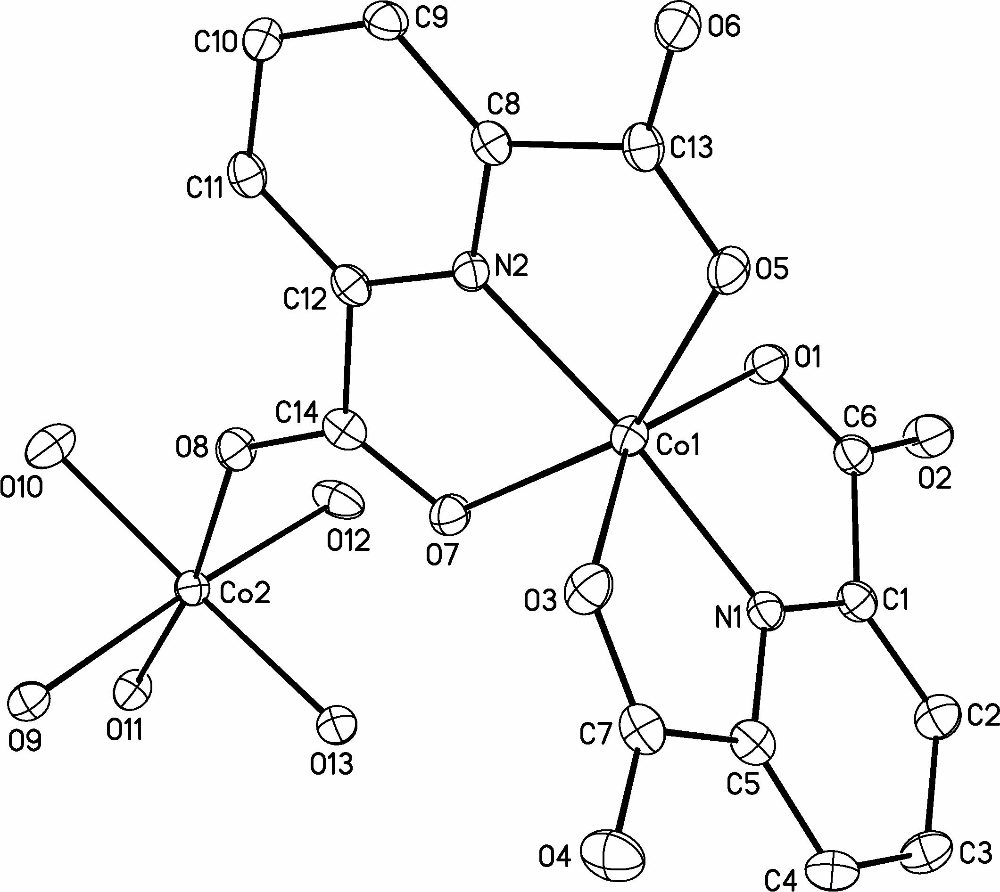
Fig. 1. An ORTEP plot of complex 1 drawn with 40% probability level. Hydrogen atoms have been omitted
for simplicity.
Complex 1 crystallizes in monoclinic system with space group P2(1)/c. It consists of elongated octahedral molecules, where the Co(1) centre exhibits a coordination surrounding O₄+N₂, of the type 4+2. The six donor atoms are the one N-pyridine and two O-carboxylate donors of each tridentate pdc ligand. They define well a mean plane (deviations < 0.032 Å), which virtually contains the metal atom (deviation of 0.019 Å). The trans-angles, O(1)–Co(1)–O(3) and O(5)–Co(1)–O(7), have a significantly low value. Both O–Co–O trans-angles of 1 reveal the rather rigid structures of such tridentate ligands, which are approximately planar (within 0.019 Å). In contrast, the trans-angle N–Co–N [N(1)–Co(1)–N(2)] is quite close to ~ 180° and the dihedral angle defined by the mean planes of two pdc ligands is 88.6°, showing that they fall almost perpendicular.
The Co(1) and Co(2) atoms are held together by single μ-carboxylate oxygen of the pdc ligand. The Co(2) atom is chelated by one oxygen atom of bridging-carboxylate from the pdc ligand and it coordinates five oxygen atoms from five water molecules. Thus, the Co(2) atom exhibits a distorted octahedral coordination geometry. Among the six coordination sites, the four sites are almost in an equatorial plane (the deviation from a regular square-planar structure is 9.47°) and these are occupied by four oxygen atoms from four water molecules, the two sites in the axial position are occupied by one oxygen atom from bridging-carboxylate and one oxygen atom from one water molecule. The deviation from the octahedral geometry is also indicated by the bond angles between the atoms in the cis positions, which vary from 79.83(5) to 99.25(5)° as well as the angles involving the trans positions that vary to a large extent from 168.78(5) to 176.58(5)°. The Co(2) sites are located on a crystal inversion centre.
Table 2. Selected bond lengths (in Å) and interbond angles 9in °) for complex 1.
Co(1)–N(1) | 2.0157(16)
Co(1)–N(2) | 2.0241(15)
Co(1)–O(1) | 2.1708(13)
Co(1)–O(5) | 2.1802(12)
Co(1)–O(3) | 2.113(13)
Co(1)–O(7) | 2.2148(12)
Co(2)–O(8) | 2.0868(12)
Co(2)–O(9) | 2.1681(13)
Co(2)–O(10) | 2.0525(14)
Co(2)–O(11) | 2.0877(13)
Co(2)–O(12) | 2.0516(14)
Co(2)–O(13) | 2.0832(13)
N(1)–Co(1)–N(2) | 171.83(6)
O(1)–Co(1)–O(3) | 149.90(5)
O(5)–Co(1)–O(7) | 151.48(5)
O(1)–Co(1)–O(7) | 96.82(5)
O(3)–Co(1)–O(5) | 85.36(5)
O(8)–Co(2)–O(10) | 79.83(5)
O(10)–Co(2)–O(9) | 86.09(5)
O(9)–Co(2)–O(11) | 85.65(5)
O(11)–Co(2)–O(13) | 99.25(5)
O(13)–Co(2)–O(12) | 88.31(6)
O(12)–Co(2)–O(8) | 87.29(5)
O(8)–Co(2)–O(11) | 170.37(5)
O(10)–Co(2)–O(13) | 168.78(5)
O(9)–Co(2)–O(12) | 176.58(5)

Extensive intermolecular hydrogen bonds are formed in the crystal by means of the five coor-dinated water molecules O9, O10, O11, O12 and O13 and the two lattice water molecules O14 and O15, the two coordinated carboxylic oxygen atoms O1 and O5, and three uncoordinated carboxylic oxygen atoms O2, O4 and O6, respectively. Thus, the complex is extended into a three-dimensional network by means of hydrogen bonds (Fig. 2). The data on hydrogen bonds for 1 is summarized in Table 3.
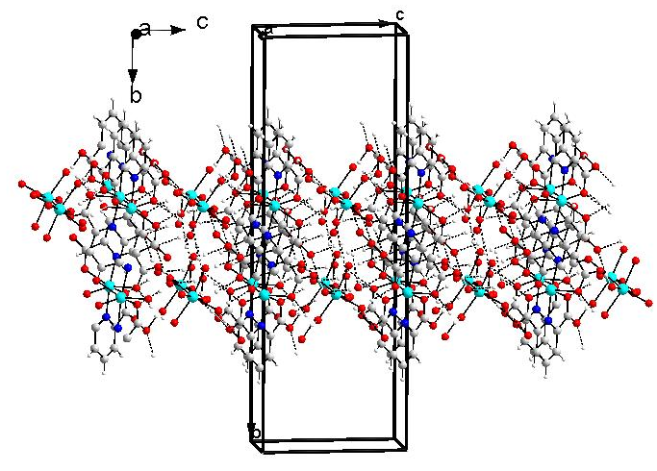
Fig. 2. The crystallographic packing diagram of
complex 1 along the a axis.
Spectral data section
The infrared spectrum of 1 is very consistent with the structural data presented in this paper. It shows characteristic absorption of the coordinated carboxyl groups. The strong bands at 1646 and 1400 cm^{–1} for Co(1) centre and 1680 cm^{–1} and 1395 cm^{–1} for Co(2) centre were assigned as ν_{as} (COO⁻) and ν_{sym} (COO⁻) stretching vibrations, respectively. In the low energy region, a series of absorption peaks is also observed, such as ν_{O–C–O} at 1670 cm^{–1}, ν_{OH} at 925 cm^{–1}, ν_{C–H} at 1370 cm^{–1} [20]. There are also three absorption peaks at 3385, 3345 and 3047 cm^{–1}, due to ν_{O–H} vibration modes for water molecules. The absorption bands in the 1400–1600 cm^{–1} region arise from the skeletal vibrations of the aromatic rings of the ligand.
A. Datta et al.: One new carboxylato-bridged dimeric network of Co(II)
The UV-visible absorption peaks correspond to the absorptions for octahedral Co(II), which has features between 19600 and 21600 cm^{–1} assigned to the ⁴T_{1g}(F) → ⁴A_{2g}(F) and ⁴T_{1g}(F) → ⁴T_{1g}(P) transitions, respectively [21].
Table 3. Data on hydrogen bonds for 1.
Bond | Distances,  Å | Bond | Distances,  Å
O11_{cw}…O14_{lw} | 2.655 | O11_{cw}…O5 | 2.767
O10_{cw}…O15_{lw} | 2.986 | O10_{cw}…O6 | 2.636
O12_{cw}…O15_{lw} | 2.821 | O12_{cw}…O4 | 2.723
O9_{cw}…O1 | 2.799 | O9_{cw}…O6 | 2.684
O13_{cw}…O2 | 2.710 | O15_{lw}…O9_{cw} | 2.938
O14_{lw}…O4 | 2.769 | O14_{lw}…O2 | 2.781
cw = coordinated water; lw = lattice water.
Thermogravimetric study
Thermogravimetric analysis was carried out in N₂ atmosphere with a heating range of 10°C·min^{–1}. The TGA curve indicates that complex 1 expe-rienced three steps of weight loss. It began to lose lattice water slowly at 115°C and this ended at about 140°C. The loss of an aqua ligand began at 160°C rapidly and ended at 190°C. This could occur because the latter has much higher bond energy than the former and higher lattice energy. Pyridine-2,6-dicarboxylate rapidly decomposes at 270°C and the process ends at 295°C.
Magnetic moment measurements
The effective magnetic moment, μ_{eff} value of 1 is close to 5.31 μ_{B} at 302 K, and much larger than the spin-only value of 3.87 μ_{B} for high-spin Co(II). Upon cooling down, the μ_{eff} value decreases gradu-ally to 3.96 μ_{B} at 18 K. The magnetic behaviour should be due to a larger orbital contribution arising from the ⁴T_{1g} ground state of Co(II). It is very close and comparable with the μ_{eff} value on cooling 3.94 μ_{B}, derived by Liao et al. [22]. The magnetic cal-culation has been done with the susceptibility equation based on H = –2J(S₁S₂ + S₂S₁).
(χ_{M} = (Ng2β²/4kT)[1 + exp(–2J/kT) +
+ 10exp(J/kT)]/[1 + exp(–2J/kT) +
+ 2exp(J/kT)] + Nα (1)
Where χ = λ/kT, χ_{M} denotes the susceptibility per dinuclear complex, λ is the spin-orbital coupling constant and Nα is the temperature independent paramagnetism. Magnetic data were well fitted to Eqn. (1) in the temperature range of 18–302 K with λ = –130.6 cm^{–1} and g = 2.31.
Very recently, Ribas and coworkers [17] derived the magneto-structural relationship for carboxylate-bridged 1-D coordination polymeric chain of Co(II) complexes, J = –5.35 cm^{–1}. Obviously, here the calculated J value may be affected by the spin-orbital coupling and should be regarded only as the highest possible value for the antiferromagnetic coupling. In our present complex (1), an agreement factor has been defined as Σ = (χ^{calcd} – χ^{obsd})²/Σ(χ^{obsd}) and its value was 2.73×10^{–5}.
A. Datta et al.: One new carboxylato-bridged dimeric network of Co(II)
Conclusion
One new carboxylato-bridged Co(II) complex, has been reported in which two different Co centres possess distorted octahedral geometry. Electronic spectra of the complex support its geometry as established based on X-ray analysis. Magnetic studies indicate that upon cooling down, the μ_{eff} value decreases gradually to 3.96 μ_{B} at 18 K. We are presently probing the capability of different modes of pyridine-dicarboxylic acids, like pyridine-2,3-, 2,4- or 2,5-dicarboxylic acids, to form metal-organic frameworks structures acting as bidentate (chela-ting) N,O donors on the Co(II) and other transition metal systems.
Supplementary material
Crystallographic data have been submitted to the Cambridge Crystallographic Data Center with depo-sition number 273379. Copies of the information may be obtained free of charge from the Director, CCDC, 12 Union Road, Cambridge, CB2 1EZ, UK (fax: +44-1233-336033; E-mail: deposit@ccdc.cam.ac.uk; http://www.ccdc.cam.ac.uk).
Acknowledgments: A.D. and W.S.H. express their gratitude to the National Science Council (Taiwan, Republic of China and National Dong Hwa University for providing the financial support necessary to carry out the study. N.R. thanks the National Research Foundation (NRF), South Africa for providing the magnetic study.
References
- R. C. Mehrotra, R. Bohra, Metal Carboxylates, Academic Press, London, 1983.
- M. Eddaoudi, H., Li, O. M. Yaghi, J. Am. Chem. Soc., 123, 1391 (2000).
- J.-C. Dai, X.-T. Wu, Z.-Y. Fu, S.-M. Hu, W.-X. Du, C.-P. Cui, L.-M. Wu, H.-H. Zhang, R.-Q. Sun, Chem. Commun., 12 (2000).
- (a) D. Sun, R. Cao, Y Liang,. Q. Shi, W. Su, M. Hong, J. Chem. Soc., Dalton Trans., 2335 (2001)
(b) C. S. Hong, S. K. Son, Y. S. Lee, M. J. Jun, Y. Do, Inorg. Chem., 38, 5602 (1999).
- S. Subramaniam, M. J. Zaworotko, Angew. Chem., Int. Ed., 34, 2127 (1995).
- M. McCann, M. T. Casey, M. Devereux, M. Curran, V. McKee, Polyhedron, 15, 2321 (1996).
- M. McCann, M. T. Casey, M. Devereux, M. Curran, C. Cardin, A. Todd, Polyhedron, 15, 2117 (1996).
- S. McCann, M. McCann, M. T. Casey, M. Devereux, V. McKee, P. McMichael, J. McCrea, Polyhedron, 16, 4247 (1997).
- M. G. B. Drew, Coord. Chem. Rev., 24, 179 (1977).
- B. Zhao, P. Cheng, Y. Dai, C. Cheng, D. Z. Liao, S. P. Yan, Z. H. Jiang, G. L. Wang, Angew. Chem., Int. Ed., 42, 934 (2003).
- C. Brouca-Cabarrecq, A. Fernandes, J. Jaud, J. P. Costes, Inorg. Chim. Acta, 332, 54 (2002).
- W. Z. Wang, X. Liu, D. Z. Liao, Z. H. Jiang, S. P. Yan, G. L. Wang, Inorg. Chem. Commun., 4, 327 (2001).
- K. Y. Choi, H. Ryu, Y. M. Lim, N. D. Sung, U. S. Shin, M. Suh, Inorg. Chem. Commun., 6, 412 (2003).
- D. C. Crans, L. Yang, T. Jakusch, T. Kiss, Inorg. Chem., 39, 4409 (2000).
- G. Nardin, L. Randaccio, R. P. Bonomo, E. Rizzarelli, J. Chem. Soc., Dalton Trans., 3, 369 (1980).
- N. Bresciani-Pahor, G Nardin, R. P. Bonomo, E. Rizzarelli, J. Chem. Soc., Dalton Trans., 12, 2625 (1984).
- S. K. Ghosh, J. Ribas, P. K. Bharadwaj, Cryst. Growth Des., 5, 623 (2005).
- G. M. Sheldrick, SHELXL-PLUS, Siemens X-ray Analytical Instruments Inc., Madison, USA, 1990.
- G. M. Sheldrick, SHELXL 93: Program for Crystal Structure Refinement, Univ. Gottingen, Germany, 1993.
- K. Nakamoto, Infrared and Raman Spectra of Inorganic and Coordination Compounds, 4th Ed., Wiley & Sons Interscience Publ., New York, 1986.
- A. B. P. Lever, Inorganic Electronic Spectroscopy, 2nd Ed., Elsevier Science, New York, 1984.
A. Datta et al.: One new carboxylato-bridged dimeric network of Co(II)
- L.-N. Zhu, M. Liang, Q.-L. Wang, W.-Z. Wang, D.-Z. Liao, Z.-H. Jiang, S.-P. Yan, P. Cheng, J. Mol. Struct., 657, 157 (2003).

нова двумерна мрежа от комплекс на Co(II) с карбоксилатни мостове: синтез и структурни аспекти
А. Датта¹, У.-С. Хуанг¹, Н. Ревапрасаду^{2,}*
Департамент по химия, Национален университет Донг-Хуа, „Да-Хсюе“ роуд, № 1, сек. 2,
Шуфенг, Хюалиен – 974, Тайван, Китайска република
Департамент по химия, Университет на Зулуленд, ПК Х1001, Ква Длангезуа,
Южноафриканска република
Постъпила на 22 юли 2008 г.; Преработена на 9 февруари 2009 г.
(Резюме)
Синтезиран е в меки условия нов димерен комплекс на Co(II) в твърдо състояние, определен като {Co(H₂O)₅[Co(2,6-pdc)₂].2H₂O} (H₂PDC = пиридин-2,6-дикарбонова киселина) чрез рентгенова дифракция от монокристал и е охарактеризиран с елементен анализ, ИЧС, електронни спектри, термогравиметричен анализ и магнитен момент при различни температури. Структурните изследвания показват че кристалната система на новия комплекс е моноклинна, пространствена група P2(1)/c, a = 8.3545(5), b = 27.1474(16), c = 9.5882(6) Å,
β = 99.089(1)°, и Z = 4. Съседните Со атоми са свързани с мостове от карбоксилатни групи от един PDC лиганд и пространственият ъгъл, определен от равнините на два PDC лиганда е 88.6°, показвайки, че те са почти перпендикулярни. Стойността на ефективния магнитен момент μ_{eff} на новия комплекс е близо до 5.31 μ_{B} при 302 K, много по-голям от спиновата стойност от 3.87 μ_{B} за високоспинов Co(II). Комплексът се разраства в триизмерна мрежа чрез водородни връзки.

