Investigation of Zn sorption by natural clinoptilolite and mordenite
Bulgarian Chemical Communications, Volume 41, Number 3 (pp. 266–271) 2009
© 2009 Bulgarian Academy of Sciences, Union of Chemists in Bulgaria
N. Lihareva*, L. Dimova, O. Petrov, Y. Tzvetanova
* To whom all correspondence should be sent:
E-mail: nlihareva@abv.bg
Central Laboratory of Mineralogy and Crystallography, Bulgarian Academy of Sciences,
Acad. G. Bonchev St., Block 107, 1113 Sofia, Bulgaria
Received October 30, 2008; Revised January 28, 2009
Sorption and desorption of zinc on two natural zeolites – clinoptilolite and mordenite was studied using batch technique. The sorbed Zn quantity was studied as a function of its concentration in solutions. The equilibrium sorption data were analyzed using Langmuir’s and Freundlich’s models. It was found that for the sorption on clinoptilolite both Langmuir’s and Freundlich’s isotherm expressions gave a good fit to the experimental data. For mordenite, at low added concentrations the sorption followed well both models, but at higher concentrations the shape is different for the two applied models. The amount of zinc, sorbed by clinoptilolite, is greater than that sorbed by mordenite. The modeling of the release of sorbed zinc is carried out by extraction with ethylenediamine tetraacetic acid (EDTA). The percentage of extracted to sorbed zinc varies from 94.2% to 74.6% and from 95.5% to 67.9% for clinoptilolite and mordenite, respectively, with the increase in Zn concentration of the initial treatment. The results of this study show that both zeolites possess a high potential for zinc sorption and slow rate of desorption.
Key words: clinoptilolite, mordenite, zinc sorption.

Introduction
Natural zeolites clinoptilolite and mordenite are potential adsorbent agents for metal cations because of their porous structure, high specific surface area and cation exchange capacity [1, 2].
Their application as sorbents is important for purification of wastewaters or for metal immobili-zation in the processes of removal of heavy metals from polluted soils. The agricultural application of natural zeolites includes also their use as fertilizers, when metals, adsorbed on zeolites are released under control in order to compensate for nutrient deficiency in microelements of some soils or as soil-additives to modify its water regime, physical properties, pH, etc.
Zinc plays a substantial role as a microelement in the formation of proteins in the body and thus it assists the general growth and maintenance of human and animal bodies, in healing skin lesions and blood formation. This metal is component in a large number of enzymes, participating in the meta-bolic processes. The main way to obtain enough zinc in our body is eating a variety of foods that contain an appropriate amount of Zn. That is why the soil content of zinc and its mobile form, accessible to plants, is very important for nutrition. The average content of zinc in soils is 50 mg∙kg⁻¹ and depends on the soil composition. When the amount of extractable forms of zinc is low, the metal is imported artificially into soils either directly (as ZnSO₄) or as an incidental component in other fertilizers [3, 4]. The direct addition of zinc is not preferable due to the risk of eventual exceeding of limit levels that results in contamination of soil. Therefore, in order to preserve environment at present the introduction of zinc as well as some other components in the soil is realized through slow-release zeolite-bound zinc fertilizers, which are considered as natural carriers for trace elements.
The effective utilization of such fertilizers needs the design of chemical models that describe the processes of equilibrium. The investigations on sorption and desorption of zinc on zeolites con-stantly increase with the time, which proves the importance of this metal for such purposes [5–7]. Chemical models, describing the processes of equilibrium between sorption and desorption of Zn are studied by Langella [8], Roman [9] and Top [10]. On the other hand several investigators have reported that clinoptilolite shows low selectivity towards the Zn²⁺ ion [8, 11–13]. The exchange reaction of Zn²⁺ on zeolite is reversible and Zn²⁺ can be released by appropriate extractants.
This study represents the applicability of two Bulgarian natural zeolites, namely clinoptilolite and mordenite, for sorption of zinc, considering utiliza-tion of ion-exchanged forms as soil fertilizer. The effect of addition of these zeolites to soil and the mobility of sorbed zinc, were evaluated by a modelling leaching procedure.

Experimental
Materials and Methods
Two naturally occurring zeolites in Eastern Rhodopes, Bulgaria, were studied – namely clinopti-lolite and mordenite. The clinoptilolite sample is a clinoptilolite rich tuff from Beli Plast layer deposit. The sample of mordenite is mordenite tuff from Lyaskovets deposit.
The samples were ground in an agate mortar and sieved through a 0.16 mm sieve. The sieve fractions of 0.016–0.032 mm for clinoptilolite and 0.016–0.064 mm for mordenite were obtained by sedimen-tation technique. The purity of the separated mate-rial was checked by powder XRD phase analysis.
Then the two samples were further enriched in zeolite phase by separation with heavy liquid (ethanol and bromoform mixture with specific gravity of 2.2).
The chemical composition of the two samples was determined by AAS and inductively coupled plasma atomic emission spectrometry ICP-AES after dissolution in a mixture of HF-HNO₃-HClO₄. The silicon was determined gravimetrically. The data are shown in Table 1.
N. Lihareva et al.: Zn sorption by natural clinoptilolite and mordenite
Table 1. Chemical composition of the studied zeolites.
Component | Clinoptilolite | Mordenite
SiO₂ | 68.05 | 60.32
Al₂O₃ | 12.63 | 12.72
Fe₂O₃ | 0.83 | 1.25
K₂O | 3.02 | 4.89
Na₂O | 0.51 | 4.03
CaO | 3.53 | 8.80
MgO | 0.18 | 0.10
TiO₂ | 0.08 | 0.06
MnO | 0.02 | 0.01
H₂O | 11.24 | 8.4
Sum | 100.09 | 100.58
Zn* | 36.8 | 34.3
Si/Al | 5.39 | 4.74
* in μg/g.
Powder XRD analysis was used to determine the mineral composition of the initial zeolite samples (Table 2).
Table 2. Quantitative phase analysis of clinoptilolite and mordenite samples (wt.%).
Sample | Clinop-tilolite | Morde-nite | Feldspar | Quartz | Opal
Clinoptilolite | 80 | – | 2 | 3 | 15
Mordenite | – | 75 | 25 | – | –
The XRD powder patterns were obtained by DRON 3M difractometer using CoKα radiation (40 kV, 25 mA) with a Fe filter. The step scan was performed in the 2θ range from 8 to 60° at a step of 0.050° with 3 s intensity measurement in each step.
The ion-exchange experiments were carried out by a bath technique. To 1 g of samples, taken in double portions, 20 ml of solutions of zinc were added, with concentrations of 0.0, 5.0, 25.0, 50.0, 100.0, 250.0 and 500.0 mg·l⁻¹, prepared from ZnSO₄.7H₂O [5]. The pH value of all used solutions of Zn was adjusted to 5.80, so the influence of different pH on the sorption was eliminated. No pH adjustment was made during the experiments. Precipitation of oxides, hydroxides or carbonates, especially at certain higher pH cannot occur in this case, because the solubility product, depending on the pH and Zn concentration, cannot be reached. The samples were agitated in a shaker (amplitude 20 mm and 150 oscillation∙min^{–1}) until equilibrium was reached. Preliminary experiments were carried out in order to determine the time interval, necessary to reach ion equilibrium. The samples were shaken for 8 hours and an aliquot was taken at 2 hours inter-vals. The Zn²⁺ concentration in the solution after each period was measured by AAS. It was found that the ion-exchange equilibrium was completely achieved in about 4 hours. The suspension was centrifuged for 15 min at 3000 rpm. The supernatant liquid was removed and the zinc concentration was measured by AAS. The amount of sorbed Zn was determined as the difference between added zinc and the amount in the equilibrium solution
The equations of Langmuir and Freundlich were applied to describe the sorption equilibrium of the studied zeolites. The Langmuir’s model used is:
q_{eq} = b.S_{max}C_{eq}/(1 + bC_{eq}),
where C_{eq} (mmol/l) and q_{eq} (mmol/g) are the equi-librium Zn concentration in the aqueous phase and in the solid phase, respectively, and the Langmuir’s parameters S_{max} (mmol/kg), representing maximum sorption capacity and b (l/mol) – the site energy factor.
The Freundlich’s model used is:
q_{eq} = K_{F}C_{eq}^{N},
where K_{F} (mmol/g)/(mmol/l) and N (dimension-less) are Freundlich’s parameters.
The biologically accessible amount of sorbed zinc is the water-soluble one and the zinc fractions dissolved during biological processes. A large number of single extractants have been studied for prediction and assessment of mobility of trace elements available for the plants [14]. Among the various organic and inorganic reagents that are used for modeling of the above processes EDTA and DTPA are mostly preferred [5, 15, 16]. In our study we used EDTA according to the method proposed by Ure et al. [14], which, at present, is a harmonized procedure of BCR of the European Commission. Moreover, Haq and Miller [17] have found that the correlation coefficients between the content of zinc in plants and the extractable zinc in soil estimated by extraction with EDTA and DTPA are respect-ively 0.607 and 0.602. These findings suggest that both extractants are applicable. As it was suggested by Ure et al. [14] EDTA is preferable because it extracts greater amounts and is simpler to prepare and use.
Results and discussion
The studies of the sorption isotherms were conducted in order to evaluate the sorption effi-ciency of clinoptilolite and mordenite. The sorption isotherms of zinc with the studied samples are shown in Figure 1 and 2.
N. Lihareva et al.: Zn sorption by natural clinoptilolite and mordenite

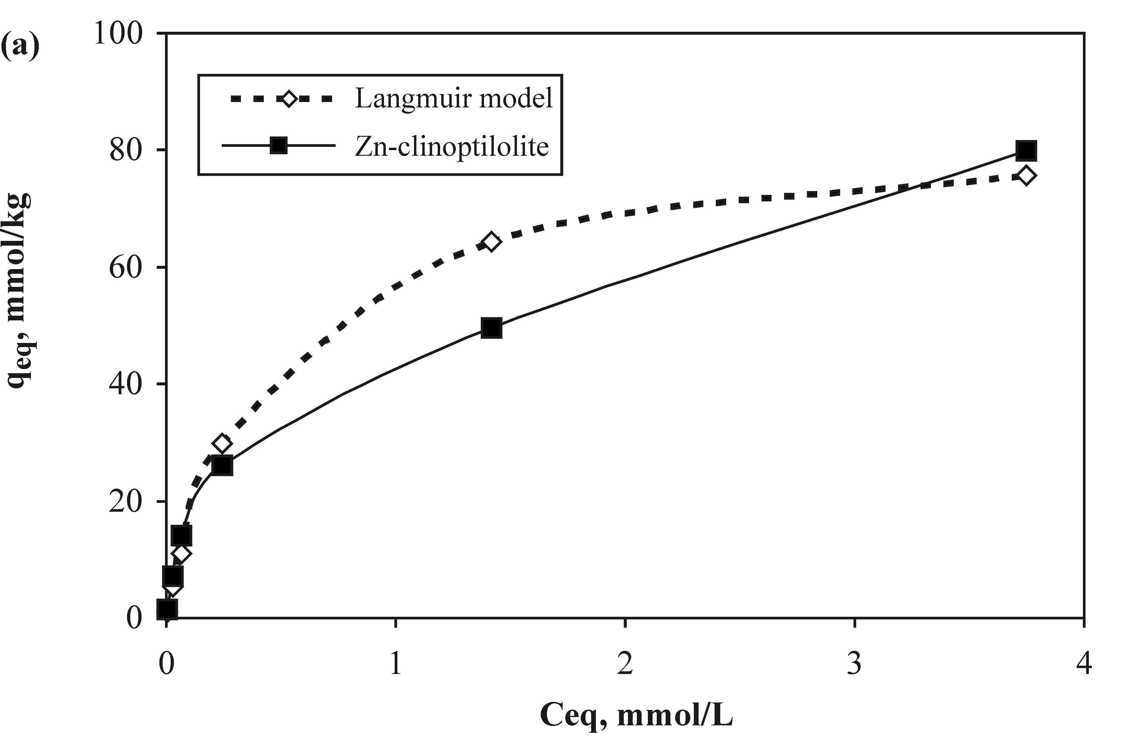
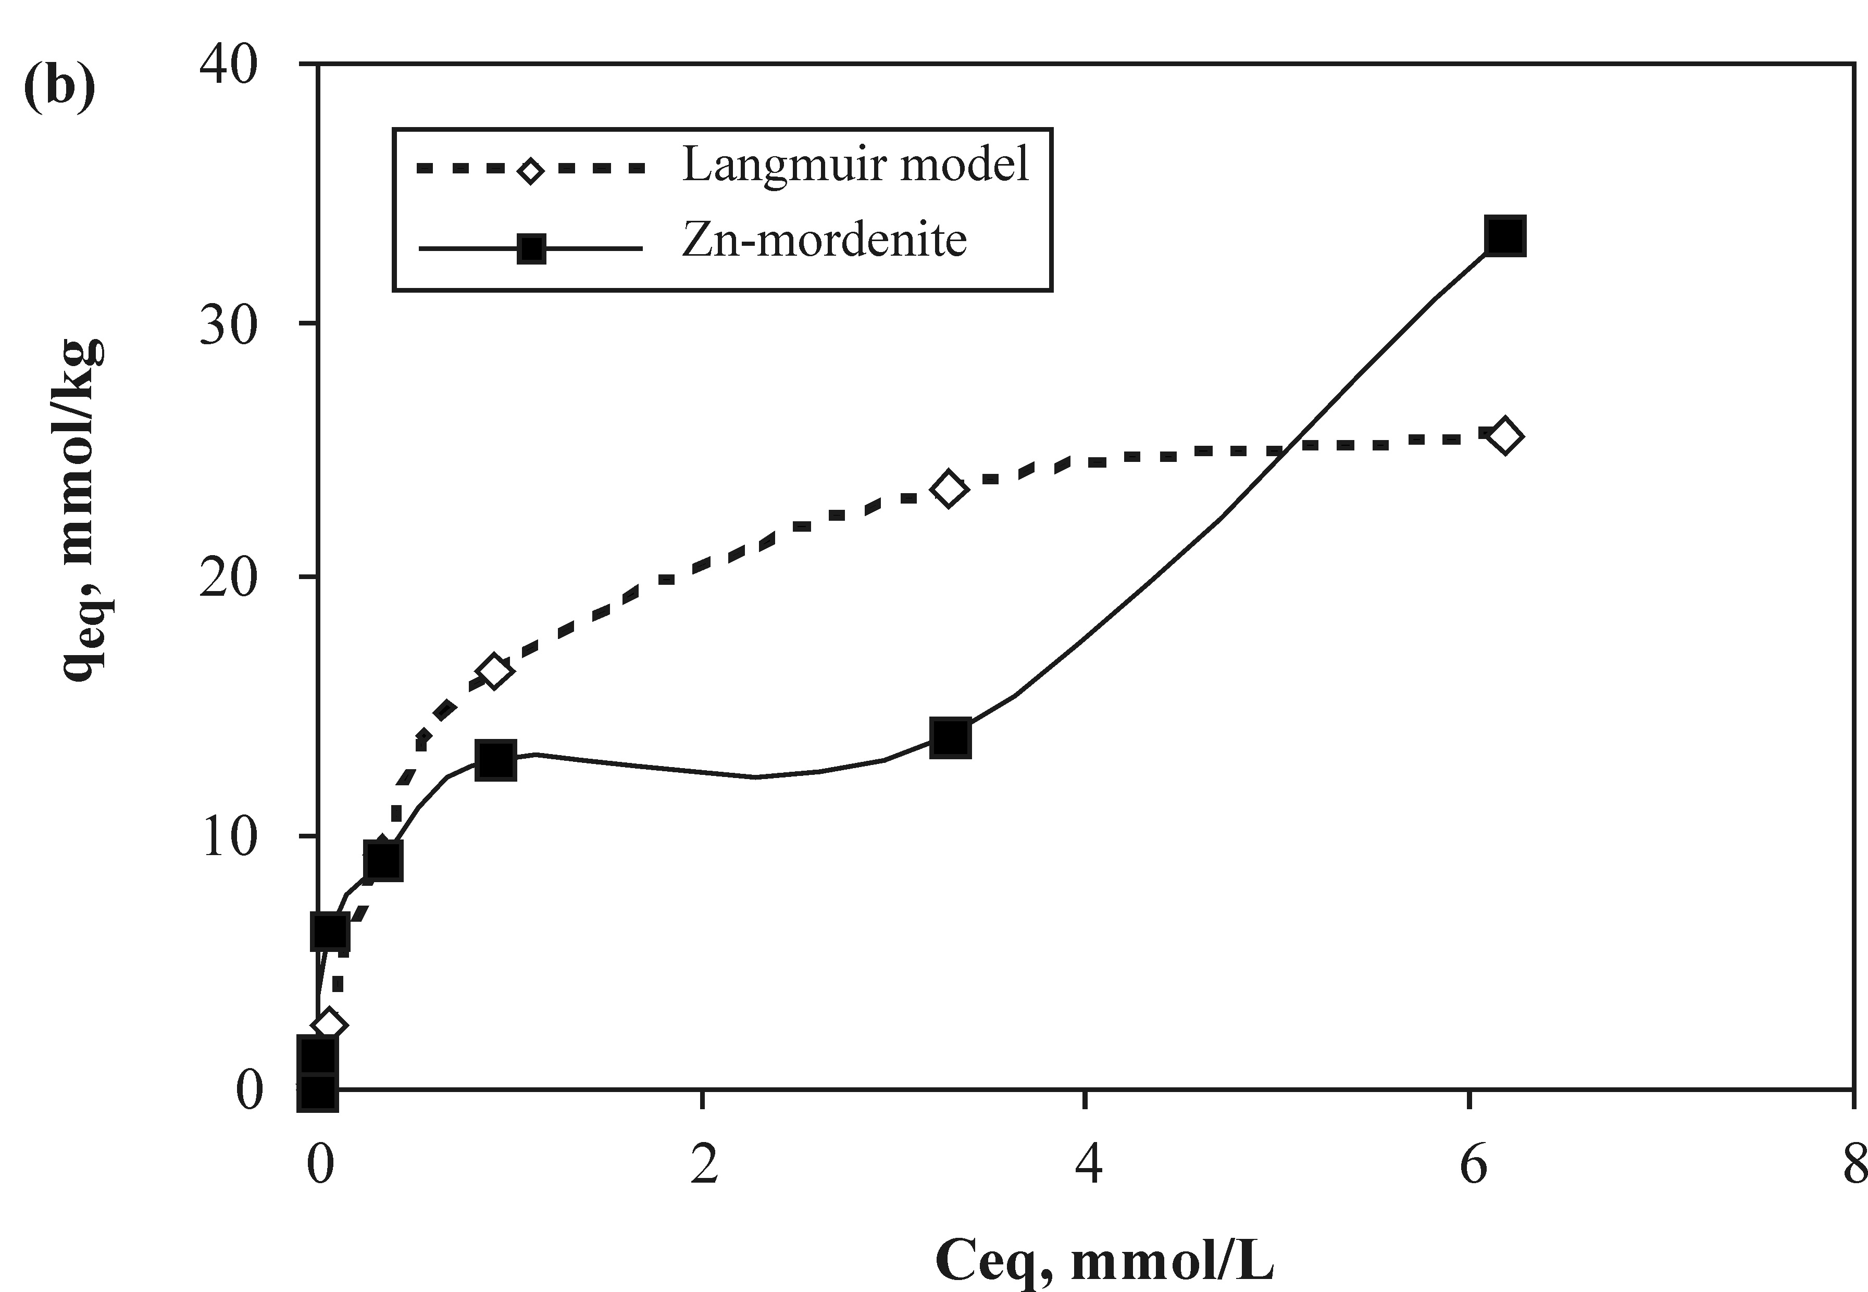
Fig. 1. Sorption isotherms of Zn on: a) clinoptilolite and b) mordenite. Solid and dashed lines represent experi-mental data and the Langmuir’s model fitting, respectively.
The shapes of the two isotherms are similar at the low initial concentrations and are characterized with relatively steep slope. At higher concentrations the slope is more uniform and the shapes are different – for clinoptilolite the sorbed amount of Zn increases, whereas for mordenite there is a defined plateau before the next increase. These results are in conformity with the results, presented by Langella [8]. The data of our experiments show that the exchange levels of zinc at different initial concen-trations are between 98% and 81% and 100% and 47.3% for clinoptilolite and mordenite, respectively.
Both Langmuir’s and Freundlich’s isotherms are displayed for the two zeolites in order to determine the model with better mathematical fit to the experi-mental data. The equation of the Zn sorption isotherms for the Langmuir’s model is:
C_{eq}/q_{eq} = C_{eq}/S_{max} + 1/b.S_{max}.
The linear Freundlich’s model used to fit the Zn sorption data is:
log q_{eq} = logK_{F} + N.logC_{eq}.
The Langmuir,s parameters (b and S_{max}) for Zn sorption were calculated from the best fitting equation, describing the C_{eq}/q_{eq} and C_{eq} dependence (Table 3). The calculated data for maximum adsorp-tion (S_{max}) show that clinoptilolite adsorbs more zinc than mordenite. The site binding energy values are of the same order: clinoptilolite > mordenite, although the difference is not significant.
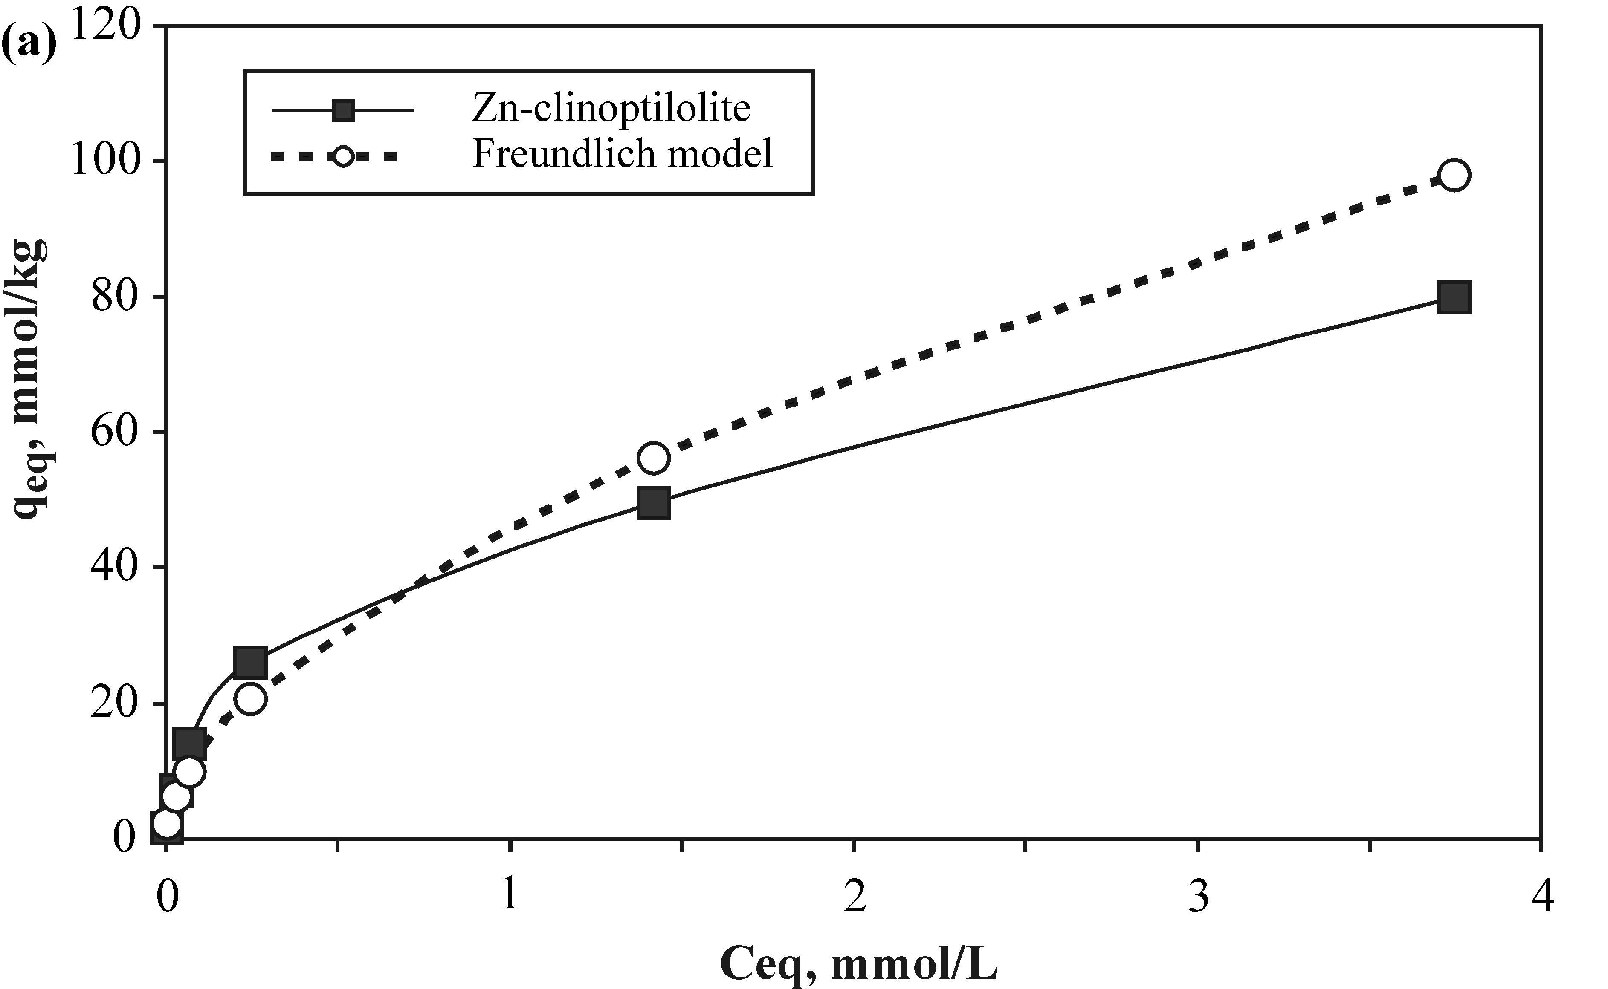
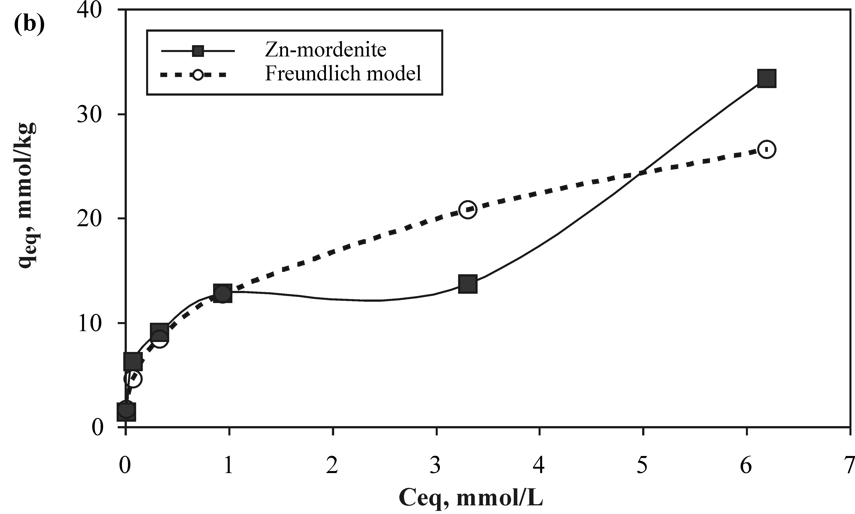
Fig. 2. Sorption isotherms of Zn on a) clinoptilolite and b) mordenite. Solid and dashed lines represent experimental data and Freundlich’s model fitting, respectively.

Table 3. Langmuir,s model parameters for sorption of Zn on clinoptilolite and mordenite.
Sample | Langmuir’s equation | R² | S_{max}, mmol/kg | b, l/mmol
Clinoptilolite | Y = 0.0118x + 0.0054 | 0.9617 | 84.74 | 2.2263
Mordenite | Y = 0.0351x + 0.0244 | 0.7349 | 28.49 | 1.4385
Table 4. Freundlich’s model parameters for sorption of Zn on clinoptilolite and mordenite.
Sample | Freundlich’s equation | R² | K_{F}  [(mmol/kg)/(mmol/l)]^{N} | N
Clinoptilolite | Y = 0.5719x + 1.6629 | 0.9611 | 48.02 | 0.5719
Mordenite | Y = 0.3893x + 1.1167 | 0.9346 | 13.08 | 0.389

The sorption isotherms of Freundlich’s model and the calculated parameters according to Freund-lich’s adsorption equation are presented in Figure 2 and Table 4, respectively. The sorption isotherms are highly nonlinear as indicated by the N-values of Freundlich’s model (0.389−0.572). They are char-acterized by an almost complete sorption at low concentrations of added zinc and decrease at the higher concentrations.
It is not clearly evident from the calculated isotherms which model describes the experimental data better. As the regression coefficient for clinoptilolite is the same for the two models it can be supposed that Langmuir’s model gives better description because the calculated values for S_{max} are close to the experimental data. Experimental results with a good fit for Zn sorption with both Langmuire’s and Freundlich’s isotherms have been presented also by Ören [18]. El Kamash [19] has found based on the obtained results for Zn sorp-tion good fitting using Freundlich’s and Dubinin-Radushkevitch (D-R) isotherm models. According to Purna et al. [20] the sorption of zinc follows Freundlich’s sorption model, while Sheta [5] finds better fitting for experimental results with Lang-muir’s model. Panalitova et al. (21), studying the Zn sorption by Bulgarian zeolite, also reported a best description of uptake by Langmuir’s isotherm. In case of mordenite the two models give difference in the isotherm shape at higher concentrations.
N. Lihareva et al.: Zn sorption by natural clinoptilolite and mordenite
In order to evaluate the sorption behavior of natural zeolites it is necessary to establish the mechanism of fixation of zinc to the zeolite struc-ture (as well as the sorption capacity of different zeolites.)
The sorption behavior of zinc ions depends on the differences in the structure of zeolite species, the surface characteristics, the amount of other cations and their ionic radii and hydrating energy.
As it is given in Table 1 the contents of sodium, potassium, and calcium are higher in mordenite than in clinoptilolite sample. The content of magnesium is low and it is similar in both zeolites. In the clinoptilolite structure, potassium is located in M(3) site, which has the highest coordination number among all the cation sites in the unit cell [22]. In this site K⁺ is coordinated by six framework oxygen atoms and three water molecules and therefore it is strongly bonded. This may be effective reason for its lower exchange ability [23].
On the other hand, the cations in the solutions interact with water molecules to form hydrated complexes. In general, the radius of these hydrates is inversely proportional to the cation radius. Thus, the smaller alkaline-earth cations Ca²⁺ and Mg²⁺, have a bigger hydration radius than the monovalent cations like K⁺ and Na⁺ [24, 25] and cannot be removed easily out of the channels. This fact can also explain the lower sorption ability of mordenite for zinc than clinoptilolite. As the contents of sodium, potassium and calcium in mordenite are higher than those in clinoptilolite the zinc selectivity in case of mordenite is lower (Fig. 3).
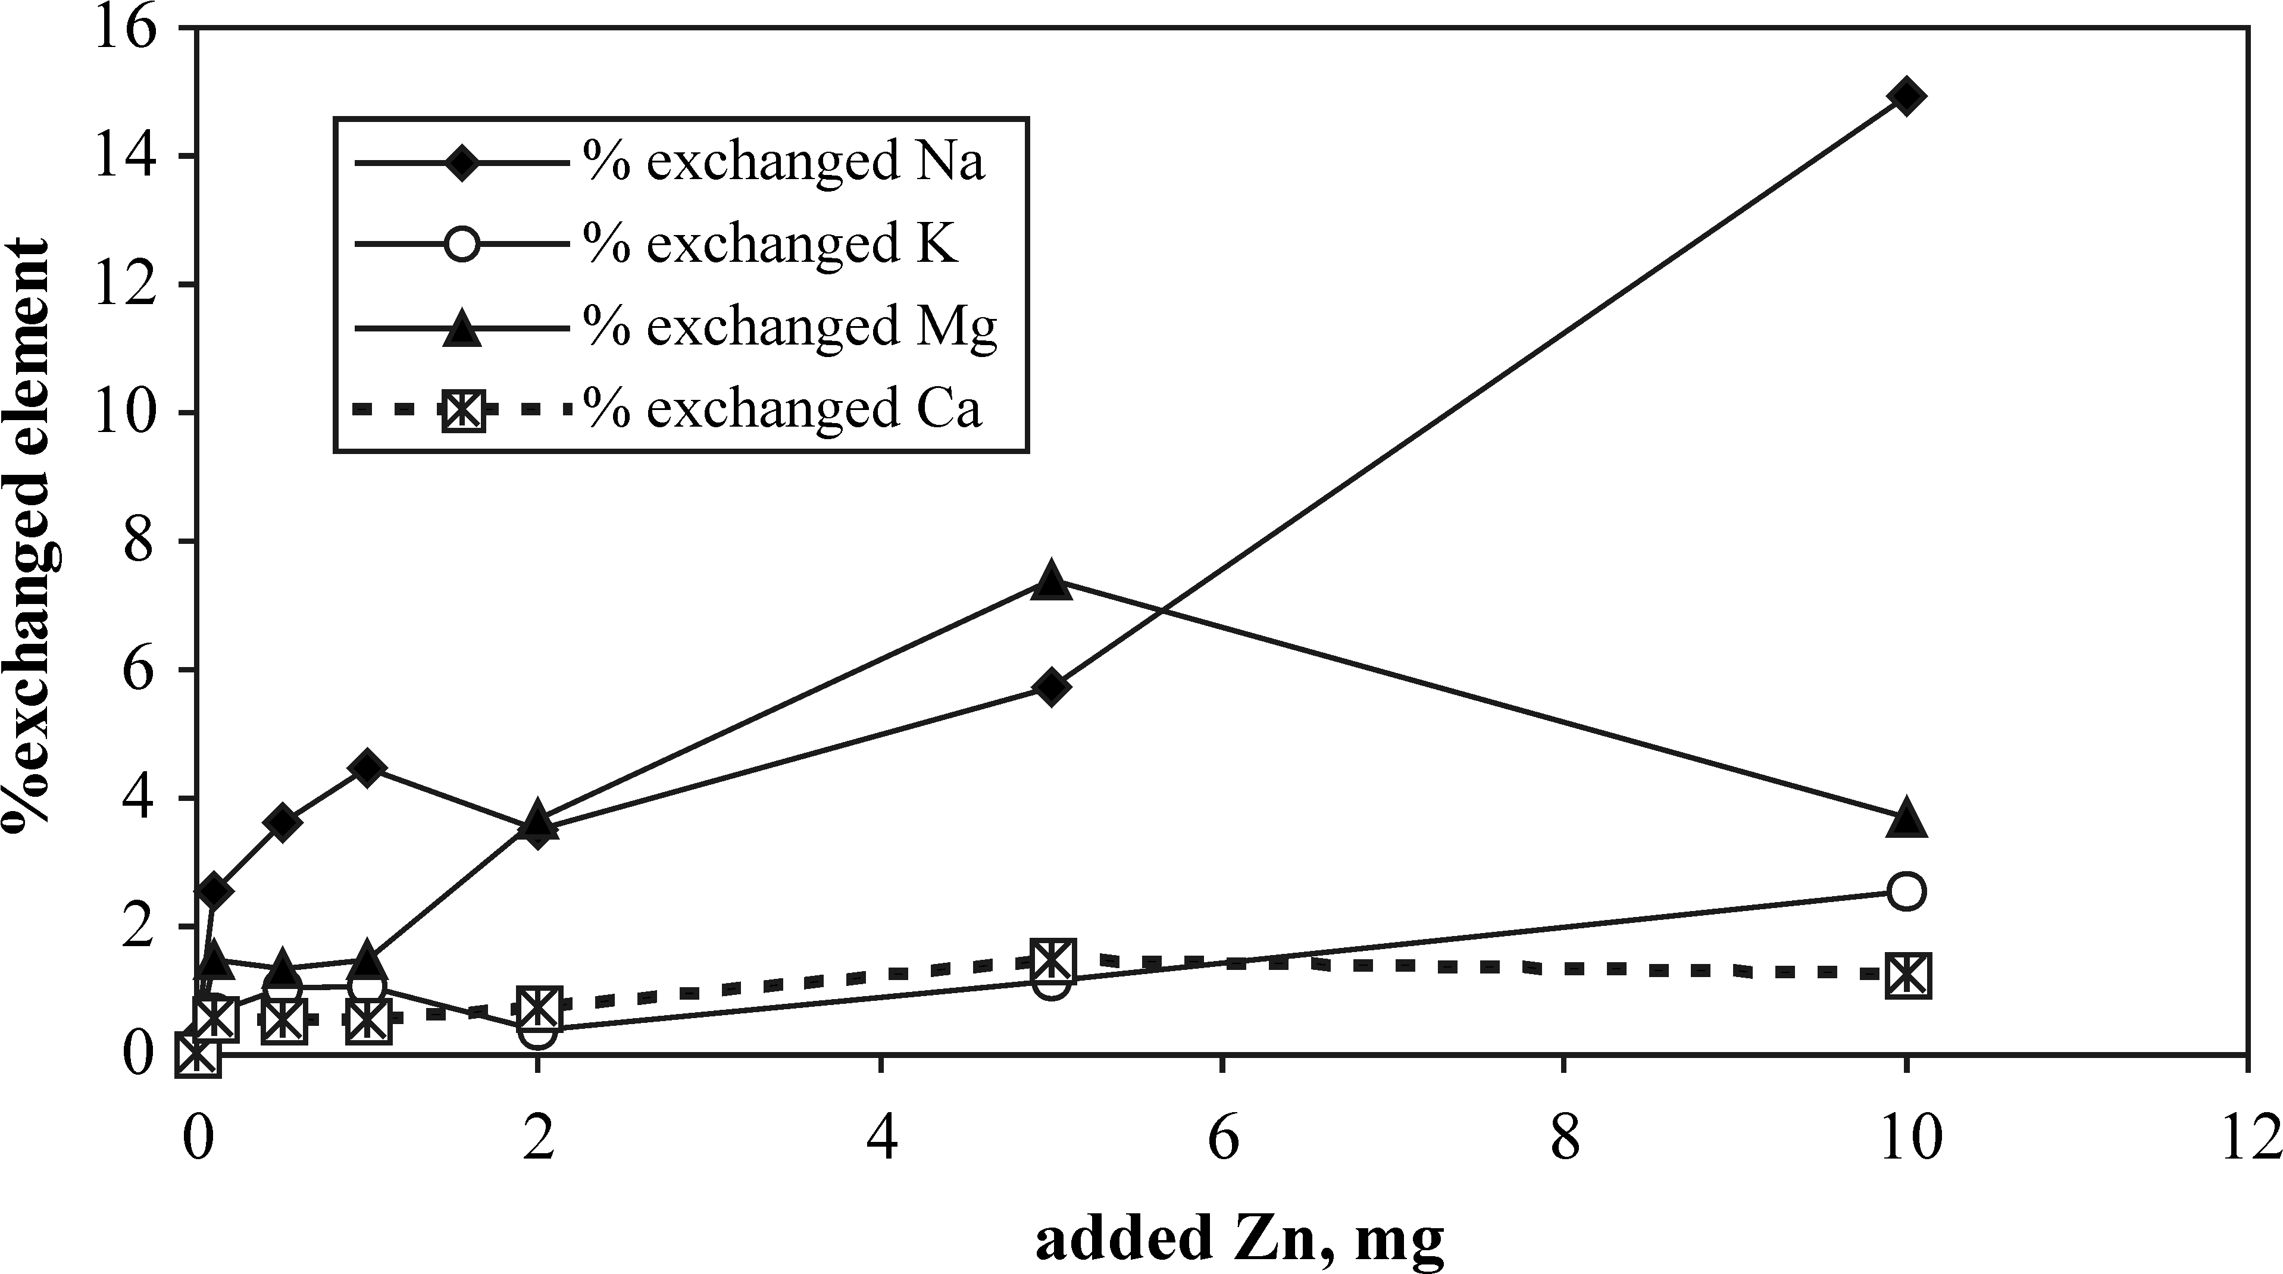
Fig. 3. Percentage of exchanged elements in the solution with respect to their content in mordenite during Zn sorption.
The low amounts of Ca, K in the solution that are registered after reaching equilibrium (Fig. 3) during Zn sorption on mordenite demonstrate that zinc cations are exchanged mainly on the sites of Na and Mg in the mordenite structure.
The results of studying the extraction of sorbed zinc are represented in Table 5. The data reveal, that the sum of the extracted amounts of zinc during four successive extractions is greater for clinoptilolite than that for mordenite.

Table 5. Amount of sorbed zinc and EDTA extracted zinc.
Zn added,  mkg/g | Zn sorbed,  mkg/g | Sum of EDTA extracted Zn,  mkg/g | Extracted/Sorbed Zn,  % | Extracted Zn in first extraction,  %
Clinoptilolite
0 | 0 | 0.31 | - | -
100 | 85.6 | 81 | 94.2 | 95
500 | 462 | 365 | 78.6 | 60.3
1000 | 919 | 796 | 86.7 | 66.4
2000 | 1704 | 1402 | 82.3 | 34/54
5000 | 3237 | 2409 | 74.4 | 56.8
10000 | 5222 | 3896 | 74.6 | 52.4
Mordenite
0 | 0 | 0.21 | - | -
100 | 93.5 | 89 | 95.5 | 100
500 | 413 | 352 | 85.2 | 100
1000 | 593 | 493 | 83.0 | 92
2000 | 837 | 681 | 81.4 | 96
5000 | 896 | 503 | 56.1 | 70.3
10000 | 2183 | 1483 | 67.9 | 81

For both zeolites, the percentage of the total amount extracted to the sorbed zinc decreases with increasing the initial amount of Zn added. Up to 2000 mg/kg added zinc, the difference between these percentages remains small. After that, the percentage becomes lower for the amounts extracted from mordenite. The lowest percentage of desorbed zinc is about 60%.
The extracted amount of Zn during the fourth extraction from clinoptilolite is 140 mg/kg for the sample treated with 500 mg/l Zn. Under the same conditions, the extraction of sorbed zinc from mordenite leads to a release of 70 mkg/g. These results indicate that both zeolites have a capacity for slow releasing of zinc allowing to use them as fertilizers.
N. Lihareva et al.: Zn sorption by natural clinoptilolite and mordenite
Conclusion
The studied natural zeolites display difference in their sorption behavior in respect to zinc cations as well as difference during extraction of zinc with EDTA. It can be accepted that the cation exchange and sorption properties of the two zeolites are dependent on the initial content and distribution of cations in the structure, which determines the different accessibility of the cationic sites for cationic exchange. Clinoptilolite has a higher sorption ability for zinc, which can be explained by more favorable cationic complex. Also the greater the zeolite content in the rock sample the higher is its sorption capacity.
Further on, in order to model the mobility of the sorbed zinc and to evaluate its accessibility and assimilation by plants we used EDTA extraction applying the method proposed by BCR.
The cation exchange and sorption properties of these two Bulgarian natural zeolites showed a good selectivity for zinc that is promising for different practical applications.
references
- D. W. Breck, Zeolite Molecular Sieves: Structure, Chemistry and Use, John Wiley and Sons, New York, 1974.
- S. K. Ouki, M. Kavannagh, Water Sci. Tech., 39, 667 (1999).
- E. C. Varsa, J. D. Hernandez, S. A. Ebelhar, T. D. Wyciskalla, in: Illinois Fertilizer Conf. Proc., 2005, Report No 10.
- G. Nzigulheba, E. Smolders, Sci. Total. Environ., 390, 53 (2008).
- A. S. Sheta, A. M. Falatah, M. S. Al-Sewailem, E. M. Khaled, A. S. H. Salam, Micropor. Mesopor. Mater., 61, 127 (2003).
- A. Bujnová, J. Lesný, Hung. Electron. J. Sci. (ISSN 1418-7108), Manuscript no.: ENV-061123-A.
- M. Rehàková, S. Čuvanová, M. Dzivák, J. Rimár, Z Gaval'ová, Curr. Opin. Solid State Mater. Sci., 8, 397 (2004).
- A. Langella, M. Pansini, P. Cappalleti, B. De Gennaro, M. de Gennaro, C. Colella, Micropor. Mesopor. Mater., 37, 337 (2000).
- P. Roman, J. Warchol, Micropor. Mesopor. Mater., 61, 137 (2003).
- A. Top, S. Ulku, Appl. Clay Sci., 27, 13 (2004).
- M. J. Semmens, M. Seyfarth, in: Natural zeolites: Occurrence, Properties, Use, L. B. Sand, F. A. Mumpton (eds.), Pergamon Press, Oxford, 1978, p. 517.
- Š. Cerjan-Stefanović, L. Ćurcović, in: Natural zeolites – Sofia' 95, G. Kirov, L. Filizova, O. Petrov (eds.), Pensoft, Sofia, 1997, p. 121.
- M. J. Zamazow, J. E. Murphy, Sep. Sci. Technol., 27, 1969 (1992).
- A. M. Ure, Ph. Quevauviller, H. Mintau, B. Griepink, Int. J. Environ. Anal. Chem., 51, 135 (1993).
- W. L. Lindsay, W. A. Norwell, Soil Sci. Soc. Am. J., 42, 421 (1978).
- J. F. Trierweiller, W. L. Lindsay, Soil Sci. Soc. Am. Proc., 33, 49 (1969).
- A. U. Haq, M. H. Miller, Agron. J., 64, 779 (1972).
- A. H. Oren, A. Kaya, J. Hazard. Mater., B131, 59 (2006).
- A. M. El-Kamash, A. A. Zaki, M. A. El Geleel, J. Hazard. Mater., 127, 211 (2005).
- Ch. R. G. Purna, S. Satyaveny, A. Ramesh, K. Seshaiah, K. Samurthy, N. V. Choudry, J. Environ. Manag., 81, 265 (2006).
N. Lihareva et al.: Zn sorption by natural clinoptilolite and mordenite
- M. Panajotova, V. Panajotov, Ts. Mitrov, Proc. 19th Balkan Mineral Processing Congr., G. Őnal, S. Atak, A. Güney, M. S. Çelik, A. E. Yüce (eds.), Istanbul, 2001, p. 617.
- K. Koyama, Y. Tackeushi, Zeits. Krist., 145, 216 (1977).
- M. A. Jama, H. Yucel, Sep. Sci. Technol., 24, 1393 (1989).
- J. L. Palmer, M. E. Gunter, Am. Mineral., 86, 431 (2001).
- E. Czaran, J. Papp, A. Meszaaros-Kis, E. Domokos, Acta Chim. Hung., 126, 673 (1989).

Изследване на сорбцията на Zn²⁺ от природни клиноптилолит и морденит
Н. Лихарева*, Л. Димова, О. Петров, Я. Цветанова
Централна лаборатория по минералогия и кристалография, Българска академия на науките,
ул. „Акад. Г. Бончев“, бл. 107, 1113 София
Постъпила на 30 октомври 2008 г.; Преработена на 28 януари 2009 г.
(Резюме)
Изследвана е сорбцията и десорбцията на цинк от два природни зеолита - клиноптилолит и морденит като експериментите са извършени в статични условия. Изследвана е зависимостта на сорбираното количество цинк от неговата концентрация в разтвора и времето на сорбция. Данните за равновесието при различни начални концентрации са анализирани, използувайки моделите на Лангмюир и Фройндлих. Намерено е, че сорбцията върху клиноптилолит се описва еднакво добре и с двата модела. При морденита и двата модела описват добре сорбцията при ниски концентрации, но при по-големи концентрации формата се различава и за двата модела. Количествата на цинка, сорбирани от клиноптилолит са по-големи от тези, сорбирани от морденит при същите условия. Изследвана е десорбцията на цинка чрез екстракция с етилендиамин тетраоцетна киселина (EDTA). Процентът на екстрахирания цинк спрямо сорбирания се изменя от 94.2 % до 74.6% и от 95.5% до 67.6%, респективно за клиноптилолит и морденит за проби, в които нараства началната концентрация на третиране с цинк. Резултатите от тези изследвания показват, че двата зеолита притежават висок потенциал като сорбенти на цинк и бавна десорция.

