Hydrometallurgical processing of dumped lead paste for lead acid batteries
Bulgarian Chemical Communications, Volume 41, Number 3 (pp. 285–296) 2009
© 2009 Bulgarian Academy of Sciences, Union of Chemists in Bulgaria
D. A. Atanasova*
* To whom all correspondence should be sent:
E-mail: dimi.atanasova@gmail.com
Department of Semiconductors, University of Chemical Technology and Metallurgy,
8 Kliment Ohridski Blvd., 1756 Sofia, Bulgaria
Dedicated to the memory of Prof. N. K. Lyakov and Prof. G. A. Haralampiev
Received January 8, 2009; Revised March 9, 2009
The present work represents an analytical survey of experimental results from conducted investigations, regarding desulphurization of dumped Pb-paste and the possibilities for the realization of the process. The aim is to compare and evaluate the results that we have obtained, with already existing data in the literature of leading technologies. Here are examined the kinetic relationships of the processes that take place and the related problems. The optimal conditions of the desulphurization process, developed by our team, are determined when using the following reagents – Na₂CO₃ and NaOH, depending on the working reactor (reactor with a laboratory stirrer and rotational reactor of drum type). The content of impurities in the solutions of our technology is investigated and compared with others of that type in order to obtain sufficiently clean crystalline Na₂CO₃ for the industry.
Key words: lead paste, Pb-paste desulphurization, lead accumulators processing.

Introduction
The main aspects regarding chemistry and conduction of the process of desulphurization are targets of many investigations and publications of different authors [1−8]. In the industry there exist installations and technologies for the realization of the process in different hydro-metallurgical schemes [9−13].
Dumped lead acid batteries can be characterized like complicated secondary products because their processing causes many difficulties [14].
Lead acid batteries consist of three basic fractions and electrolyte [1−15]:
- Metalic (combs, poles, lattices and others) with Pb content of 93−95% and Sb content of 0.1−0.3%.
- Oxysulphatic (positive and negative paste), which has 68−76% Pb and 0.1−0.3% Sb.
- Not metallic – organic (boxes made from either ebonite, polypropylene or polyethylene, polyvinyl chloride separators and others).
During the production of the metal fraction lead and antimony or lead and calcium [1, 16] are mainly used, which causes reduction of impurities in the metal.
On the other hand the oxysulphatic fraction is divided into two categories: waste and dumped lead paste [1, 17]. Waste lead paste is obtained during the production of lead acid batteries and it consists of 79−86% Pb, mainly as oxide phase and 0.1−0.3% Sb. Redeemed (positive and negative) paste has 68−76% Pb in the form of PbSO₄ ~ 50–60%, PbO₂ ~ 30–35%, PbO ~ 10–15% and Sb ~0.2–0.7%.
Many authors have investigated the pyrometal-lurgical processing of the lead pastes [18−21]. During these methods the extraction of lead reaches 98% and it can be conducted at relatively low temperatures 500−600°C under the condition that no lead sulphates are present. The presence of lead sulphate requires increasing of the temperatures of the process above 900°C, which leads to decreasing the degree of lead extraction and causes techno-logical and ecological problems.
The necessity of desulphurization of pastes prior to pyrometallurgical processes of melting and refining is theoretically predicted and experiment-tally proved [22].
The preliminary desulphurization of lead paste contributes to the decreasing of the melting tempe-rature, decreasing of the amounts of fluxes and caustic soda, slag and dusts, reduces the content of SO₂ in the gases and the quantity of chemical reagents used in the refining cycle, enhances the degree of lead extraction and so on [5, 11, 22].
The essence of the desulphurization process consists in taking the sulphate ions out of the paste into the solution and generating chemical compound of the lead, which does not cause any difficulties during following pyrometallurgical treatment [22].
Physicochemical and technological investiga-tions of the main aspects of the desulphurization process of the lead sulphate have been published in the literature [22].
The basic chemical and kinetic principles like: stoichiometry of the reaction and diffusion kinetics, are thoroughly examined by Laidler et al. [23].
The most commonly used reagent for desulphuri-zation of dumped lead pastes is the sodium carbo-nate [1−11, 24−26]. The desulphurization process is accomplished by treating the paste with solutions of sodium carbonate according to the reaction:
PbSO₄ + Na₂CO₃ → PbCO₃ + Na₂SO₄ (1)
The sulphur goes into the solution in the form of sodium sulphate. The obtained solutions, after separation of the liquid and solid phase, can be subjected to evaporation and centrifuging in order to obtain waterless sodium sulphate [2, 27].
In the presence of electrolyte in the paste - H₂SO₄, a complete neutralization of the acid in the solution of Na₂CO₃ takes place, with molar pro-portion Na₂CO₃:H₂SO₄ > 1, according to the following reaction:
Na₂CO₃ + H₂SO₄ → Na₂SO₄ + H₂O + CO₂ (2)
This explains the generation of Na₂CO₃:
2Na₂CO₃ + H₂SO₄ → Na₂SO₄ + 2NaHCO₃ (3)
In view of the conditions during the desulphuri-zation process – concentration of sodium carbonate, ratio of liquid to solid mass, temperature, duration of the process, etc., it is possible to have parallel reactions.
When the consumption of the reagent exceeds the stoichiometrically corresponding to the reaction (1), actually in excess of sodium carbonate, the following reactions take place:
PbSO₄ + 4Na₂CO₃ + 2H₂O →
→ 2PbCO₃.Pb(OH)₂ + 3Na₂SO₄ + 2NaHCO₃ (4)
3PbCO₃ + Na₂CO₃ + 2H₂O →
→ 2PbCO₃.Pb(OH)₂ + 2NaHCO₃ 5)
The interaction between the lead sulphate and sodium carbonate has been studied by many authors [1, 2, 8, 28, 29], and according to them reaction (1) describes accurately enough the process of desulphurization. Investigations of the chemistry of the process prove the generation of complex compound of the lead, incorporating in itself sodium and sulphatic ions of the type: Рbз(СОз)₂(ОН)₂, NaPb₂(CO₃)₂OH, Pb₁₀O(CO₃)₆(OH)₆, Pb₄(SO₄)(CO₃)₂(OH)₂ [24, 30].
The nature of the compounds in solid phase depends on several factors, in particular on the pH and on the concentration of sodium carbonate and sodium sulphate in the solutions [24]. The formation of these compounds causes increase of the reagent consumption and difficulties during further treat-ment and usage of the ready product.
It is established that during desulphurization of Pb paste with Na₂CO₃, 2−3% of the Sb, contained in the paste, can pass into the solution [22].
D. A. Atanasova: Hydrometallurgical processing of dumped lead paste
Many technologies for processing of dumped lead paste use sodium base for the desulphurization process [7, 9, 10, 30−34].
Also during this method a reaction of neutrali-zation of the H₂SO₄ contained in the paste initially takes place:
2NaOH + H₂SO₄ → Na₂SO₄ + 2H₂O (6)
The transformation of PbSO₄ into Pb(OH)₂ is typical for the process of desulphurization and it takes place according to the reaction:
PbSO₄ + 4NaOH → Pb(OH)₂ + Na₂SO₄ (7)
The desulphurization using NaOH can be accom-plished at room temperature. Increasing of the temperature may lead to changes in the solid phase of Pb(OH)₂ to 3PbO.2H₂O (or PbO.1/3H₂O), according to the reactions:
PbSO₄ + 2NaOH →
→ PbO.1/3H₂O + Na₂SO₄ + 2/3H₂O (8)
PbSO₄ + 2NaOH → PbO + Na₂SO₄ + H₂O (9)
An excess of NaOH ~10−20% of the stoichio-metrically needed for the reaction (7) is necessary, for a complete desulphurization process in the technological practice [7, 22].
Part of the lead is transferred into the solution in the form of Na₂PbO₂, according to the reaction:
PbSO₄ + 4NaOH ↔ Na₂PbO₂ + Na₂SO₄ + 2H₂O (10)
There is a direct relationship between the concentration of NaOH and the content of Na₂PbO₂ in the solutions. The concentration of Na₂PbO₂ increases at higher excess of NaOH [7, 29].
The solution of Na₂SO₄, obtained after desul-phurization process, can be subjected to purifying from the lead using neutralization with H₂SO₄, according to the reaction:
Na₂PbO₂ + H₂SO₄ → PbSO₄ + Na₂SO₄ + 2H₂O (11)
The separated PbSO₄ in the form of deposit, again returns into stage for desulphurisation, and the solution of Na₂SO₄ is good for obtaining crystalline Na₂SO₄ which is free of impurities.
Many authors suggest that the regeneration of the Na₂SO₄ is to be conducted using Ca(OH)₂ [25, 38−42] and Ba(OH)₂ [42].
The degree of desulphurization is determined by the content of PbSO₄ in the treated paste. The bigger that percentage content in the initial product is, the higher is the consumption of NaOH (the concen-tration in the solution), which leads to increases in the concentration of Pb in the solutions [7, 29].
During desulphurisation with NaOH almost no Sb passes into the solutions, and no insoluble sodium salts are created [7, 29, 43].
There exists also technology for desulphurization of lead pastes with NaOH, during which the solutions of Na₂SO₄ are subjected to electrolysis for regeneration of NaOH. The ratio of liquid to solid phase, when using this method, is 10−15:1 [33].
In many technologies the desulphurisation of lead pastes with NaOH is followed by treatment with NBF₄ [44−46]. The insoluble remainder is treated with concentrated H₂SO₄. Because of that PbO₂ is transferred in the electrolyte and proceeds as electrolysis with insoluble anode.
Desulphurization of Pb paste can be successfully accomplished with ammonium carbonate, as well [47−52]. The chemical reaction takes place according to the reaction:
PbSO₄ + (NH₄)₂CO₃ → PbCO₃ + (NH₄)₂SO₄ (12)
Data in the literature, concerning the usage of ammonium carbonate as a desulphurisation agent, is mainly connected with the investigation of kinetic and technological parameters. According to data by the authors, when the process lasts 30 minutes, the degree of desulphurization reaches 90%. Further increasing of the duration of the process does not affect significantly the degree of desulphurization. Increasing of the temperature in the range of 22−60°С is insignificantly accelerating the process.
Many authors are also investigating the possibi-lity to use K₂CO₃ [2, 53−55] as a desulphurization agent, which reacts with PbSO₄ according to the reaction:
PbSO₄ + K₂CO₃ → PbCO₃ + K₂SO₄ (13)
High degree of desulphurization reached ~95%. The process proceeds at temperature ~60°С, ratio of liquid to solid 3:1, excess of K₂CO₃ 10−15% and duration of 60 minutes [2].
In the literature there exist data on the influence of the basic factors in the process (degree of desulphurization and utilization of the reagent). The authors have also investigated possible schemes for continuous process, which are followed by evapo-ration and taking out the salts from the solutions with the aim to obtain crystalline K₂SO₄ [2].
The hydrometallurgical treatment of the lead-containing raw materials can also be done with the use of amines. There also exists a technology for desulphurization of dumped lead pastes using the organic solvent diethylenetriamine (DETA) [1, 8, 56, 57]. The method is based on the formation of metallic complex compound, in which the metal-amine bond is stronger than the metal-water bond.
When the liquid phase is being treated with Na₂CO₃ pure compounds can be obtained: PbCO₃ and PbSO₄, and when it is treated with H₂SO₄ – pure PbSO₄ for the needs of lead acid battery industry. Soft lead can be obtained from the solid phase, when melted at relatively low temperatures, [1, 8].
D. A. Atanasova: Hydrometallurgical processing of dumped lead paste
The chemistry of the process comprises the following reactions:
3PbSO₄ + 4DETA → [Pb₃(DETA)₄](SO₄)₃ (14)
[Pb₃(DETA)₄](SO₄)₃ + 3NaCO₃ →
→ 3PbCO₃ + 3NaSO₄ + 4DETA (15)
[Pb₃(DETA)₄](SO₄)₃ + 2DETA + 3H₂SO₄ →
→ 3PbSO₄– + 2DETA.3H₂SO₄ + 4DETA (16)
2DETA.3H₂SO₄ + Ca(OH)₂ →
→ 2DETA + 3(CaSO₄.2H₂O) (17)
On the basis of the above literature review concerning the methods for desulphurization of dumped lead pastes from lead batteries, the aims of the present investigation are formulated as follows:
- to determine the influence of the basic kinetic factors (concentration of Na₂CO₃ (NaOH) and the ratio of liquid to solid phases as a function of the temperature and duration of the process), that influence the parameters of the process of desul-phurization of Pb-pastes − degree of desulphuri-zation and utilization of the reagent;
- to specify the optimal conditions for accom-plishing desulphurization of Pb-pastes with Na₂CO₃ or NaOH, depending on the type of the reactors used;
- investigation of the content of impurities in the solutions in order to obtain sufficiently pure crystal-line sodium sulphate for further use in the industry;
- the results from the conducted experimental researches on both samples will be compared with each other and with the existing experimental and technological data in the literature.
Experimental
Object of the first part of our investigations [7] is dumped lead paste from lead acid batteries imported from Romania - Sample № 1 given to us by “KCM-Plovdiv”, Bulgaria.
The second part of the investigations is done with dumped lead acid battery paste imported from Poland (Sample No. 2) given to us by the same company.
The pastes have the following chemical compo-sition (%):
Sample No. 1: Pb 59.85; Sb 0.73; As 0.042; Cl 0.33; Сu 0.13; Zn 0.10; S∑ 7.20; $S_{{\text{SO}}_{4}^{2−}}$ 6.45.
Sample No. 2: Pb 73.05; Sb 0.053; As 0.015; Cl 0.01; Cu 0.007; Zn 0.009; S∑ 7.15; $S_{{\text{SO}}_{4}^{2−}}$ 6.38.
It should be pointed out that Sample No. 2 is purer than Sample No. 1 with respect to impurities.
Before subjecting to desulphurization process, the Pb-paste is dried and sifted in a sieve of mesh 5.0 mm.
Sample No. 1: The fraction (< 5.0 mm) is 80% and the fraction (> 5.0 mm) is 20%.
Sample No. 2: The fraction (< 5 mm) is 95%, and the fraction (> 5 mm) is 5%.
Sample № 1 is contaminated, which may be due to ineffective separation technology.
A laboratory stirrer type ER 10 and mass of the paste 200 g are used for the laboratory work and the temperature is maintained constant by thermostat type Ultra NBA. When treating in rotational reactor of drum type VEB Elmo Hartha DDR, the mass of the paste is 400 g. In this case the amount of paste is higher because of the larger working volume of the equipment and the related difficulties. These dif-ficulties concern maintaining constant working temperature in this type of reactor under laboratory conditions, as with increasing the amount of material the rate of cooling under atmospheric air decreases.
The lead paste 200 (400) g is added to solutions of specified Na₂CO₃ (NaOH) concentration and at definite liquid-solid phase ratio (at preset temperature and duration of the desulphurization process).
The analyses are realized using analytical chemical methods. Upon accomplishment of the chemical treatment, the pulp is filtered and the solid phase is washed with water on the filter, dried to constant weight and analyzed for content of SO₄²⁻. The liquid phases are analyzed for content of Na₂CO₃ (NaOH) and SO₄²⁻. The determination of SO₄²⁻ in the solid phase is done using weighting method. Initially the sample is decomposed with solution of Na₂CO₃ and after that from the obtained solutions SO₄²⁻ is precipitated using BaCl₂ in the form of BaSO₄. The analysis of SO₄²⁻ in liquid phase is identical (precipitation with BaCl₂). The data from it in this case can be used for verification of the results from the analysis for SO₄²⁻ in solid phase (balance with respect to sulphur).
The remaining concentration of uncombined Na₂CO₃ and NaOH in the liquid phases (filtrates) is determined by titration with 0.1 М HCl and Methyl orange as indicator.
D. A. Atanasova: Hydrometallurgical processing of dumped lead paste
The content of sulphatic sulphur $S_{{\text{SO}}_{4}^{2−}}$in the non-desulphurized paste and the chemical composi-tion is determined by phase analysis.
The desulphurization degree α (%) is calculated by the formula:
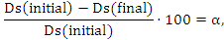
where: Ds_{(initial)} and Ds_{(final)} are initial and residual SO₄²⁻ concentration.
The reagent utilization degree β (%) is calculated by the formula:
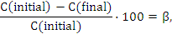
where: С_{(initial)} and С_{(final)} are initial and residual reagent concentrations, g∙L⁻¹.
Results and discussion
Desulphurization of Pb-paste with Na₂CO₃
in a reactor with a laboratory stirrer
For the purposes of the present research, regarding the desulphurization of the paste, an examination regarding the influence of the basic kinetic factors is conducted: initial concentration of Na₂CO₃ (con-sumption of Na₂CO₃), ratio of liquid to solid phase, duration of the desulphurization process with set temperature interval, which is connected with the properties of the reagent and the products from the reaction.
Based on the conducted preliminary experiments [7, 28, 29] and data from the literature [2] it is determined that the temperature does not affect significantly the parameters of the desulphurization process (degree of desulphurization α, degree of utilization β of the Na₂CO₃), because the work is done in an environment of diffusion control [23]. The coefficients α and β have highest values in the range 30−40°С, above that temperature the solu-bility of Na₂CO₃ and Na₂SO₄ in water decreases [58−60].
The solubility of Na₂CO₃ and Na₂SO₄ and of the compounds, obtained from them, are directly connected with the indexes of the process – degree of desulphurization and degree of utilization of the reagent and the stoichiometric realization of the filtration process, as well [5, 6].
Fig. 1 presents the results from the desulphu-rization of Pb-paste – Sample No. 2 with ratio of liquid to solid phase m = 2.25 (m = 2.25:1), tempe-rature 38−40ºС and different initial concentrations of Na₂CO₃:
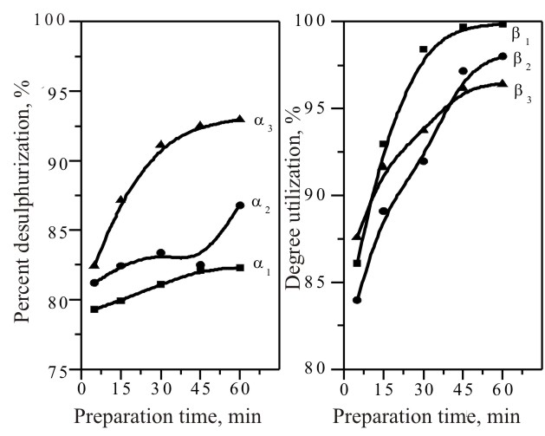
Fig. 1. Dependence of the percentage of desulphurization (α) and Na₂CO₃ utilization degree (β) on the treatment time (τ) when stirring with laboratory agitator (m = 2.25; t = 38−40°С): C_{initial(1)} = 84.51 g∙L−1 (α₁, β₁), С_{initial(2)} = 93.93 g∙L⁻¹ (α₂,β₂) and С_{initial(3)} = 103.33 g∙L⁻¹ (α₃, β₃);
a −α₁, α₂, and α₃; b − β₁, β₂ and β₃.
I experiment – with shortage of 10% with respect to the stoichiometric ratio С_{initial(1)} = 84.51 g∙L⁻¹ Na₂CO₃; II experiment – С_{initial(2)} = 93.93 g∙L⁻¹ Na₂CO₃ (stoichiometric ratio); III experiment – С_{initial(3)} = 103.33 g∙L⁻¹ Na₂CO₃ (10% excess).
A satisfactory degree of desulphurization, corresponding to the technological requirements [10], is achieved after 30 minutes but it is desirable that τ > 45, when the degree of desulphurization is α = 92.48 % (content of $S_{{\text{SO}}_{4}^{2−}}$ in the desulphuri-zated paste 0.48%). With an excess of Na₂CO₃ 10% (С_{initial(3)} = 103.33 g∙L⁻¹) and duration of the process 60 minutes, the degree of desulphurization is α₃ = 92.95% ($S_{{\text{SO}}_{4}^{2−}}$ = 0.45%).
The obtained results are in accordance with the data from the literature [2, 7, 22] and are close to those for Sample No. 1. After 15 min treatment of Pb-paste with stoichiometric amount of Na₂CO₃ (С_{initial(2)} = 94.95 g∙L⁻¹) the degree of desulphuri-zation is α = 94.11% (0.38% $S_{{\text{SO}}_{4}^{2−}}$ in the desul-phurized paste) [7]. For Sample No. 1, even with 10% shortage of the Na₂CO₃ the degree of desulphurization is α₁ = 92.09% (0.51% $S_{{\text{SO}}_{4}^{2−}}$ in the desulphurized paste) [7].
The high degree of utilization of the Na₂CO₃ is noticeable. This imposed a series of two more experiments with Sample No. 2, to be conducted upon changing the ratio m = 2.5, temperature 37−40°С and increasing the initial concentration of Na₂CO₃:
D. A. Atanasova: Hydrometallurgical processing of dumped lead paste
I experiment – with С_{initial(1)} = 93.00 g∙L⁻¹ Na₂CO₃ (10% excess);
II experiment – С_{initial(2)} = 101.45 g∙L⁻¹ Na₂CO₃ (20% excess).
The results are presented in Fig. 2.
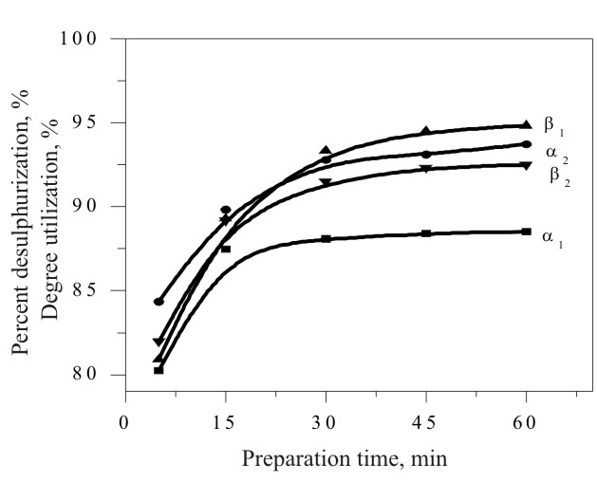
Fig. 2. Dependence of percentage of desulphurization (α) and Na₂CO₃ utilization degree (β) on the treatment time (τ) when stirring with laboratory agitator (m = 2.5;
t = 37−40°С): C_{initial(1)} = 93.00 g∙L⁻¹ (α ₁, β₁),
С_{initial(2)} = 101.45 g∙L⁻¹ (α ₂, β₂).
Satisfactory for the practice results [10] are obtained after τ = 30 min, with initial concentration of Na₂CO₃ with 20% excess (С_{initial(2)} = 101.45 g∙L⁻¹) – degree of desulphurization α₂ = 92.79% ($S_{{\text{SO}}_{4}^{2−}}$= 0.46 % in the desulphurized paste), for 45 min and 60 min respectively 93.10% ($S_{{\text{SO}}_{4}^{2−}}$= 0.44 %) and 93.73% ($S_{{\text{SO}}_{4}^{2−}}$= 0.40%).
These results correspond to existing data in the literature from laboratory experiment, during which the possibility for optimal running of the desulphuri-zation process with excess of Na₂CO₃ − 20% is determined, duration 2 hours, temperature 55°С, <33% solid phase in the pulp and pH 8 [24].
Recommended conditions for desulphurization of Pb-paste – Sample № 1 with Na₂CO₃, when stirred with a laboratory stirrer, were established: excess of the reagent up to 10%; ratio of liquid to solid phase m = 2.0−2.5; temperature and duration of the process – t = 35−40ºС and τ = 15−30 min respectively [7].
As optimal conditions in regard to degree of de-sulphurization and utilization of the reagent for Sample No. 2, can be accepted: initial concentration of Na₂CO₃ with 20% excess (С_{initial(2)} = 101.45 g∙L⁻¹), m = 2.5 and duration of the process τ = 35−40 min.
These minor differences in the obtained results for the different Pb-paste samples are due to the differences in their chemical composition.
The condition to work in excess of Na₂CO₃ not higher than 20% was observed during running this group of experiments, in order to avoid the forma-tion of NaHCO₃ and the double salt NaPb₂(CO₃)₂OH [24, 30], which increase the consumption of Na₂CO₃.
The results from investigations of the process pointed out by Yanakieva [2] are analogous. For op-timal concentration, when working with a laboratory stirrer, the author recommends 20% excess of Na₂CO₃. The same methods of the experiment and the same analytical chemical analysis for determi-nation of the results have been used.
The world leading company in desulphurization of dumped lead acid battery pastes is the Italian company “Engitec Impianti [10]” - installation “СХ Compact”.
When using the installation “CX Compact”, dumped lead paste, after wet transportation on vibration sieve, is transferred into a precipitation device, and after compaction in it, is fed into one of two parallel working mechanical stirrers, where it is treated with solutions based on sodium carbonate or sodium hydroxide. During the process the pulp is heated, where upon the lead sulphate is transformed in either lead carbonate or lead hydroxide, and the sulphur passes into the solution as sodium sulphate. After the desulphurization process the pulp is fed into an automatic filter-press. The filtered solution is then sent for evaporation-crystallization, the solid desulphurizated paste, with humidity below 13% and sulphur content less than 0.8%, is collected in containers for revision.
Based on this technology the following com-panies are working: Monbat АD - Bulgaria; Asarco; Doerun; GNB - USA; Metallgesellschaft - Germany, STCM - France, Metallum-Switzerland; Enirisorse - Italy, Tonolli - Canada, Brittania - England and others [8].
Desulphurization of Pb-paste with Na₂CO₃
in rotational reactor of drum type
The investigations are conducted in order to avoid the difficulties, which are typical of stirrers: stirring of the materials and emptying the device. The inconvenience when working with rotational reactor is that it is not possible to maintain constant temperature. This disadvantage can be overcome by heating with sharp vapour in the volume of the device.
At temperature 56−28°С and m = 2.25 two expe-riments were conducted with Na₂CO₃ and Sample No. 2 (Fig. 3), with changed initial concentration:
D. A. Atanasova: Hydrometallurgical processing of dumped lead paste
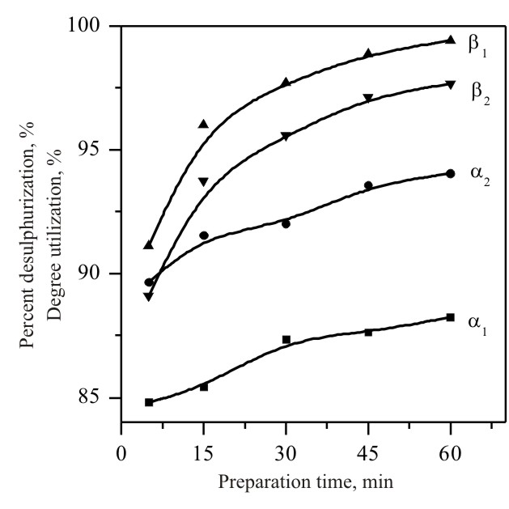
Fig. 3. Dependence of the percentage of desulphurization (α) and the Na₂CO₃ utilization degree (β) on the treatment time (τ) when using rotary reactor at t = 56−28ºС, m = 2.25: С_{initial(1)} = 93.92 g∙L⁻¹ (α ₁, β ₁),
С_{initial(2)} = 103.31 g∙L⁻¹ (α ₂, β ₂).
I experiment – С_{initial(1)} = 93.92 g∙L⁻¹ (stoichio-metric ratio);
II experiment – С_{initial(2)} = 103.31 g∙L⁻¹ (10% ex-cess).
Good results, which correspond to the already mentioned technological requirements, were obtained with 10% excess of Na₂CO₃ (С_{initial} = 103.31 g∙L⁻¹) and duration of the treatment τ = 30 min – degree of desulphurization α₂ = 92.01% ($S_{{\text{SO}}_{4}^{2−}}$= 0.51%); when τ = 45 and 60 min correspondingly 93.57% ($S_{{\text{SO}}_{4}^{2−}}$= 0.41%) and 94.04% ($S_{{\text{SO}}_{4}^{2−}}$= 0.38%).
The following parameters can be accepted as optimal for the process when working with rotational reactor: initial concentration of Na₂CO₃ with excess of 10% (С_{initial} = 103.31 g∙L⁻¹), m = 2.25 and τ = 30−45 min.
The obtained results supplement the previous data received for Sample № 1. Two experiments were conducted with it using Na₂CO₃, t = 55−28ºС and changing the ratio m [7], for the following conditions:
I experiment – C_{initial} = 94.95 g∙L⁻¹ (stoi-chiometry); m = 2.25;
II experiment – C_{initial} = 94.00 g∙L⁻¹ (10% ex-cess); m = 2.5.
For m = 2.25 and τ = 15 min the obtained degree of desulphurization is 92.40% (in the desulphurized paste $S_{{\text{SO}}_{4}^{2−}}$ = 0.49%); at τ = 30 min – α = 93.95% ($S_{{\text{SO}}_{4}^{2−}}$ = 0.39%);
For m = 2.5 and τ = 15 min − α = 92.87% ($S_{{\text{SO}}_{4}^{2−}}$= 0.46%), when τ = 30 min. − α is 93.64% ($S_{{\text{SO}}_{4}^{2−}}$= 0.41%).
The optimal conditions for desulphurization of Sample No. 1 are excess of Na₂CO₃ up to 10%; m = 2.25−2.50; t = 40−38ºС; τ = 15−30 min.
The obtained results are close to those obtained when working with an ordinary reactor equipped with a laboratory stirrer [7].
In order to optimize the influence of the initial concentration of Na₂CO₃ and m when using rotational reactor of the drum type, an experiment is conducted with Sample No. 2 (Fig. 4), under the fol-lowing conditions: m = 2.5, t = 58−28°С and initial concentration С_{initial} = 101.44g∙L⁻¹ Na₂CO₃ (20% excess).
With 20% excess of Na₂CO₃ the process runs at higher speed. On the 15th minute the degree of desulphurization is 93.57% ($S_{{\text{SO}}_{4}^{2−}}$= 0.41%).
As it has already been determined for the same sample (Sample No. 2 in the section above, when using laboratory reactor with a stirrer and initial concentration of Na₂CO₃ with 20% excess (С_{initial(2)} = 101.45 g∙L⁻¹), results which are satisfactory for the practice are obtained after τ = 30 min.
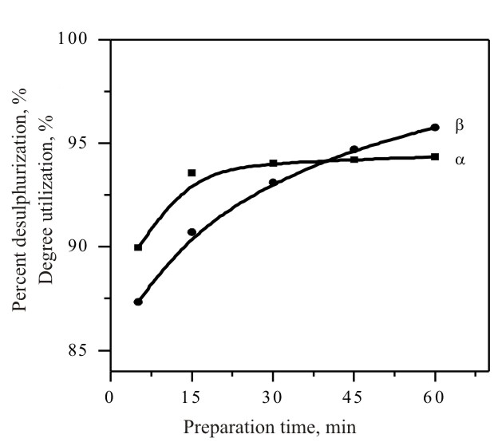
Fig. 4. Dependence of the percent desulphurization (α) and Na₂CO₃ utilization degree (β) on the treatment time (τ) when using rotary reactor at t = 58–28ºС, m =2.5, С_{initial} =101.44 g·L^{–1}.
The process of desulphurisation takes place faster in a rotational reactor compared to that in a laboratory stirrer, which is due to improvement of the conditions for better contact with the reagent.
D. A. Atanasova: Hydrometallurgical processing of dumped lead paste
The obtained results clearly show the kinetic correlations described above, that is upon increasing of the concentration of Na₂CO₃ the degree of desulphurization increases but the degree of utili-zation of the reagent decreases because the process runs with diffusional difficulties [23].
The change in the ratio m does not affect signi-ficantly the kinetics of the process. The obtained data are in accordance with those mentioned in the literature [7, 22].
The correlations were determined also by Yanakieva [2] by indicating data regarding perio-dical and continuous process of desulphurization in rotational drum separator in a technological line No. 1 in department “Lead acid battery waste” of the company OCK-LTD in Kurdjali. It is established that when using 20% excess of Na₂CO₃ under industrial conditions, after washing the paste a higher degree of desulphurization is achieved (99%) than under laboratory conditions with a stirrer (95%).
Desulphurization of Pb-paste with NaOH
in a reactor with a laboratory stirrer
These investigations were done in order to determine the influence of the initial concentration of NaOH and the ratio of liquid to solid phase at temperature 38−40ºС upon the parameters of the process, as a function of time: degree of desulphu-rization of the paste and degree of utilization of NaOH.
Here, similarly to the other groups of experi-ments, it was found out that the temperature above certain value does not affect significantly the para-meters of the desulphurization process [7, 28, 29].
Four experiments with Sample No. 2 paste were done at t = 40°С and m = 2.25 (Fig. 5а, b) and the following conditions:
I experiment − С_{initial(1)} = 63.80 g∙L⁻¹ (stoi-chiometric ratio);
II experiment − С_{initial(2)} = 67.00 g∙L⁻¹ (5% ex-cess);
III experiment − С_{initial(3)} = 70.20 g∙L⁻¹ (10% excess);
IV experiment − С_{initial(4)} = 76.56 g∙L⁻¹ (20 % excess).
On the 5th minute a very high degree of desul-phurization is reached, at a stoichiometrical ratio (С_{initial(2)} = 63.80 g∙L⁻¹) the degree of desulphuri-zation is α₁ = 94.62% ($S_{{\text{SO}}_{4}^{2−}}$= 0.37%), and at 5% excess (С_{initial} = 67.00 g∙L⁻¹) − α₂ = 96.08% ($S_{{\text{SO}}_{4}^{2−}}$= 0.25%).
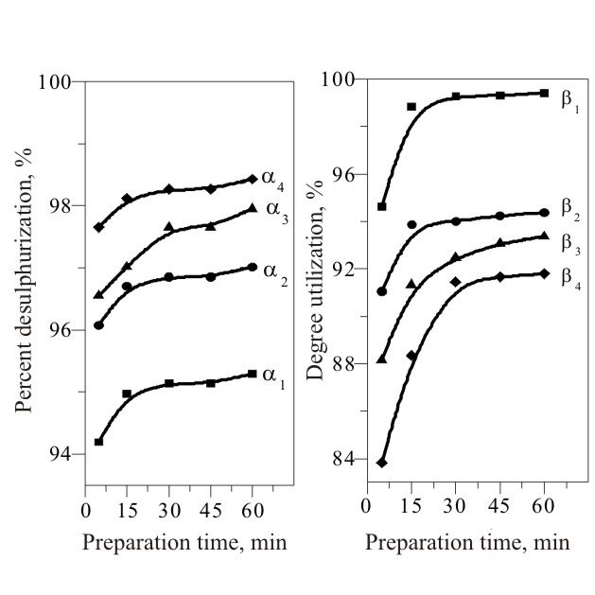
Fig. 5. Dependence of the percentage of desulphurization (α) and Na₂CO₃ utilization degree (β) on the treatment time (τ) when stirring with laboratory agitator (m = 2.5;
t = 40°С): C_{initial(1)} = 63.80 g∙L⁻¹ (α₁, β ₁), С_{initial(2)} = 67.00 g∙L⁻¹ (α ₂, β₂), C_{initial(3)} = 70.20 g∙L⁻¹ (α ₃, β₃),
С_{initial(4)} = 76.56 g∙L⁻¹ (α ₄, β₄), a − α₁, α₂, α₃ and α₄;
b − β₁, β₂, β₃ and β₄.
Analogous research works were done with NaOH and change in the ratio m with Sample No. 1 as well [7], at t = 38−40ºС, m = 2.0 and concentration:
I experiment – stoichiometric ratio (C_{initial} = 80.62 g∙L⁻¹);
II experiment – 5% excess (C_{initial} = 84.65 g∙L⁻¹);
III experiment – 10% excess (C_{initial} = 86.68 g∙L⁻¹).
The indexes of the desulphurization process with NaOH were very good with Sample No. 1, as well [7]. On the 5th minute the degree of desulphuri-zation at stoichiometric ratio is α = 92.10% (in the desulphurized paste $S_{{\text{SO}}_{4}^{2−}}$= 0.51%). After 15 min degrees of desulphurization are achieved α = 93.64−94.88%, depending on the initial concen-tration of NaOH.
Decrease in the conversion of the reagent (β) is observed with the increase of the initial concen-tration (excess 5−10%), which is in complete correspondence with the kinetic laws.
When using a bigger excess of NaOH (Sample No. 2) – 10% and 20%, the desulphurization degree is: α₃ =96.55% ($S_{{\text{SO}}_{4}^{2−}}$= 0.22%) and α₄ = 97.65% ($S_{{\text{SO}}_{4}^{2−}}$= 0.15%).
It is noticeable that the change in the ratio of liquid to solid phase for desulphurization with NaOH in the range m = 2−2.5, does not affect significantly the parameters of the process.
It can be accepted that m = 2.5 is optimal, because bigger ratio will increase the volume of the system and the amount of waste solutions and the consumption of the reagent respectively.
D. A. Atanasova: Hydrometallurgical processing of dumped lead paste
The optimal conditions for desulphurization in relation to α and β are: from 0 to 5% excess of NaOH (С_{нач} = 63.8−67.00 g∙L⁻¹), m = 2.5, t = 40°С and τ = 5−15 min.
According to data from the technological practice of the desulphurization process, the need of ~10−20% excess of NaOH is determined, and the degree of desulphurization reaches ~95%, and the content of sulphate sulphur in the desulphurized paste does not exceeds 0.6% [22].
Desulphurization with NaOH when working with rotational reactor of the drum type
In order to confirm and summarize the results three experiments were conducted with Sample № 2 (Fig. 6a, b), at t = 48−28°С, m = 2.5 and initial concentration of NaOH:
I experiment − С_{initial(1)} = 63.80 g∙L⁻¹ (stoi-chiometric ratio);
II experiment − С_{initial(2)} = 67.00 g∙L⁻¹ (5% excess);
III experiment − С_{initial(3)} = 70.20 g∙L⁻¹ (10% excess).
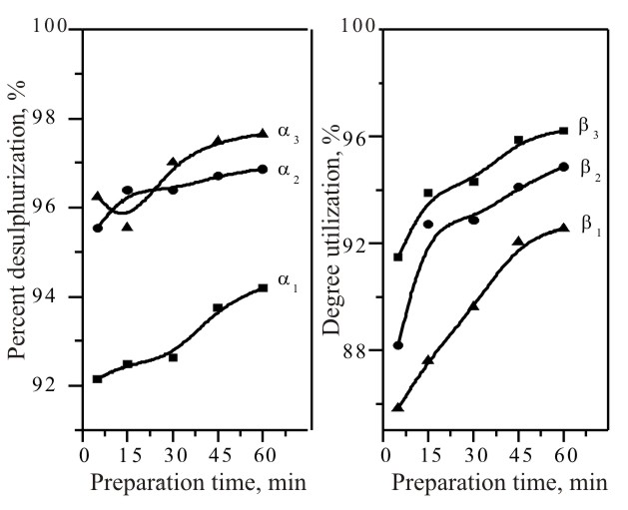
Fig. 6. Dependence of percentage of desulphurization (α) and Na₂CO₃ utilization degree (β) on the treatment time (τ) when using rotary reactor at t = 48−28°С, m = 2.5: C_{initial(1)} = 63.80 g∙L⁻¹ (α₁, β₁), С_{initial(2)} = 67.00 g∙L⁻¹ (α₂, β₂) and С_{initial(3)} = 70.20 g∙L⁻¹ (α _{3,} β ₃); a − α_{1,} α _{2,} and α ₃;
b − β₁, β₂ and β₃.
On the 5th minute and stoichiometric ratio С_{initial(1)} = 63.80 g∙L⁻¹: α₁ = 92.16% ($S_{{\text{SO}}_{4}^{2−}}$= 0.50%).
For 5% excess of NaOH (С_{initial} = 67.00 g∙L⁻¹) we obtained α₂ = 95.55% ($S_{{\text{SO}}_{4}^{2−}}$= 0.28%), and for 10% excess (С_{initial} = 70.20 g∙L⁻¹) – α₃ = 96.24% ($S_{{\text{SO}}_{4}^{2−}}$= 0.24%).
These data are also confirmed by three expe-riments conducted with Sample № 1 [7], under the following conditions: m = 2, t = 48−28ºС and initial concentration of NaOH: С_{initial} = 80.62 g∙L⁻¹ (stoichiometric content) − I experiment; С_{initial} = 84.65 g∙L⁻¹ (5% excess) – II experiment ; С_{initial} = 86.68 g∙L⁻¹ (10% excess) − III experiment.
These results are similar to those obtained by treating the Pb-paste with NaOH in a reactor with a laboratory stirrer.
During desulphurization in rotational reactor of the drum type increase of the degree of desulphuri-zation is observed after the 15th minute. On the 30th minute values of α = 95.50−97.36% are reached.
These results exceed significantly the technolo-gical requirements [10]. Because of this, the following conditions can be accepted as optimal for both samples: up to 5% excess of NaOH, m = 2−2.5, t = 48−42°С and τ = 5−15 min.
Data, regarding desulphurization process with NaOH in rotational reactor of the drum type, were not found in the literature.
Behaviour of the impurities during desulphurization of Pb-pastes
Behaviour of the impurities during desulphuri-zation of Pb-pastes with Na₂CO₃. The results from analysing the liquid phase after desulphurization of the pastes with Na₂CO₃, using a laboratory stirrer, regarding the concentration of impurities are presented in Table 1.
It is also important to point out the fact that the solutions obtained after treating Sample No. 2 are 10−100 times purer than those from Sample No. 1, regardless of the fact that with it values of the degree of desulphurization above 90% are achieved with stoichiometric amount of Na₂CO₃ and the process of desulphurization is of shorter duration.
The value of pH of the solutions after desulphu-rization, is 9.20−9.40 for Sample No. 1 and 8.17−8.63 for Sample No. 2.
D. A. Atanasova: Hydrometallurgical processing of dumped lead paste
The concentration of Sb in the solutions is directly connected with the excess of Na₂CO₃. For 100% excess of Na₂CO₃ in the solution one can obtain up to 7% Sb [22]. This causes additional purification of the solutions, including also from Pb, which in the technological practice is done by adding iron salts.
Data by other authors were not found in the literature, concerning investigation of the concen-tration of impurities under the different conditions of conducting the desulphurization process. There exist only data regarding the content of lead in the crystalline Na₂SO₄ obtained after desulphurization of the pastes. Yanakieva [2] indicates data received by X-ray-structural (Röntgen-structural) analysis for the percentage content of Pb in the crystalline Na₂SO₄, which is in the range 0.0129−0.0099%.
Behaviour of the impurities during desulphuri-zation of Pb pastes with NaOH. The results from analyzing the obtained liquid phase after desul-phurization of the pastes with NaOH, using a laboratory stirrer and a rotational reactor of the drum type, concerning the concentration of impu-rities, are presented in Table 2.
In contrast to the solutions obtained after desulphurization of the pastes with Na₂CO₃, here the lead passes to a greater extent and the antimony to smaller degree.

Table 1. Concentration of impurities in the liquid phase of Na₂SO₄ when treating the pastes with Na₂CO₃ and a laboratory stirrer.
No. | Condition of carrying out the process | Inclusion concentrations, mg∙L⁻¹ |  |  |  |  |  |  | pH
No. | Sample No. 1 | Pb | Sb | Cl₂ | As | Cu | Zn | Fe | pH
1 | stoichiometric; m = 2; τ = 30 min | 4.76 | 38.40 | 2160.0 | 51.00 | 4.30 | 0.22 | 1.5 | 9.42
2 | stoichiometric; m = 2.25; τ = 30 min | 2.90 | 28.44 | 2140.0 | 24.20 | 7.49 | 2.21 | 0.04 | 9.20
3 | 10% excess Na₂CO₃; m = 2.25; τ = 15 min | 6.80 | 13.40 | 1980.0 | 50.80 | 2.62 | 0.54 | 0.09 | 9.41
4 | 10% excess Na₂CO₃; m = 2.5; τ = 30 min | 6.10 | 15.90 | 1940.0 | 42.00 | 2.39 | 0.26 | 0.08 | 9.27
 | Sample No. 2
1 | 10% excess Na₂CO₃; m = 2; τ = 30 min | 0.40 | 32.40 | 170.0 | 0.47 | 0.07 | 1.16 | 1.20 | 8.63
2 | 10% excess Na₂CO₃; m = 2.5; τ = 30 min | 0.11 | 29.63 | 140.0 | 0.44 | 0.14 | 2.20 | 0.05 | 8.17
3 | 20% excess Na₂CO₃; m = 2.5; τ = 15 min | 1.20 | 15.30 | 170.0 |  | 0.11 | 0.53 | < 0.01 | 8.48
4 | 20% excess Na₂CO₃; m = 2.5; τ = 30 min | 1.20 | 14.70 | 170.0 | 0.83 | 0.05 | 1.85 | < 0.01 | 8.22

Table 2. Concentration of impurities in liquid phase of Na₂SO₄, when the pastes are treated with NaOH.
No. | Conditions of carrying out the process | Inclusion concentrations, mg∙L⁻¹ |  |  |  |  |  |  | рН
No. | Sample No. 1 | Pb | Sb | Cl₂ | As | Cu | Zn | Fe | рН
А | Common reactor with laboratory agitator
1 | stoichiometric; m = 2; τ = 30 min | 972.0 | < 0.1 | 1320.0 | 52.5 | < 0.01 | 13.93 | 1.8 | 12.55
2 | 5% excess of NaOH; m = 2; τ = 30 min | 1602.6 | < 0.1 | 1640 | 65.3 | < 0.01 | 6.16 | 1.8 | 12.60
3 | 10% excess of NaOH; m = 2; τ = 30 min | 2019.2 | < 0.1 | 1560.0 | 70.3 | < 0.01 | 5.10 | 1.7 | 12.60
B | Rotary reactor of drum type
4 | stoichiometric; m = 2; τ = 30 min | 874.7 | < 0.1 | 1460.0 | 48.5 | 0.60 | 14.60 | 1.70 | 12.50
5 | 5% excess of NaOH; m = 2; τ = 30 min | 1097.8 | < 0.1 | 1640.0 | 60.0 | 0.90 | 20.40 | 1.90 | 12.53
6 | 10% excess of NaOH; m = 2; τ = 30 min | 1496.8 | < 0.1 | 1840.0 | 68.9 | 0.80 | 26.50 | 2.00 | 12.55
 | Sample No. 2
А | Common reactor with laboratory agitator
1 | stoichiometric; m = 2.5; τ = 30 min | 0.12 | < 0.1 | 54.0 | < 0.01 | 0.05 | 0.1 | < 0.01 | 10.35
2 | 5% excess of NaOH; m = 2.5; τ = 30 min |  | < 0.1 | 40.0 | 10.8 | 0.04 | 4.12 | < 0.01 | 12.46
3 | 10% excess of NaOH; m = 2.5; τ = 30 min | 43.84 | < 0.1 | 44.0 | 4.0 | 0.07 | 0.20 | < 0.01 | 12.22
B | Rotary reactor of drum type
1 | stoichiometric; m = 2.5; τ = 30 min | 76.82 | < 0.1 | 64.0 | 0.77 | < 0.01 | 1.00 | 1.2 | 12.15
2 | 5% excess of NaOH; m = 2.5; τ = 30 min | 30.4 | < 0.1 | 60.0 | 2.40 | 0.40 | 0.12 | 1.2 | 12.15
3 | 10% excess of NaOH; m = 2.5; τ = 30 min | 20.4 | < 0.1 | 46.0 | 4.70 | 0.50 | 0.10 | 1.30 | 12.22

The lead passes into the solutions in the form of sodium plumbite (Na₂PbO₂).
D. A. Atanasova: Hydrometallurgical processing of dumped lead paste
Regarding the chlorine and arsenic, the purity of the solutions depends on the purity of the nonde-sulphurized paste and the presence of other lead-containing impurities or additives (for example lead powder). The latter also holds true to some extent for the arsenic and some of the other impurities in the paste.
The pH value of the solutions after desulphuri-zation is: 12.50−12.60 for Sample No. 1 and 10.30−12.40 for Sample No. 2, respectively.
Based on the analysis of the results received from both paste samples, the increase in concen-tration of impurities is important when the process is done in rotational reactor of the drum type, which is due to the better conditions of contact between the paste and the reagent.
Data were not found in the literature, concerning investigations on the effect of the concentration of impurities in the solutions after desulphurization with both types of reactors.
Conclusions
- The process of desulphurization runs at higher speed when using NaOH, than using Na₂CO₃ for both types of reactors;
- The optimal conditions for desulphurization of Pb-paste with Na₂CO₃ in both reactors are: excess of Na₂CO₃ up to 10%, m = 2.0−2.5, t = 55−35ºС and τ = 15−30 min (the degree of desulphurization under these conditions is 92.4−94.4%, and $S_{{\text{SO}}_{4}^{2−}}$= 0.49−0.36%);
- For the two reactors the optimal conditions for desulphurization of Pb-paste with NaOH are: excess of NaOH up to 10%, m = 2, t = 55−35ºС and τ = 15−30 min. (the degree of desulphurization under these conditions is 93.64−96.90%, and $S_{{\text{SO}}_{4}^{2−}}$= 0.41−0.20%);
- After desulphurization with Na₂CO₃ greater amount of Sb goes into the solutions than of Pb, while when using NaOH into the solutions goes more Pb, and the amount of Sb in them is below 0.1 mg∙L⁻¹;
- The process of desulphurization of Pb-paste can be realized continuously when using rotational reactor of the drum type, and from the solutions significantly pure crystalline Na₂SO₄ can be obtained, which is suitable for the aims of the industry (Tables 1 and 2).
References
- N. K. Lyakov, PhD Thesis, UCTM, Sofia, 1989.
- V. P. Yanakieva, PhD Thesis, UCTM, Sofia, 2003.
- A. G. Morachevskii, Zh. Prikl. Khim., 70, 3 (1997).
- Yu. S. Kuznetsova, O. A. Kal’ko, A. G. Morachevskii, E. V. Bakhvalova, Russ. J. Appl. Chem., 81, 1283 (2008)
- K. Arai, J. M. Toguri, Hydrometallurgy, 12, 49 (1984).
- M. S. Kogan, PhD Thesis, St. Petersburg Tekh. Univ., 1994.
- N. K. Lyakov, D. A. Atanasova, V. S. Vassilev, G. A. Haralampiev, J. Power Sources, 171, 960 (2007).
- N. K. Lyakov, Secondary Metallurgy of Non-ferrous Metals and Alloys, Martilen, Sofia, 1996 (in Bulgarian).
- Engitec Impianti, Firm material, System “СХ Compakt”, 1993.
- Eur. Patent EP 1 619 261 A1, 1 (2006).
- K. F. Lamm, in: Proc. 1st Int. Congr. Processing of Secondary Raw Materials, Moscow, 1992 (in Russian).
- R. M. Reynolds, E. K. Hudson, M. Olper, in: The Engitec CX Lead-Acid Battery Recovery Technology, (Proc. 1st Int. Seminar Battery Waste Management, Deerfield Beach, FL, USA, 1989, p. 1.
- M. Olper, B. Asano, in: Primary and Secondary Lead Processing, Halifax, Nova Scotia, August 1989, M. L. Laeck (Ed.), Pergamon Press, New York, 1989, p. 119.
- A. G. Morachevskii, J. Appl. Chem., 76, 1427 (2003).
- T. T. Chen, J. E. Dutrizac, Hydrometallurgy, 40, 223 (1996).
- S. Gishin, Accumulators, Tech. Univ., Sofia, 2003 (in Bulgarian??).
- M. E. Stout, in: Hydrometallurgy: Fundamentals, Technology and Innovations, I. B. Hiskey, G. W. Warren (eds.), Society for Mining, Metallurgy & Exploration, Inc., Colorado, 1993, p. 1185.
- N. M. Barbin, G. F. Kazantsev, Processing of Secondary Lead Raw Materials in Ion-Salt Melts, Ural Dept. Russ. Acad. Sci., Ekaterinburg, 2002 (in Russian).
- G. F. Kazantsev, G. K. Monsevich, N. M. Barbin, Khimiya v interesah ustoichivogo razvitiya, 2, 461 (1994).
- F. M. Loskutov, Metallurgy of Lead, Metallurgia, Moscow, 1965 (in Russian).
- A. G. Morachevskii, O. A. Kalko, Z. I. Vaisgant, Zh. Prikl. Khim., 68, 1899 (1995).
- A. G. Morachevskii, Zh. Prikl. Khim., 71, 881 (1998).
- K. J. Laidler, E. T. Denisov, K. H. Homman, T. M. Sugden, Pure Appl. Chem., 53 753 (1981).
- Y. Gong, J. E. Dutrizac, T. T. Chen, Hydrometallurgy, 28, 399 (1992).
- Y. Gong, J. E. Dutrizac, T. T. Chen, Hydrometallurgy, 31, 175 (1992).
- K. Arai, J. M. Togury, Hydrometallurgy, 12, 49 (1984).
- V. P. Yanakieva, Sci. Rep. Union Sci. Techn. Mech. Eng., 3, 236 (2004) (in Bulgarian).
- D. A. Atanasova, N. K. Lyakov, V. S. Vassilev, G. Angelov, G. A. Haralampiev, in: Proc. 10th Nat. Conf. Metallurgy, A. Avramov (ed.), Varna, 2007.
- D. A. Atanasova, N. K. Lyakov, V. S. Vassilev, G. Angelov, G. A. Haralampiev, J. UCTM, 43, 267 (2008).
- P. Taylor, V. J. Lopata, Canad. J. Chem., 62, 395 (1984).
- A. G. Morachevskii, Zh. Prikl. Khim., 70, 167 (1997).
- D. Blana, Erzmetall, B 32, 262 (1979).
D. A. Atanasova: Hydrometallurgical processing of dumped lead paste
- RU Patent 2016104 C1 C22 B7/00, 13/00 (1999).
- UK Patent GB 2309464 A, C22 B 7/00, (1997).
- R. M. Reynolds, E. K. Hudson, M. Olper, in: Lead-Zinc’90, T. S. Mackey, R. D. Prengaman (eds), TMS, Warrendale, PA, 1990, p. 1001.
- T. Corsini, in: EPD Congress 93, J. P. Hager (ed.), TMS, 1993, p. 909.
- M. Olper, M. Maccagni, in: Interbat, M., Feb., 2001.
- E. V. Javgel, Zh. Prikl. Khim., 8, 1681 (1978).
- H. J. Bittrich, E. Leibritz, J. Prakt. Chem., 17, 92 (1962).
- E. V. Margulis, P. E. Margulis, V. V. Brigadnova, A. Archinova, Zh. Prikl. Khim., 3, 558 (1989).
- A. G. Morachevskii, M. S. Kogan, A. I. Demidov, Z. I. Vaisgant, Zh. Prikl. Khim., 66, 1871 (1993).
- A. G. Morachevskii, A. I. Demidov, M. S. Kogan, Z. I. Vaisgant, Zh. Prikl. Khim., 66, 2101 (1993).
- A. G. Morachevskii, O. A. Kalko, Z. I. Vaisgant, Zh. Prikl. Khim., 68, 127 (1995).
- US Patent 4.927.510,5 (1990).
- US Patent 5.039.337,8 (1991).
- US Patent 5.441.609,8 (1995).
- V. I. Avdyukov, V. T. Tulenkov, L. I. Bezginova, V. V. Studentsov, Complex Utilization of Mineral Raw Materials, 3, 24 (1985).
- E. R. Cole, A. Y. Lee, D. L. Paulsen, in: Invest. Bur. Mines. Washington: USA Bur. Mines No. 8857, 1984, p. 20.
- US Patent 4220628 (1980).
- US Patent 4.118.219, 10 (1978).
- US Patent 262, 11 (1998).
- US Patent 4.850.278 (1991).
- M. P. Smirnov, V. S. Sorokina, Tsvetn. Met., 2, 23 (1999).
- M. P. Smirnov, V. S. Sorokina, R. A. Gerasimov, Tsvetn. Met., 9, 13 (1996).
- V. P. Yanakieva, G. A. Haralampiev, N. K. Lyakov, J. Power Sources, 85, 178 (2000).
- BG Patent 100627 C22B7/00; C22B3/16 (1997).
- L. A. Kochubei, Kompleksnoe Izpol’zovanie Mineral’nogo Syr’ia (Almaty), 3, 47 (1990).
- G. Remi, Course of Inorganic Chemistry, Inostrannaya Literatura, Moscow, 1963, (in Russian?).
- Handbook of the Chemist, Gostkhimizdat, vol. III, 1962, (in Russian?).
- Yu. Yu. Lurie, Handbook of Analytical Chemistry, Gostkhimisdat, Moscow, 1962, (in Russian?).

ХИДРОМЕТАЛУРГИЧНО ПРЕРАБОТВАНЕ НА АМОРТИЗИРАНА ОЛОВНА АКУМУЛАТОРНА ПАСТА
Д. А. Атанасова
Химикотехнологичен и металургичен университет, бул. „Климент Охридски“ № 8, 1756 София
В памет на проф. Н. К. Ляков и проф. Г. А. Харалампиев
Постъпила на 8 януари 2009 г. Преработена на 9 март 2009 г.
(Резюме)
Настоящата работа представя анализ на експериментални резултати от извършени изследвания относно десулфатизиране на амортизирана оловна паста и възможностите за осъществяване на процеса. Целта е да се направи сравнителна оценка на получените резултати със съществуващи данни в литературата и водещи технологии. Разгледани са кинетичните зависимости на протичащите процеси и свързаните с това проблеми. Определени са оптималните условия на процеса на десулфатизиране, при използване на реагентите Na₂CO₃ и NaOH в зависимост от типа на работния реактор (обикновен реактор с лабораторна бъркалка и ротационен реактор от барабанен тип). Изследвано е съдържанието на примеси в разтворите с цел получаване на достатъчно чист кристален Na₂SO₄ за промишлеността.

