Bulgarian Chemical Communications, Volume 43, Number 4 (pp 483 – 488) 2011
Effect of activated carbons derived from agricultural by-products on the hydrogen storage properties of magnesium
*To whom all correspondence should be sent:
E-mail: egeorg@svr.igic.bas.bg
© 2011 Bulgarian Academy of Sciences, Union of Chemists in Bulgaria
E. Grigorova^{a*}, Ts. Mandzhukovaª, M. Khristovª, P. Tzvetkovª, B. Tsyntsarski^{b}
ª Institute of General and Inorganic Chemistry, Bulgarian Academy of Sciences, bl.11, Acad. G. Bonchev str. 1113 Sofia, Bulgaria
^{b} Institute of Organic Chemistry, Bulgarian Academy of Sciences, bl.9, Acad. G. Bonchev str., 1113 Sofia, Bulgaria
Received February 15, 2011; Accepted April 4, 2011
The absorption-desorption characteristics towards hydrogen of the composites 95wt.% Mg-5wt.% activated carbons derived from bean pods and apricot stones, obtained by ball milling in argon atmosphere were investigated. Hydriding of the composites was performed at temperatures 573 K and 473 K and pressure of 1 MPa and dehydriding - at T = 623 K and P = 0.15 MPa. Absorption capacity values of 5.43 wt.% and 6.13 wt.% (at T = 573 K and P = 1 MPa) were reached for the composites containing activated carbons derived from bean pods and from apricot stones, respectively. The hydriding/dehydriding characteristics of the studied composites were compared with those of pure magnesium. It was established that the activated carbons derived from bean pods and apricot stones improved the hydrogen sorption kinetics of magnesium.
Keywords: hydrogen storage materials; metal hydrides; mechanochemical processing; gas-solid reactions.

Introduction
Magnesium is considered as a promising material for hydrogen storage due to its high theoretical absorption capacity of 7.6 wt%, volumetric density, availability and low cost. The limitation of its practical application is due to two main reasons: i) sluggish hydriding/dehydriding kinetics and ii) high temperatures of hydrogen absorption and desorption. The mechanochemical treatment, along with the use of an appropriate additive, could resolve these drawbacks. Mechanical grinding in high-energy ball mills consists of repetitive cold welding and fracturing. Its application for the preparation of hydrogen storage materials leads to an increase in the specific surface area and appearance of different defects, which modify the hydriding kinetics of the composites. Several types of additives to magnesium based materials were used, such as: 3d metals [1,2], metal oxides [3-7], intermetallic [8,9] and carbon containing compounds as: graphite [10-15,17,18,20-22,24], multi and single-walled carbon nanotubes [16-19, 24], carbon black [17,18, 23], nanodiamonds [23], amorphous carbon soot [23] and carbon nano-fibers [24]. Depending of the nature of the additive the mechanism of its catalytic effect is different.
Some aspects of the role of carbon containing additives on the hydrogen sorption properties of magnesium are not clarified in the literature. This was discussed and well illustrated by V. Fuster et al. [20]. Many authors agreed that carbon containing additives improved the hydrogen sorption properties of magnesium. Some of them have proved that graphite protects magnesium from oxidation and acts as a process controlling agent during ball milling due to its lubricant properties. There are some controversial opinions about the catalytic role of graphite on hydrogen sorption properties. As a conclusion it should be mentioned that the effect of carbon containing additives to magnesium is complex and not yet sufficiently clarified.
Activated carbons are often synthesized from precursors based on expensive and depleting fossil fuels. They can also be prepared from biomass or agricultural by-products with lower price.
The subject of the present work was to investigate the effect of activated carbons prepared from plant precursors as bean pods and apricot stones on the hydrogen sorption properties of magnesium. The hydriding/dehydriding characteristics of the studied composites were compared with those of pure magnesium.
EXPERIMENTAL
Activated carbons were prepared by steam pyrolysis from apricot stones and bean pods. The raw material was heated up to the carbonization temperature (873 K) and the solid product was activated with water vapour for 60 min at 1073 K for bean pods and 973 K for apricot stones. Details on the preparation procedure of activated carbons can be found in [25-28].
The mixtures of 95 wt% powdery Mg with 99.9% purity and 5 wt% activated carbons derived from bean pods (BP) and apricot stones (AS) were ball milled in the planetary monomill Fritsch Pulverisette 6 for 30 min and 180 min under argon with rotation speed 200 rpm and 1:10 sample-to-balls weight ratio. Only the composite with 5 wt% BP was subjected to prolonged ball milling. Further in the text, these composites will be denoted as follows: Mg-BP-30: 95 wt% Mg-5 wt% activated carbon derived from bean pods after 30 min ball milling; Mg-BP-180: 95 wt% Mg-5 wt% activated carbon derived from bean pods after 180 min ball milling and Mg-AS: 95 wt% Mg-5 wt% activated carbon derived from apricot stones ball milled for 30 min. The purity of the argon and hydrogen gases used was 99.998% and 99.999%, respectively.
All composites were characterized by X- ray diffraction analyses on a Bruker D8 Advance diffractometer using CuKα radiation and by scanning electron microscopy on a Philips 515 electron microscope. The hydrogen absorption/desorption measurements were performed on a Sivert type apparatus. Particle size measurements of the ball milled samples were performed in distilled water using the Fritsch Analysette 22 Compact device with ultrasonic equipment. Textural characterization of the activated carbons was carried out by measuring the nitrogen adsorption isotherms in an automatic apparatus (Tristar 3000, Micromeritics).
RESULTS AND DISCUSSION
The X-ray diffraction patterns of the activated carbons are presented in Fig.1. The broad diffuse peaks at 24 and 43 degrees 2θ can be indexed as 002 and 100 lines in the graphite structure. Minor quantities of inorganic compounds like CaCO₃ and MgO were detected, notably in the activated carbon derived from bean pods. The higher and narrower peak at 24 2θ (002) for the activated carbon from AS in comparison with the activated carbon from BP points to the higher degree of graphitization and the more ordered structure of the former.
The X-ray diffraction patterns of the composites Mg-BP-30, Mg-BP-180 and Mg-AS, obtained after ball milling under argon, showed no substantial difference (Fig.2). The main phase is magnesium with traces of Mg(OH)₂. One of the composites (Mg-BP) was subjected to prolonged ball milling under argon. Due to the decrease in the crystallite
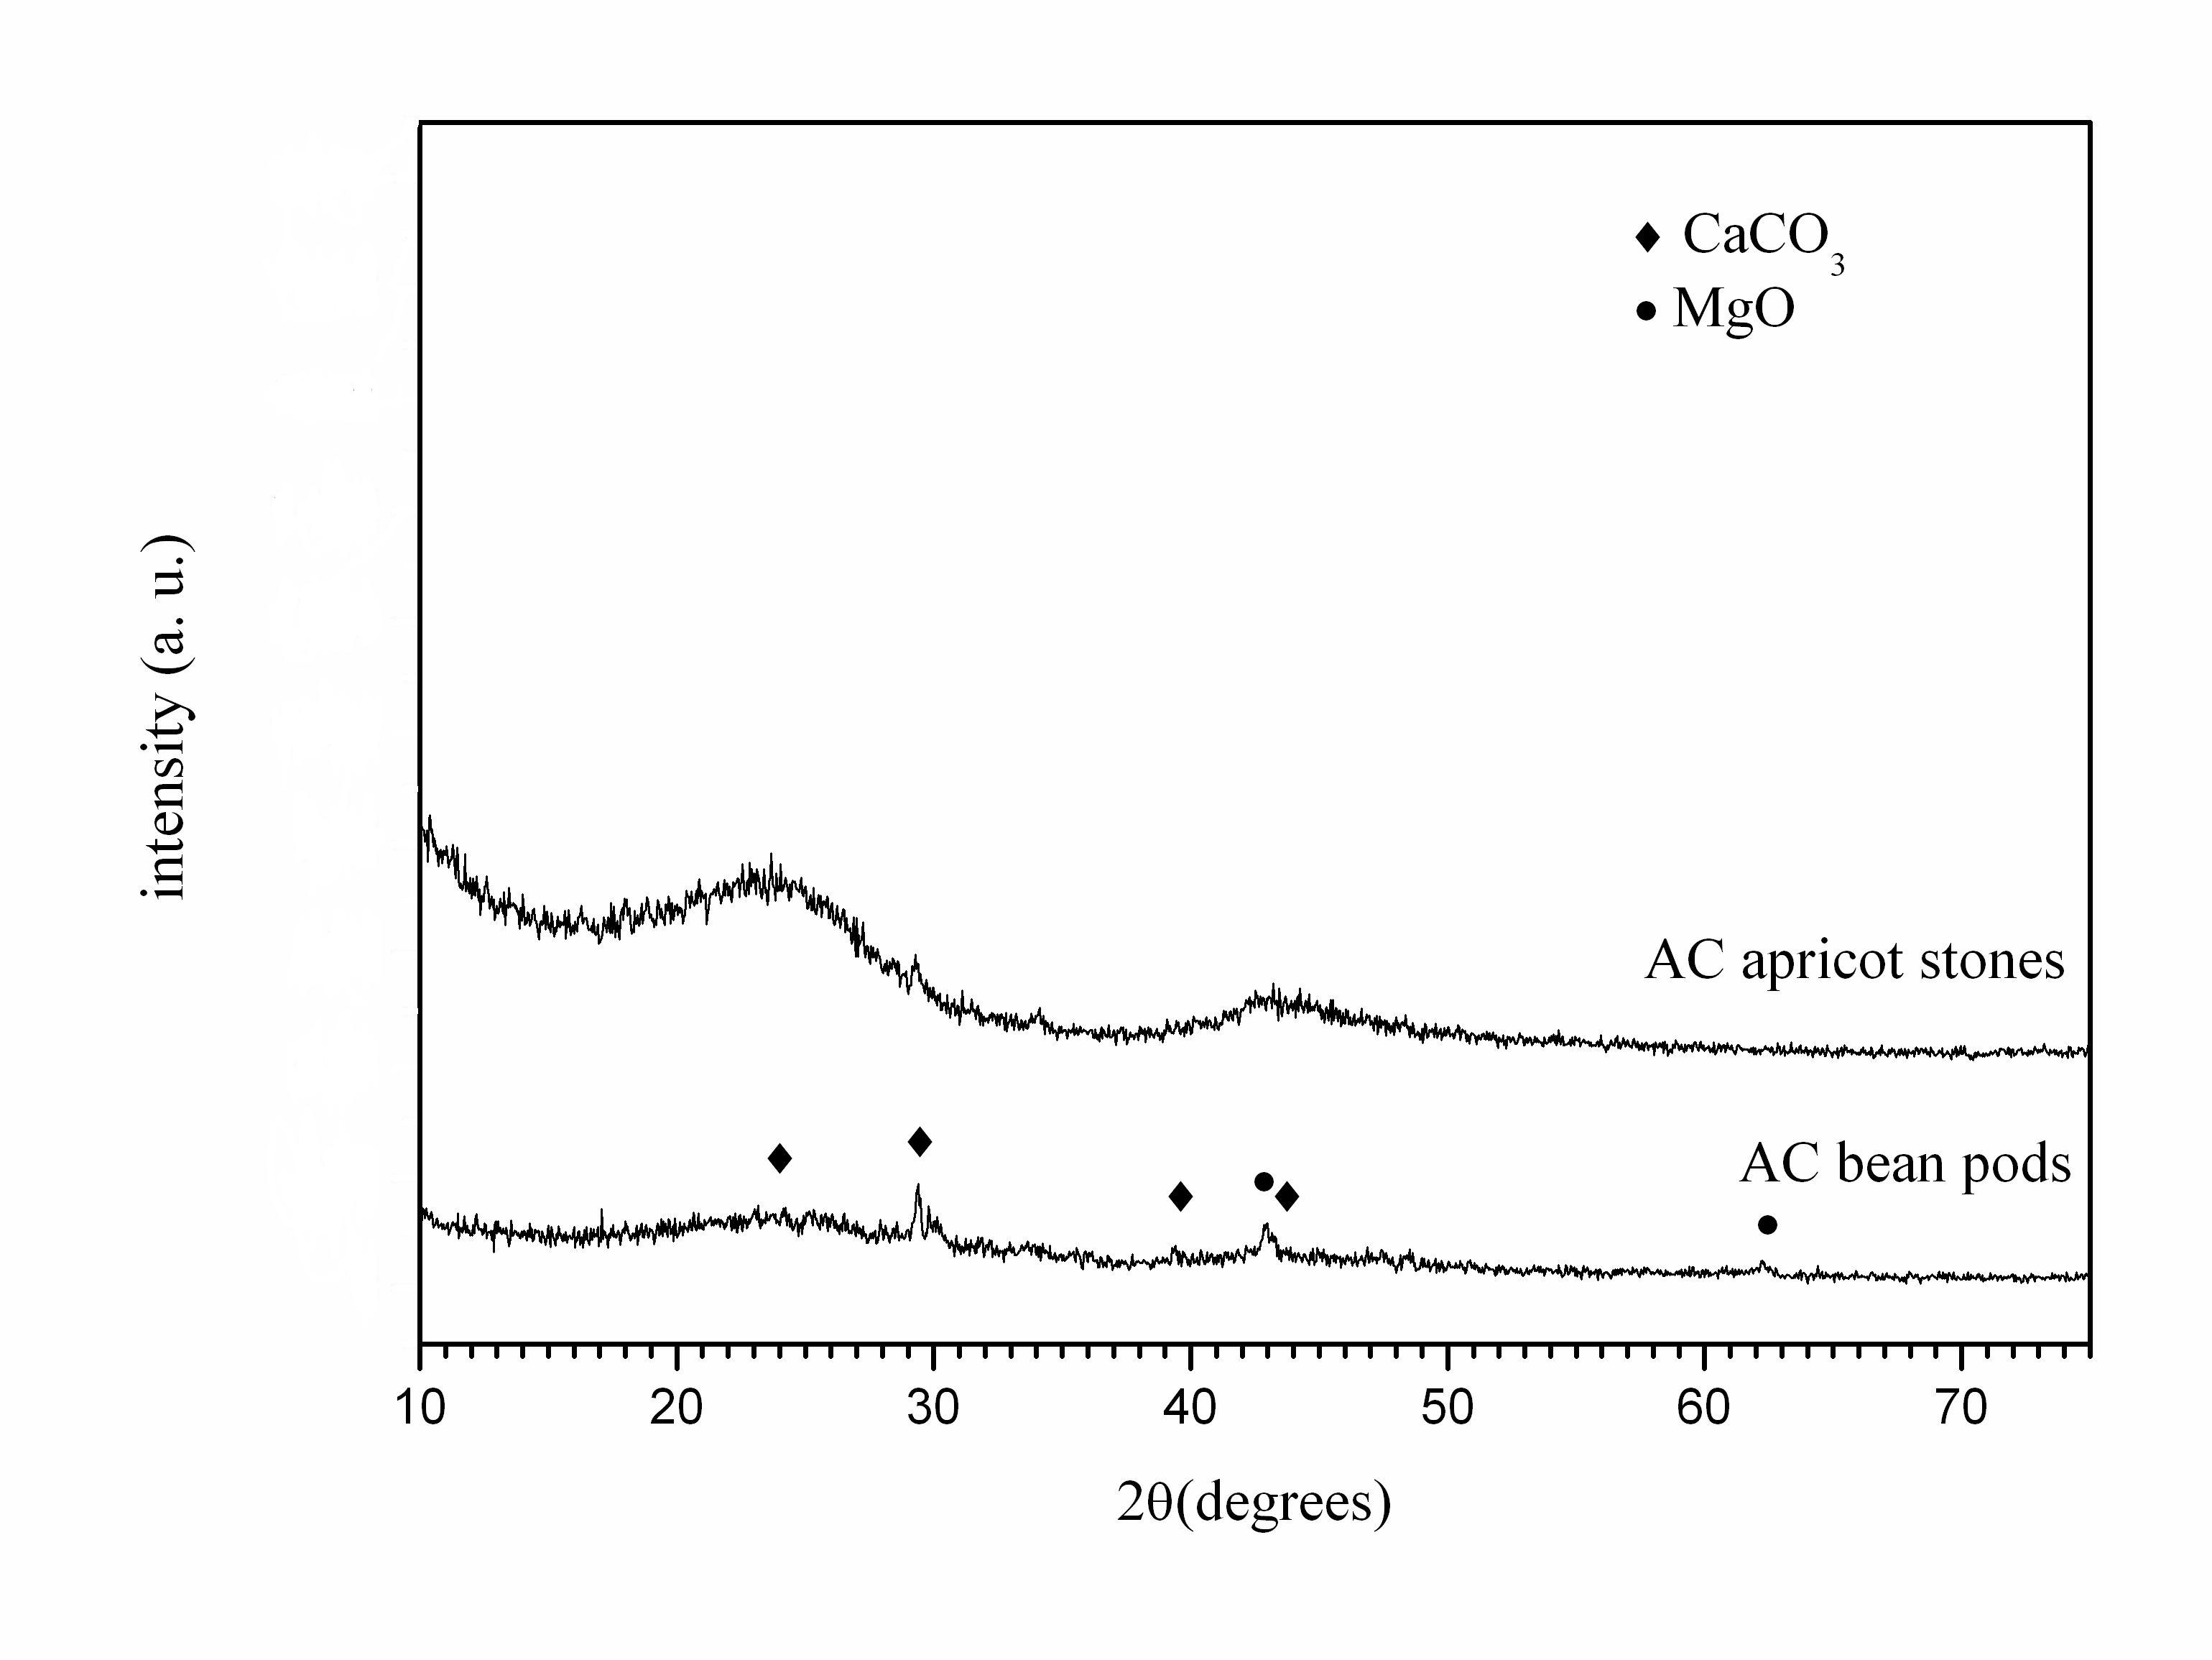
Fig. 1 X-ray diffraction patterns of activated carbon derived from: a) bean pods and b) apricot stones
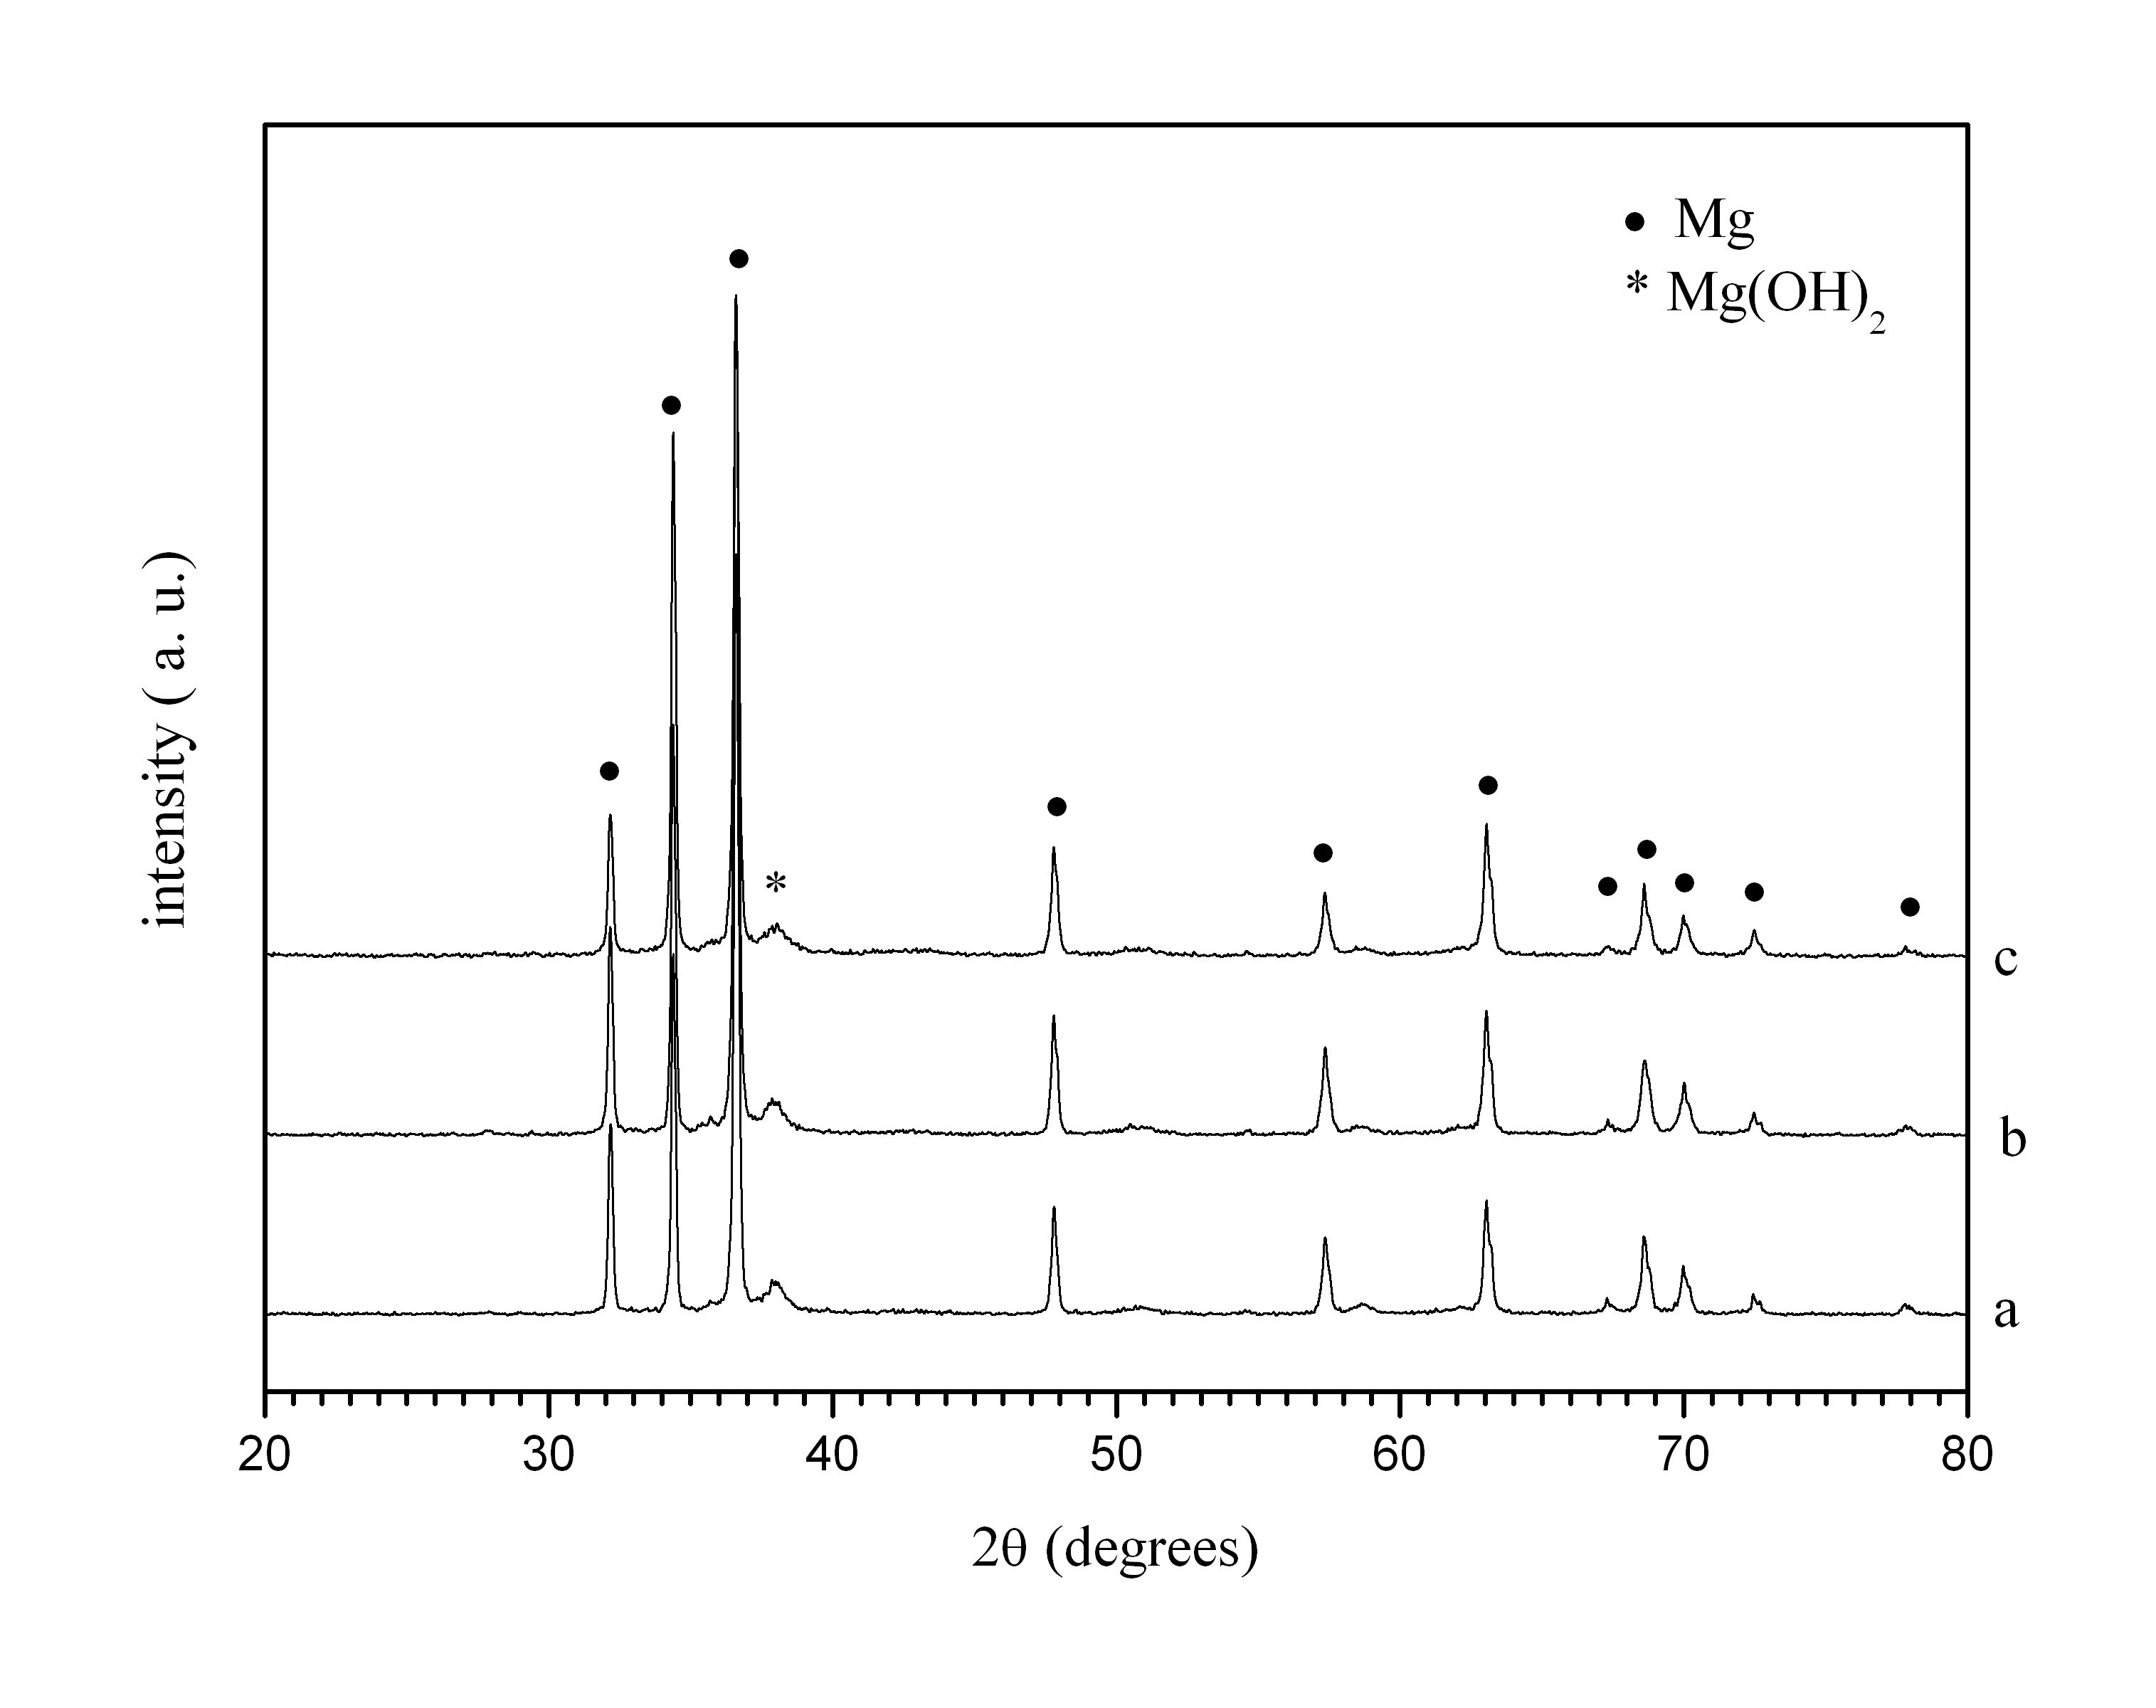
Fig.2 X-ray diffraction patterns of the composites obtained after ball milling under argon a) Mg-AS); b) Mg-BP-30min and c) Mg-BP-180 min.
size and the accumulation of lattice stresses and defects, broadening of the Mg diffraction peaks after prolonger ball milling could be expected. Even after ball milling of the composite Mg-BP for 180 min, the diffraction peaks have the same shape, position and intensity as for the composite ball milled for 30 min. After hydriding at T= 573 K and P= 1 MPa, the X-ray diffraction patterns of the composites showed main phase of MgH₂, small amount of unreacted magnesium and presence of MgO (Fig.3).
The kinetic curves obtained at temperatures 623 K for the first cycle and 573 K for the fifth cycle and pressure of 1 MPa are given in Fig 4. The effect of ball milling duration on the hydrogen sorption properties of the composite Mg-BP was investigated. The sample ball milled for 180 min showed easier activation than that, ball milled for only 30 min. Nevertheless, after few cycles of hydriding/dehydriding, no substantial difference in
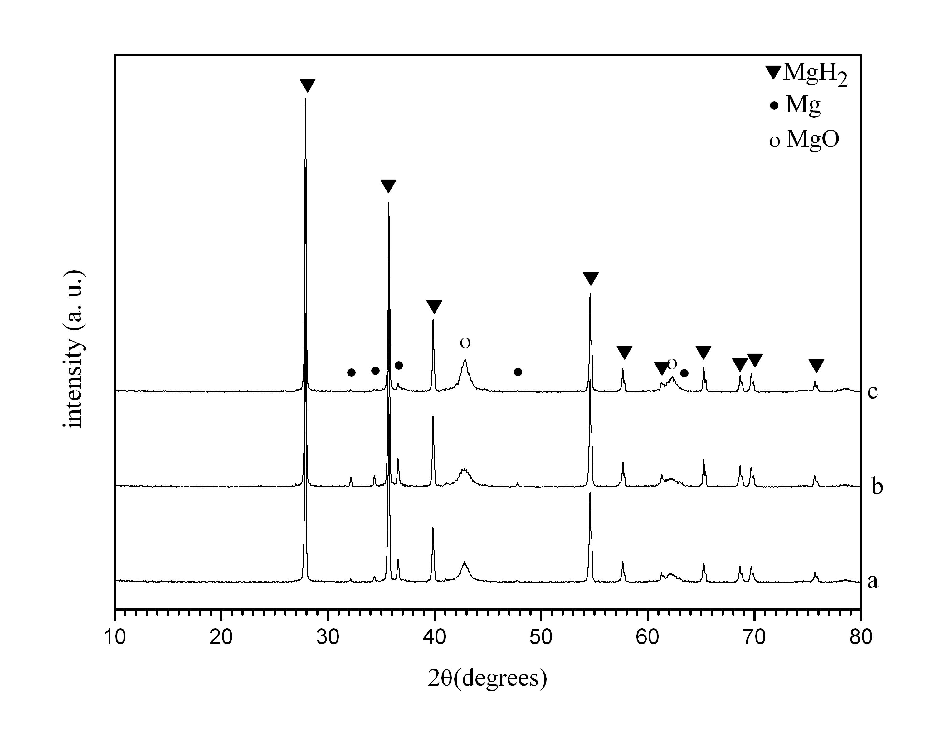
Fig. 3. X-ray diffraction patterns of the composites obtained after hydriding at T= 573 K and P= 1 MPa a) Mg-AS; b) Mg-BP-30min and c) Mg-BP-180 min.
the hydriding curves was observed. The two composites reached about 5.4 wt.% hydrogen storage capacity after 60 min hydriding at temperature 573 K and a pressure of 1MPa. The samples Mg-BP-30 and Mg-BP-180 displayed better absorption kinetics and reached higher hydrogen absorption capacity than pure magnesium at the same conditions.
The effect of activated carbons as additives on the hydriding properties of magnesium at 573 K and 1 MPa is illustrated in Fig.5. The specific surface area may be considered as an important characteristic which has a positive effect on the hydrogen sorption properties of Mg. The specific surface area of activated carbon derived from bean pods is about three times lower (280 m²/g) than that of activated carbon derived from apricot stones (960 m²/g). Improved kinetics was observed for the composite containing activated carbon with higher specific surface area. With advance of hydriding process the rate of reaction for Mg-BP-30 and Mg-BP-180 decreased in comparison with the Mg-AS sample. The composites reached maximum hydriding capacity of 5.43 wt% for Mg-BP-30; 5.35 wt% for Mg-BP-180 and 6.13 wt% for Mg-AS. At T = 473 K the kinetics of the hydriding reaction for all samples decreased and the hydrogen absorption capacity values after 60 min of hydriding were close to 1 wt%.
The composite Mg-AS desorbs 50% of the absorbed hydrogen within 17 min (Fig.6). The desorption curves of Mg-BP-180 and Mg-AS are quite similar up to 20 min. The worst hydrogen desorption properties manifests pure magnesium followed by Mg-BP-30. When the processes of 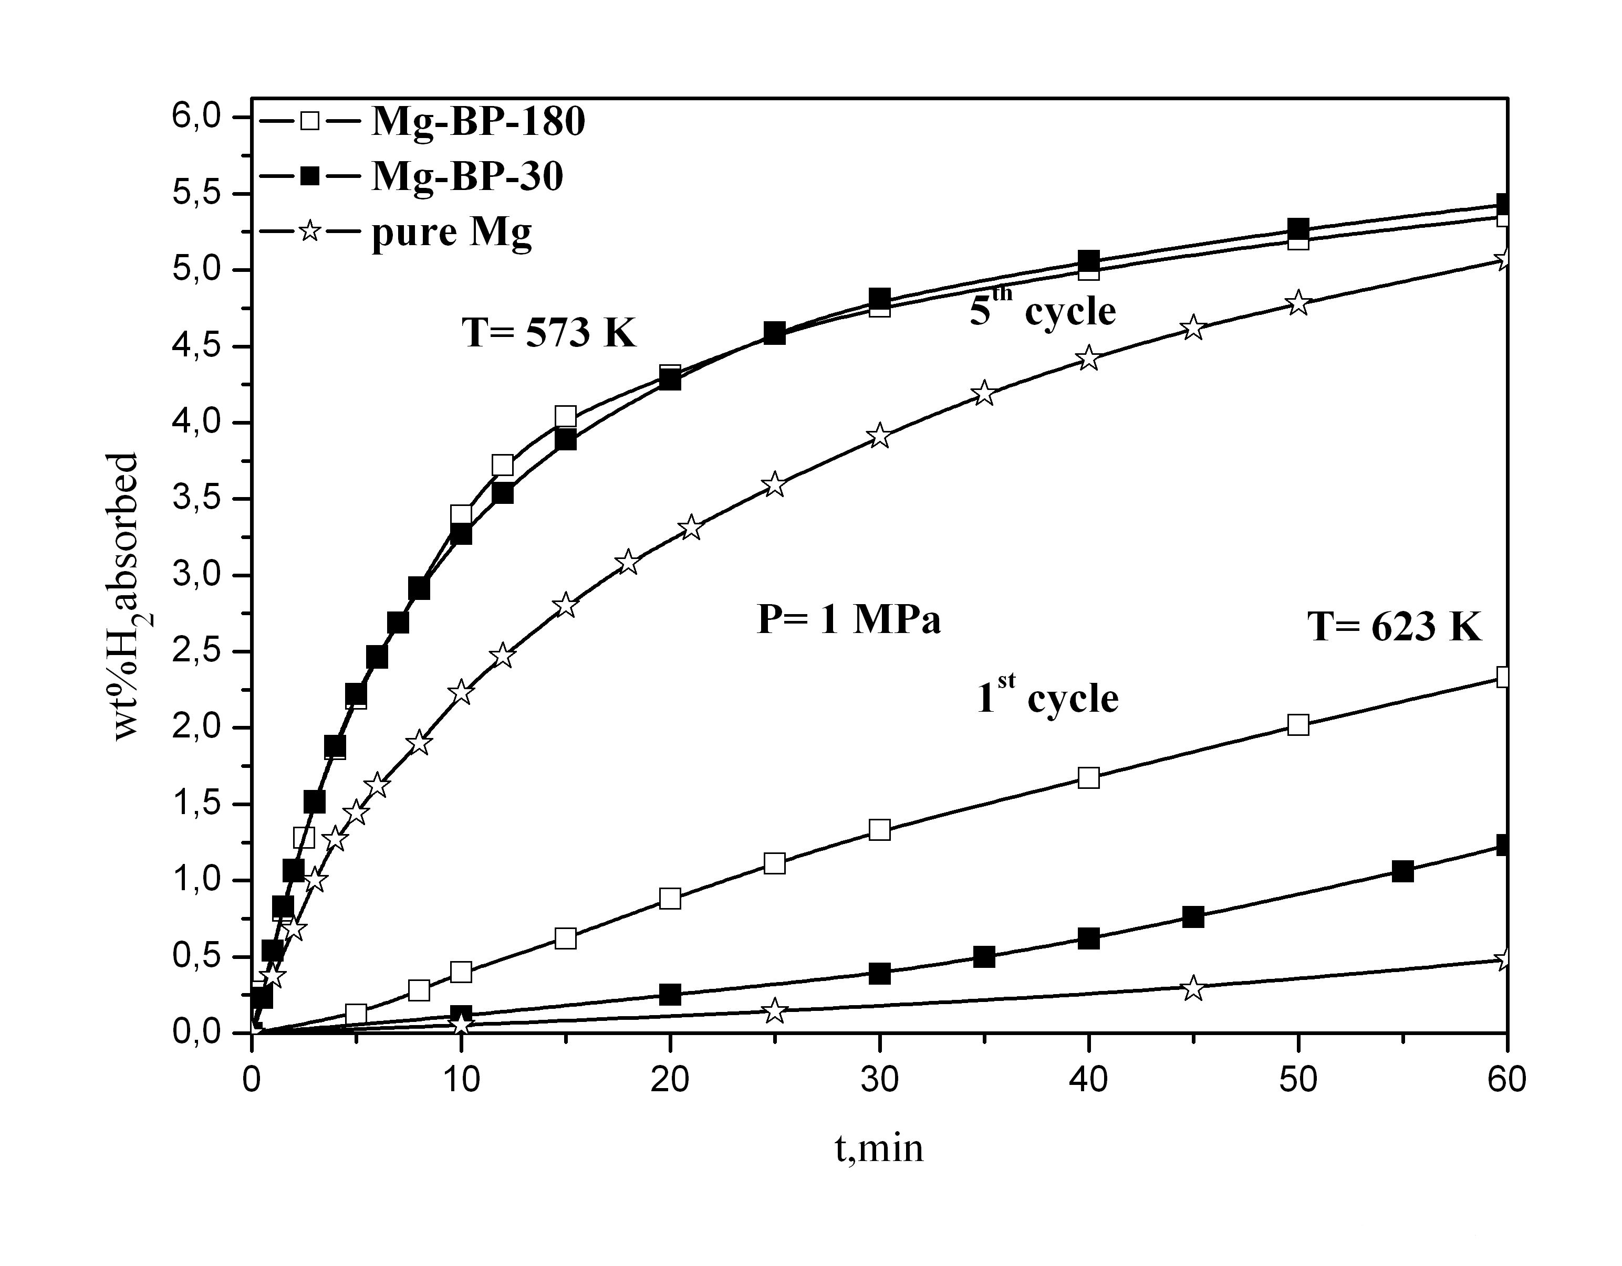 Fig. 4 Kinetic curves at the first and fifth cycles of hydriding of the composites Mg- BP ball milled 30 min or 180 min and pure magnesium.
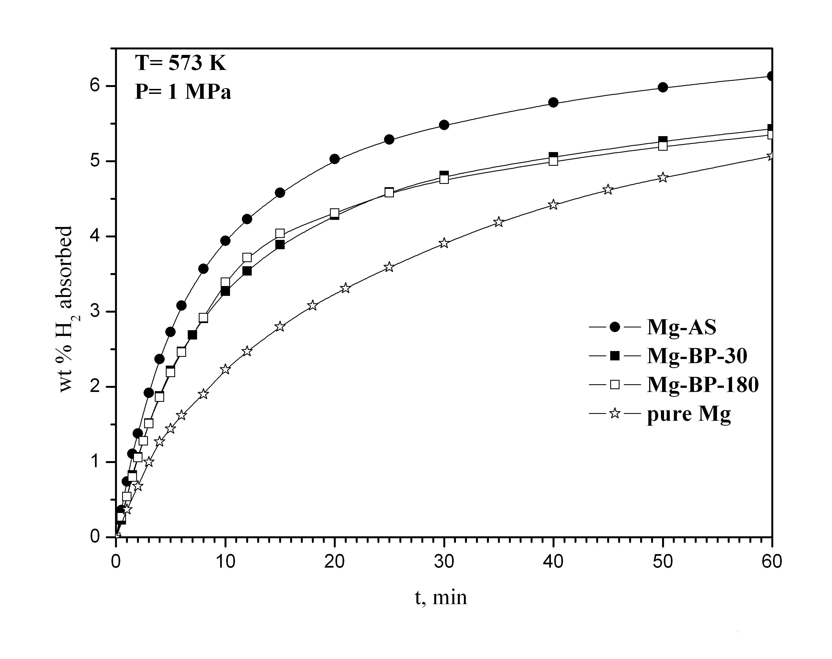
Fig. 5 Kinetic curves of hydriding of the composites Mg-BP-30, Mg-BP-180, Mg-AS and pure magnesium.
hydrogen dissociation and recombination during desorption are faster, the hydrogen molecules should diffuse through the growing metal layer and the rate controlling step should change earlier. The
growing metal layer during desorption plays the role of a diffusion barrier. The desorption curves of the composite ball milled for a longer time indicate a slightly faster rate of the reaction at the beginning of the process and a lower hydrogen absorption capacity, which could explain the earlier tendency of saturation.
As it is evident from Figs. 4, 5 and 6, the addition of activated carbons derived from apricot stones more favourably affects the hydrogen sorption characteristics than activated carbon from bean pods. It should be noted that compared to pure magnesium, the composites under consideration have better absorption/desorption characteristics.
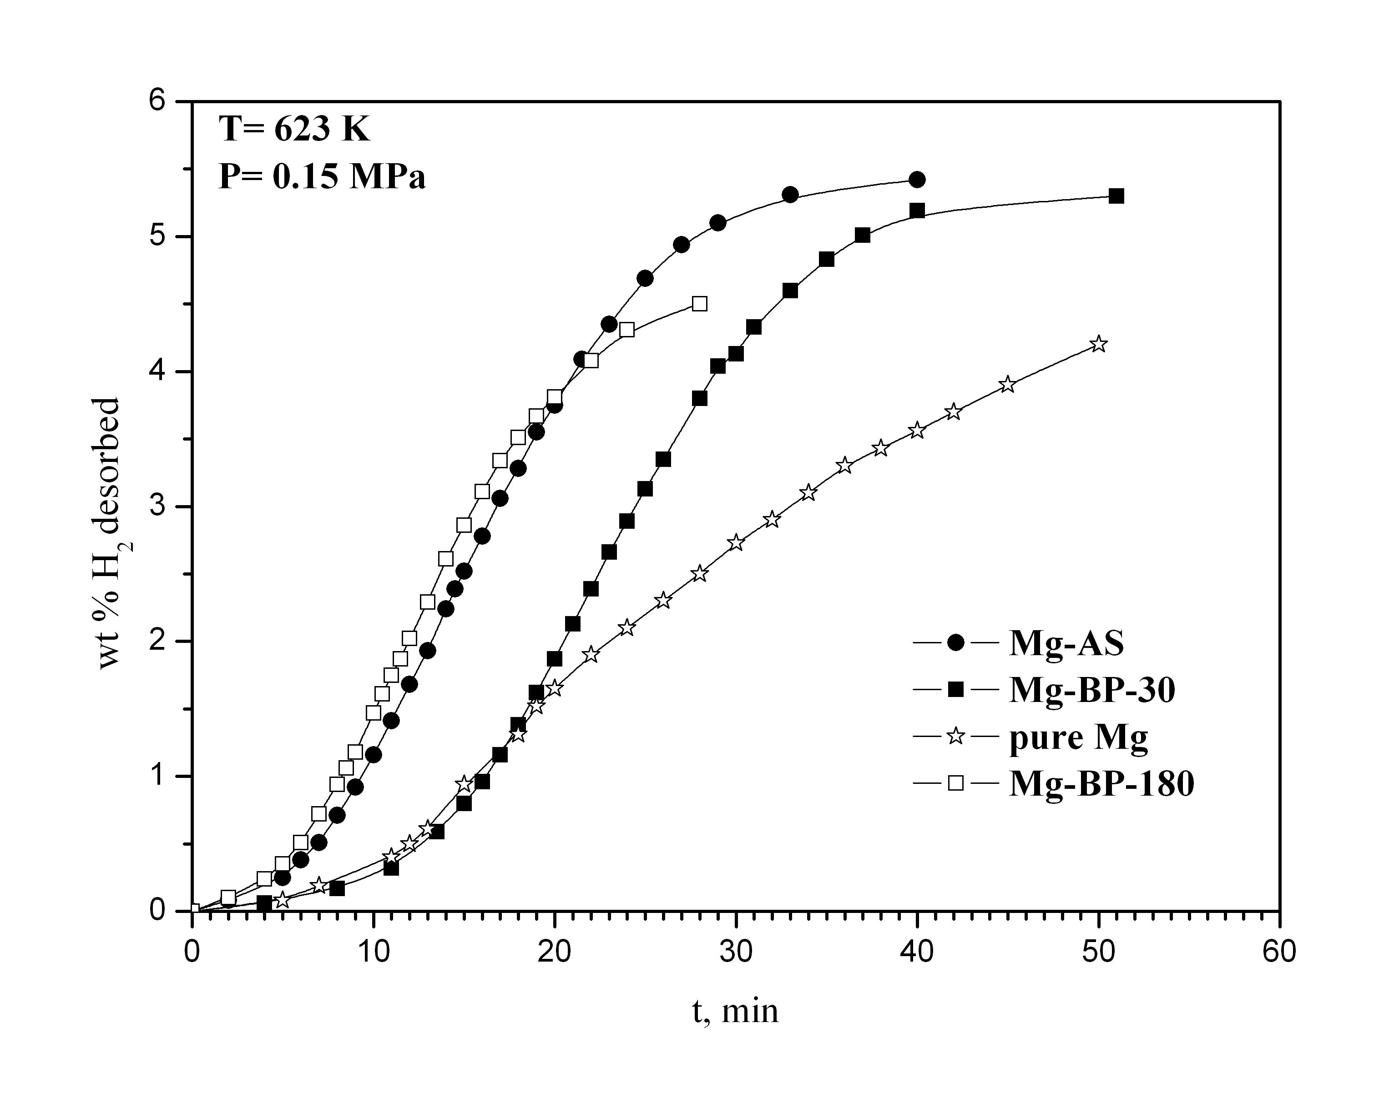 Fig. 6 Kinetic curves of dehydriding of the composites Mg-BP-30, Mg-BP-180, Mg-AS and pure magnesium.
Both the destruction of the MgO layer covering magnesium and the presence of more defects and active sites help and accelerate hydrogen dissociative chemisorption and nucleation. The
activated carbon derived from apricot stones has a more favourable effect on the hydriding kinetics of magnesium probably because of the more effective destruction of the MgO layer and the prevention of its restoration, hindering oxygen back diffusion (Fig.4).
It should be noted that the activated carbons were prepared from various precursors and they differed not only by specific surface area. It was shown in the literature that the electrochemical hydrogen storage is favoured in carbon materials with a well developed porosity and a low content of surface oxygen complexes [29]. The ash content was 22.8 % for activated carbon derived from bean pods and 2.0 % for activated carbon derived from apricot stones. The functional groups on the surface of the activated carbons have a strong effect on the adsorption properties. The surface of both activated carbons is of basic nature. The amount of acidic groups determined by Boehm’s method, was higher for AC derived from apricot stones than that for AC derived from bean pods [25- 28]. According to Su et al. [30], the adsorption capacity of activated carbon for non-polar molecules such as hydrogen, increased with the increase in the amount of surface acidic groups. Moreover, Gergova et al. [25] established that higher amount of chemical groups containing oxygen (or another heteroatom) on the surface of activated carbons derived from apricot stones and other agricultural by-products provided higher concentrations of active sites. The micropore volume of the activated carbon derived from apricot stones (AS) is higher than that of the activated carbon derived from bean pods (BP). AS has the highest microporosity and total pore volume. The relatively high microporosity of the carbon from apricot stones may be partly attributed to the higher cellulose content of this precursor. On the other hand, the activated carbon derived from bean pods is characterized by meso- and macroporous structure [27, 28].
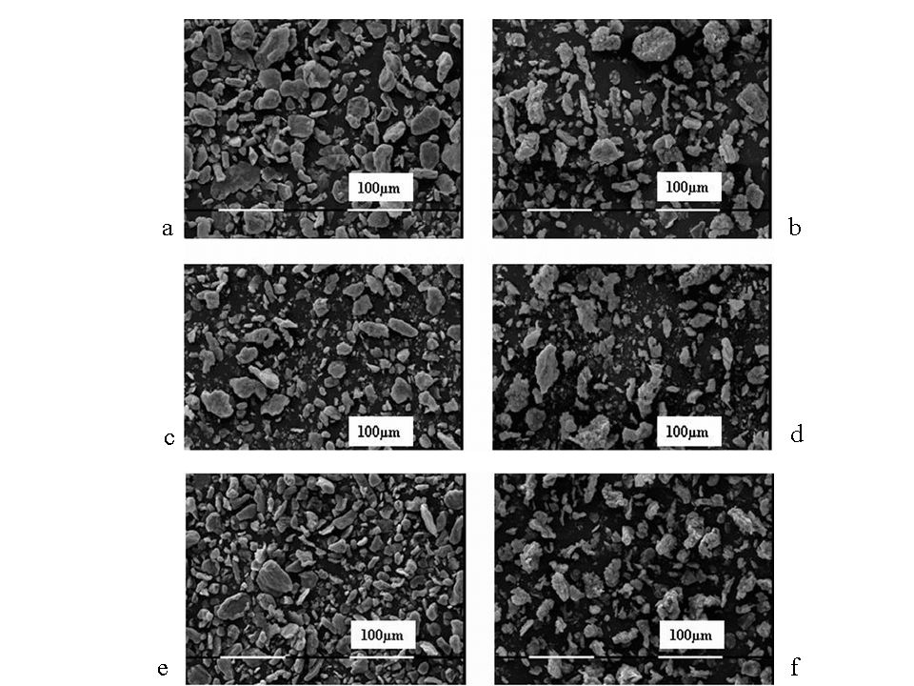
Fig. 7 SEM microphotographs of the composites: a) Mg-BP-30; b) Mg-BP-30 hydrided at 573K; c) Mg-BP-180; d) Mg-BP-180 hydrided at 573 K; e) Mg-AS after ball milling and f) Mg- AS hydrided at 573K
In Fig. 7 scanning electron microscopy images are presented for the composites after ball milling and hydriding. For all samples the size of the larger particles is from 20 to maximum 50 µm and for the smaller particles - a few µm. More small particles are visible in the sample ball milled 180 min with activated carbon derived from bean pods. After hydriding, the particles of the two samples with activated carbon derived from bean pods displayed similar size and shape. After hydriding of the composites, the surface was not so flat and some roughness and cracks are visible.
In Table 1 the particle size distribution of the ball milled composites is given. For all composites the median diameter d_{0.5} is almost the same. Only for the composite Mg-AC-180 a lower d_{0.1} value was registered. The span (d_{0.9}-d_{0.1}/d_{0.5}) for this sample slightly increases compared to the other composites ball milled for 30 min which have the same particle size distribution. These results are in good agreement with the scanning electron microscopy images showed in Fig. 6. The d_{0.9} value for all composites is about 50 µm. The increase in the duration of ball milling of Mg-BP lead to some
Sample | d_{0.1}  (µm) | d_{0.5} (µm) | d_{0.9} (µm) | span  d_{0.9}-d_{0.1}/d_{0.5}
Mg-BP-30 | 8.5 | 22.6 | 52.1 | 1.9
Mg-BP-180 | 5.1 | 20.9 | 53.8 | 2.3
Mg-AS | 8.6 | 22.6 | 49.9 | 1.8
Table 1. Particles size distribution, measured in water. The d_{0.1} and d_{0.9} is the maximal diameter of 10 and 90% of the particles. The d_{0.5} is the median diameter.
Mg-BP: 95wt% Mg-5 wt% activated carbon derived from bean pods, ball mill 30 min and 180 min; Mg-AS: 95wt% Mg-5 wt% activated carbon derived from apricot stones.
diminution of the particle size and probably to better reduction of the oxide layer on the surface. These facts could explain the easier activation during the hydriding process and the better hydrogen desorption properties of the sample ball milled for 180 min. Despite their close particle size values, the composites ball milled for 30 min displayed different hydrogen sorption properties. These observations confirmed the assumption that the carbon containing additives to magnesium not only acted as process controlling agents to diminish cold welding during ball milling, but their effect appears to be much more complex.
CONCLUSIONS
The role of new carbon based additives synthesized from agricultural by-products on the hydrogen sorption characteristics of magnesium was studied. The 95wt% Mg-5 wt% activated carbon derived from apricot stones reached the maximum value of hydrogen absorption capacity of 6.13 wt% at 573 K and 1 MPa after 60 min of hydriding. The composite containing activated carbon derived from apricot stones showed a more pronounced positive effect on the hydrogen sorption characteristics of magnesium. Ball milling for 180 min under argon for the composite Mg-BP-180 lead to easier activation, but after few cycles of hydriding/dehydriding, the absorption kinetics of the two samples ball milled for a longer or a shorter time did not show any difference.
The higher specific surface area of the activated carbon additive reflected favourably on the hydrogen sorption kinetics. Some other characteristics of activated carbons, such as surface chemistry and porosity, also affected these processes. It was established that the activated carbons derived from bean pods and apricot stones improved the hydrogen sorption kinetics of magnesium.
Acknowledgement: The financial support of Bulgarian Ministry of Science and Education, the National Science Fund of Bulgaria under contracts YS No02 -220/2008 and National Centre for New Materials UNION, No DCVP-02/2/2009 is highly appreciated.
References
- E. Yu. Ivanov, I. G. Konstanchuk, A. A. Stepanov and V. V. Boldyrev, Dokl. Akad. Nauk SSSR 286, 385 (1986).
- C.X. Shang, M. Bououdina, Y. Song, Z.X. Guo, Int. J. Hydrogen Energ. 29, 73 (2004).
- M. Khrussanova, M. Terzieva, P. Peshev, Int. J. Hydrogen Energ. 15, 799 (1990).
- Z. Dehouche, T. Klassen, W. Oelerich, J. Goyette, T.K. Bose, R. Schulz, J. Alloys Compd. 347, 319 (2002).
- J.-L. Bobet, F.J. Castro, B. Chevalier, Scr. Mater. 52, 33 (2005).
- F.J. Castro, J.-L. Bobet, J. Alloys Compd. 366, 303 (2004).
- G. Barkhordarian, T. Klassen, R. Bormann, Scr. Mater. 49, 213 (2003).
- M. Khrussanova, J.-L. Bobet, M. Terzieva, B. Chevalier, D. Radev, P. Peshev, B. Darriet, J. Alloys Compd. 307, 283 (2000).
- R. Vijay, R. Sundaresan, M. P. Maiya, S. Srinivasa Murthy, Y. Fu, H.-P. Klein and M. Groll, J. Alloys Compd. 384, 283 (2004).
- C. X. Shang, Z. X. Guo, J. Power Sources 129, 73 (2004).
- S. Bouaricha, J.-P. Dodelet, D. Guay, J. Huot, R. Schulz, J. Mater. Res. 16, 2893 (2001).
- J.-L. Bobet, E. Grigorova, M. Khrussanova, M. Khristov, P. Stefanov, P. Peshev, J. Alloys Compd. 366, 298 (2004).
- C. Iwakura, H. Inoue, S. G. Zhang, S. Nohara, J. Alloys Compd. 293-295, 653 (1999).
- S. Bouaricha, J. P. Dodelet, D. Guay, J. Huot, S. Boily, R. Schulz, J. Alloys Compd. 307, 226 (2000).
- S. S. Ruggeri, L. Roué, G. Liang, J. Huot, R. Schulz, J. Alloys Compd. 343, 170 (2002).
- F.X. Wang, X.P. Gao, Z.W. Lu, S.H. Ye, J.Q. Qu,F. Wu, H.T. Yuan, D.Y. Song , J. Alloys Compd. 370, 326 (2004).
- C.Z. Wu, P. Wang, X. Yao, C. Liu, D.M. Chen, G.Q. Lu, H.M. Cheng, J. Alloys Compd. 414, 259 (2006).
- Z.G. Huang, Z.P. Guo, A. Calka, D. Wexler, H. K. Liu, J. Alloys Compd. 427, 94 (2007).
- C. S. Goh, J. Wei, L. C. Lee, M. Gupta, Compos. Sci. Technol. 68, 1432 (2008).
- V. Fuster, G. Urretavizcaya, F.J. Castro, J. Alloys Compd. 481, 673 (2009).
- C. Milanese, A. Girella, S. Garroni, G. Bruni, V. Berbenni, P. Matteazzi, A. Marini, Int. J. Hydrogen Energ. 35, 9027 (2010).
- E. Grigorova, M. Khristov, M. Khrussanova, Cent. Eur. J. Chem. 8, 737 (2010) DOI: 10.2478/s11532-010-0040-0.
- Tony Spassov, Zlatina Zlatanova, Maya Spassova, Stanislava Todorova, Int. J. Hydrogen Energ. 35, 10396 (2010).

- M.A. Lillo-Ródenas, Z.X. Guo, K.F. Aguey-Zinsou, D. Cazorla-Amorós, Carbon 46, 126 (2008).
- K. Gergova, N. Petrov and S. Eser, Carbon 32, 693 (1994).
- B. Cabal, T. Budinova, C. O. Ania, B. Tsyntsarski, J. B. Parra, B. Petrova, J. Hazard. Mater. 161, 1150 (2009).
- B. Petrova, T. Budinova, B.Tsyntsarski, N. Petrov, G. Bardarska, C. Ania, J. Parra, Bulg. Chem. Commun. 42, 141 (2010).
- N. Petrov, T. Budinova, B. Tsyntsarski, B. Petrova, D. Teodosiev, N. Boncheva, Bulg. Chem. Commun. 42, 19 (2010).
- M.J. Bleda-Martinez, J.M. Pérez, A. Linares-Solano, E. Morallón, D. Cazorla-Amorós, Carbon 46, 1053 (2008).
- W. Su, Y. Zhou, L. Wei, Y. Sun, L. Zhou, New carbon mater. 22, 135 (2007).
- A. Nithya, S. Rajendran, Bulg. Chem. Commun., 42 119 (2010).

Влияние на добавката от активни въглени получени от селскостопански продукти върху свойствата на магнезий за съхранение на водород
Е. Григорова^{а}*, Цв. Манджукова^{а}, М. Христов^{а}, Петър Цветков^{а} и Бойко Цинцарски^{б}
^{а} Институт по обща и неорганична химия, Българска академия на науките,
ул. Акад. Г. Бончев, блок 11, София 1113
^{б} Институт по органична химия с център по фитохимия, Българска академия на науките, ул. Акад. Г. Бончев, блок 9, София 1113
Постъпила на 15 февруари, 2011 г. ; приета на 4 април, 2011 г.
(Резюме)
Изследвани са абсорбционно- десорбционните характеристики по отношение на водород на композитите 95 мас.% Mg- 5 мас.% активен въглен, синтезиран от кайсиеви костилки или бобени шушулки, получени чрез механоактивиране под аргон. Процесът на хидриране е извършен при температура 573 K и 473 K и налягане 1 MPa, а на дехидриране - при T = 623 K и P = 0.15 MPa. Достигнатите стойности на абсорбционния капацитет са 5.43 мас.% за композита, съдържащ активен въглен от бобови шушулки и 6.13 мас.% за композита, съдържащ активен въглен от кайсиеви костилки (при T = 573 K и P = 1 MPa). Характеристиките на хидриране/дехидриране на изследваните композити са сравнени с тези на чистия магнезий. Установено е, че активните въглени, получени от бобови шушулки и кайсиеви костилки, подобряват сорбционните характеристики на магнезия по отношение на водорода

