Bulgarian Chemical Communications, Volume 44, Number 4 (pp. 364 – 370) 2012
Dual membrane fuel cell – impedance approach for proof of concept
D. Vladikova^{1,}*, Z. Stoynov¹, G. Raikova¹, M. Krapchanska¹, A. Thorel², A. Chesnaud²
¹Institute of Electrochemistry and Energy Systems (IEES – BAS), 10 Acad. G. Bonchev, 1113 Sofia, Bulgaria
²Centre Matériaux, Mines-ParisTech BP87 Evry Cedex 91003, Franc
Received February 20, 2012, accepted February 20, 2012
The dual membrane fuel cell (DMFC) is an innovative SOFC architecture in which an oxygen compartment (cathode and oxide ion conducting electrolyte) is combined with a hydrogen compartment (anode and proton conducting electrolyte) through a porous mixed conducting central membrane (CM) where the two types of ions react and produce water which is evacuated through the pores. This concept is proved on a model cell via sets of investigations based on D.C. testing and Impedance Spectroscopy. For optimization of the three DMFC compartments (oxygen, hydrogen and CM) with regard to materials and technological conditions for the deposition of the functional layers, impedance studies were carried out on symmetrical half cells. Special attention was given to some new experiments elucidating the processes of water formation and propagation through the central membrane.
Key words: Dual membrane fuel cell, Impedance spectroscopy, Central membrane, LSCF48, BCY15, YDC15

Introduction
When compared to conventional PEM FC, solid oxide fuel cells (SOFC), including the proton conducting design (PCFC), offer several advantages, mainly concerning efficiently and multi-fuel operation. However, they also have some limitations that slow down their marketing. A weak point is the dilution of the reacting gases with the exhaust water at the anode side in SOFC and at the cathode side in PCFC and decrease of the electrodes catalytic activity. In order to overcome those limitations, innovative Dual Membrane Fuel Cell (DMFC) architecture was proposed [1] and is under development in an FP7 project [1–3]. The new concept combines the advantages and eliminates the disadvantages of both SOFC and PCFC. The main idea is the separation of the hydrogen and oxygen from the exhaust water. It is realized by the introduction of a junction layer between a SOFC electrolyte/cathode (cathode compartment) and a PCFC anode/electrolyte (anode compartment) with mixed (H⁺ and O^{2–}) conducting porous structure. Thus protons produced at the anode progress toward the junction central membrane (CM) where they meet the oxide ions that are created at the cathode and produce water which is evacuated through the pores of the membrane. Therefore hydrogen, oxygen and exhaust water are located in three independent chambers (Fig. 1).

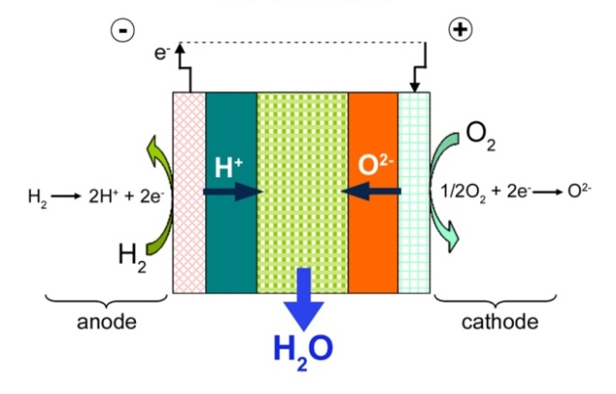
Fig. 1. Schematic representation of the dual membrane fuel cell concept.
The innovative concept (Fig. 1) avoids the gases dilution, the inhibition of the electrodes’ charge/mass transfer by the water, and the corrosion by the oxygenized water at high temperatures [2, 3].
In order to prove the new concept and to understand and evaluate the processes taking place, impedance studies of the cell and its compartments were carried out and presented in this work.
Experimental
© 2012 Bulgarian Academy of Sciences, Union of Chemists in Bulgaria
* To whom all correspondence should be sent:
E-mail: d.vladikova@bas.bg
For investigations of the dual membrane fuel cell and its three compartments, the following materials appropriate for operating temperatures 700–600ºC were selected: LSCF48 (La_{0.6}Sr_{0.4}Co_{0.2}Fe_{0.8}O_{3–δ}) as cathode, YDC15 (Ce_{0.85}Y_{0.15}O_{1.925}) as oxide ion conductor, BCY15 (BaCe_{0.85}Y_{0.15}O_{2–δ}) as proton conductor and BCY15-Ni cermet as anode. For elimination the influence of the electrodes quality on the electrolytes characterization, metal (Me = Pt, Ag) electrodes were also used. For electrochemical characterization of the selected materials and the technological procedures for the fabrication of the functional layers, impedance measurements were performed on 3 types of symmetrical half cells: electrolyte supported LSCF48/YDC15/LSCF48, electrolyte supported BCY15-Ni/BCY15/BCY15-Ni and central membrane supported Me/YDC15_{porous}BCY15_{porous}/Me with cell diameter about 2 cm and thickness about 1 mm. The measurements of the CM half cell were carried out in oxygen/air and in wet hydrogen, which ensured information about the conductivity of every component of the composite porous membrane. For the proof of the concept measurements at operating conditions were performed on a model button type cell (diameter / thickness = 20 / 1 mm) with Pt electrodes:
Pt/YDC15/ YDC15_{porous}BCY15_{porous}/BCY15/Pt.
From system theory point of view, SOFC are large statistical multivariable electrochemical systems with distributed parameters in macro- and micro-levels. Processes of charge and mass transfer are taking place, changing (at least partially) the behavior of the electrodes and that of the cell as an electrochemical system. Since a big number of external parameters (temperature, gases flows etc.) determine the intensity and the nature of the dominating processes, those parameters should be conditioned carefully. For improving the quality of the impedance data, a special furnace with D.C. galvanostatic current supply (100A, 15V) and a system for temperature regulation with two thermocouples was constructed. It ensures less noisy conditions for measurements in the range 20 – 900ºC with stability 0.2ºC and sensitivity 0.02ºC. The gases flows (air, N₂, Ar₂, O₂ and H₂ or mixtures of them) were regulated with flow-regulators ensuring stability exceeding 0.2 % in the full range of 140 NmL/min.
D. Vladikova et al.: Dual membrane fuel cell – impedance approach for proof of concept
The impedance measurements were carried out on Solartron 1260 FRA. The D.C. conditioning/loading was ensured by the internal galvanostat or by external 100 mA galvanostat. The total control of the experiments was performed by a home made threefold computerized system for measurement, monitoring and registration of the impedance data, temperature and load. The D.C. control system is monitoring directly the current I, the voltage U, the power P and P_{max} of the cell. For low impedance measurements inductance errors correction procedure, based on carefully collected calibration measurements, was applied [4–6]. For the most interesting experiments the method of the Differential Impedance Analysis [5–6], which improves the model assessment and the parameters estimation, was performed.
The big volume of impedance data (more than 3000 records of experimental impedance diagrams together with their temperature profiles) was stored in Data Bank applying Large Structured Files (LSF) [6] as data exchange formats.
The impedance measurements were performed in a very large frequency range - from 10 MHz down to 1 mHz. Thus a big variety of phenomena (with very different time-constants) could be monitored, distinguished and evaluated: ionic conductivity, fast electrochemical kinetics, interface behaviour, diffusion and other types of transport limitations, accumulation of species, formation and growth of new (water-based) phase. The combination of impedance with mirco-structural analyses (Scanning Transmission Electron Microscopy - High Angle Annular Dark Field (STEM-HAADF) and X-ray diffraction) ensured the necessary completeness of the experimental information and its interpretation.
Results and Discussion
Cathode compartment studies
The performance of the impedance measurements on symmetrical half cells LSCF48/YDC15/LSCF48 in temperature range 100–700ºC combined with the procedures for cell rig errors correction and DIA ensured evaluation of both the electrolyte resistance with its two components coming from the bulk and from the grain boundaries (Fig. 2a, c) and the polarization resistance (Fig. 2b, d) [3].
Due to the application of DIA, the charge transfer was separated from the dominating transport limitation of the charged species in the bulk of the electrode, identified as Bounded Constant Phase Element (BCP) [5–7] (Fig. 2b, d). It was strongly reduced by replacement of the pure LSCF with a composite LSCF/YDC15 (Fig. 3).
Anode compartment studies
For characterization of the anode compartment impedance measurements of symmetrical half cell BCY15-Ni/BCY15/BCY15-Ni (starting powders ratio: 71,4 vol.% NiO; 28,6 vol.% BCY15) were

Fig. 2. Impedance measurements of symmetrical LSCF/YDC/LSCF half cell at different temperatures: (a), (b) - complex plane impedance diagrams; (c) - Arrhenius plots of the electrolyte: (▲) bulk; (●) grain boundaries; (■) total;
d) - Arrhenius plots of the electrode reaction: (▼) transport; (●) charge transfer.

Fig. 3. Arrhenius plots of the polarization resistance for: (■) LSCF electrode; (●) composite LSCF/YDC15 electrode.
performed, preceded by measurements of Pt/BCY15/Pt for optimization of the electrolyte support sintering conditions [8]. The obtained results show that the anode microstructure is an important optimization parameter. At lower sintering temperatures (1100ºC), which ensure sufficient porosity of the anode, both the electrolyte resistance and the polarization resistance are much higher than the parameters measured on half cell with Pt electrodes (Fig. 4). Since the electrolyte support is the same, the deterioration of the half cell performance should be related to the cermet anode. The increase of the sintering temperature above 1350ºC brings to significant improvement of the anode compartment electrochemical behaviour Fig. 4. Measurements of symmetrical half cell BCY15-Ni/BCY15/BCY15-Ni: (a) Arrhenius plots for the electrolyte resistivity, (b) Arrhenius plots for the anode polarization; Sample 1 (▲) - cermet sintered at 1100ºC; Sample 2 (■) - cermet sintered at 1350ºC; comparative measurements of Pt/BCY15/Pt (•). The electrolyte support for both samples is sintered at 1450ºC.
D. Vladikova et al.: Dual membrane fuel cell – impedance approach for proof of concept

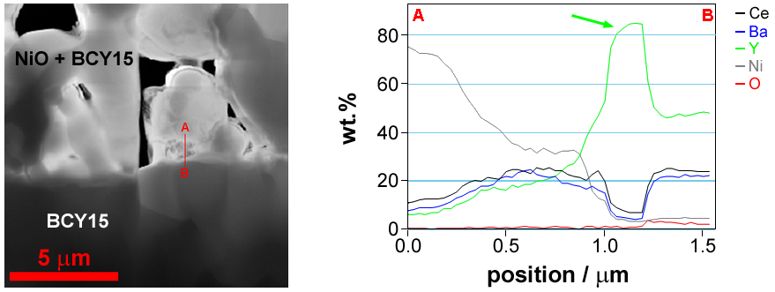
Fig. 5. STEM-HAADF image of anode/electrolyte interface (A-B) and linear composition profile (in wt. %) across this interface.
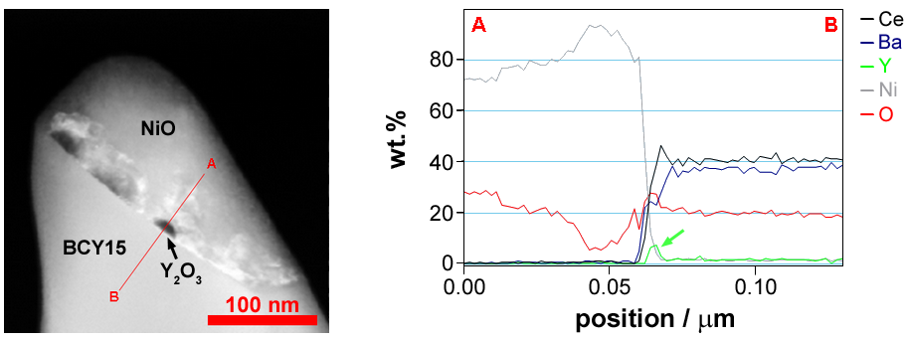

Fig. 6. STEM-HAADF image of BCY15/NiO interface (A-B) and linear composition profile (in wt. %) across this interface

(Fig. 4). STEM-HAADF analysis of the samples sintered at lower temperatures registered precipitation of Y₂O₃ on both electrolyte/electrode (Fig. 5) and BCY/NiO (Fig. 6) interfaces, which can be regarded as an efficient electrical barrier.
At higher sintering temperatures of the anode the system is stabilized towards segregation of Y₂O₃. However, XRD analysis registers small quantity of a new cerium yttrium oxide phase (Ce₂Y₂O₇). Although its influence on the electrochemical behaviour of the anode is not so strong (Fig. 4), the deposition of pure BCY/Ni cermet needs further optimization of the volume ratio BCY15/NiO and the sintering temperature. Recent studies showed that the decrease of the NiO content (starting powders ratio: 67,1 vol.% NiO; 32,9 vol.% BCY15) combined with sintering at 1100ºC ensures cermet anodes with 40 vol% open porosity. XRD analysis confirms lack of parasitic phases before and after the NiO reduction [9]. Electrochemical testing is in progress.
D. Vladikova et al.: Dual membrane fuel cell – impedance approach for proof of concept
It was supposed that BCY, which in principle has oxygen vacancies for initialization of the proton conductivity [4], could have also oxygen conductivity. For this purpose measurements of Me/BCY15/Me half cell in oxygen atmosphere were performed. They confirmed the presence of good oxide ion conductivity (Fig. 7). This phenomenon should be studied systematically, since it is important for the central membrane design, as well as for the development of a “monolithic” DMFC design, based on the replacement of YDC15 with BCY15. The first experiments on monolithic design are very promising [8].
Dual membrane fuel cell performance studies
The impedance measurements of half cells Me/YDC15_{porous}BCY15_{porous}/Me with CM support in both oxygen and hydrogen atmospheres provided important information about the individual conductivity of each one of the two electrolytes in the real ceramic structure. As it could be expected, the porosity increased the resistivity of both electrolytes. Those experiments, however, can not give information about the water vapour formation and transport in the CM, which is an important factor in the optimization of the cell performance. For this purpose impedance measurements during operation of a model dual membrane fuel cell were
performed in especially selected working points and frequency range, which ensured observability of the studied phenomena. The processes related to the water formation and transport should be measured at low frequencies. The impedance notification of water formation and growth could be a combination of capacitive and inductive loops corresponding respectively to the formation and to the spontaneous growth of the new phase. For registration of the second process impedance measurement was performed on dried central membrane after OCV under small current. Those conditions ensure enough “impedance time” for registration of the inductive loop, which disappears after longer exploitation (Fig. 8a, b) when the CM is watered and the clusters form a layer of polarized semiliquid film (the BCY pore walls are

Fig. 7. Arrhenius plots for the electrolyte resistivity of symmetrical half cell Pt/BCY15/Pt measured in wet hydrogen and in oxygen.

D. Vladikova et al.: Dual membrane fuel cell – impedance approach for proof of concept

Fig. 8. Complex plane impedance diagrams of monolithic cell Pt/BCY15/BCY15 _{porous}/BCY15/Pt measured at 700ºC: a) small load after OCV (AC = 0.5 mA, DC = 2 mA), frequency range 1 MHz - 0,1 Hz; b) small load (AC = 0.5 mA, DC = 2 mA) and long time of operation, frequency range 1 MHz - 0,1 Hz; c) bigger load (AC = 0.5 mA, DC = 16 mA), frequency range 1 MHz - 0,1 Hz; d) same load as in c), frequency range 1 MHz - 1 mHz.

hydrophilic). This new phenomenon is described in more details in [10]. For observation of the slowest phenomenon - water permeability in the CM, the frequency range was additionally extended in the low frequency range down to 1 mHz, where a new capacitive semi-circle with diameter increasing with the time was registered (Fig. 8c, d). It can be related to the continuous formation of water which fills the volume of the pores and penetrates towards the periphery of the CM where it can be evacuated.
It should be noted that the contribution of the water formation and evacuation from the CM in the total resistance of the cell is much smaller than that of the electrolytes, including the CM. Thus the decrease of their thickness is of big importance. Since a chemical reaction is taking place in the central membrane, the principle of Le Chatelier could be applied for improving water evacuation and cell performance.
Conclusions
The impedance investigations carried out confirmed the dual membrane fuel cell concept. It was shown that the oxygen ions and the protons, produced at the electrodes move toward the central membrane where they produce water.
The impedance measurements performed on half cells ensured detailed characterization of the cell components – electrolytes (including granular and inter-granular conductivity), electrodes (charge transfer and gas transport), central membrane (mixed conductivity, porosity and presence of water). Mixed (oxide ion and proton) conductivity was registered in the proton conducting electrolyte BCY15. The first steps towards the application of this phenomenon for optimization of the DMFC are in progress. Activation of the cells during operation was also observed, which may be related to the new phenomenon registered and studied for a first time - formation of adsorbed film of water in porous ceramic media at high temperatures. It could be related to a super-critical state of the water supported by strong hemisorption. For further investigations of this phenomenon permittivity and permeability measurements are in progress.
Acknowledgements: The research leading to these results has received funding from the European Community’s Seventh Framework Programme (FP7/2007–2013) under grant agreement No 213389. Powders were fabricated and supplied by Marion Technologies.
References:
- Patent No 0550696000, March 7ht, 2005: CELLULE DE PILE A COMBUSTIBLE HAUTE TEMPERATURE A CONDUCTION MIXTE ANIONIQUE ET PROTONIQUE, International extension in 2006.
- A. Thorel, A. Chesnaud, M. Viviani, A. Barbucci, S. Presto, P. Piccardo, Z. Ilhan, D. Vladikova and Z. Stoynov, in Solid Oxide Fuel Cells 11 (SOFCXI), edited by S.C. Singhal, and H. Yokokawa, The Electrochemical Society Proceedings Series 25, ECS Transactions, Pennington, NJ, p. 753 (2009).
D. Vladikova et al.: Dual membrane fuel cell – impedance approach for proof of concept
- D. Vladikova, Z. Stoynov, G. Raikova, A. Thorel, A. Chesnaud, J. Abreu, M. Viviani, A. Barbucci, S. Presto and P. Carpanese, Electrochim. Acta 56, 7955, (2011).
- D. Vladikova, Z. Stoynov, G. Raikova, in Z. Stoynov, D. Vladikova (Eds.), Portable and Emergency Energy Sources, Marin Drinov Academic Publishing House, Sofia, p. 383, (2006).
- Z. Stoynov and D. Vladikova, in Encyclopedia of Electrochemical Power Sources, edited by U. Garche, Elsevier, p.632, (2009).
- Z. Stoynov, D. Vladkova, Differential Impedance Analysis, Marin Drinov Academic Publishig House, Sofia, 2005.
- A. Barbucci, M. Viviani, P. Carpanese, D. Vladikova, Z. Stoynov, Electrochim Acta 51, 1641, (2006).
- M. Viviani, S. Presto, A. Barbucci, M. Carpanese, R. Amendola, A. Thorel, A. Chesnaud, J. Abreu, R. Costa, Z. Ilhan, S. Ansar, D. Vladikova, Z. Stoynov, 2011 MRS Spring Meeting Symposium J: Proton in Solids, April 25–29, 2011, San Francisco, CA, USA.
- A. Chesnaud, A. Thorel, J. Valy, D. Vladikova, Z. Stoynov, G. Raikova, in D. Vladikova, Z. Stoynov (Eds.), Proc. Internat. Workshop “Advances and Innovations in SOFCs 2”, 11-16 September, 2011, Katarino, Bulgaria, p. 45.
- S. Presto, A. Barbucci, M. Viviani, Z.Ilhan, S. Ansar, D. Soysal, A. Thorel, J. Abreu, A. Chesnaud, T. Politova, K. Przybylski, J. Prazuch, Z. Zhao, D. Vladikova, Z. Stoynov, in Solid Oxide Fuel Cells 11 (SOFCXI), edited by S.C. Singhal, and H. Yokokawa, The Electrochemical Society Proceedings Series 25, ECS Transactions, Pennington, NJ, p.773, (2009).

Двойно-мембранна горивна клетка - импедансен подход за доказване на концепцията
D. Vladikova et al.: Dual membrane fuel cell – impedance approach for proof of concept
Д. Владикова^{1*}, З. Стойнов¹, Г. Райкова¹, М. Кръпчанска¹, А. Торел², А. Чесно²

¹Институт по електрохимия и енергийни системи „Акад. Е. Будевски”, Българска академия на науките, ул. „Акад. Г. Бончев” бл. 10, 1113 София, България
² Център по материалознание, Мини-ПариТех, BP 87, 91 003 Еври, Франция
Постъпила на 20 февруари, 2012 г.; приета на 20 февруари, 2011 г.
(Резюме)
Двойно-мембранната горивна клетка (ДМГК) е нов иновативен дизайн на високо-температурна горивна клетка, в която кислородна секция (катод и йон-проводящ електролит) е свързана с водородна секция (анод и протон-проводящ електролит) посредством пореста централна мембрана (ЦМ) със смесена проводимост, където двата типа йони реагират. Получената вода се отделя през порите на мембраната. Концепцията е доказана на моделна клетка с помощта на техники, базирани на D.C. измервания и импедансна спектроскопия. С цел оптимизиране на трите компонента на ДМГК (кислороден, водороден и ЦМ) по отношение на материалите и технологичните условия за отлагането им, са проведени импеднансни измервания на симетрични полуклетки. Специално внимание е отделено на някои нови методи за изясняване процеса на образуване и отделяне на водата в централната мембрана

