Bulgarian Chemical Communications, Volume 44, Number 4 (pp. 395 – 398) 2012
Electrochemical analysis of solid oxide electrolytes for intermediate temperature fuel cell
A.M. Ionascu ^{1*}, G. Raikova ², E. Mladenova ², I. Mercioniu³
¹ University Politehnica of Bucharest, Department of Electrical Engineering, 313 Splaiul Independentei Str., Bucharest, Romania
²Institute of Electrochemistry and Energy Sources, Bulgarian Academy of Sciences, Acad. G. Bonchev Str., bl.10,1113 Sofia, Bulgaria
3 National Institute of Materials Physics, 105 bis Atomistilor Str., Magurele, Bucharest, Romania
Received February 20, 2012, revised October 29, 2012
In this paper the electrochemical analysis of new materials, designed to be used as solid electrolytes for intermediate temperature fuel cells (IT-SOFC) was made. The materials are two different composites based on ceria 10YDC + (10%) 150ppm YA and 10ScDC + (10%) 150ppm YA, obtained by sol-gel method and sintered at temperature of 1500 ⁰C. The electrochemical investigation was performed by Electrochemical Impedance Spectroscopy technique. According of these analyses the composite 10YDC + (10%) 150ppm YA presents better conductivity than 10ScDC + (10%) 150ppm YA. These results were related with morphological investigation, realized by SEM.
Keywords: Electrochemical Impedance Spectroscopy, SEM, Y₂O₃, CeO₂, α–Al₂O₃, Sc₂O₃, solid electrolyte, intermediate temperature fuel cells.

INTRODUCTION
In recent years new technologies for production of cheaper and cleaner energy were developed. Among them are also the intermediate temperature fuel cells (IT-SOFC). These cells are constructed of two electrodes (anode and cathode) and solid electrolyte and they operate in the temperature range (600 – 650 ºC) [1].
The problems which designers face regarding these cells are due to the choice of electrolyte, because the electrodes design and the materials used in their production depend on the electrolyte [2]. The electrolyte of these cells must to have the average grain diameter less than 1 µm, absence of porosity, electrical and ionic conductivity as large as possible at the operating cell temperature [1]. Among the electrolytes used for IT-SOFC, the most studied are those based on ceria (CeO₂). They are doped with yttrium trioxide (Y₂O₃), scandium trioxide (Sc₂O₃), Y₂O₃ + Sc₂O₃, gadolinium (Gd), samaria (Sm), etc. [2].
Yttria doped ceria (YDC) with a cubic structure, containing 10 mol % Yttria, is an attractive ceramic used as electrolyte or matrix for electrolyte in IT-SOFC [3]. For obtain a better structure in correlation with good material properties, the introduction of a second phase with good electro-mechanical properties will be beneficiary. Given the properties of low Yttrium doped α-Al₂O₃, mechanical properties, chemical inertness and resistance, high temperature corrosion resistance, good conductivity, high thermal conductivity, in these paper two new electrolytes for IT-SOFC are proposed.
* To whom all correspondence should be sent:
E-mail: amionascu@elmat.pub.ro
© 2012 Bulgarian Academy of Sciences, Union of Chemists in Bulgaria
This paper presents a study of the conductivity of two new ceramic composites, based on the combination between the doped ceria and low doped alumina, [(90 %) 10 Y₂O₃: CeO₂ + (10 %) (150 ppm) Y₂O₃: α – Al₂O₃] and [(90 %) 10 Sc₂O₃: CeO₂ + (10 %) (150 ppm) Y₂O₃: α – Al₂O₃], both used as solid electrolyte for IT-SOFC.
Since the electrochemical impedance spectroscopy became a very useful and perspective method for investigating the performance of electrolyte materials, the investigations are based on impedance measurements.
The final results are correlated with morphological investigation realized by scanning electron microscopy (SEM).

EXPERIMENTS
Materials
Two types of ceramic composite samples based on ceria, denoted by A and B, were used for electrochemical investigation.
The sample A is composed of (10 mol %) Y₂O₃ doped CeO₂ (denoted 10 YDC) and (10 %) (150 ppm) Y₂O₃ doped α – Al₂O₃ (denoted 150 ppm YA).
The sample B is composed of (10 mol %) Sc₂O₃ doped CeO₂ (denoted 10 ScDC) and (10 %) (150 ppm) Y₂O₃ doped α – Al₂O₃ (denoted 150 ppm YA).
A.M. Ionascu et al.: Electrochemical analysis of solid oxide electrolytes for intermediate temperature fuel cell
Both samples were made by mechanical mixing of two nanopowders, 10 YDC (90 %) and 150 ppm YA (10 %) respectively 10 ScDC (90 %) and 150 ppm YA (10 %), synthesized by sol-gel method. The mixtures (for both samples A and B) were homogenized mechanically, compacted at 3000 kgf and sintered at 1500 ºC for 2 h [4].
The samples present a disk shapes with a diameter of 10 mm and a thickness of 1.2 mm (Fig. 1a).

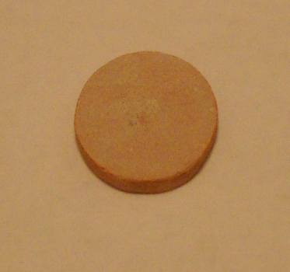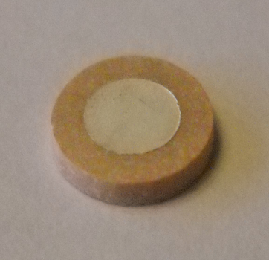
- b.
Fig. 1. Samples used for electrochemical investigation: (a) sample before the deposition of the electrodes; (b) sample with silver electrodes.

For electrochemical measurements symmetrical electrolyte supported half cells with Ag electrodes were performed (Fig. 1b). The silver paste for electrodes deposition was painted on both sides of the samples.
Equipments
The impedance measurements were performed with Solartron 1260 Frequency Response Analyser in a temperature interval of 200 – 700ºC at frequency range from 10 MHz down to 0.1 Hz and density of 5 points/decade. For lower temperatures, where the sample resistance is in the MΩ-range, the studies were carried at amplitude 200 mV, which was reduced to 50 mV above 400ºC.
Morphological characterization (grain shape, average grain diameter) of the samples were performed by scanning electron microscopy (SEM). To obtain the SEM images, a scanning electron microscope type TESCAN LYRA 3 XMU was used.
RESULTS AND DISCUSSION
The characterization of the electrolytes behavior was made with Voigt’s model structure containing two time constants, i.e. two meshes with R and C in parallel connection which correspond to the bulk and grain boundary behavior (Fig. 2) [5-8]. Impedance diagrams of samples A and B are shown in Figure 3.
Fig. 2. Equivalent circuit of a two time constant Voigt’s model structure.

Fig. 3. Complex plane impedance diagrams of samples A and B at 500 ⁰C temperature.

For the both samples the resistivity is dominated by the grain boundaries. The big arc in the impedance diagrams is an indication for the formation of non-clean grain boundaries. A possible explanation of these results could be due to the presence of two different phases in the electrolytes with different microstructures (different grains, average diameter, orientation, porosity etc), which determine their higher resistivity.
The resistance values obtained from the impedance measurements for different temperatures were used for the construction of the Arrhenius plots (Fig. 4):

ρ=A / T exp (–E_{a} /kT) | (1)

where ρ is the resistivity, A is the pre-exponential term, k is the Boltzmann constant, E_{a} is the activation energy and T is the temperature in K. The Arrhenius plots for both samples A and B are linear (Fig. 4) and their slopes give the corresponding activation energies Ea (Table 1).
Fig. 4. Arrhenius plots for samples A and B.

Table 1. The conductivities and activation energies of samples A and B.
 | σ [S/cm] |  | E_{a} [eV]
 | 600 ⁰C | 700 ⁰C
Sample A | 1.41∙10⁻³ | 3.16∙10⁻³ | 1.09
Sample B | 1.52∙10⁻⁴ | 6.35∙10⁻³ | 1.48

A significant difference in the conductivity related to the different dopants is observed. The sample A has lower resistivity and higher conductivity than sample B. On the other hand the values of resistivity decrease with temperature. This is due to the intensification of diffusion of ions which participate in conduction process. However at working temperature of IT-SOFC fuel cells, the difference between the values of conductivity is 13%. From this point of view the sample A present a good value of conductivity (1.41∙10^{–3} S/cm) at 600 ºC in comparison with the sample B. The values of activation energy and conductivity at 600 ºC and 700 ºC temperatures are tabulated in table 1.
These results are in concordance with the morphological investigation realized by SEM (Figs. 5, 6).

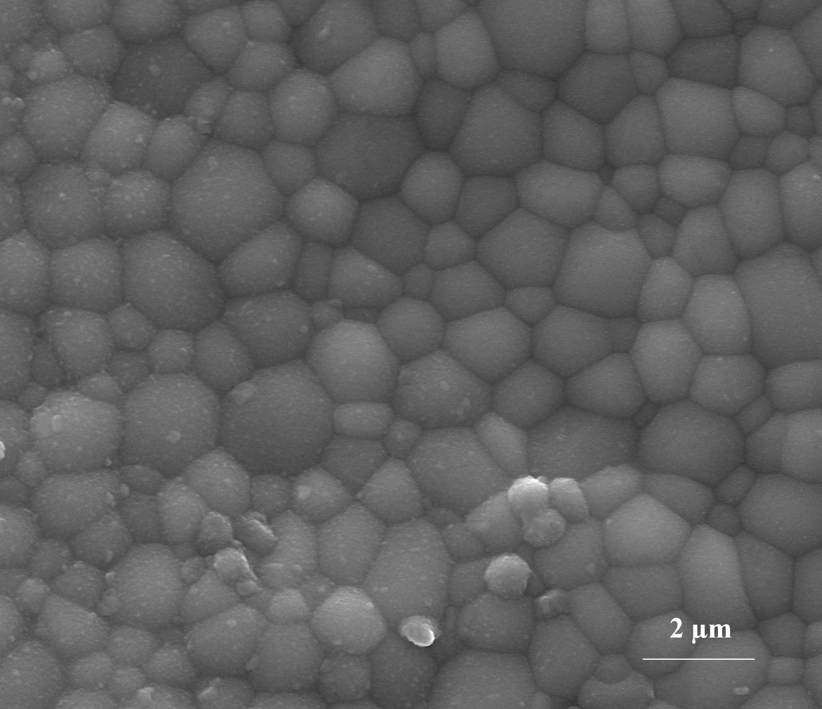
Fig. 5. Scanning electron microscopy for sample A.
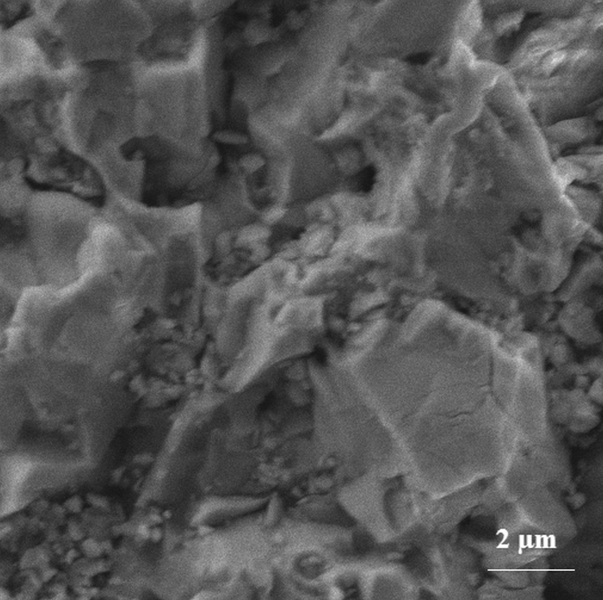
Fig. 6. Scanning electron microscopy for sample B.
For sample A, the 10YDC area contains the spherical grains with the average value of grains diameter 1.18 µm and 3.18 µm for 150 ppm YA area, while for sample B, 10 ScDC area has polyhedral grains with the average grains diameter 1.57 µm and 2.32 µm for 150 ppm YA area.
This investigations show that the microstructure of sample A is much better (small grains, more compact areas, is not so porous) than that of sample B. These results are in concordance with the electrochemical behavior.
The electrochemical behavior of these new electrolytes can be optimized further by using the strong influence of the small variation of doped alumina.
CONCLUSIONS
The results obtained from the electrochemical analysis of the new electrolytes for IT-SOFC, show that, the electrolyte A has a better values (lower resistivity and higher conductivity, σ = 1.41∙10⁻³ S/cm at 600 ⁰C) than electrolyte B. At working temperatures of IT-SOFC fuel cell the registered difference is about 13% between the values of the conductivity. The electrochemical results are in concordance with the morphological investigation.
A.M. Ionascu et al.: Electrochemical analysis of solid oxide electrolytes for intermediate temperature fuel cell
Therefore the electrolyte A will be used for future studies. To be used as a solid electrolyte for IT-SOFC, this material requires investigation from point of view of mechanical properties.
Acknowledgment: The authors would like to thank Prof. Daria Vladikova and Prof. Zdravko Stoynov for assistance and support for the impedance measurements and Dr. Nicoleta Popescu – Pogrion for useful advices.
A.M. Ionascu acknowledges also the Sectoral Operational Programme Human Resources Development 2007-2013 of the Romanian Ministry of Labour, Family and Social Protection through the Financial Agreement POSDRU/88/1.5/S/60203, who funded her work.
REFERENCES
- G. Pasciak, K. Prociow,W. Mielkarek, B. Gornicka, B. Mazurek, Solid electrolytes for gas sensors and fuel cells applications, Journal of the European Ceramic Society 21, 1867, (2001).
- H.He, Y. Huang, J. Regal, M. Boaro, G. M. Vohs, R. J. Gorte, Low temperature fabrication of oxide composites for solid-oxide fuel cells, J. Am. Ceram. Soc. 87, 331, (2004).
- M. Dudek, J.Molenda, Ceria-ytria-based solid electrolytes intermediate temperature solid oxide fuel cell, Materials Science-Poland 24, 45, (2006).
- A. M. Vlaicu, I. Mercioniu, B. S. Vasile, C. C. Negrila, C. Logofatu, N. C. Cretu, P. Nita, N. Popescu-Pogrion, Structural and chemical properties of cerium-magnetoplumbite in cerium based IT-SOFC compounds, Optoelectronics and Advanced Materials-Rapid Communications 5, 143, (2011).
- Z. Stoynov and D. Vladikova, in: Impedance Spectroscopy of Electrochemical Power Sources, Encyclopedia of Electrochemical Power Sources, edited by U. Garche, Elsevier, 2009, pp.632-642.
- Z. Stoynov, D. Vladkova, Differential Impedance Analysis, Marin Drinov Academic Publishig House, Sofia, (2005).
- D. Vladikova, Z. Stoynov, G. Raikova, A. Thorel, A. Chesnaud, J. Abreu, M. Viviani, A. Barbucci, S. Presto and P. Carpanese, Impedance Spectroscopy Studies of Dual Membrane Fuel Cell, Electrochim. Acta 56, 7955, (2011).
- G. Raikova, D. Vladikova, Z. Stoynov, Differential impedance analysis of the cathode compartment in dual membrane fuel cell, Bulgarian Chemical Communications 43, 134, (2011).

Електрохимичeн анализ на твърдo-оксидни електролитни материали за горивни клетки, функциониращи при средни температури
A.M. Йонашку¹, Г. Райкова², E. Младенова², И. Меркьониу³
¹Политехнически Университет Букорещ, Департамент по електро-инженерство, ул. Сплаиул индепенденей 313, Букорещ, Румъния
²Институт по електрохимия и енергийни системи-Българска академия на науките, ул. Акад. Г. Бончев, бл.10, София, България
³ Национален институт по физика на материалите, ул. Атомистилор 105, Магуреле, Букорещ, Румъния
Постъпила на 20 февруари 2012 г., преработена на 29 октомври 2012 г.
(Резюме)
Настоящата статия представя резултати от електрохимичното изследване на нови материали, предназначени да бъдат използвани като твърди електролити за горивни клетки, функциониращи при средни температури (IT-SOFC). Електролитите са съставени от два различни композитни материала, базирани на серий 10YDC + (10%) 150ppm YA и 10ScDC + (10%) 150ppm YA, получени чрез зол-гел метода и синтезирани при температура 1500^{о}C. Материалите са анализирани с техниката на Електрохимичната импедансна спектроскопия. Според анализа композитът 10YDC + (10%) 150ppm YA показва по-добра проводимост от 10ScDC + (10%) 150ppm YA. Тези резултати са свързани с данните от морфологичният им анализ, реализиран чрез СЕМ изследване на материалите.

