Bulgarian Chemical Communications, Volume 45, Number 3 (310 – 313) 2013
Permutation symmetry of fullerene isomers of C82
Morteza Yavari
Department of Physics, Islamic Azad University, Kashan Branch, Kashan, Iran
Received March 13, 2012; Revised September 30, 2012
A fullerene is a cubic planar graph, all faces of which consist of 5- or 6- cycles. The symmetry of these molecules is important with a view to counting their isomers. In this article the permutation symmetry group of the isomers of a C₈₂ fullerene is calculated.
Keywords: Fullerene, C₈₂, symmetry, isomers.

Introduction
A fullerene is any molecule composed entirely of carbon, in the form of a hollow sphere, ellipsoid, or tube. Since their discovery in 1985 by Kroto et al., the fullerenes have been the objects of interest of scientists all over the world [1,2]. Symmetry of these macromolecules is important in spectroscopy and also in some part of nanoscience.
The molecular symmetry group is first defined by Longuet-Higgins [3]. Although there have been earlier works that suggested the need for such a framework. Bunker and Papoušek [4] extended the definition of the molecular symmetry group to linear molecules using extended molecular symmetry.
A graph is a collection of vertices and a collection of edges that connect pairs of vertices. It may be undirected, meaning that there is no distinction between the two vertices associated with each edge. Graphs are one of the prime objects of study in Discrete Mathematics. Refer to Glossary of graph theory for basic definitions in graph theory.
The symmetry of a graph means the automorphism group symmetry and it does not need to be isomorphic to the molecular point group symmetry. However, it does represent the maximal symmetry which the geometrical realization of a given topological structure may possess.
By symmetry we mean the automorphism group symmetry of a graph. Randic [5,6] showed that a graph can be depicted in different ways, such that its point group symmetry or three-dimensional (3D) perception may differ, but the underlying connectivity symmetry is still the same, as characterized by the automorphism group of the graph.
* To whom all correspondence should be sent:
E-mail: yavari@iaukashan.ac.ir
Balasubramanian [7-9] in some leading papers considered the Euclidean matrix of a chemical graph to find its symmetry. He proved that for computing the symmetry of a molecule, it is sufficient to solve the matrix equation
P^{t}EP = E,
where E is the Euclidean matrix of the molecule under consideration and P varies on the set of all permutation matrices with the same dimension as E. He computed the Euclidean graphs and automorphism group for benzene, eclipsed and staggered forms of ethane and eclipsed and staggered forms of ferrocene.
Ashrafi and his co-workers [10-20] in a series of papers applied a computational method for computing symmetry of fullerenes. We continue the mentioned method to compute the permutation symmetry of the isomers of C₈₂ fullerenes. Our calculations were done by computer algebra system GAP [21]. Here, GAP stands for Groups, Algorithms and Programming. The name was chosen to reflect the aim of the system, which is a group theoretical software for solving computational problems in computational group theory. This software was constructed by the GAP team in Aachen.
2. Results and Discussion
In this section, we first describe a notation which will be kept throughout. Suppose X is a set. The set of all permutations on X, denoted by S_{X}, is a group which is called the symmetric group on X. In the case that X = {1, 2,…, n}, we denote S_{X} by S_{n} or Sym(n). Also, for a group G

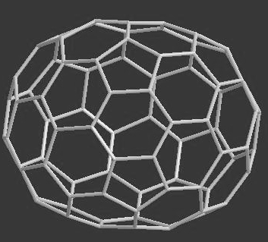 | 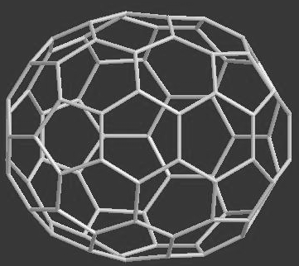 | 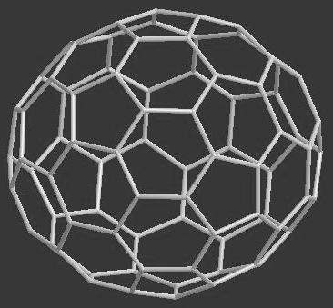
C₈₂ No 1. | C₈₂ No 2. | C₈₂ No 3.
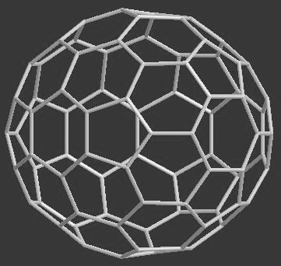 | 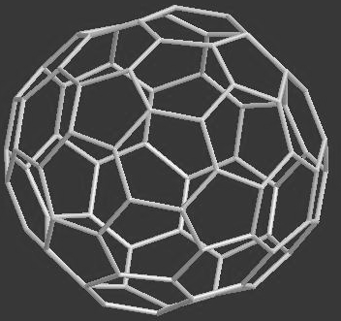 | 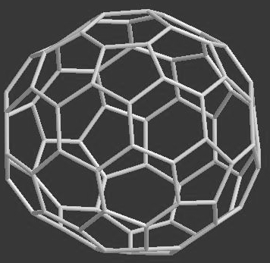
C₈₂ No 4. | C₈₂ No 5. | C₈₂ No 6.
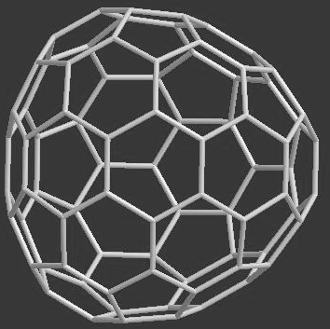 | 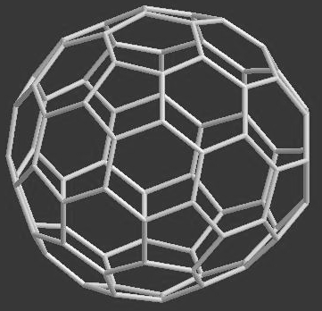 | 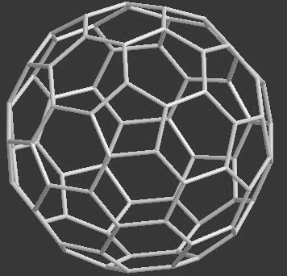
C₈₂ No 7. | C₈₂ No 8. | C₈₂ No 9.
Figure 1. The isomers of C₈₂ fullerene.

and a subset A of G, <A> is the subgroup of G generated by A.
M. Yavari: Permutation symmetry of fullerene isomers of C₈₂
In this section, we apply some GAP programs to calculate a generating set for the automorphism group of the isomers of the fullerene molecule C₈₂. We name these molecules C₈₂[1], C₈₂[2], … and C₈₂[9] which are depicted in Figure 1. By some calculations, we can see that the symmetry group of C₈₂[2], C₈₂[6], C₈₂[7] and C₈₂[8] is a trivial group.
The symmetry group of C₈₂[1], C₈₂[3], C₈₂[4] and C₈₂[9] is a group of order 2 generated by A₁, A₃, A₄ and A₉, respectively. Finally, the symmetry group of A₅ is isomorphic to the symmetric group on 3 symbols. The symmetry elements of this group are denoted by A₅[1], A₅[2], A₅[3], A₅[4] and A₅[5]. These permutations are calculated by GAP as follows.
Generators of Permutational Isomer Groups of C₈₂ Fullerenes
A₁:= (1,82)(2,81)(3,80)(4,79)(5,78)(6,77)(7,12)(8,13)(9,14)(10,57)(11,56)(15,62) (16,63)(17,65)(18,64)(19,61)(20,58)(21,59)(22,60)(23,53)(24,54)(25,55)(26,66) (27,67)(28,69)(29,68)(30,49)(31,46)(32,47)(33,48)(34,43)(35,44)(36,45)(37,42)
(38,70)(39,71)(40,73) (41,72)(50,74)(51,75)(52,76).
A₃:= (1,42)(2,43)(3,44)(4,45)(5,76)(6,75)(7,74)(8,39)(9,40)(10,38)(11,41)(12,71) (13,67)(14,60)(15,61)(16,59)(17,68)(18,69)(19,70)(20,37)(21,35)(22,34)(23,36) (24,46)(25,49)(26,47)(27,48)(28,55)(29,56)(30,57)(31,51)(32,50)(33,52)(53,72) (54,73)(58,79)(62,82)(63,77)(64,78)(65,80)(66,81).
A₄:= (1,11)(2,9)(3,10)(4,8)(5,14)(6,15)(7,16)(17,31)(18,30)(19,29)(20,50) (21,48)(22,49)(23,47)(24,54)(25,55)(26,53)(27,52)(28,51)(32,35)(36,39) (40,57)(41,58)(42,56)(43,59)(44,61)(45,60)(46,64)(62,67)(63,66)(65,68) (69,79)(70,73)(71,78)(72,82)(74,75)(76,81)(77,80).
A₅[1]:= (1,13)(2,14)(3,15)(4,12)(5,20)(6,19)(7,21)(10,11)(16,82)(17,18)(22,24) (26,36)(27,37)(28,35)(29,34)(30,49)(31,47)(32,48)(33,46)(38,44)(39,45) (40,43)(41,42)(50,79)(51,78)(52,77)(53,75)(54,76)(55,67)(56,72)(57,71) (58,70)(59,69)(60,74)(61,73)(62,63)(64,65)(80,81),
A₅[2]:= (1,30,39)(2,31,40)(3,32,38)(4,33,41)(5,79,59)(6,78,61)(7,77,60)(8,27,37) (9,28,35)(10,26,34)(11,29,36)(12,42,46)(13,45,49)(14,43,47)(15,44,48) (16,70,55)(17,71,56)(18,72,57)(19,73,51)(20,69,50)(21,74,52)(22,25,24) (53,75,68)(54,76,66)(58,82,67)(62,64,81)(63,80,65)
A₅[3]:= (1,39,30)(2,40,31)(3,38,32)(4,41,33)(5,59,79)(6,61,78)(7,60,77)(8,37,27) (9,35,28)(10,34,26)(11,36,29)(12,46,42)(13,49,45)(14,47,43)(15,48,44) (16,55,70)(17,56,71)(18,57,72)(19,51,73)(20,50,69)(21,52,74)(22,24,25) (53,68,75)(54,66,76)(58,67,82)(62,81,64)(63,65,80)
A₅[4]:= (1,45)(2,43)(3,44)(4,42)(5,69)(6,73)(7,74)(8,27)(9,28)(10,29)(11,26) (12,33)(13,30)(14,31)(15,32)(16,67)(17,72)(18,71)(19,78)(20,79)(21,77) (24,25)(34,36)(38,48)(39,49)(40,47)(41,46)(50,59)(51,61)(52,60)(53,68) (54,66)(55,58)(56,57)(62,80)(63,64)(65,81)(70,82),
A₅[5]:= (1,49)(2,47)(3,48)(4,46)(5,50)(6,51)(7,52)(8,37)(9,35)(10,36)(11,34) (12,41)(13,39)(14,40)(15,38)(16,58)(17,57)(18,56)(19,61)(20,59)(21,60) (22,25)(26,29)(30,45)(31,43)(32,44)(33,42)(55,82)(62,65)(63,81)(64,80) (66,76)(67,70)(68,75)(69,79)(71,72)(73,78)(74,77)
A₉ := (2,15)(4,13)(5,17)(6,16)(7,19)(8,18)(9,28)(10,29)(11,27)(12,48)(14,47)(20,23) (21,22)(24,53)(25,51)(26,54)(30,52)(31,49)(32,50)(33,45)(34,46)(35,44)(36,64) (37,63)(38,56)(39,57)(40,55)(41,82)(42,81)(43,80)(58,61)(62,75)(65,73)(66,74) (67,70)(71,76)(72,79)(77,78).
3. Concluding Remarks
The GAP SYSTEM is a useful software for research and education in chemistry. In this article, this package is applied to compute the symmetry of C₈₂ fullerenes. There are several examples showing that the symmetry group of a molecule critically depends to the accuracy in computing the Cartesian coordinates of atoms in the molecule under consideration.
M. Yavari: Permutation symmetry of fullerene isomers of C₈₂
Acknowledgment. The author is indebted to Professor A.R. Ashrafi for some discussion about the symmetry of fullerenes. This work was supported in part by the Islamic Azad University-Kashan Branch.
References
1. H.W. Kroto, J.R. Heath, S.C. O’Brien, R.F. Curl, R.E. Smalley, Nature, 318, 162 (1985).
2. H.W. Kroto, J.E. Fichier, D.E. Cox, The Fullerene, Pergamon Press, New York, 1993.
3. H.C. Longuet-Higgins, Mol. Phys., 6, 445 (1963).
4. P.R. Bunker, D. Papoušek, J. Mol. Spectrosc., 32, 419 (1969).
5. M. Randic, Chem. Phys. Letters., 42, 283 (1976).
6. M. Randic, J. Chem. Phys., 60, 3920 (1974).
7. K. Balasubramanian, Chem. Phys. Letters., 232, 415 (1995).
8. K. Balasubramanian, J. Chem. Phys., 72, 665 (1980).
9. K. Balasubramanian, Int. J. Quant. Chem., 21, 411 (1982).
10. A.R. Ashrafi, Chem. Phys. Letters., 403, 75 (2005).
11. A.R. Ashrafi, MATCH Commun. Math. Comput. Chem., 53, 161 (2005).
12. A.R. Ashrafi, M. Hamadanian, Croat. Chem. Acta., 76, 299 (2003).
13. M. Hamadanian, A.R. Ashrafi, Croat. Chem. Acta., 76, 305 (2003).
14. A.R. Ashrafi, Chinese J. Chem., 23, 829 (2005).
15. M.R. Darafsheh, A.R. Ashrafi, A. Darafsheh, Int. J. Quant. Chem., 105, 485 (2005).
16. M.R. Darafsheh, A.R. Ashrafi, A. Darafsheh, Acta Chim. Slov., 52, 282 (2005).
17. M.R. Darafsheh, Y. Farjami, A.R. Ashrafi, Bull. Chem. Soc. Japan., 78, 996 (2005).
18. M.R. Darafsheh, Y. Farjami, A.R. Ashrafi, MATCH Commun. Math. Comput. Chem., 54, 53 (2005).
19. M. Yavari, A.R. Ashrafi, Asian J. Chem., 20, 5119 (2008).
20. M. Yavari, A.R. Ashrafi, Asian J. Chem., 20, 409 (2008).
21. The GAP Team, ‘GAP, Groups, Algorithms and Programming’, Lehrstuhl D für Mathematik, RWTH: Aachen, Germany, 1995.

M. Yavari: Permutation symmetry of fullerene isomers of C₈₂
Пермутационна симетрия на изомери на фулерен с 82 въглеродни атома
Мортеза Явари
Департамент по физика, Ислямски университет “Азад”, клон Кашан, Кашан, Иран
Постъпила на 13 март, 2012 г.; коригирана на 30 септември, 2012 г.
(Резюме)
Фулеренът е кубичен планарен граф, на който всички страни се състоят от 5 или 6 пръстена. Симетрията на тези молекули е важна с оглед броя на нейните изомери. В настоящата работа е определена пермутационната симетрия на изомерите на фулкерен C₈₂.

