Bulgarian Chemical Communications, Volume 45, Number 3 (357 – 365) 2013
Electrodeposition of Ag and Ag-Ni powders in potentiostatic and pulse potential modes
K. Ignatova
University of Chemical Technology and Metallurgy, Sofia 1756, Bulgaria
Received July 24, 2012; Revised September 30, 2012
The kinetics of electrodeposition and the microstructure of pure Ag and alloyed Ag-Ni powders were investigated depending on the type of electrolyte and conditions for deposition. It was found out that in acid nitrate electrolyte the Ag powders are white after deposition and have a more determined crystal structure. In complex ammonia-nitrate electrolyte grey Ag powders with irregularly shaped particles and higher dispersion are formed. In ammonia-citrate electrolyte the deposited Ag powders are dark grey to black in color, with typical dendrite structure of particles and susceptible to agglomeration. Each type of Ag powder consists of a single phase, i.e. silver phase with cubic face-centered lattice (fcc). The advantages of ammonia-citrate electrolyte compared to ammonia-nitrate one for obtaining fine dispersed Ag-Ni powders are proved. The use of higher cathode potentials in potentiostatic mode and pulse frequency up to 1000 Hz in pulse potential mode in the ammonia-citrate electrolyte results in decreasing the average size of particles to approximately 1 µm and increasing the content of nickel up to 12-18%.
Key words: Alloyed metal powders, Pulse potential mode, Morphology, Phase structure
© 2013 Bulgarian Academy of Sciences, Union of Chemists in Bulgaria

- introduction
Silver powder and alloyed silver-based powders are used in many industrial areas, e.g., in electronics for preparation of electroconductive pastes and solders [1, 2], in silicone solar cells [22], as well as in storage battery manufacturing as active mass in silver-nickel batteries [2]. Silver-nickel powder may be used as a substitute for silver powder, which prolongs its operational life and results in some savings [3].
*All correspondence should be sent to:
E-mail: katya59ignatova@gmail.com
Electrolysis is a method allowing direct preparation of alloyed metal powders of high purity and dispersibility, controlled phase and composition [4–6]. The application of non-stationary (impulse) current modes [7, 8], the use of complex electrolytes and the introduction of special additives [6, 8] affecting the crystal growth are becoming more and more frequently applied means in order to meet the high requirements for maximum dispersity and morphological homogeneity of the powders. Moreover, electrolysis is the only possible method for obtaining some alloyed metal powders [9].
It is known that Ag is one of the metals easily obtained in powder form [10-13], unlike Ni that belongs to the group of metals that are most difficult to obtain in powder form through electrolysis [9, 23]. The Ag powder precipitates from acid nitrate electrolyte [12, 13]; there are evidences, however, that very fine powders can be obtained from ammonia solutions of some silver salts [10, 14]. Depending on the conditions for deposition, Ag powders of various morphologies and colors from white to black can be obtained. In solutions free of organic additives the Ag powder is usually black in the beginning and changes its color to white when the current is turned off [14-16]. Additives like gelatin or composition of gelatin and sodium thiosulphate in a ratio of 1:10 [14-16] either impede or partially prevent this transformation. In some sources [16, 17] the change of color upon turning off the current is explained with re-crystallization from hexagonal to cubic singonia with simultaneous aggregation of micro-crystals into larger ones.
Ag-Ni powders can be deposited from ammonia electrolyte [21] and from sulphamin acid electrolyte [24]. The investigations carried out point that in the first case powders with high nickel content (up to 30%) can be obtained, while in the second case the content of Ni in the Ag-Ni powders does not exceed 5%.
This paper aims at studying the effect of three different electrolyte compositions (acid nitrate, ammonia-nitrate and ammonia-citrate) on the kinetics of deposition, morphology and phase structure of pure Ag powder in potentiostatic mode, as well as to examine the kinetics of deposition, morphology and elemental composition of Ag-Ni powder in ammonia-nitrate and ammonia-citrate electrolyte upon application of potentiostatic and
2. experimental conditions
The experiments were carried out at ambient temperature (t=20ºC) in a three-electrode cell with a total volume of 150 ml. Platinum was used as counter-electrode, silver as cathode (1 cm² disk surface), and saturated calomel electrode (E_{SCE}=0.241÷ 0.244 V) as reference electrode.
The investigation of the kinetics of processes and electrodeposition of Ag powder was carried out in three different compositions of electrolytes, as follows:
Electrolyte No1 – acid nitrate: 8 g dm⁻³ AgNO₃; 15 g dm⁻³ NaNO₃; 64%HNO₃ up to pH=4.5;
K. Ignatova: Electrodeposition of Ag and Ag-Ni powders in potentiostatic and pulse potential modes
Electrolyte No2 – ammonia-nitrate: 8 g dm⁻³ Ag (as AgNO₃); 15 g dm⁻³ NH₄NO₃; 25%NH₃ up to pH=10.0;
Electrolyte No3 – ammonia-citrate: 8 g dm⁻³ Ag (as AgNO₃); 50 g dm⁻³ Na citrate (from citric acid, C₆H₈O₇ and NaHCО₃); 25%NH₃ up to pH=10.0.
The investigation of the kinetics of processes and electrodeposition of Ag-Ni powders was carried out by adding 20 g dm⁻³ Ni(NO₃)₂.2H₂O to compositions No2 and No3 (the resulting compositions are designated as Electrolytes No2* and 3*, respectively).
The kinetics of deposition of Ag and Ag-Ni was studied by the method of potentiodynamic polarization dependencies (v=30 mV s⁻¹); the rate of powder formation was determined by the method of chronoamperometry with potentioscan Wenking (Germany).
The pulse electrodeposition of the coatings was carried out using rectangular pulses of potential generated by a pulse generator connected to the input of a specially designed for the purpose potentiostat connected to the three-electrode cell. The average values of polarization, ΔĒ, (calculated as a difference between the potential at the current and the equilibrium potential) and the average current, I_{av}, were measured using a digital voltmeter with high input resistance and milliammeter. The amplitude values of the polarization, ΔΕ_{p}, were measured using an oscilloscope.
The relation between the average (ΔĒ) and amplitude (ΔΕ_{p}) polarization values at potentiostatic rectangular pulse conditions is: ΔĒ = ӨΔĒ_{p}, where Ө = τ_{p}/( τ_{p +} τ_{z}), τ_{p} - pulse time, and τ_{z} – time between the pulses. At each pulse frequency (f = 1/T, Hz; T = τ_{p +} τ_{z}), and Ө = 0,5 the relations ΔĒ - I_{av} and ΔĒ_{p} - I_{av} were calculated. The investigation of morphology and elemental composition is carried out using SEM and Energy Dispersive Spectral Analysis (EDSA), respectively, on an equipment of Oxford Instruments, JSM-6390- Jeol.
The phase and crystal structure of the deposited coatings were studied using automatic Philips PW 1050 X-Ray diffractometer, equipped with a secondary graphite monochromator for Cu Kα radiation, and scintillation counter. The diffractograms were recorded in the 2-theta range from 10° to 100° with a step of 0.04° and a counting time of 1s per step.
3. results and discussion
3.1. Electrodeposition kinetics of Ag and Ag-Ni
3.1.1. Electrodeposition of Ag from electrolytes No 1 to 3
Fig.1. Comparison of the curves of Ag deposition in electrolytes No1 (1); No2 (2); No3 (3), v=30 mV s⁻¹.
In Fig. 1 the potentio-dynamically taken polarization dependencies in the three electrolyte compositions for deposition of Ag powder are compared. In electrolyte No1 (acid nitrate) the equilibrium potential of the silver electrode is the most positive one (Е_{eq} = 0.360V in relation to SCE) compared to the two other electrolytes, i.e. ammonia-nitrate (Fig.1, curve 2) and ammonia-citrate (Fig.1, curve 3), with values of -0.173 V and -0.035V (SCE), respectively. In all three electrolytes (No 1 to 3) the deposition of Ag proceeds with reaching a plateau of the limiting diffusion current, the plateau being shifted to the most negative potentials and covering the widest potential area in the case of ammonia-citrate electrolyte (Fig. 1, curve 3). Obviously, in the presence of Na citrate, deposition of Ag is associated with greatest difficulties.
3.1.2. Co-deposition of Ag and Ni in electrolytes No 2* and 3*.
Fig. 2. Comparison of the curves of individual deposition (v = 30 mV s⁻¹ ) of Ag (1), Ni (2) and co-deposition of Ag-Ni (3) in ammonia-nitrate electrolyte (No 2*).
Fig. 3. Comparison of the curves of individual deposition (v = 30 mV s⁻¹ ) of Ag (1), Ni (2) and co-deposition of Ag-Ni (3) in ammonia-citrate electrolyte (No 3*).
In Figs. 2 and 3 potentio-dynamically taken polarization dependencies of independent and joint deposition of Ag and Ni in ammonia-nitrate (Fig. 2) and in ammonia-citrate (Fig. 3) electrolytes (compositions No 2* and No 3*) are presented. In both electrolytes the deposition of Ni is characterized with high initial polarization and absence of plateau, indicating a predominant activation nature of the polarization (curve 2 in Figs. 2 and 3), unlike the deposition of silver discussed above. Silver is always deposited at more positive potentials, i.e. it is the first deposited metal
Fig. 4. Comparison of I-t dependencies at potentials corresponding to I=5I_{d} for Ag powders (curves 1-3) in electrolytes No1, No2 and No3, resp. and for Ag-Ni powders (curves 2*, 3*) in electrolytes No2* and No3*, resp.
of the Ag-Ni alloy in the electrolyte investigated. In simultaneous presence of nickel and silver in the electrolyte, the total polarization decreases in comparison to the polarization of each metal in electrolyte No 2* (Fig. 2), while in electrolyte No 3* (Fig. 3) it approaches that for silver deposition.
The strong shift of potential for deposition of nickel to the negative range of potentials in ammonia-citrate electrolyte (Fig. 3) compared to the potentials of its deposition in ammonia-nitrate electrolyte, allows assuming formation of citrate or mixed citrate-ammonia complexes of nickel, which have higher stability than pure ammonia ones [25].
It can be concluded from Figs. 2 and 3 that under the examined conditions the joint deposition of Ag and Ni as Ag-Ni powder is completely possible but it will proceed with less difficulties in ammonia-nitrate electrolyte (Fig. 2).
3.2. Conditions for powder formation of Ag and Ag-Ni
The current-time dependencies taken in electrolytes No 1, 2, and 3 for Ag powder and in No 2* and 3* for Ag-Ni powder at different potentials, are indicative of the growth of the surface area of the electrodes as a result of powder formation. In Fig. 4 the curves taken are compared in such a way that the current corresponds to the same position on the polarization curve (as I=5I_{d} for all electrolytes selected for the purpose). Through this selection of conditions it is possible to obtain data for the influence of composition on the rate of powder formation from the curves in Fig. 4.
K. Ignatova: Electrodeposition of Ag and Ag-Ni powders in potentiostatic and pulse potential modes
It follows from the data obtained that the powder formation for deposition of Ag powder proceeds at the highest rate in acid nitrate electrolyte (Fig. 4, dashed curve 1), which well agrees with the kinetic data from Fig. 1. In the complex electrolytes 2 and 3 the deposition of pure Ag powder (Fig. 4, dashed curves 2 and 3) proceeds at a lower rate, as the difficulties in citrate-ammonia electrolyte are the greatest. The presence of nickel in the electrolyte results in further decrease of the rate of powder formation (Fig. 4, solid lines 2*, 3*).
3.3. Electrodeposition of Ag-Ni from electrolytes No 2* and 3* in pulse potential mode.
In accordance with the method described in the experimental part, the polarization dependencies in electrolytes 2* and 3* (ΔĒ-I_{av}) and (ΔE-I_{av}) were taken at different frequencies of pulses in the range from 100 Hz to 1000 Hz. These curves are similar by type to the polarization dependencies for joint deposition of metals in c.p.m., but differ for different frequencies. For a more clear comparison based on the data obtained, the dependencies of both average and amplitude polarization on frequency (Fig. 5) were built for the same average value of current I=5.Id for electrolytes 2* and 3*. The same comparison could be made for each other value of I/I_{d} and it will be analogous to the one presented in Fig. 5.
K. Ignatova: Electrodeposition of Ag and Ag-Ni powders in potentiostatic and pulse potential modes
Fig. 5. Comparison between dependencies of the average (2*a; 3*a) and the amplitude values of polarization (2*b; 3*b) on the frequencies of pulses (recorded for average current I=5Id) in ammonia-nitrate (2*a,2*b) and ammonia-citrate electrolytes (3*a,3*b); the values of polarization for I=5 Id in constant potential potentiostatic mode (c.p.m.) are also indicated.
As seen in Fig. 5, with the increase in pulse frequency from 100 Hz to 1000 Hz, both the average and the amplitude value of polarization in the two electrolytes increase. The possibility for relaxation of the concentration gradient in the pauses between pulses explains why the average polarization in impulse conditions is lower than that in stationary mode. The increase in frequency of pulses reduces the time of pause, which results in approximating the average polarization pulse to that in c.p.m. (curves 2*а and 3*a). At the same time, as seen from Fig. 5, the values of amplitude polarization remain almost twice as high as the average value for the given frequency, at frequency 1000 Hz the amplitude polarization reaching 1.8-2.0 V (curves 2*b and 3*b). At all pulse frequencies, in ammonia-citrate electrolyte both the average and the amplitude value of polarization are higher than those in ammonia-nitrate electrolyte (curves 3*a, 3b).
3.4. Morphology and phase structure of Ag powder in potentiostatic mode.
As seen from the SEM images of Ag powders (Fig. 6a to 6d), Ag powders deposited from acid nitrate electrolyte (Fig. 6a) have round-shaped crystals, as the average size of particles varies in a wide range from 0.5 µm to 3.5 µm. These powders have white color and metallic luster after deposition. In ammonia-nitrate electrolyte all powders have grey color after deposition and no luster, with much smaller average size of particles (about 0.5-1.0 µm), which witnesses for heavier difficulties during deposition (Fig. 6b). The Ag powders deposited from ammonia-citrate electrolyte remain dark grey to black, as the particles have a typical branched dendrite structure and are susceptible to agglomeration (Fig. 6с). The X-ray diffractogram of the same powders (Fig. 7c) also proves that the “black” Ag powders deposited from electrolyte No 3 (ammonia-citrate) have the greatest dispersion and the dendrites observed consist of agglomerated powder particles.
In Fig. 7a to 7c the X-ray diffractograms of white (Fig. 7a), dark grey (Fig. 7b) and black (Fig. 7c) Ag powders obtained from acid nitrate, ammonia-nitrate and ammonia-citrate electrolyte are compared. The reflexes are closest in the acid nitrate electrolyte (Fig. 7а) and are gradually widening with the increasing dispersion, being widest and of lowest intensity in the ammonia-citrate electrolyte (Fig. 7c). It is seen from the X-ray diffractograms that regardless of the composition of solution, the deposited Ag powders contain a single crystal phase, i.e. that of Ag with face-centered cubic lattice (fcc).

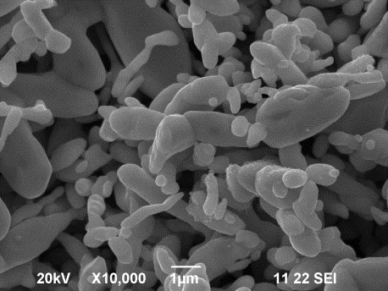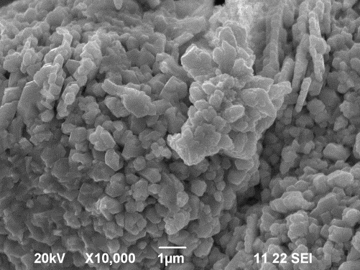
(a) (b)
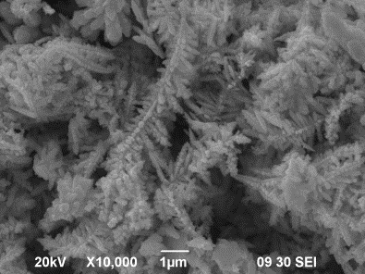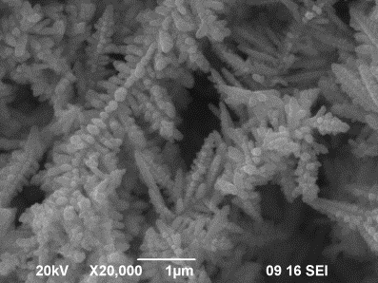
(c) (d)
Fig. 6. SEM images of Ag powders, deposited at potentials corresponding to I=5I_{d} in polarization curves for electrolytes No1 (a); No2 (b) and No3 (c,d).
K. Ignatova: Electrodeposition of Ag and Ag-Ni powders in potentiostatic and pulse potential modes
(a) | (b)
(c) | Fig. 7. X-ray diffractograms of Ag powders deposited at potentials corresponding to I=5I_{d} in polarization curves for electrolytes No1 (a); No2 (b) and No3 (c).

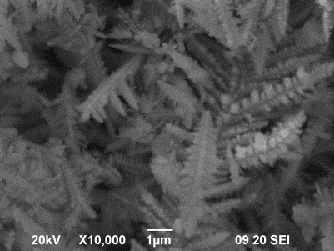  (a) | 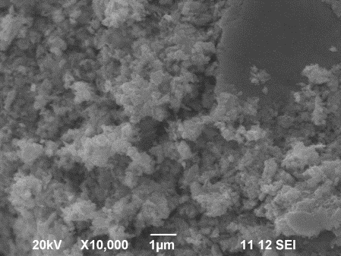  (b)
Fig. 8. SEM images of Ag-Ni powders deposited at potentials corresponding to I=5I_{d} in polarization curves for electrolyte No2* in potentiostatic (a) and in pulse potential mode at frequency of pulses f=500 Hz (b). Elemental content (from EDSA): (a) 83%Ag-12%Ni-5%O; (b) 89%Ag-5%Ni-6%O.
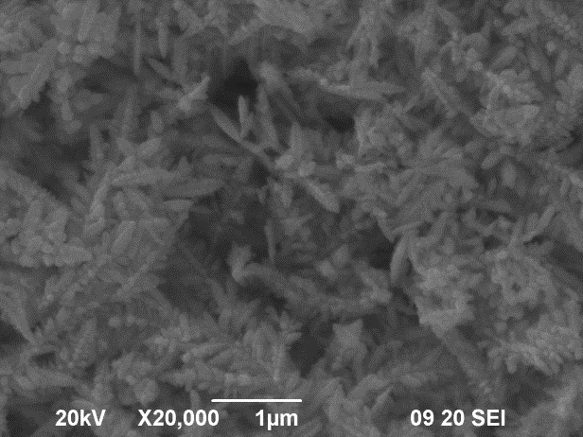  (a) | 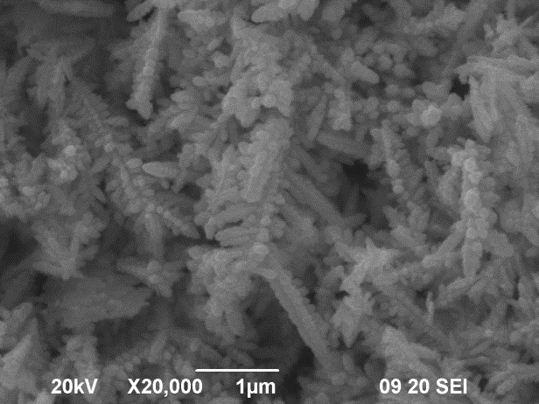  (b)
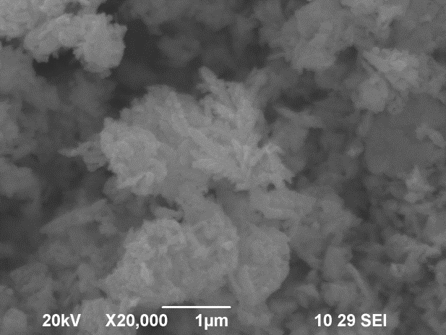  (c) | Fig. 9. SEM images of Ag-Ni powders deposited from electrolyte No3* in potentiostatic mode at different potentials E (SCE): -1,0V (a); -1,3V (b) and -1,5V (c). Elemental content: (a)95%Ag-5%Ni ; (b) 87%Ag-9%Ni-4%O; (c)76%Ag-18%Ni-6%O.

3.5. Morphology and elemental composition of Ag-Ni powders in potentiostatic and pulse potential modes.
K. Ignatova: Electrodeposition of Ag and Ag-Ni powders in potentiostatic and pulse potential modes
In Fig. 8 SEM images and elemental content of Ag-Ni powder deposited (in figure caption) in potentiostatic and pulse potential modes from ammonia-nitrate electrolyte (composition No 2*) are presented. In potentiostatic mode powders enriched in silver (up to 95%Ag) with typical dendrite structure were formed (Fig. 8a), unlike the irregular rounded shape of the particles of pure Ag powder deposited from the same composition (Fig. 7b). The application of pulse mode results in strong changes in the morphology of the powders. The particles are strongly shortened, of irregular shape and very small average diameter (less than 1 μm).
In Fig. 9 SEM images and elemental content (in figure caption) of Ag-Ni powder deposited from ammonia-citrate electrolyte (composition No3*) at different cathode potentials in potentiostatic mode are presented. The higher cathode potential applied leads to powders enriched in nickel (up to
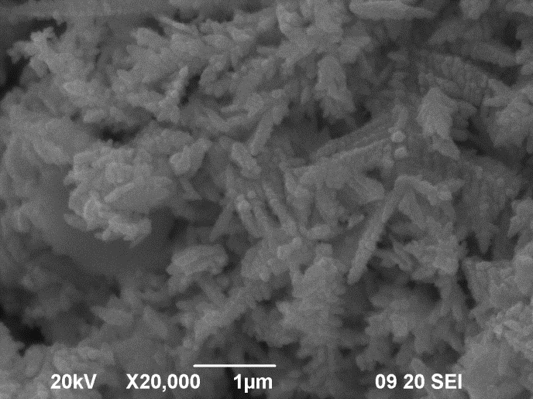 (a)
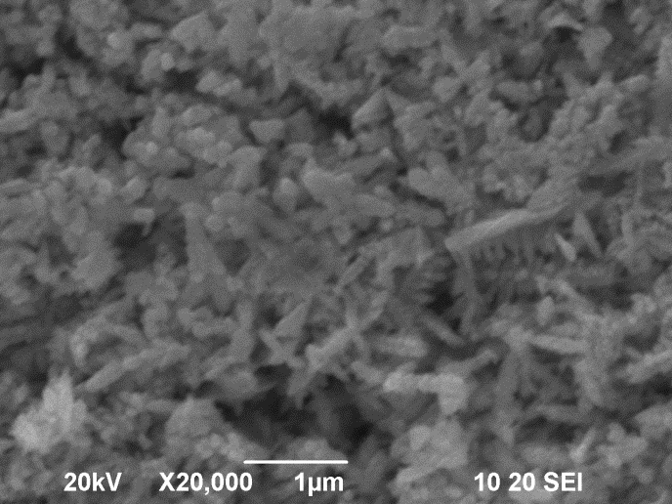 (b)
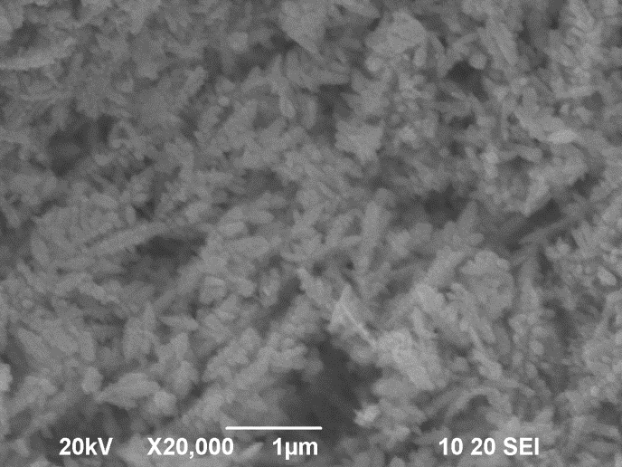 (c)
Fig. 10. SEM images of Ag-Ni powders deposited from electrolyte No3* in pulse potential mode with different frequencies of pulses: 100 Hz (a); 500 Hz (b) and 1000 Hz (c); the potential values correspond to I=5I_{d} in polarization curves for each frequency; elemental content: (a) 92%Ag-8%Ni; (b) 91%Ag-9%Ni; (c)83%Ag-12%Ni-5%О.
maximum 12 % Ni), whilst a decrease of the average size of particles is observed.
Agglomerates of small particles less than 1 µm are observed on the images at the highest cathode potential (Fig. 9с).
The comparison between the morphology of powders from the two electrolytes (No 2* and No 3*) in potentiostatic mode that is seen in Figs. 8a and 9a-c proves the advantages of the ammonia-citrate electrolyte (composition No 3*) for obtaining more finely dispersed Ag-Ni powders. That is why the influence of pulse frequency on the change of morphology and elemental content of Ag-Ni powders was precisely studied (Fig.10, a-c) in ammonia-citrate electrolyte (No 3*).
The susceptibility to formation of dendrite structure decreases with the increase of pulse frequency from 100 Hz to 1000 Hz (Fig.10a-c). The Ag-Ni powders obtained at frequencies 500-1000 Hz have either needle-like particles or irregular shaped particles with small lateral branching and average size of particles about or less than 1 µm (Fig.10, b and c).
It follows from the data for the elemental content of Ag-Ni powders given in the figure captions that achieving a higher content of Ni up to 18% in ammonia-citrate electrolyte (composition No 2*) and up to 12% in ammonia-citrate electrolyte (composition No 3*) is possible solely in potentiostatic mode at higher cathode potentials. At higher potentials in both electrolytes and at higher frequencies in ammonia-citrate electrolyte, oxides are present in the powders accounted for through the content of oxygen. The most probable reason for oxide formation is that the solution close to the electrode becomes alkaline because of hydrogen evolution at high amplitude values of the polarization at these conditions. The presence of Ni that cannot be found out through regular X-ray analysis is proved through the EDSA spectra of Ag-Ni powders (Fig. 11).
4. conclusions
It is found out that the transition from a regular acid electrolyte to complex electrolytes leads to increased dispersion of Ag powders and the deposited powders have different colors – white, dark grey, and black. This is due to the transition from round to dendrite shape of the particles and not to the occurrence of a new structure different from cubic crystal structure (fcc). The advantages of ammonia-citrate electrolyte towards the ammonia-nitrate one are proved, as well as those of pulse potential mode towards the potentiostatic mode for obtaining more finely dispersed Ag-Ni powders of average size of particles about or less than 1 µm. The maximum content of Ni in Ag-Ni powders 12-18% is achieved in potentiostatic mode.
K. Ignatova: Electrodeposition of Ag and Ag-Ni powders in potentiostatic and pulse potential modes

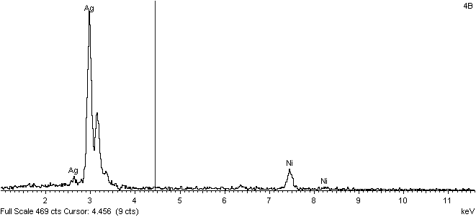
(a)

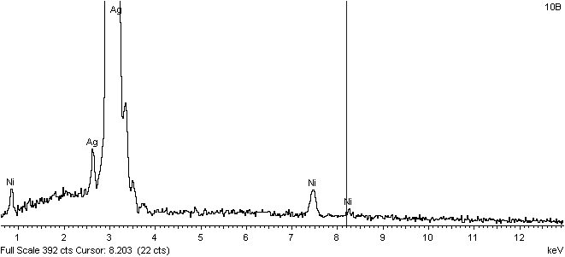
(b)
Fig. 11. EDSA spectra of Ag-Ni powder deposited from electrolyte No2* at E=-1,0V (а) and from electrolyte No3* at E=-1,3V (b) in potentiostatic mode.

references
- Ch. Cheng, T. Arunagiri, O. Chyan, American Journal of Undergraduate Research, 2, Nr 1, (2003).
- D. Pilone and G. H. Kelsall, Electrochimica Acta, 51, 3802 (2006).
- D.L. Deborah and Chung at all, Materials for Electronic Packaning, London, UK, Butterworth-Heinemann, (1995)
- K.I. Popov, M.G. Pavlovic‘, in “Modern Aspects of electrochemistry”(Electrodeposition of metal powders with controlled particles grains size and morphology), vol.14, Nr24, Eds. : E.White and J.O’M Bockris, Plenum Press Co, New York, pp. 299-391 (1993).
- K.J. Popov, N.D. Nikolic‘, M.G. Pavlovic‘, J. Serbian Chem. Soc., 74, 397 (2006).
- H.M.A. Solimen, H.H. Abdel-Rahman, J .Braz. Chem.Soc., 17, 705 (2006).
- K.I. Popov, M.D. Maksimovic‘, S.K. Zecevic‘, M.R. Stojic‘, Surf. Coat. Technol., 27, 117 (1986).
- M.G. Pavlovic‘, M. D. Maksimovic‘, K. I. Popov, M. B. Krsul, J. Appl. Electrochem., 8, 61 (1978).
- A.T. Kuhn, P. Neufeld, K. Young, J. Appl. Electrochem., 14, 605 (1984).
- V. Maksimovic, M. G. Pavlovic, Lj. J. Pavlovic, M. V. Tomic, V. D. Jovic, Hydrometallurgy 86, 22 (2007).
- C.K. Mital, J.Electrochem.Soc, India, .22, 251, (1973).
- A.T. Kuhn, P. Neufeld, G.Butler, Surface Technology, 16, 3 (1982).
- A.T. Kuhn, Oberfläche/Surfaces, 23, 279 (1981).
- Yu.M. Polukarov, Electrochimia (Russian), 4, 568, (1968).
K. Ignatova: Electrodeposition of Ag and Ag-Ni powders in potentiostatic and pulse potential modes
- G.A. Emelyanenko, G. Simulin, Electrochimia (Russian), 4, 187 (1968).
- Yu.M. Polikarov, Trud. Ukrainskoi Respubl. Konferencii electrochimii, Novomoskovsk, Dnepropetrovskaya oblast, (Sept. 1977), pp. 116-119
- Yu.M. Polukarov, Electrochimia (Russian), 2, 79 (1966).
- A. Radisic, G.J. Lany, P.M. Hoffman, P.C. Searson, J. Electrochem. Soc., 148, 41 (2000).
- P. Borthen, J.B. Hwang, H.H. Strechblow, D.M. Koev, J. Phys. Chem., 104, 5078 (2000).
- M.G.Pavlovic, K.I.Popov, Metal powder production by electrolysis. Electrochemistry Encyclopedia (2005). Available from http://electrochem.cwru.edu/ed/encycl/.
- O.I.Kuntyi, R.R.Olenych, Russian Journal of Applied Chemistry, 78, 556 (2005).
- [22Advance Powder Technology, (2011), in press
- N.Ibl, Cl.J.Puippe, Plating and Surface Finishing, 6, 68 (1980).
- A.W. Pomosov, A.A. Yun, I.W. Muratova, Poroshkovaya Metalutgiya, 4, 1 (1983).
- T.A. Green, A.E. Russel, S. Roy, J. Electrochem. Soc., 145, 875, (1998).

K. Ignatova: Electrodeposition of Ag and Ag-Ni powders in potentiostatic and pulse potential modes

Електроотлагане на Ag и на Ag-Ni прахове в стационарен и в импулсен режим

К. Игнатова
Химикотехнологичен и металургичен университет, София 1756, България
Постъпила на 24 юли, 2012 г.; коригирана на 30 септември, 2013 г.
(Резюме)
Изследвани са кинетиката на отлагане, морфологията и състава на чист Ag прах и на AgNi прах в зависимост от вида на електролита и условията на отлагане. Установено е, че в кисел нитратен електролит Ag прахове са бели след отлагане, с по-ясно проявена кристална структура. В комплексен аминонитратен електролит се формират сиви Ag прахове с неправилна форма на частиците и по-висока дисперсност. В цитратноамонячен електролит отложените Ag прахове са тъмносиви до черни на цвят, с типично дендритна, склонна към агломериране структура на частиците. Всеки от типовете Ag прахове се състои от една единствена фаза – тази на сребро с кубична стенноцентрирана решетка (fcc). Доказани са предимствата на цитратноамонячния електролит в сравнение с аминонитратния за получаване на финодисперсни AgNi прахове. Прилагането на по-високи катодни потенциали в стационарен режим и прилагането на импулсен режим с честота на импулсите до 1000 Hz в цитратноамонячния електролит води до понижение на средния размер на частиците до около и под 1 µm и нарастване на съдържанието на никел до 12-18%.

