Bulgarian Chemical Communications, Volume 45, Number 3 (394 – 399) 2013
Conversion of free fatty acids in low grade crude palm oil to methyl esters for biodiesel production using chromosulfuric acid
A. Hayyan^{1*}, F.S. Mjalli², M.A. Hashim¹, M. Hayyan¹, I.M. AlNashef³
¹Department of Chemical Engineering, Centre for Ionic Liquids (UMCiL), University of Malaya, Kuala Lumpur 50603, Malaysia
²Petroleum and Chemical Engineering Department, Sultan Qaboos University, Muscat 123, Sultanate of Oman
³Chemical Engineering Department, King Saud University, Riyadh 11421, Saudi Arabia
Received September 29, 2012 ; Revised November 12, 2012
In this study low grade crude palm oil (LGCPO) was proposed as a potential agro-industrial raw material for biodiesel production. Chromosulfuric acid was used as a new homogenous catalyst in the pre-treatment process to reduce the free fatty acids (FFA) content in LGCPO to the acceptable level for producing biodiesel via alkaline transesterification reaction. The results of esterification reaction showed that the FFA of LGCPO was reduced from 7.0 % to less than 1% using optimum operating conditions. The yield of the final product after the alkaline transesterification was 85% with 0.14 % FFA content and ester content 97.5% (mol mol⁻¹) which meets the international standard quality specifications for biodiesel.
Keywords: biodiesel, esterification, free fatty acids, chromosulfuric acid.

INTRODUCTION
The limited resources to produce fuel have driven the attention to biodiesel as an alternative renewable fuel. The production of biodiesel was mainly using vegetable and animal oils [1,2]. Malaysia is one of the biggest palm oil producer and exporter in the word [3]. There has been an increasing interest in the utilization of palm oil for biodiesel raw material as an alternative, renewable, non-toxic, biodegradable and environment friendly one [4-6]. The high value of palm oil as a food product makes its production very expensive [7, 8]. However, many large industrial vegetable oil mill facilities produce low grade crude palm oil (LGCPO). LGCPO is oil with high acidity that can be converted to biodiesel fuel. LGCPO is an attractive feedstock and a significant raw material for biodiesel production. The use of LGCPO can lower the cost of biodiesel production significantly. A number of researchers have worked on a variety of feedstock that have elevated FFA levels [9-12]. LGCPO typically contain 5% to 10% FFAs and this value is high compared to the acceptable level that can be converted to biodiesel fuel [4, 6]. It is reported that the oil should not contain more than 1% FFA for alkaline-catalyst transesterification reactions [2, 5, 12, 13]. Thus, an acid-catalyzed pre-treatment step to convert the FFA to fatty acid methyl esters (FAME) followed by an alkali–catalyzed step to convert the remaining triacylglycerols (TAG) to FAME and glycerol is the typical process to produce biodiesel fuel from acidic oils [14]. Lipase enzyme was used as a biocatalyst for biodiesel production [15]. Methane-sulfonic acid, ethane-sulfonic acid, and sulfuric acid were used in the esterification reaction for biodiesel production [7-9] while, p-toluene sulfonic monohydrate acid (PTSA) was used in the pre-treatment of sludge palm oil (SPO) [6]. Tri-potassium phosphate as a heterogeneous catalyst was studied for biodiesel production by Guan et al [17]. Introducing new type of homogenous acid catalyst is gaining an increasing interest in the development of biodiesel production process. No study was reported in the literature for the esterification of acidic oil using chromosulfuric acid (CSA). Therefore, the main objective of this study was to investigate the potential of using LGCPO as a low-cost feedstock in biodiesel production and to study the influence of operational conditions such as dosage of CSA to LGCPO, molar ratio, reaction temperature, reaction time and stirrer speed for reducing FFAs content to less than 1% in LGCPO and to give high biodiesel yield.
* To whom all correspondence should be sent:
E-mail: adeeb.hayyan@yahoo.com
© 2013 Bulgarian Academy of Sciences, Union of Chemists in Bulgaria
MATERIALS AND METHODS
Raw materials and chemicals
LGCPO was obtained from local mill, Selangor, Malaysia. LGCPO was stored in cool room at 4ºC. Methyl alcohol anhydrous was purchased from Mallinckrodt Chemicals USA, CSA and potassium hydroxide laboratory grade were purchased from Merck.
Preparation of biodiesel
First, a pre-heating step was performed because LGCPO usually exists in semisolid phase at room temperature similar to sludge palm oil and acidic crude palm oil. The LGCPO was molten in an oven at a temperature of around 70ºC and the preheated LGCPO was then transferred into the reactor. The LGCPO was pre-treated by using an acid esterification step. This was followed by an alkaline transesterification under fixed conditions of 10:1 molar ratio, 60ºC reaction temperature and 30 min reaction time. The final product was separated and purified to produce high quality biodiesel fuel.
Chemical analysis
The fatty acid composition of LGCPO was determined using a GC/MS (Agilent Technologies 7890A); the capillary column was DB- wax 122–7032, with length of 30 m, film thickness of 0.25 µm and an internal diameter of 0.25 mm. Helium was used as a carrier gas with a flow rate of 36 cm/sec, measured at 50ºC; and the experimental run was done for 35 min. A neat sample was diluted in hexane prior to injection into GC. Ester content was analyzed using GC/FID (Perkin Elmer Clarus 500), with a capillary column (Polyethylene glycol wax phase) and an isotherm oven at 250ºC. Monoacylglycerols, diacylglycerols, triacylglycerols, free and total glycerol content were determined using GC/FID (Perkin Elmer Clarus 500). The GC/FID was equipped with an on-column injector, high temperature column with polysiloxy divynil benzene phase (DB-HT type), and temperature program of oven up to 350ºC. The FFA content of LGCPO was tested according to the American Oil Chemists’ Society (Ca 5a–40) methods [18]. Product yield is defined as the weight percentage of the final product relative to LGCPO weight at the beginning of experiment [6]. The LGCPO was characterized according to the MPOB test methods [19]. The mean molecular weight of LGCPO was determined based on the saponification value calculated according to Equation 1 [20].
(1)
where:
S.V. is saponification value defined as mg KOH per g of sample
3 is the number of fatty acids per triacylglycerols
56.1 is molecular mass of KOH (g/mol)
1000 is conversion of units (mg/g)
92.09 is molecular mass of glycerol (g/mol)
18 is molecular mass of water (g/mol)
RESULTS AND DISCUSSION
LGCPO characterization
The study of fatty acid composition is very important to identify properties and the type of carbon chains contained in oil and fat [6]. As shown in Figure 1, the common fatty acids are oleic, palmitic, linoleic and stearic acid.
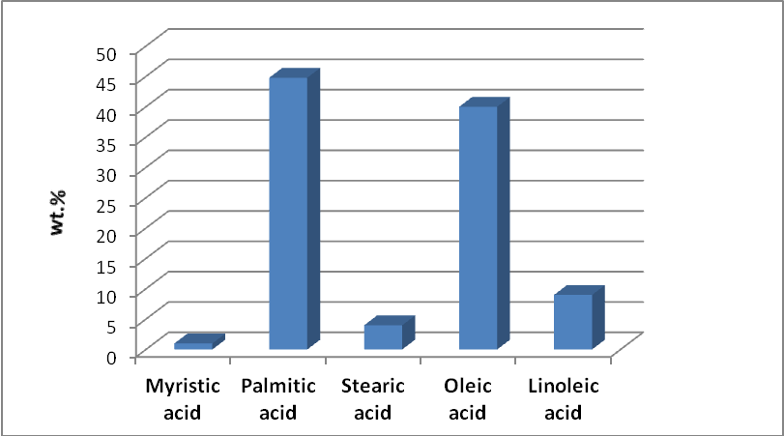
Fig. 1. Fatty acid profile of LGCPO.
The percentage of saturated fatty acids in LGCPO is 44%. Due to the high percentage of saturated fatty acids and FFA, LGCPO exists as a gel phase at room temperature (25±2ºC). Higher saturated fatty acids in oils such as LGCPO give a higher cetane number and this type of acidic oil is less prone to oxidation [4]. The vehicle engine works more efficiently with an oil of high cetane number. Table 1 illustrates the characteristics of LGCPO. Based on the saponification value, the average molecular weight calculated was 816.9 g/mol and the LGCPO FFA content used was 7.0 % as shown in Table 1.
A. Hayyan et al.: Conversion of free fatty acids in low grade crude palm oil to fatty acid methyl ester for biodiesel …
Table 1. Characteristics of LGCPO.
Parameters | LGCPO
FFA content (%) | 7.0± 0.30
Peroxide value (meq mol/kg) | 7. 5 ± 0.65
Moisture content (%) | 1.03±0.1
Impurities (%) | 0.050±0.006
Saponification value (mg KOH/g oil) | 198.00 ± 1.70
Unsaponification matter (%) | 6.8± 0.22
Ash (%) | 0.010± 0.001
Anisidine Value (AV) | 3.2± 0.042
DOBI (Index) | 1.81± 0.023
The moisture content in LGCPO was found to be 1.03% while the impurities and the ash content were 0.05% and 0.01%. The LGCPO was characterized with high FFA as well as high moisture and impurities content. This indicates that the LGCPO has a lower quality as compared to normal CPO.
Effect of CSA dosage
Using a fixed reaction time (30 min) and fixed molar ratio (10:1), the dosage of CSA was varied in the range of 0.25- 3.5 wt%. The results showed that CSA was a very effective catalyst in the esterification reaction. Figure 2 shows the effect of different dosage of CSA on the reduction of FFA content, conversion of FFA to FAME and yield of treated LGCPO.
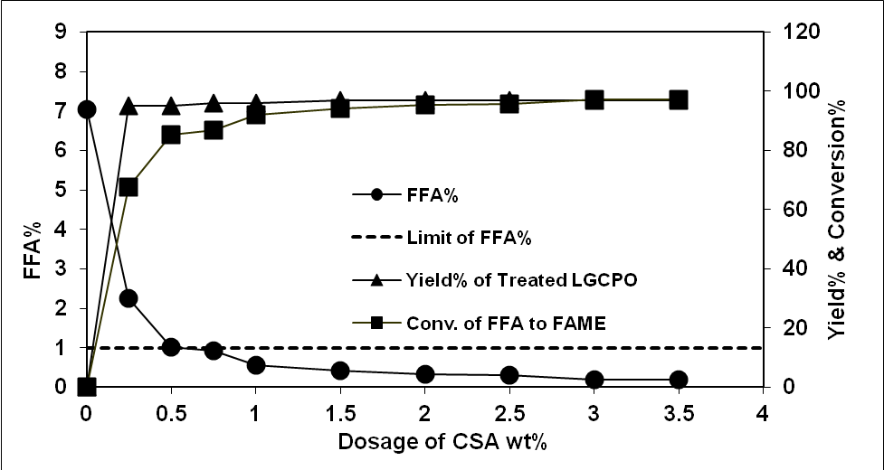
Fig. 2. Effect of CSA dosages on FFA content reduction, conversion of FFA to FAME and yield of treated LGCPO.
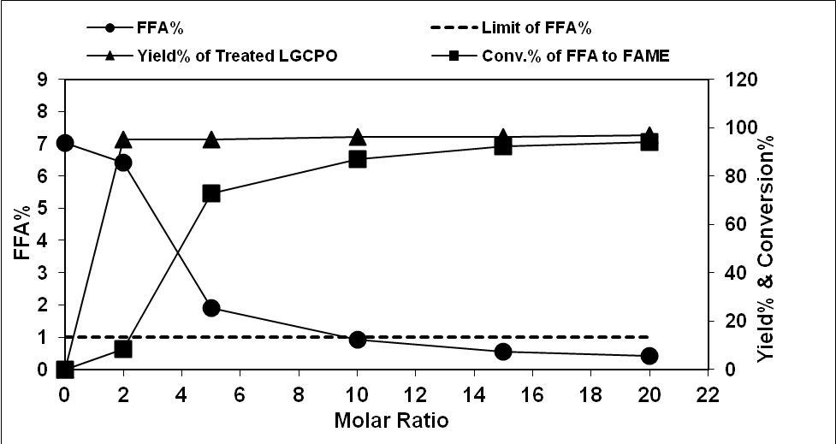
Fig. 3. Effect of molar ratio on FFA content reduction, conversion of FFA to FAME and yield of treated LGCPO.
A FFA content of less than 1% was achieved using a CSA dosage of more than 1 wt%. To minimize catalyst usage, a catalyst dosage value of 0.75% was selected as optimum dosage to reduce the FFA content to the acceptable limit. The conversion of FFAs to fatty acid methyl ester (FAME) was 86.77% after the esterification process. The FFA content of LGCPO was reduced from 7.0% to 0.92%. In a similar work on SPO, it was reported that 0.75 wt% of the catalyst (such as PTSA) was the optimum dosage needed to reduce the high FFA content [6].
Effect of molar ratio
A. Hayyan et al.: Conversion of free fatty acids in low grade crude palm oil to fatty acid methyl ester for biodiesel …
Molar ratio is one of the important factors affecting the conversion of FFA to FAME, as well as the overall production cost of biodiesel. In this
study, the molar ratio of methanol to LGCPO was varied between 2:1 and 20:1. Figure 3 describes the effect of molar ratio on the reduction of FFA content, conversion of FFA to FAME and yield of treated LGCPO. No significant change observed in the reduction of FFA within the molar ratio range of 10:1 to 20:1. On the other hand, a minimum of 10:1 molar ratio were required to reduce the FFA content of LGCPO from 7.0 % to below than 1%, which is the limit of FFA for a successful transesterification reaction. In order to save methanol consumption, a molar ratio of 10:1 was sufficient for the esterification reaction. This ratio was also the optimum ratio reported for the esterification of SPO using PTSA as acid catalyst [6].
Effect of reaction temperature
The reaction temperature during the different steps was reported to range between 40 - 70ºC [8, 13]. Figure 4 presents the effect of reaction temperature on the reduction of FFAs content of LGCPO. In this study, it was found that the lowest reaction temperature to reduce the FFA content in LGCPO was 60ºC. At this temperature the FFAs content was reduced from 7.0 % to below 1%, with a very high conversion of FFA to FAME. Therefore, a reaction temperature of 60ºC was selected for the esterification of LGCPO. It was reported by Leung and Guo [21] that a temperature higher than 50ºC had a negative impact on the product yield for neat oil, but had a positive effect for waste oil with higher viscosities. Effect of reaction time
In order to determine the optimum reaction time, esterification reaction time was varied in the range (3-150 minutes). Figure 5 shows the effect of the reaction time on the reduction of FFA content, conversion of FFA to FAME and yield of treated LGCPO. During the course of the reaction and at the first 10–20 minutes, most of FFA was removed as shown in Figure 5. The fast reduction reflects the
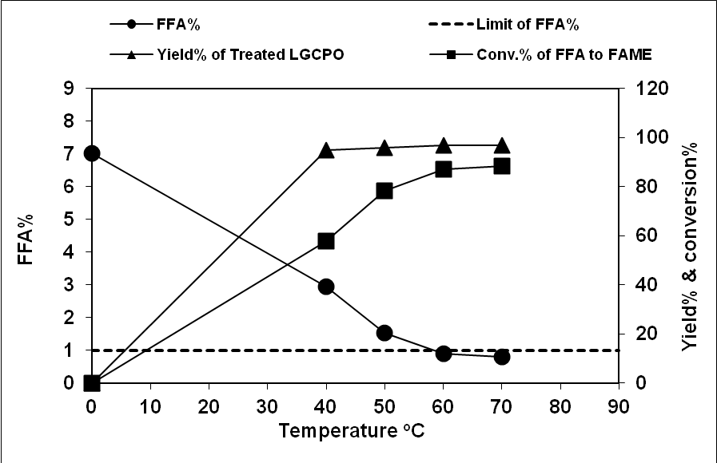
Fig. 4. Effect of reaction temperature on FFA content reduction, conversion of FFA to FAME and yield of treated LGCPO.
catalytic activity of CSA. As shown in Figure 5, the FFA content decreased significantly with the increase in reaction time. A bout 30 to 60 min was sufficient to reduce the FFA content to less than 1%. It was found that after 30 min there was no improvement in the reduction of the acidity along reaction time. Hence, in order to optimize the reaction time, 30 minutes was selected as the shortest reaction time for the pre-treatment of LGCPO. The shortest reaction time can be considered as the optimum value due to the additional cost entailed with longer reaction time. Hashim et al. [22] used trifluoromethanesulfonic acid for the esterification of CPO with high FFA content and the optimum time of reaction was 30 min. The matching between the current study and the mentioned study illustrates that CSA has high catalytic activity compared to super acid (trifluoromethanesulfonic acid).
Effect of stirrer speed
Mixing intensity is a very important operational parameter. Therefore, in order to achieve an effective mass transfer in the esterification reaction, continuous mixing and sufficient reaction time should be used in order to complete the reaction. Mixing intensity affects the kinetics and consequently the whole process. In this study a wide range of mixing speed (100 to 400 rpm) was tested in order to investigate the optimum value for the pre-treatment of LGCPO. Figure 6 shows the effect of stirrer speed on the reduction of FFA content in LGCPO via the esterification reaction. The results revealed that a stirrer speed of 200 was sufficient to reduce FFA content to less than 1%. In order to save energy requirements, lower stirrer speed should be taken as the optimum for LGCPO
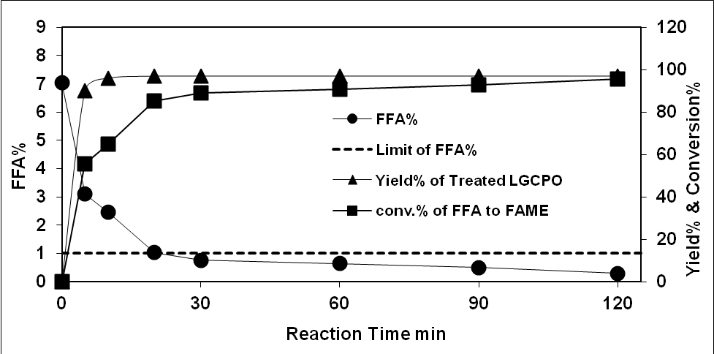
Figure 5. Effect of reaction time on FFA content reduction, conversion of FFA to FAME and yield of treated LGCPO
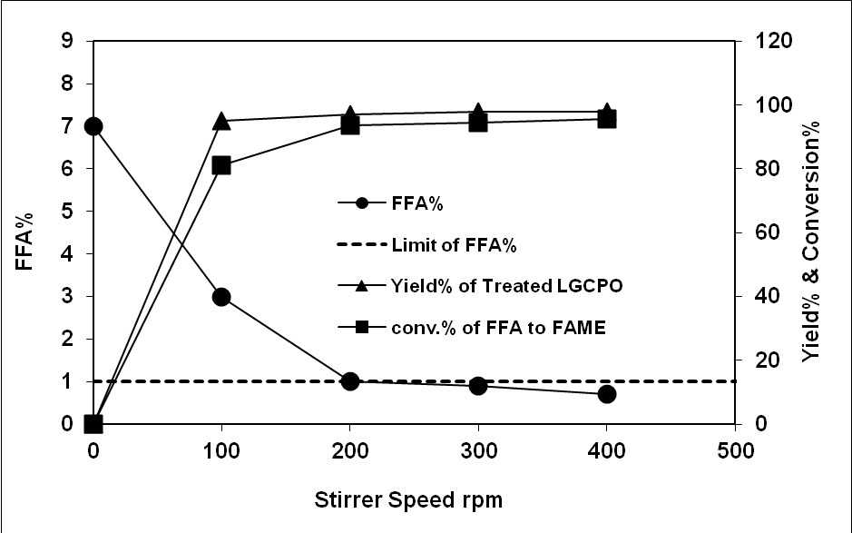
Fig. 6. Effect of stirrer speed on FFA content reduction, conversion of FFA to FAME and yield of treated LGCPO.
esterification. Therefore, a speed of 200 rpm was selected as the optimum mixing intensity. Hayyan et al. [6] used 400 rpm for the pretreatment of SPO due to the high FFA content in SPO compared to LGCPO.
A. Hayyan et al.: Conversion of free fatty acids in low grade crude palm oil to fatty acid methyl ester for biodiesel …
Transesterification reaction
During the esterification reaction, FFA is converted to FAME in the presence of an acid catalyst. The remaining neutral TAG is converted to FAME via transesterification reaction in presence of an alkaline catalyst such as potassium hydroxide. The conditions of biodiesel production were fixed [6,7,23]. The FFA content was less than 0.5% which meets the international standards ASTM D6751-02 and EN 14214. Table 2 shows the fatty acid composition of biodiesel from LGCPO. Using the optimum conditions for the esterification reaction the FFAs were reduced from 7.0 % to less than 1%. The yield of biodiesel was 85% with 0.14 % FFA. The results of this study meet the standard specification for biodiesel fuel as shown in Table 3.

Table 2. Fatty acid composition of biodiesel from LGCPO; results are the average of three replicates ± standard deviation.
Systematic name of FAME | Carbon chain | Type of fatty acid | FAME content  (%)
Dodecanoic acid methyl ester | C12:0 | Saturated | 0.19 ± 0.02
Tetradecanoic acid methyl ester | C14:0 | Saturated | 0.91 ± 0.02
Hexadecanoic acid methyl ester | C16:0 | Saturated | 44.1 ± 1.00
Hexadecenoic acid methyl ester | C16:1 | Unsaturated | 0.285 ± 0.002
Octadecanoic acid methyl ester | C18:0 | Saturated | 4.3 ± 0.03
cis-9-Octadecenoic acid methyl ester | C18:1 | Unsaturated | 40.40 ± 2.40
All-cis-9,12-Octadecadienoic acid methyl ester | C18:2 | Unsaturated | 9.4 ± 0.05
All-cis-9,12,15-Octadecatrienoic acid methyl ester | C18:3 | Unsaturated | 0.28 ± 0.02
Eicosanoic acid methyl ester | C20:0 | Saturated | 0.3 ± 0.003
Table 3. Properties of biodiesel from LGCPO.
Properties | Biodiesel from LGCPO
Ester content | 97.5% (mol mol⁻¹)
Monoacylglycerol content | 0.1% (mol mol⁻¹)
Diacylglycerols content | 0.02% (mol mol⁻¹)
Triacylglycerols content | <0.02% (mol mol⁻¹)
Free glycerol content | <0.01% (mol mol⁻¹)
Total glycerol content | 0.04% (mol mol⁻¹)
K content | 1 mg kg⁻¹max
P content | 7.2 mg kg⁻¹ max
Sulphated ash | <0.005 % (w/w)
Total contamination | 0.002 mg kg⁻¹
FFA content | 0.14 %
Copper Strip Corrosion  (3hr at 50◦C) | Class 1
Cetane Number | 77

CONCLUSIONS
This study concludes that LGCPO is a suitable feedstock for biodiesel production with a pre-treatment stage using CSA as a catalyst at 0.75% wt/wt (catalyst to LGCPO) with 10:1 molar ratio and 60º C at 30 min and 200 rpm as stirrer speed. Using these conditions the FFA content was reduced from 7.0 % to less than 1%. The yield of biodiesel was 85% with 0.14 % FFA and ester content 97.5% (mol mol⁻¹). The results attained in the current study meet the international standard specifications for the biodiesel fuel. It is recommended to study the catalytic activity of CSA compared to other conventional homogenous catalysts in the esterification reaction. The comparative study may assists in highlighting the advantages and disadvantages of the different catalysts used for the pre-treatment of acidic oils.
A. Hayyan et al.: Conversion of free fatty acids in low grade crude palm oil to fatty acid methyl ester for biodiesel …
Acknowledgement: The authors would like to express their thanks to University of Malaya HIR-MOHE (D000003-16001), Centre for Ionic Liquids (UMCiL), and the National Plan for Science, Technology, and Innovation at King Saud University (10-ENV1315-02), and Petroleum & Chemical Engineering Department, Sultan Qaboos University for their support to this research.
REFERENCES
- F. Ma, M.A. Hanna, Bioresour. Technol., 70, 1 (1999).
- L.C. Meher, D. Vidya Sagar, S.N. Naik. Renew. Sustain. Energy Rev., 10, 248 (2006).
- M.A. Kalam, H.H. Masjuki. Biomass Bioenerg., 23, 471 (2002).
- M. Canakci, J. Van Gerpen. Trans. ASAE., 44, 1429 (2001).
- M. Canakci., Bioresour. Technol., 98, 183 (2007).
- 6. A. Hayyan, M. Z. Alam, M.E.S. Mirghani, N.A. Kabbashi, N.I.N.M. Hakimi, Y.M. Siran, S. Tahiruddin. Bioresour. Technol., 101, 7804 (2010).
- A. Hayyan, F. S. Mjalli, M. A. Hashim, M. Hayyan, I. M. AlNashef, S. M. Al-Zahrani, M. A. Al-Saadi. Bioresour. Technol. 102, 9564 (2011).
- A. Hayyan, M. Z. Alam, M.E.S. Mirghani, N.A. Kabbashi, N.I.N.M. Hakimi, Y.M. Siran, S. Tahiruddin. Fuel Process. Technol., 92, 920 (2011).
- A. Hayyan, F.S. Mjalli, M.A. Hashim, M. Hayyan, I. M. AlNashef, S.M. Al-Zahrani, Chem. Pap., 66, 39 (2012).
- S. Chongkhong, C. Tongurai, P. Chetpattananondh, C. Bunyakan. Biomass Bioenerg., 31, 563 (2007).
- Y.A. Elsheikh, Z. Man, M.A. Bustam, S. Yusup, C.D. Wilfred. Energy Convers. Manag., 52, 804 (2011).
A. Hayyan et al.: Conversion of free fatty acids in low grade crude palm oil to fatty acid methyl ester for biodiesel …
- M. Naik, L.C. Meher, S.N. Naik, L.M. Das. Biomass Bioenerg., 32, 354 (2008).
- S.V. Ghadge, H. Raheman. Biomass Bioenerg., 28, 601 (2005).
- M. Canakci, J.V. Gerpen. Trans. ASAE., 46, 945 (2003).
- W.J. Ting, C.M. Huang, N. Giridhar, W.T. Wu. J. Chinese Inst. Chem. Engineers, 39, 203 (2008).
- G. Guan, K. Kusakabe, S. Yamasaki. Fuel Process. Technol., 90, 520 (2009).
- American Oil Chemists’ Society (AOCS), Ca 5a-40: free fatty acids. Official Methods and Recommended Practices of the AOCS, 5th ed. American Oil Chemists’ Society Press, Champaign, IL. (1997).
- A. Kuntom, S.W. Lin, T.Y. Ai, N.A. Idris, M. Yusof, T.T. Sue, N.A. Ibrahim. Malaysian Palm Oil Board (MPOB) Test Methods. MPOB, Bangi, Malaysia, (2005).
- S. Suzanne Nielsen, Food Analysis, Springer, New York Dordrecht Heidelberg London, pp. 247-248 (2010).
- D.Y.C. Leung, Y. Guo. Fuel Process Technol., 87, 883 (2006).
- M.A. Hashim, A. Hayyan, F.S. Mjalli,M. Hayyan, I. M. AlNashef. Int. J. Sustainable Water Environ. Systems, 3, 19 (2011).
- M. Hayyan, F.S. Mjalli, M.A. Hashim, I.M. AlNashef. Fuel Process. Technol., 91, 116 (2010).

Използването на хлор-сулфонова киселина за превръщане на свободните мастни киселини от ниско-качествено палмово масло в метилови естери при производството на биодизел
А. Хайян¹, Ф.С. Миджали², М.А. Хашим¹, М. Хайян¹, И.М. АлНашеф³
¹Департамент по инженерна химия, Център за йонни течности (UMCiL), Малайски университет, Куала Лумпур, Малайзия
²Департамент по нефтено и химично инженерство, Университет “Султан Кабус”, Мускат, Султанат Оман
³ Департамент по инженерна химия, Университет “Крал Сауд”, Риад, Саудитска Арабия
Постъпила на 29 септември, 2012 г.; коригирана на 12 ноември, 2012 г.
Предложено е ниско-качествено палмово масло (LGCPO) като потенциална растителна суровина за производството на биодизел. Като катализатор на хомогенната химична реакция при предварителното третиране на суровината за намаляване съдържанието на свободните мастни киселини (FFA) в палмовото масло до приемливо ниво преди последващата алкална транс-естерификация е използвана хлор-сулфонова киселина. Резултатите от естерификацията показват, че FFA в палмовото масло са намалели от 7.0 до под 1% при оптимални работни условия. Добивът на крайния продукт след естерификацията е 85% с 0.14 % свободни мастни киселини и съдържание на естери от 97.5% (mol mol⁻¹) което удовлетворява международните изисквания за качеството на биодизел..

