Study on the wet inside filtration theory of fiber layer for dust particles based on equivalent analogy hypothesis
Xishan Chen, Yongliang Zhang*, Yuqi Zhang
Environmental and Municipal Engineering College of Qingdao University of Technology, Qingdao 266520
Received March 24, 2016; Accepted August 8, 2016
Article is intended for the process of wet fiber layer which was the combination of fiber filtration mechanism and washing mechanism, the hypothesis of the cleaning fluid in the fiber layer evenly distributed on the surface of the fiber filament is introduced by adopting the equivalent analogy, thereby establishing the theoretical model of purification efficiency, and achieving the theoretical analysis of filtration process of wet fiber layer for the dust particle. Meanwhile, the semi-theoretical and semi-empirical purification efficiency formula for dust purification and its correction method are obtained through dimensionless correction of the theoretical formula by means of the experiments carried out, which facilitates the theoretical study of the wet fiber layer for dust purification and is of guiding significance to practical application.
Key words: Dust particles, Fiber filter layer, Wet filter, Equivalent analogy, Filter efficiency.

INTRODUCTION
The wet fiber filtration is an efficient method for dust purification combining fiber layer filtration with spray washing and the purification process of wet fiber layer for dust particles is the combination of fiber filtration mechanism and washing mechanism [1]. This combination process which has the high effect of the dust filtration of fiber filter layer, in addition to the cleaning effect of the fluid on the dust deposit within the fiber filter layer. Compared to the dry fiber layer for dust filtration and purification, it features advantages such as long service life of fiber filter material, no re-entrainment of dust, high efficiency of dust capture, etc. especially significant in the trapping of fine dust and widely used for industrial dust collection.
In the filtration process of wet fiber layer, due to the extremely complex distribution of washing fluid in the fiber filter layer, it is impossible to make theoretical analysis, currently there is no perfect theoretical formula to describe the purification theory of wet fiber layer for dust filtration [2, 3, 4]. In this paper, the in-depth research on the purification mechanism of wet fiber layer for dust filtration was carried out on the basis of the assumption of equivalent analogy, avoiding the complex fluid distribution in the fiber filter layer, serves as the bridge for theoretical and quantitative description of filling rate of the fluid in the fiber filter layer ,thereby obtaining the theoretical formula of filtration efficiency, while with the help of experiments and the dimensionless correction method, a semi-theoretical semi-empirical formula of the filtration and purification efficiency of the wet fiber layer was given, which accomplished an access to a relatively perfect semi-theoretical semi-empirical formula for filtration efficiency of the wet fiber layer and provides a theoretical explanation for the filtration and purification method of wet fiber layer for dust particles.
To whom all correspondence should be sent:
E-mail: zhyoliang@163.com

ANALYSIS OF FILTRATION EFFICIENCY OF THE WET FIBER LAYER
Equivalent analogy analysis
In order to avoid the distribution complexity of washing fluid in the fiber filter layer in the whole analytical process, so that the wet filtration process can be described theoretically, under the premise of the equal filling rate of the fluid in the fiber filter layer, based on the assumption of the previous dry fiber layer filtration [5,6], the following assumption of equivalent analog was proposed.
1) The filament in the filter material has a circular cross-section and the dust particles are spherical;
2) The dusty air flows perpendicular to the filament
3) the flushing fluid that flew into the inside of fiber filter layer flows uniformly and attached to the surface layer of the filaments under the action of the air flow, forming a composite trap with the static fiber and dynamic flushing fluid for dust particle collection;
4) Once the dust particle is filtered, it will be taken away by the flowing cleaning fluid, having no influence on the subsequent purification process.
5) Dust particle filtration process is taking place in the spatial volume occupied by the fiber filter material, which is defined as the dust collection space.
© 2016 Bulgarian Academy of Sciences, Union of Chemists in Bulgaria
Composite trap and the equivalent diameter d
After the analog equivalent assumption, the cleaning fluid and filaments formed the composite trap, as shown in Figure 1, the equivalent diameter of the composite trap should consist of the diameter of filaments and the flowing cleaning fluid film attached to the surface of the filaments.
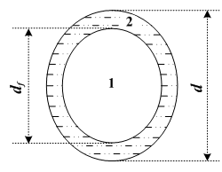

Fig. 1. The cross-section of composite trap. 1 – Filaments, 2 - flowing cleaning fluid film.
The annular cross-sectional area of the flowing cleaning fluid film formed in the composite trap should be:
$$\frac{π}{4}\left(d^{2}−d_{f}^{2}\right)=\frac{V⋅β_{1}}{l_{f}}$$
Where: V – the volume of space occupied by wet fiber filter layer (m3); β₁ - Dynamic filling rate of the cleaning fluid (%); lf – the overall length of the filament (m), ($l_{f}=4β_{f}V/\left(π d_{f}^{2}\right)$ where β_{f} - static filling rate of the filament ( % ) .
The total length of the filaments is substituted into the above formula, and the expression for equivalent diameter of the composite trap can be drawn:
$d=d_{f}\sqrt{ 1+\frac{β_{1}}{β_{f}}}$ (1)
The relationship between the equivalent diameter d of the composite trap and the dynamic filling rate of the fluid β₁ and the fiber filament d_{f} was established in formula (1), which serves as the bridge for theoretical analysis of filtration and purification of the wet fiber layer.
2.1.2 The filling rate β of the composite filter. In the filtration and purification process of the wet fiber layer, the internal composite trap contains the cleaning fluid film in a flowing state in addition to the filaments, so the total filling rate in the wet filter trapping space should include the static filling rate β_{f} of the filaments and the dynamic filling rate β₁ of the cleaning fluid, that is:
β = β_{f} + β₁ (2)
Wherein, the static filling rate β_{f} of the fiber was given when the product manufactured, the dynamic filling rate β₁ of the cleaning fluid and the wet filtration purification process depend on the amount of water spray, experiments show that when the filling rate of filaments in the fiber layer is less than 3%, it should be the ratio of spray amount per unit time and the volume of filter material in the fiber layer being sprayed (dust collecting space), i.e.:
$β_{1}=\frac{q}{A⋅H}$ (3)
Where: q is the spray volume received on the surface of filaments in the fiber layer per unit time (m3/s); A is the sprayed area of the fiber filter layer surface (m2); H is the thickness (m) of the fiber filter layer.
Theoretical analysis of the wet fiber layer filtration efficiency
Theoretical analysis
The filtration and purification model of dust-laden air flowing through the wet fiber layer is shown in Figure 2, due to the spherical spray section, the circular filtration model is given in Figure 2.
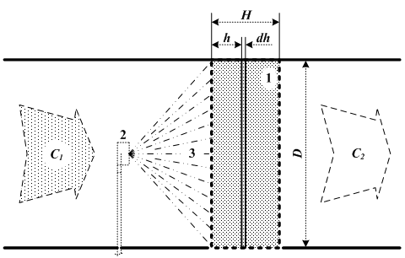

Fig. 2. Filtration model.
Provided that the air volume flowing through the wet fiber layer is Q, the flow rate of air flow before filtration is u, the dust concentration in the air flow before filtration and after filtration is C1, and C2, the thickness of the wet filter layer is H, the frontal area (also the sprayed wet area) is A, the filling rate of the composite trap in the fiber filter layer is β, then the filtration velocity of the air flow in the wet filter layer should be:
$u_{x}=\frac{u}{\left(1−β\right)}=\frac{Q}{A\left(1−β\right)}$ (4)
As shown in Fig. 3, infinitesimal sheet taken from the wet filter layer is used for analysis. The volume of infinitesimal sheet should be dV = A·dx. The concentration of dust particles in the air entering the infinitesimal sheet is Cx. In the infinitesimal sheet, the mass of dust particles under the captured per unit time in the composite trap per unit length should be C_{x}· u_{x}·E, wherein, E is the dust collecting efficiency of the composite trap per unit length.
Provided that the length of composite trap in the infinitesimal sheet is set as dl, after the air flows through the infinitesimal sheet dV, the concentration of dust particles reduced by -Q·dCx, and the mass of dust particles trapped in this infinitesimal sheet is C_{x}· u_{x}·E·dl, the two should be equal, namely:
$$−Q⋅{\text{dC}}_{x}=C_{x}⋅u_{x}⋅E⋅\text{dl}$$
The length of the composite trap in infinitesimal sheet can be written as
$\text{dl}=\frac{4⋅β⋅A⋅\text{dx}}{π⋅d^{2}}$,
where d is the equivalent diameter of the composite trap, dl and u_{x} in formula (3) are substituted into the above formula and the analyzed differential expression can be obtained as follows:
$$−\frac{{\text{dC}}_{x}}{C_{x}}=\frac{4⋅β⋅E}{(1−β)⋅π⋅d} \text{dx}$$
Taking the integral for both ends of the equal sign, the following formula is obtained:
$$\int_{C_{1}}^{C_{2}}{−\frac{{\text{dC}}_{x}}{C_{x}}}=\int_{0}^{H}{\frac{4⋅β⋅E}{(1−β)⋅π⋅d}} \text{dx}$$
The ratio of dust concentration after and before the airflow filtration obtained by integrating:
$$\frac{C_{2}}{C_{1}}=\text{exp}\left[−\frac{4}{π}⋅\frac{β}{1−β}⋅\frac{H}{d}E\right]$$
The stage purification efficiency η_{d} of wet filtration should be:
$η_{d}=1−\frac{C_{2}}{C_{1}}=\frac{C_{1}−C_{2}}{C_{1}}=1−\text{exp}\left[−\frac{4}{π}⋅\frac{β}{1−β}⋅\frac{H}{d}⋅E\right]$ (5)
The theoretical formula of stage efficiency based on the deduced hypothesis of equivalent analogy has been obtained through theoretical analysis, where d represents the equivalent diameter of the composite trap in the wet filtration and purification process; β indicates the sum of the dynamic filling rate of the cleaning fluid and the static filling rate of filaments in the dust collecting space.
The foregoing expression of the equivalent diameter (1) and the total filling rate expression (2) are substituted into formula (5), the derived theoretical formula of stage efficiency of wet filtration and purification based on the equivalent analogy hypothesis can be obtained:
$η_{d}=1−\text{exp}\left\{−\frac{4}{π}⋅\frac{\sqrt{β_{f}⋅(β_{1}+β_{f})}}{1−(β_{1}+β_{f})}⋅\frac{H}{d_{f}}⋅E\right\}$ (6)
The formula (6) comprises the filling rate of the cleaning fluid, allowing the theoretical analysis of the wet filtration process to be achieved, furthermore, the equivalent diameter of the composite trap formed by the cleaning fluid and filaments is introduced into the E value in formula (6), reflecting the co-trapping effect of filaments and flushing fluid for dust particles.
The dust purification efficiency of singly rooted composite trap
The quantity E in formula (6) represents the dust filtration and purification efficiency of the dust-laden air flowing round the single composite trap per unit length in the wet filtration and purification process. Research shows that when the dust air flows around the single cylindrical trap, although the trapping of dust particles is the result of multiple mechanism of the entrapment, collision, diffusion and coagulation etc, the major effect of the entrapment by the cylindrical trap and the inertia separation of the dust particles as well as the diffusion of fine particles lead to the result (d_{p} < 1μm), therefore, the purification efficiency of the single composite trap can be calculated according to the following formula:
$E=1−(1−η_{R})(1−η_{I})(1−η_{d})$ (7)
The entrapment effect and efficiency η_{R} in formula (6) is the efficiency of the dust particles trapped when the dust air flows around the single composite trap per unit length, expressed as follows [5] :
$$η_{R}=1+\frac{d_{p}}{d}−\frac{1}{1+d_{p}/d}$$
Where: R = d_{p}/d is called interception parameter, d_{p} is diameter (m) of dust particles; d is the equivalent diameter (m) of the composite trap, which is to be calculated by formula (1).
INERTIA EFFECT AND EFFICIENCY
The quantity η₁ in formula (6) represents the efficiency of the dust particle trapped due to the separation from the flow line and collision on the composite trap as the result of its own inertia when the dust air flows around the single composite trap per unit length, expressed as follows
$$η_{I}=\frac{S_{\text{tk}}^{3}}{S_{\text{tk}}^{3}+0\text{.}\text{77}S_{\text{tk}}^{2}+0\text{.}\text{22}}$$
Where: $S_{\text{tk}}=ρ_{p}d_{p}^{2}u_{x}/9μd$is named the Stokes dimensionless number.
DIFFUSION EFFECT AND EFFICIENCY
The quantity η_{D} in formula (6) indicates the efficiency of diffusion of fine dust particles (d_{p} < 1μm) in the dust-laden air towards the cylindrical composite trap, expressed as follows
$$η_{D}=\sqrt{\frac{8}{u_{x}d/D}}$$
Where: D = k_{B}TC_{u}/3πμ d_{p} is called the diffusion coefficient; k_{B} = 1.38×10⁻²³ (J/K), is called the Boltzmann constant; C_{u} = 1 + 0.165/d_{p} is referred to as Cunningham correction factor, the unit for dust particle diameter d_{p} is set as μm.
EXPERIMENTAL TESTS OF THEORETICAL FORMULA
Experimental conditions
The theoretical formula (6) was tested through laboratory analogue experiment and the experiment system is shown in Figure 3.
The microbead-like silicon powder was used as the specimen for dust particles, and water as the flushing fluid in the experiment. Basic parameters used in the experiment are as shown in Table 1.
Comparison and analysis of the experimental results and theoretical calculation
The experimental curve of stage purification efficiency was obtained through analogue experiments with the parameters in Table 1, while the theoretical curve of the stage purification efficiency was calculated with the parameters in Table 1 according to theoretical equations (6) and (7). The resulting two curves are plotted in Figure 4.

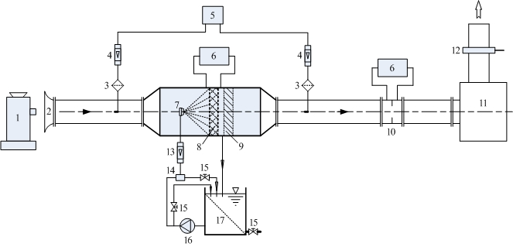
Fig. 3. The analogue experiment system. 1 - Dust emitter; 2 - collector; 3 - sampling head; 4 - gas flowmeter; 5 - sampler; 6 - micro-manometer; 7 - atomizing nozzle; 8 - fibrous filter layer; 9 - fluid exhaustion unit; 10 - orifice flowmeter; 11 - blower and control cabinet; 12 - gate valve; 13 - fluid flow meter; 14 - filter; 15 - valves; 16 –feed liquid pump; 17 – fluid storage tank.
Table 1. Analogue experiment parameters.
Air flow parameters |  |  | Fiber filter parameters |  |  |  | Dust parameters | Spray parameters
Dynamic viscosity  μ/ N·s·m⁻² | Absolute temperature  T / ⁰K | Filtration velocity  u_{x} /m·s⁻¹ | Filament diameter  d_{f} / μm | Thickness  H / m | Area of  fluid received  A / m² | Filling  rate  β _{f} / % | true density of dust spcimen  ρ_{p} / kg·m⁻³ | Quantity of  fluid supplied  Q/L·h⁻¹ | Filling rate  β₁ / %
1.81×10⁻⁵ | 290 | 1.39 | 133 | 0.04 | 0.11 | 1.01 | 2750 | 72 | 0.45

As can be seen from Figure 4, the curve trend of the calculation by theoretical equation (6) and the measured one in the analogue experiments are basically consistent, adequately revealing the law of the wet filtration and purification, especially for the dust particles larger than 10μm, the theoretical calculations and experimental results are consistent, while for the dust particles below 10μm, there is certain deviation between the results, the smaller the dust particle size is, the greater the deviation, the theoretically calculated purification efficiency of fine dust particles is higher than the experiment measured one.
The main reason lies in the surface tension of the cleaning fluid (water), and the trapping of fine dust mainly relies on diffusion effect, so fine dust particles can hardly break through the fluid (water) surface to be moistened and trapped, while in theory it is simply assumed that as long as the dust particles come into contact with the fluid surface, they will be moistened and trapped, the effect of surface tension is not taken into account.

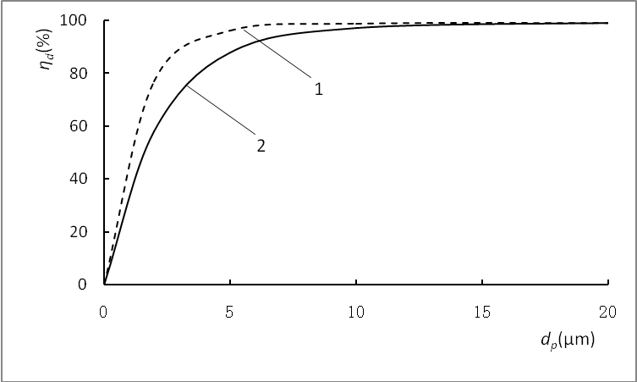
Fig. 4. Comparison between the calculated results using formula (6) and measured results.1— Calculated results by formula (6); 2—measured results in the experiments
Despite the gap between the theoretical and the measured results of the fine dust particles, the result of theoretical analysis has fully reflected the basic law of the filtration process. Meanwhile, the analysis of analogue experimental curve shows that in the wet filtration and purification process, the purification efficiency of the fine dust will be improved by sufficiently reducing the surface tension of the cleaning fluid, and the actual experiment result will be closer to the calculated result by theoretical formula (6), which instructs the way to further improve the purification efficiency of the fine dust.
CORRECTION OF THE THEORETICAL FORMULA
In practical applications, to get the calculated result of theoretical formula (6) closer to the actual one, the experimental data obtained are applied for its dimensionless correction.
The exponential term in theoretical formula (6) is set with a correction factor ζ, the equation becomes the following one:
$η_{d}=1−\text{exp}\left\{−ζ⋅\frac{4}{π}⋅\frac{\sqrt{β_{f}⋅(β_{1}+β_{f})}}{1−(β_{1}+β_{f})} ⋅\frac{H}{d_{f}}⋅ E\right\}$ (8)
Taking the natural logarithm for both ends of the equal sign after the deformation of the formula, the following one is obtained:
$$\text{ln}\frac{1}{1−η_{d}}=ζ⋅\frac{4H}{π⋅d}⋅\frac{\sqrt{β_{f}⋅(β_{1}+β_{f})}}{1−(β_{1}+β_{f})}⋅E$$
Provided that
$Y=\text{ln}\frac{1}{1−η_{d}}$ and
$X=\frac{4H}{π⋅d_{f}}⋅\frac{\sqrt{β_{f}⋅(β_{1}+β_{f})}}{1−(β_{1}+β_{f})}⋅E$,
the following linear equation is obtained:
Y = ζX (9)
The relevant values ​​of different particle sizes are calculated with experimental data and the parameters in Table 1 and substituted to determine the scatter plot of X corresponding to Y, as per the form of formula (9) for linear equation regression, the slopeζ = 0.97 of the linear equation is obtained, which is substituted into formula (8) and the corrected formal of the theoretical formula is obtained:
$η_{d}=1−\text{exp}\left\{−0\text{.}\text{97}⋅\frac{4}{π}⋅\frac{\sqrt{β_{f}⋅(β_{1}+β_{f})}}{1−(β_{1}+β_{f})} ⋅\frac{H}{d_{f}}⋅ E\right\}$(10)
Formula (10) is a semi-theoretical and semi-empirical formula for stage efficiency of the wet fiber layer for dust filtration and purification after the dimensionless correction. The stage efficiency curve of the wet fiber layer filtration and purification calculated with this formula compared with the measured result is as shown in Figure 5.
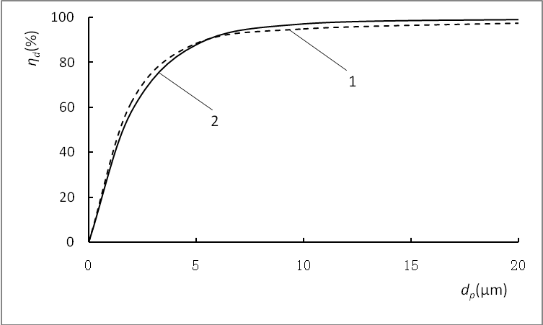
Fig. 5. Comparison between the calculated result based on formula (10) and the measured result. calculated results by formula (10); 2—measured results in the experiments.
It can be seen from Fig. 5 that the two curves are very close, indicating formula (10) can accurately reflect the actual situation of the wet fiber layer filtration and purification, which can be used to guide the practical application.
CONCLUSIONS
For the wet filtration and purification technology combining the fiber layer with spray for dust particles, the equivalent relationship has been established between the system fluid amount and the filling rate inside the fiber layer by means of the equivalent analogy hypothesis, enabling the complex problems to be described theoretically.
The derived purification efficiency formula for wet filtration and purification process of dust particle reflects the functions and influences of physical parameters in the process of wet filtration, which can be used to guide actual wet filtration and purification process. The semi-empirical and semi-theoretical efficiency formula obtained through dimensionless correction of the theoretical formula reflects the actual situation more accurately. For other specific cases, the correction method mentioned in this article may be used to obtain accurate semi-empirical and semi-theoretical calculation formula for practical application.
The theoretical calculations and experimental results in Figure 4 show that the surface tension of the cleaning fluid is an important factor affecting the purification effect of the fine dust, it is just because the surface tension of the cleaning fluid that hinders the cleaning fluid from moistening and trapping the fine dust particles, as a result, the surface tension of the cleaning fluid reduced as much as possible will be of significance to purification of fine dust particles.
Acknowledgements: Fund program: The project funded by the National Natural Science Fund (51274127, 51204100)
REFERENCES
- Sun G.Y., Filtering performance and mechanism research of wet fiber, Master’s Thesis, Northeastern University, 1987, pp. 126-132.
- Zhang Y.L., Tang M.K., Metal Mines, 9, 91 (2010).
- Chen X.S., Li Y., Environ. Eng., 6, 38 (2005).
- Rao C.S., Environmental Pollution Control Engineering, New York: John Wiley & Sons, 8, 25 (1991).
- Xiang X.D., Metallurgical Industry Press, 8, 108-113 (2002).
- Zhang G.Q., Beijing: China Environmental Science Press, 12, 53 (1987).

