© 2017 Bulgarian Academy of Sciences, Union of Chemists in Bulgaria

Dyeing of offset printing paper with new reactive dyes - influence over the paper properties and the ageing
D. A. Todorova, P. M.Miladinova, V. N. Blyahovski
University of Chemical Technology and Metallurgy, 8 Kl. Ohridski, 1756 Sofia, Bulgaria
Received November 16, 2016; Accepted May 8, 2017
According to Smithers Pira, the paper and board demand in the region of Central and East Europe, is expected to increase and not a small part is coloured paper mainly because the increased consumption of corrugated board papers, but also because the increased consumption of specially coloured printing papers, for the new digital technology for the printing and publishing industry. Ttherefore, dyeing of offset paper is reasonable and the use of reactive dyes would have benefits. The aim of this study was to investigate the influence of three new reactive dyes over the main strength and hydrophobic properties of the coloured offset printing paper and colour stability during ageing.
In the present study were used three reactive dyes, both of them were laboratory synthesized monochlorotriazine reactive orange and red dyes, containing stabilizer fragment and the other was commercial reactive red product of Kemira®. Dyes were used in the composition of offset printing paper with a fibre content of bleached softwood and hardwood pulp. The main strength and hydrophobic properties of the coloured papers were examined. The optical properties and colour stability of the paper samples were also being examined before and after the thermal and light accelerated ageing.
As a result of the studies carried out it was found out that with the three reactive dyes were obtained paper samples with uniform colouring. The obtained papers were with stable colour, distinguished by stability under thermal and light accelerated aging. The sizing of the paper was enhanced and the strength was at the same level.
Key words: reactive dyes, offset paper, hydrophobic properties, optical properties, thermal ageing, light ageing

Introduction
According to Smithers Pira, the paper and board demand in the region of Central and East Europe, is expected to increase with about 2 million tons during 2014 to 2019 [1]. Not a small part of it is coloured paper mainly because the increased consumption of corrugated board papers, but also because the increased consumption of specially coloured printing papers, for the new digital technology for the printing and publishing industry. Ttherefore, dyeing of offset paper is reasonable and the use of reactive dyes would have benefits.
Reactive dyes are widely used in the textile industries not only for cotton, but also wool and polyamides, because of their wide variety of color shades, simple dyeing procedure and good stability during washing process and brilliant colors, but they have only limited use in paper production [2,3].
Reactive dyes for cellulose resemble acid dyes in their basic structure, but additionally possess one or more reactive groups. Dyes containing a dichlorotriazinyl reactive group are capable of reacting with cellulosic fiber, in the presence of alkali, to form covalent bond between the dye and the fibre [4].
Reactive dyes are divided, according to their structure of reactive group, in haloheterocycle and vinyl sulfone based dyes, which react with cellulose through nucleophilic substitution and addition mechanisms, respectively. Commercially, the widest used systems are: vinyl sulfone, monochlorotriazine, bifunctional dyes, difluoro chloropyridine, monofluoro triazine and dichlorotriazine. In addition to reacting with fibre, reactive dyes also react with water (dye hydrolysis) in a form which cannot bound to cotton, but behaves as a substantive dye and affects colour fastness, when is used on fabric. The most important parameter affecting exhaustion and „fixation“of reactive dyes are temperature, salt and alkali concentration and liquid ratio [4,5].
*) To whom all correspondence should be sent:
E-mail: todorova.dimitrina@uctm.edu
Reactive dyes require high concentrations of an electrolyte to improve dye-fibre interaction. One approach to improve the fixing ability of the dye is by using a fixative agent (cationic chemical reagent) before adding the reactive dye. [6-9]
Because of the limited use of reactive dyes in the paper dyeing process, there are not so much results about the properties of the paper suspensions, paper white waters and paper properties.
This article is a continuation of our previous work to investigate the influence of new reactive dyes over the properties of the paper suspensions and the white waters from the production of coloured offset printing paper [10,11].
The purpose of this study was to investigate the influence of three new reactive dyes over the main strength and hydrophobic properties of the coloured offset printing paper and colour stability during ageing.
EXPERIMENTAL
In the current experiment were used three reactive dyes, both of them are laboratory synthesized monochlorotriazine reactive orange and reactive red dyes, containing stabilizer fragment and the other was commercial reactive red product from the Levacell® range of Kemira®.
The used Reactive Dye 2 (RD2) was laboratory synthesized and it is compound of monoazo reactive dyes whose chromophore is an orange acid dye, prepared by diazotization of the amino C acid and subsequently coupling with I acid in a slightly alkaline medium. Reactive group (chlorine atom) was introduced into the chromophore by reaction of the acid orange dye with cyanuric chloride and the dichlorotriazine reactive dye was obtained. In the subsequent step by a reaction of the last one with 4-amino-2,2,6,6-tetramethylpiperidine or ammonia the monochlorotriazine reactive orange dyes (1) and (2) were obtained.
The tetramethylpiperidine fragment in the molecule acts as a stabilizer fragment and its introduction was done with purpose - increment of the colour fastness to light (photo-stability). It was expected that the paper dyed with this dyes exhibit also an enhanced photo-stability. This assumption was made based on the fact that the dyed fibres (cotton and wool) and chemically coloured polymers showed high photo-stability [12,13]. The reactions of the synthesis are shown on Fig. 1.

Fig.1 Chemical characteristic of reactive dye 2.

Based on our previous studies [10] conducted with RD1 and RD2, for further research we chose working with RD2.
Reactive Dye 3 (RD3) is commercial reactive red dye from the Levacell® range of Kemira® – Levacell® Neon Red 2B 05, which is Azo-reaktivfarbstoff (azo-reactive dye).
Reactive Dye 4 (RD4) was synthesized similarly to the RD2, where instead of amino C acid and I acid the 2-aminobenzenesulfonic acid and H acid were used (Fig.2).

Fig.2 Synthesis of reactive dye 4.

The consumption of Reactive Dyes in the paper is 0,2%, 0,4%, 0,6% from o.d.f.
The investigations were carried out with laboratory obtained paper samples (70 g/m²) from bleached hardwood and softwood pulp in proportion 1:1, with beating degree of 42°SR (Schopper Riegler).
The colour and the wavelength of the dyes are shown on Fig. 3. For fixing the reactive dyes was used cationic polymer fixative on the basic of epichlorhydrin-dimethylamin-copolymer (Levogen E 1063 LQ of Kemira) with a consumption of 1% of o.d.f. The paper was sized with alkyl ketene dimer – 2% of o.d.f (Fennosize KD 157YC of Kemira) and as filler was used ground calcium carbonate – 20% of o.d.f (Hydrocarb V40 of Omya). As a retention additive was used modified polyacrylamide with cationic charge – 0,05% of o.d.f.

RD 2 λ= 504nm RD 3 λ= 618nm RD 4 λ= 528nm
Fig. 3 Dyed paper samples with the three examined reactive dyes
The obtained paper samples were being examined for its strength properties - the Tensile Index (TI), Nm/g acc. ISO 1924-2:2008 [14], hydrophobic properties – water absorptiveness Cobb₆₀, g/m² acc. ISO 535:2014 [15], optical properties – colour coordinates L*, a* and b* before and after the accelerated ageing, by Frank – PTI spectrophotometer / D65_10.
The thermal ageing was conducted according to ISO 5630-1:2014 [16] at temperature of 105 °C, and duration of 48h.
The light ageing was conducted according to ISO 5630-7:2014 [17], by exposure to light with intensity of 765±75W/m² and wavelength of 290-800nm and duration of 48h.
RESULTS & DISCUSSION
Influence of the quantity and type of the reactive dyes, on the properties of the papers
The parameter Tensile Index (N.m/g), depends primarily on the amount and strength of the bonding forces between the fibres in the finished paper sheet. As it is shown on Fig.4, with adding of reactive dyes, the tensile strength of the paper samples is improved or remained unchanged. It is interesting that RD2 give an enhanced for the tensile index of the paper samples in all three consumptions, and the improvement is with about 2 N.m/g. When adding RD3 the results for this parameter are higher than those with RD2 and RD4. As it is seen from the figure, best result is obtained at 0,4% consumption of RD3. RD 4 give limited effect over the strength properties and just about at 0,4% quantity the parameter is higher that the sample without reactive dye. Probably, with the small consumption of the RD4 the hydrogen bonds between the fibres are less, but after 0,4% dye, the bonding forces in the paper are also with the participation of the hydroxyl groups from the dye molecule.
Fig. 4. Dependence of Tensile Index (TI) of the paper samples, from the RD type and consumption
On Fig.5 are shown the results for the water absorptiveness Cobb₆₀ (g/m²) of the obtained paper samples. As it is seen from the figure, by adding and increasing the dye consumption, the water absorptiveness decreases, which means that the paper is with higher hydrophobicity. Probably the results are due to the presence of covalent bonds and the less free hydroxyl groups, which can react with the water. Best results are obtained with RD4 even at 0,2% quantity of the dye. According to the positive effect of the reactive dyes, for the water absorptiveness Cobb₆₀, the dyes can be arranged in the following descending order: RD4 > RD3 > RD2.
Fig. 5. Dependence of water absorptiveness (Cobb₆₀, g/m²) of the paper samples, from the RD type and consumption
The water absorption of the paper is one of the most important indicators relating to the good printability of offset papers. Therefore, the effect of the investigated reactive dyes upon water absorptiveness can be considered as a great advantage over the other types of dyes used in the paper industry.
190
Influence of the quantity and type of reactive dyes, on the colour stability of the paper samples during accelerated thermal ageing.
Accelerated ageing of paper is carried out for three major purposes. The first is to establish in a conveniently short time the relative ranking of materials, or physical combination of materials, with respect of their chemical stability or physical durability. The second is to estimate or predict potential long-term serviceability of material systems under expected conditions of use, and the third is to elucidate the chemical reactions involved (the degradation mechanism) and the physical consequences thereof. [18]
It is well known that the main reason for the loss of paper strength, during ageing is the hydrolytic degradation, while for the colour stability is the lignin content.
From different previous publications [19,20] is known, that three days (72h) of accelerated thermal ageing at 105ºC is equal to 25 years of natural ageing. In view of the fact, that the received by us paper samples are by bleached cellulose and the thermal aging is most noticeable during the first six hours, we assumed that for the colour parameters longer aging more that 48h is not necessary.
The results for the colour coordinate - L*, which expresses the lightness, brightness and the brilliance of the paper, during the accelerated thermal ageing of the paper samples, are presented in Table.1. It is clearly seen that L* decreases with adding of the three examined reactive dyes and the biggest difference is in the paper samples dyed with RD 3. The colour parameter variation with time is comparatively low, being most sensitive during the first 24 hours.
Table 1. Colour coordinate L* during 48h of thermal ageing
Reactive Dye Type | Reactive  Dye, % | L*
Reactive Dye Type | Reactive  Dye, % | Duration of Thermal Ageing
 |  | 0h | 6h | 12h | 24h | 36h | 48h
without RD | 0% | 93,34 | 92,49 | 92,93 | 92,73 | 92,77 | 92,67
RD2 | 0,2% | 80,3 | 80,09 | 79,6 | 79,55 | 79,6 | 79,65
RD2 | 0,4% | 75,61 | 75,33 | 75,26 | 75 | 74,95 | 74,96
RD2 | 0,6% | 72 | 72,06 | 71,73 | 71,73 | 72,14 | 72,09
RD3 | 0,2% | 74,87 | 74,79 | 74,95 | 74,9 | 74,65 | 74,68
RD3 | 0,4% | 68,81 | 68,94 | 68,93 | 68,82 | 68,73 | 68,72
RD3 | 0,6% | 65,02 | 65,08 | 64,87 | 64,95 | 64,88 | 64,88
RD4 | 0,2% | 79,71 | 79,41 | 79,32 | 79,34 | 79,64 | 79,42
RD4 | 0,4% | 73,79 | 73,91 | 73,92 | 74,1 | 74 | 74,2
RD4 | 0,6% | 72,15 | 72,27 | 72,30 | 72,64 | 73,11 | 73,24
As regards the influence of the quantity of the dye, it can be said that the variation of this parameter is more sensitive at lower dye consumption. The difference between the lightness of the paper at 0,2% to 0,4% compared to that between 0,4%-0,6% is higher. With increasing consumption of the dyes the parameter changes with smaller variations.
With increasing the dyes consumption and the duration of the thermal ageing, the colour of the paper samples is slightly getting lighter.
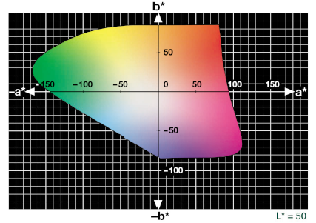
Fig.6 CIE L*a*b* colour space, at L*=50
With the three examined reactive dyes are obtained paper samples with uniform colouring. If the a* parameter, in the colour system CIE L*a*b*, is positive the colour is red and if the b* parameter is also positive the colour is yellow (Fig.6).
The results for the colour coordinates a* and b* of the paper samples dyed with the three examined reactive dyes, during the 48h thermal ageing, are presented in Fig. 7, Fig.8 and Fig.9.
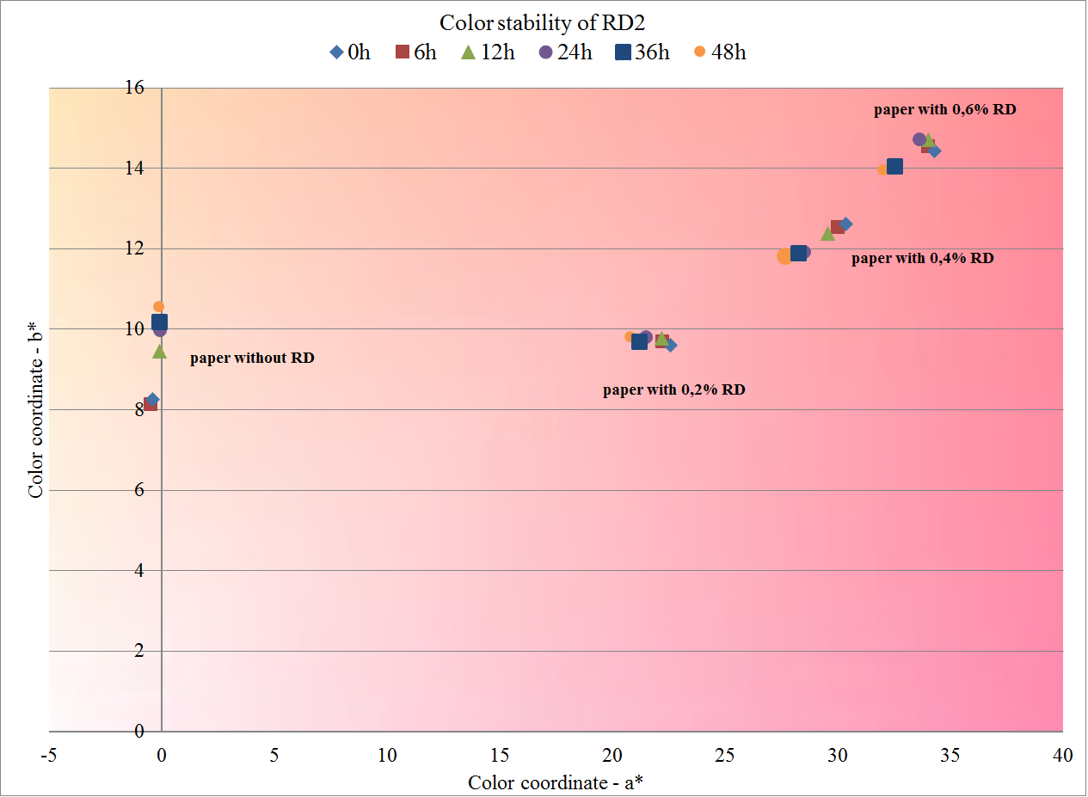
Fig. 7. Color stability, expressed as the a* and b* color coordinates of the paper samples dyed with RD2 during the thermal ageing
The general review of the figures shows that the paper samples dyed with RD2 has a substantially different colour from the other two reactive dyes, as both parameters have positive values, hence its colour is red-orange. Reactive dyes 3 and 4 have negative values ​​of b*, which means that their colour is in the range of magenta.
From Fig. 7, which represent the stability of the colour paper samples dyed with RD2, it can be seen that the greatest colour change was observed after the first 24 hours of the thermal aging, and the least is the change in the paper samples at dye consumption of 0.2%. With increasing of the consumption of RD2, the difference in the colour characteristics are increased, as is most apparent at 0.6%. In all three examined reactive dyes, paper becomes darker and the colour shifts to yellow hues. Least change is observed at the low dye quantity.
At RD3 the colour change has a different character than that of RD2 (Fig.8). The points that unsubscribed the chromaticity coordinates of the paper samples with dye consumption of 0.2% are relatively scattered, but with a clear and smooth tendency towards yellowing, while at a rate of 0.6%, are relatively compact, but again with continuous variation. And here, as it is at RD2, the colour of the paper samples is changing to yellow hues. With increasing the dye concentration, the colour stability is increased and the change to yellow hues in the smaller ranges.
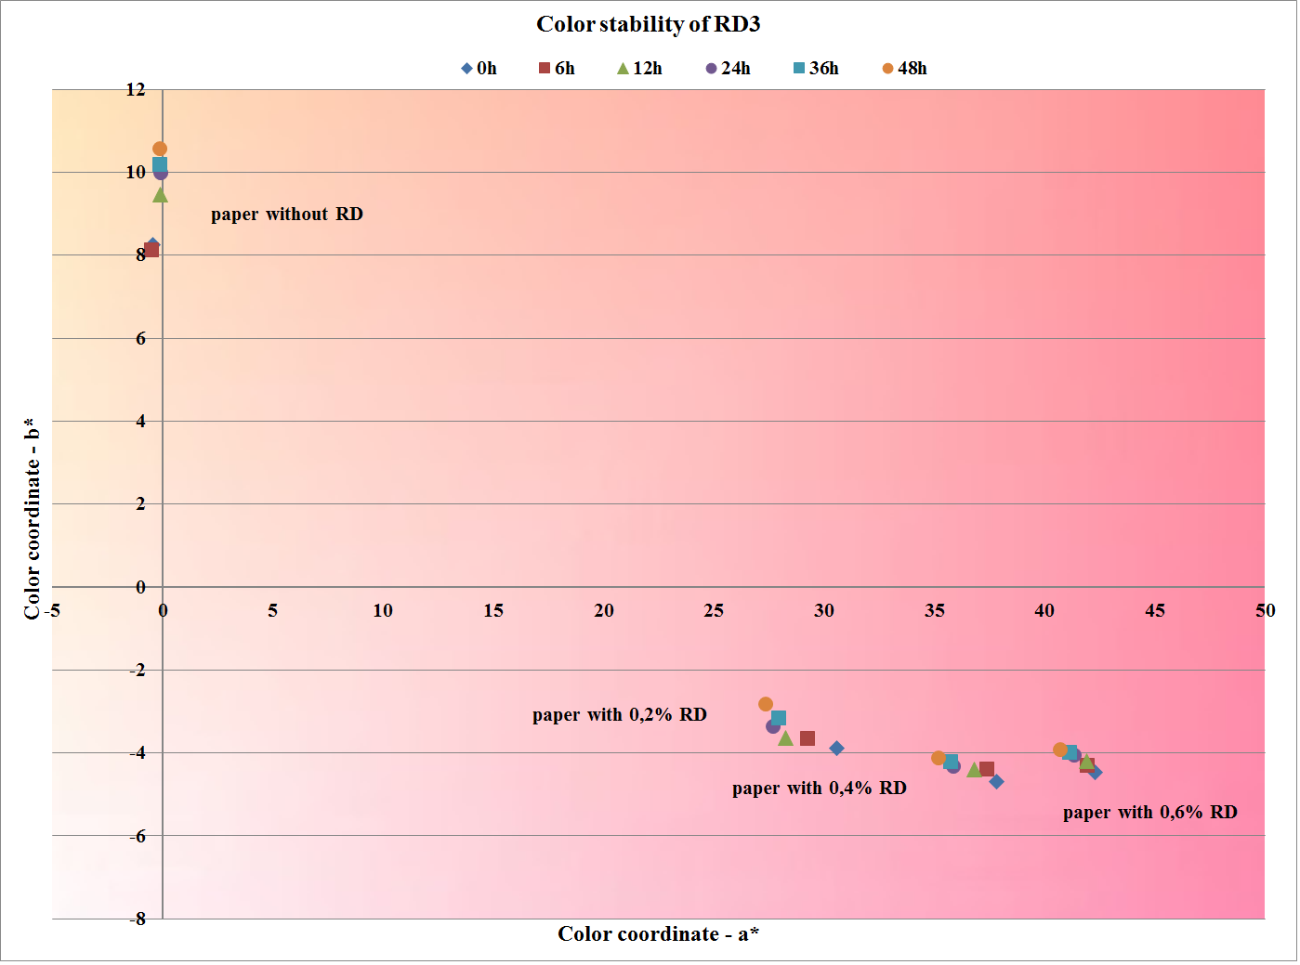
Fig. 8. Colour stability, expressed as the a* and b* colour coordinates of the paper samples dyed with RD3 during the thermal ageing
The colour stability of the paper samples, dyed with RD4, during the accelerated thermal ageing is shown on Fig. 9. Regarding the RD4, the results are the most controversial and it is difficult to be defined a clear boundary between the colours of the paper samples at different reactive dye consumption. This is the dye with the lowest colour stability and the greatest change in the direction of yellowing.
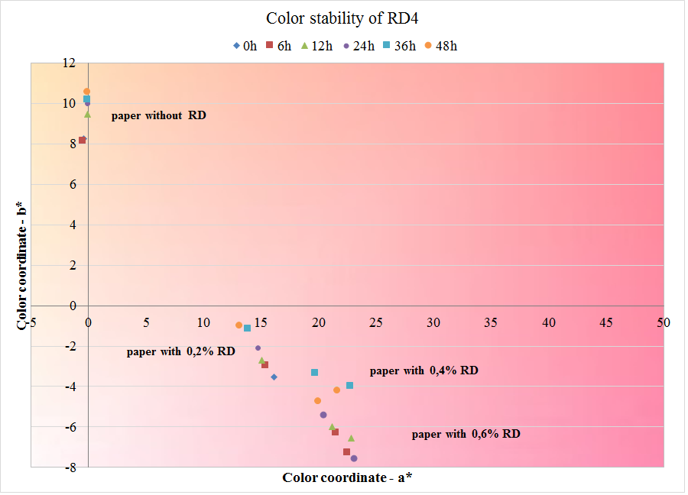
Fig. 9. Colour stability, expressed as the a* and b* colour coordinates of the paper samples dyed with RD4 during the thermal ageing
Influence of the quantity and type of reactive dyes, on the colour parameters of the paper samples during accelerated light ageing
Light plays an important role in the natural ageing of paper. The effect of light on paper has been reviewed by several authors [13,14] and a lot of experiments had been made during the natural conditions. Experimental results indicate that the mechanisms for aging with pollutants, light and heat are all different from each other and are also fibre dependent [15].
In our experiment the accelerated light ageing is being conducted in apparatus - Ametek Atlas MTS Suntest CPS+Benchtop Xenon Exposure Environment Tester Chamber.
Table 2. Colour coordinate L* during 48h of light ageing
Reactive Dye Type | Reactive  Dye, % | L*
Reactive Dye Type | Reactive  Dye, % | Duration of Thermal Ageing
 |  | 0h | 6h | 12h | 24h | 36h | 48h
without RD | 0% | 93,34 | 93,19 | 93,18 | 93,32 | 93,23 | 93,09
RD2 | 0,2% | 80,3 | 80,69 | 80,73 | 82,58 | 82,23 | 84,67
RD2 | 0,4% | 75,61 | 75,98 | 75,83 | 77,41 | 79,23 | 81,5
RD2 | 0,6% | 72 | 72,24 | 72,43 | 72,8 | 74,92 | 78,89
RD3 | 0,2% | 74,87 | 74,66 | 75,32 | 75,11 | 75,63 | 78,35
RD3 | 0,4% | 68,81 | 68,51 | 69,52 | 68,96 | 69,39 | 71,54
RD3 | 0,6% | 65,02 | 64,91 | 65,01 | 65,26 | 65,5 | 65,51
RD4 | 0,2% | 79,71 | 79,57 | 79,88 | 81,7 | 81,62 | 80,7
RD4 | 0,4% | 74,64 | 74,42 | 74,86 | 76,09 | 76,87 | 77,33
RD4 | 0,6% | 71,23 | 71,05 | 71,43 | 73,12 | 73,95 | 74,41
The results for the colour coordinate - L* during the accelerated light ageing of the paper samples, are presented in Table 2. During the light aging, this parameter is most sensitive. But unfortunately we cannot highlight clear dependence between the dye consumption and the duration of the light aging. However, it can be said that the paper samples dyed with RD3 are most stable and there is no drastically amending of the lightness. For the other two examined reactive dyes, the colour amending occurs after the 36 hours of light aging. The values of the parameter L* increases, which means that the paper is getting brighter.
192
The results for the colour parameters of the paper samples, during the accelerated light ageing, are shown on Fig.10, Fig.11 and Fig.12.
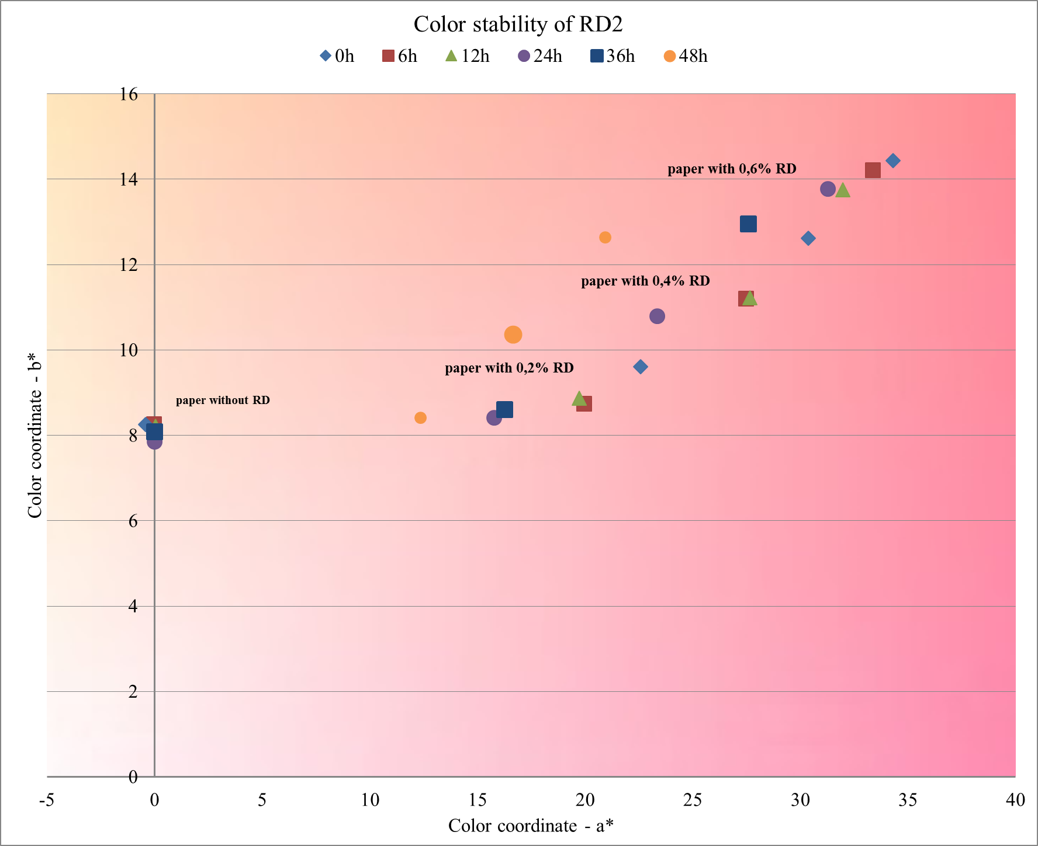
Fig. 10. Colour stability, expressed as the a* and b* colour coordinates of the paper samples dyed with RD2 during the light ageing
From Fig. 10, which represent the stability of the colour paper samples dyed with RD2 it is seen that in this dye the colour change over time is smooth and follows a clear pattern - from left to right, which means that the colour of the paper samples lightens as the greatest change occurred in the first 6 hours of light aging, and between 36^{-th} and 48^{-th} hour.
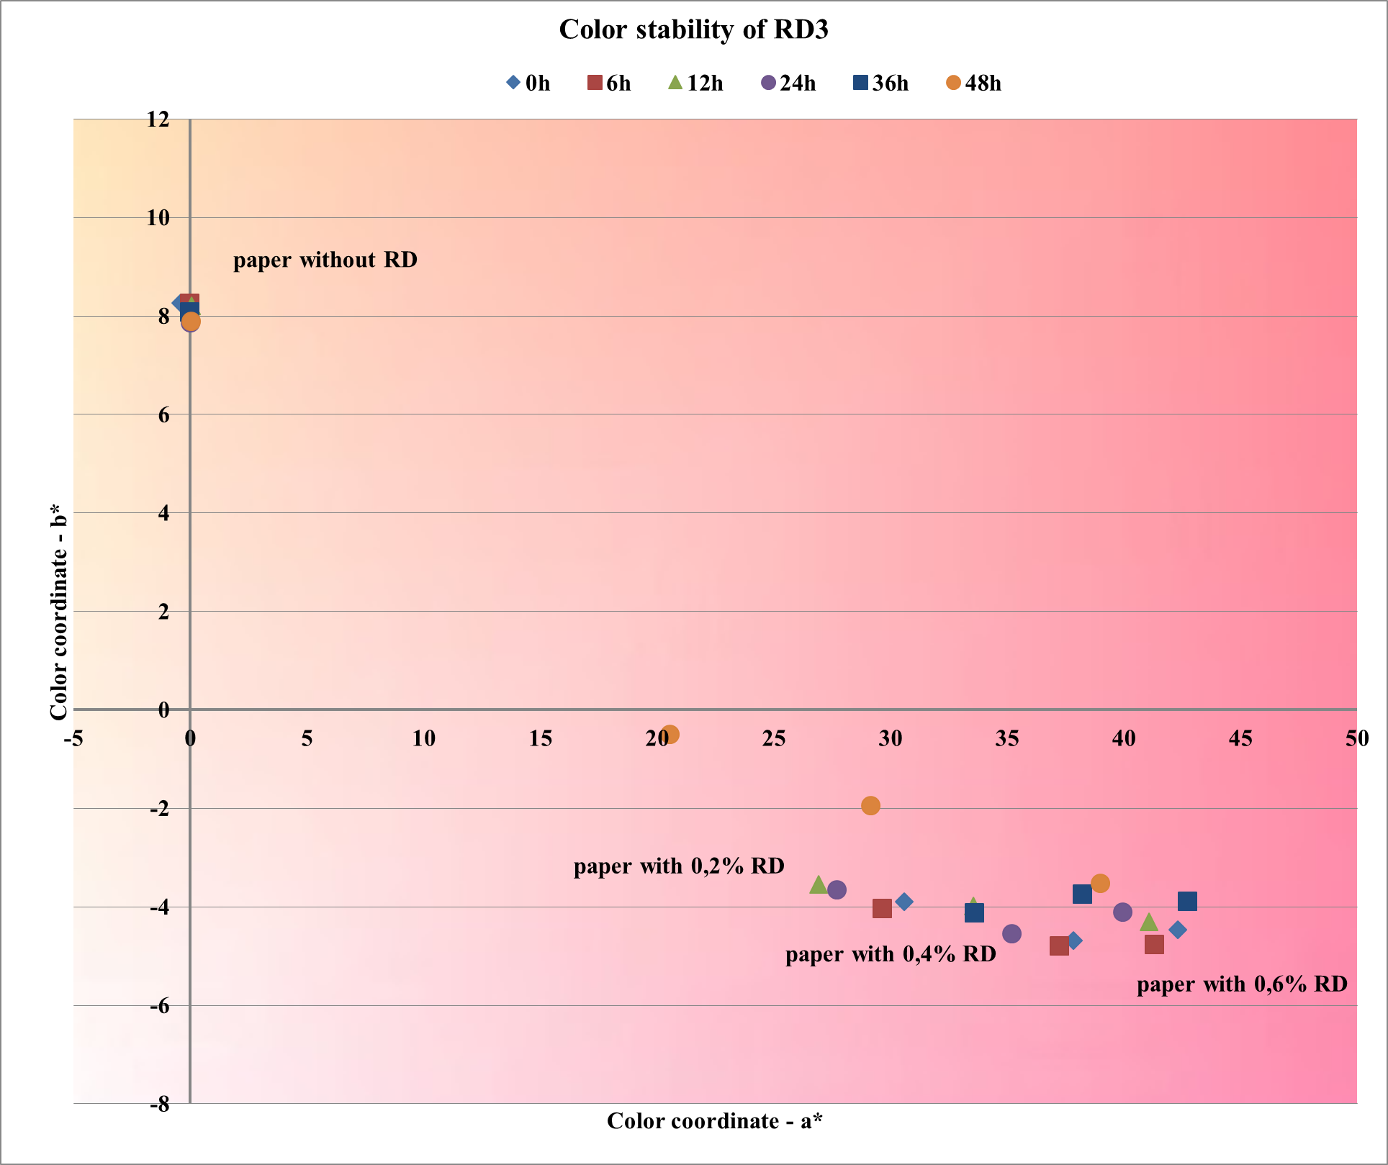
Fig. 11. Colour stability, expressed as the a* and b* colour coordinates of the paper samples dyed with RD3 during the light ageing
The change of the colour parameters a* and b*, of paper hand-sheets dyed with RD3 are presented in Fig. 11. As with RD2 here trends in colour changing are again clear and the change is from left to right, but the differences are smaller, probably because the colour is darker and the influence of light is not so intense as in bright shades. The greatest aging was observed at dye consumption of 0,2%. Drastically changes in the colour occurred at the three examined dye quantities after the 36^{-th} hour of light aging.
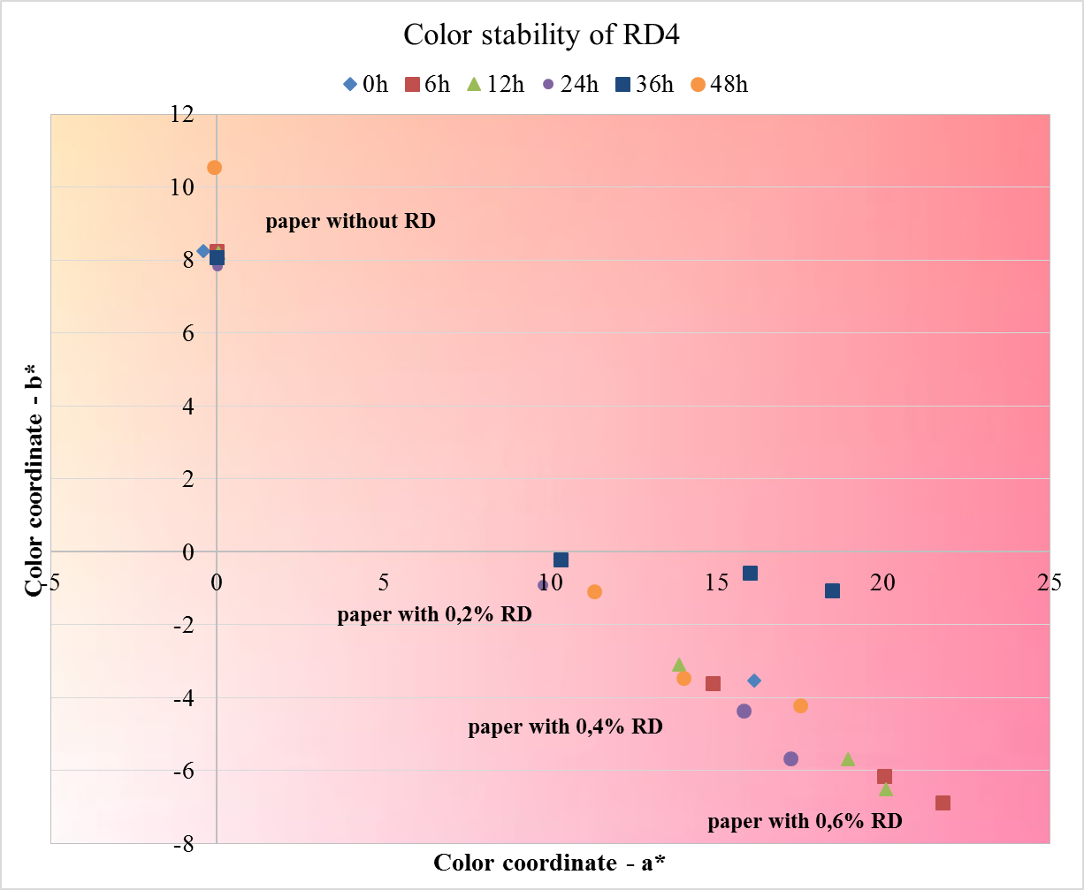
Fig. 12. Colour stability, expressed as the a* and b* colour coordinates of the paper samples dyed with RD4 during the light ageing
The results for the colour stability of the RD4 during light aging are difficult to be interpret because the colour coordinates of the resulting paper samples are too scattered and cannot define a clear boundary between the individual reactive dye consumptions.
Striking is the fact that unlike RD2 and RD3, even at 36^{-th} hour of the light ageing the colour of the paper is strongly shifted towards the lighter shades, but the location of the points describing the colour of the paper during the 48 hours run again darkening, which is associated with the burnout of the paper.
During the light aging of the paper samples, the largest variation is observed for the paper samples dyed with RD4. According to the positive effect of the reactive dyes, for the colour stability during light ageing, the dyes can be arranged in the following descending order: RD2 > RD3 > RD4.
CONCLUSIONS
On the basis of the results of the studies carried out for dyeing wood free neutrally sized paper by three reactive dyes, using cationic polyacrylamide as retention additive and with a view of the complex influence on the properties and colour stability during accelerated ageing the following conclusions can be made:
- With adding of the three examined reactive dyes, the tensile strength of the paper samples is improved or remained unchanged.
- According to the positive effect of the reactive dyes, for the water absorptiveness Cobb₆₀, the dyes can be arranged in the following descending order: RD4 > RD3 > RD2.
- The positive effect of the investigated reactive dyes upon water absorptiveness can be considered as a great advantage over the other types of dyes used in the paper industry.
- During the thermal aging, more stable over time is the bright coloured paper samples and the changes are smooth.
- During the accelerated light aging, the changes in the colour are larger and have more variation in the parameters and after the 36-th hour of ageing the paper is burned-out.
- According to the positive effect of the reactive dyes, for the colour stability during thermal and light ageing, the dyes can be arranged in the following descending order: RD2 > RD3 > RD4.
- Both examined laboratory synthesized reactive dyes are suitable for dyeing of offset printing paper.
REFERENCES
- http://www.smitherspira.com, Paper and Board Market in Central and Eastern Europe to grow by 2% annually from 2013 to 2019, January, (2015)
- Ali S¹, Mughal MA², Shoukat U², Baloch MA², Kim SH³, Cationic starch (Q-TAC) pre-treatment of cotton fabric: influence on dyeing with reactive dye, Carbohydr Polym. 117, (2015), 271-278
- K.F. Morris, D.M. Lewis, P.J. Broadbent, Society of Dyers and Colourists, Coloration Technology, 124, 186 (2008).
- H. Tappe, W. Helmling, P. Mischke, K. Rebsamen, U. Reiher, W. Russ, L. Schläfer, P. Vermehren "Reactive Dyes"in Ullmann's Encyclopedia of Industrial Chemistry, Wiley-VCH, Weinheim, (2000)
- K. Venkataraman, The Chemistry of Synthetic Dyes, Vol. 7. Academic Press: New York, (1972),
- A. Tawfik, D.F. Zaki, M.K. Zahran, Degradation of reactive dyes wastewater supplemented with cationic polymer (Organo Pol.) in a down flow hanging sponge (DHS) system, J. Ind. Eng. Chem., 20, 2059 (2014).
- I.A. Bhatti, Sh. Adeel, S. Siddique, M. Abbas, J. Saudi Chem. Soc., 18, 606 (2014).
- Haiyan Li, Shiyu Liu, Jianhai Zhao, Na Feng, Colloids & Surfaces A Physicochemical and Engineering Aspects, , January 2016, 494.
- K. Chinoune, K. Bentaleb, Z. Bouberka, A. Nadim, U. Maschke, Appl. Clay Sci., 123, 64 (2016).
- D. Todorova, P. Miladinova, Int. Sci. J. Sci.. Business.Soc., Year 1, 22 (2016).
193
- V. Blahovski, D. Todorova, „New reactive dyes for offset paper – influence over the properties of white waters“, XXI international Symposium in the Field of Pulp, Paper, Packaging and Graphics, Proceedings, Zlatibor, 21-24 June, 2016.pp. 59-65.
- P. Petrova-Miladinova, T. Konstantinova, J. Univ. Chem. Technol. Metall., 39, 405 (2004).
- T. Konstantinova, P. Petrova-Miladinova, Dyes and Pigments, 67, 63 (2005).
- ISO 1924-2:2008 Paper and board -- Determination of tensile properties, International Organization for Standardization, Geneva, Switzerland, (2008)
- ISO 535:2014. Paper and board -- Determination of water absorptiveness - Cobb method, International Organization for Standardization, Geneva, Switzerland, (2014)
- ISO 5630-1:2014. Paper and board — Accelerated ageing — Part 1: Dry heat treatment at 105 °C, International Organization for Standardization, Geneva, Switzerland, (2014)
- ISO 5630-7:2014. Paper and board — Accelerated ageing — Part 7: Exposure to light, International Organization for Standardization, Geneva, Switzerland, (2014)
- M. Area, H. Cheradame, BioResources, 6, 5307 (2011).
- X. Zou, T. Uesaka, N. Gurnagul, Cellulose, 3, 243, (1996).
- X. Zou, T. Uesaka, N. Gurnagul, Cellulose, 3, 269 (1996).
- B. Havlínová, S. Katuščák, M. Petrovičová, A. Maková, V. Brezová, J. Cultural Heritage, 10, 222 (2009).
- H. Kipphan, „Hand Book of Print Media”, Heidelberg, Springer, 2001.
- S. Zervos, A. Moropoulou, Int. J. Preservation Library & Archival Material, 27, 219 (2006).
- V. Bukovski, Restaurator, 21, 55 (2000).
- M. Area, H. Cheradame, BioResources, 6, 5307 (2011).

БАГРЕНЕ НА ОФСЕТОВА ХАРТИЯ ЗА ПЕЧАТ С НОВИ РЕАКТИВНИ БАГРИЛА - ВЛИЯНИЕ ВЪРХУ СВОЙСТВАТА НА ХАРТИЯ И СТАРЕЕНЕТО
Д.А. Тодорова, П.М. Миладинова, В.Н. Бляховски
Химикотехнологичен и металургичен университет, бул. Климент Охридски №8, София 1756
Постъпила на 16 ноември, 2016 г.; приета на 18 май, 2017 г.
(Резюме)
Според Смитърс Pira, търсенето на хартия и картон в региона на Централна и Източна Европа се очаква да нарасне и не малка част да е цветна хартия, не само поради увеличеното потребление на вълнообразен картон, но и заради увеличеното потребление на специално оцветени хартии за печат, за новите цифрови технологии и издателската индустрия. Ето защо, багренето на офсетова хартия за печат е разумен подход и използването на реактивни багрила ще има ползи. Целта на това проучване е да се изследва влиянието на три нови реактивни багрила върху основните якостни и хидрофобни свойства на цветни офсетови хартии за печат и цветостабилността им по време на стареенето.
В настоящото изследване се използват три реактивни багрила, като двете от тях са лабораторно синтезиран монохлортриазинови реактивени оранжеви и червени багрила, съдържащ стабилизаторен фрагмент, а другото е реактивно червено багрило, търговски продукт на Kemira®. Багрилата се използват в състава на офсетова хартия за печат от избелена целулоза на иглолистна и широколистна дървесина. Разгледани са основните якостни и хидрофобни свойства на оцветените хартии, техните оптични свойства и стабилност на цвета им преди и след термично и светлинно изкуствено стареене.
В резултат на проведените изследвания се установи, че с трите реактивни багрила се получават хартиени проби с еднородно оцветяване. Получените хартии са със стабилен цвят, отличаващ се със стабилност както при топло, така и при светлинно стареене. Проклейването на хартията се подобрява, а якостта запазва нивото си.

