Study of color characteristic changes of printed images under artificial ageing on different papers
I.T. Spiridonov¹ *, R.K. Boeva¹, I.V. Lozanova-Doncheva¹, T.Ts. Bozhkova¹,
Ž. Pavlović ², G. Vladić ², N. Kašiković², M. Stančić ², B. Tacheva¹

¹Department of Pulp, Paper and Printing Arts University of Chemical Technology and Metallurgy,
²Department of Graphic Engineering and Design, University of Novi Sad,
Faculty of Technical Sciences, Novi Sad, Serbia
Submitted November 28, 2016; Accepted May 8, 2017
A comprehensive study of color characteristic changes of offset printed images have been performed. A specialized and designed for this research test form have been used. In real printing conditions on different papers have been printed the test form with big number of control strips and elements. The optical and color characteristics properties of different combinations of inks, paper and printing press were measured before and after artificial ageing time periods. The main goal of this paper is estimating and evaluation in real printing conditions on real papers the impact of artificial ageing of inks and papers.
Key words: color characteristics, offset printing, color difference, print quality, ageing of materials

- INTRODUCTION
Examination of color characteristiks of printed materials during the thermal ageing processes provides important information about preventive care, which should be undertaken for the purpose of preservation of printed materials kept in museums, libraries and archives and increase of their durability [1]. Until now there was not made enough experiments recording to the problems of aging and discoloring of offset prints. The main purpose of these studies is to follow the change of the color range and color difference arising on aging of prints.
For the determination of these parameters was needed to exposing the paper samples on artificial thermal ageing. The main goal is estimating and evaluation in real printing conditions on real papers the impact of artificial ageing of inks and papers.
- EXPERIMENTAL
For the purpose of the experiment were used printing samples printed on 5 major types of paper for sheet and reel offset printing machines, according to [2].
- Paper type 1 and 2, responding to coated papers – glossy and mat;
- Paper type 3, responding to LWC paper /coated reel paper/;
- Paper type 4, responding to offset uncoated paper;
- Newspaper.
On paper samples have been measured the change of color characteristics and brightness of the sealing material, and the change in the 3D color ranges, depending to the time of artificial thermal aging.
*) To whom all correspondence should be sent:
E-mail; i_spiridonov@abv.bg
© 2017 Bulgarian Academy of Sciences, Union of Chemists in Bulgaria
- Printing conditions and color measurement of printing samples
Printing was done in real production conditions with state-of-the-art-equipment. Implemented print forms were positive acting and were exposed by Computer to Plate System for direct exposure. Heat set reel offset printing presses Komori System 40 and sheet-fed offset printing press Heidelberg SpeedMaster 7.4-5 P+L was emoloyed. The ink sequence was Black (К), Cyan (C), Magenta (M), Yellow (Y). After printing of all test copies, printing samples were selected meeting the optimal inking requirements and corresponding to all examinations, according to [2, 3, 4]. Color measurements were performed with spectrophotometer GretagMacbeth Spectrolino installed on a scanning table GretagMacbeth X-Y SpectroScan [5]. Measurement conditions – standard light source D50, measuring geometry 45°/0° or 0°/45°, 2° standard observer [6].
Paper samples with printed control scales (TC 6.02) containing 999 color fields of dimensions 5x5 mm were treated and subjected to thermal ageing. The fields have single, double, triple and quadruple overprinting of inks. Resulting colors are the most common one, in respect where of human eye is particularly sensitive. Control scales may be used to examine changes in color characteristics of a printed image on the respective paper during the artificial thermal ageing process.
- Artificial thermal ageing
The color characteristics of 5 papers and printing samples were measured before and after artificial thermal ageing in cupboard at 105ºC for 72 hours. The measurements were done on intervals: 2 hours, 4 hours, 6 hours, 12 hours, 24 hours, 36 hours, 48 hours and 72 hours.
The following parameters were measured:
● CIE L*a*b [7, 8, 9] color charecteristics with spectrophotometer GretagMacbeth Spectrolino.
● Brightness of 5 papers was measured with apparatus ELREPHO-2000 on standard light source CIE D65, Brightness R₄₅₇, according to [10].
- RESULT AND DISCUSSION
А. Color characteristics and brightness of investigated printed materials before thermal ageing
Color characteristics and brightness of five types of papers, have been measured before printing and artificial thermal ageing. The results are shown in Table 1.
- Color characteristics and brightness of investigated materials depending of time of artificial thermal ageing
On next figures (Fig. 1, 2, 3) are presented graphic dependences of CIE L* values CIE a* and CIE b* of paper before and after exposing of artificial thermal ageing.
In addition to color range changes, it is essential to study color changes expressed by the color difference (∆E) resulting from thermal ageing as compared to untreated sample. For objectivity reasons, color difference was assessed using ∆E_{AVERAGE} – mean arithmetic color difference of 999 measured fields between the specific sample and the original untreated sample, before and after thermal ageing period calculated by Formula 1:

${ΔE}_{\text{AVERAGE}}=\frac{{ΔE}_{{\text{Sample}}/{\text{Original}}}^{\text{Field} 1}+{ΔE}_{{\text{Sample}}/{\text{Original}}}^{\text{Field} 2}+\text{.}\text{.}\text{.}+{ΔE}_{{\text{Sample}}/{\text{Original}}}^{\text{Field} \text{999}}}{\text{999}}$, (1)

where, ${ΔE}_{{\text{Sample}}/{\text{Original}}}^{\text{Field} }$ – color difference between a specific sample color field and the same field of the original untreated sample.
The results on Fig. 1 are showing relatively big change approx. 3,5 units of L in CIE L* between 0 - 24 hours and 36 - 72 hours. The difference of CIE L* is insignificant - about 1,5 units.
On the Fig. 2 the results shows sharp increase in the value of CIE a* /between 24 and 36 hours of thermal ageing/, approx 1,6 units. The exception is for newspaper where CIE a* difference between 36 and 72 hours is about 1 unit.
The experimental results shown on Fig. 4 presented constantly and uniformly increase of ΔE_{ab AVERAGE} between 0 and 72 hours of ageing. In the Fig. 1, 2 and 3 the changes of CIE L*, CIE a* and CIE b* are between specific time period of 12 hours. In Fig. 4 the resulting difference of ΔE_{ab} which is generalizing the results of Fig. 1-3, shows constant difference in all ageing hours 0-72.

Table 1. Color characteristics of papers before ageing
Type of paper | CIE L*a*b* |  |  | Brightness,  % | Mass  of paper,  g/m²
Type of paper | L* | a* | b* | Brightness,  % | Mass  of paper,  g/m²
Coated paper – glossy | 99,99 | -0,02 | -0,19 | 97,19 | 130
Coated paper – mat | 98,99 | -0,30 | 2,86 | 91,70 | 130
LWC paper | 97,49 | 0,48 | -0,31 | 91,00 | 90
Uncoated offset paper | 98,38 | 0,72 | -2,21 | 97,64 | 80
Newspaper | 90,25 | 0,07 | 10,34 | 58,88 | 45

CIE L* | 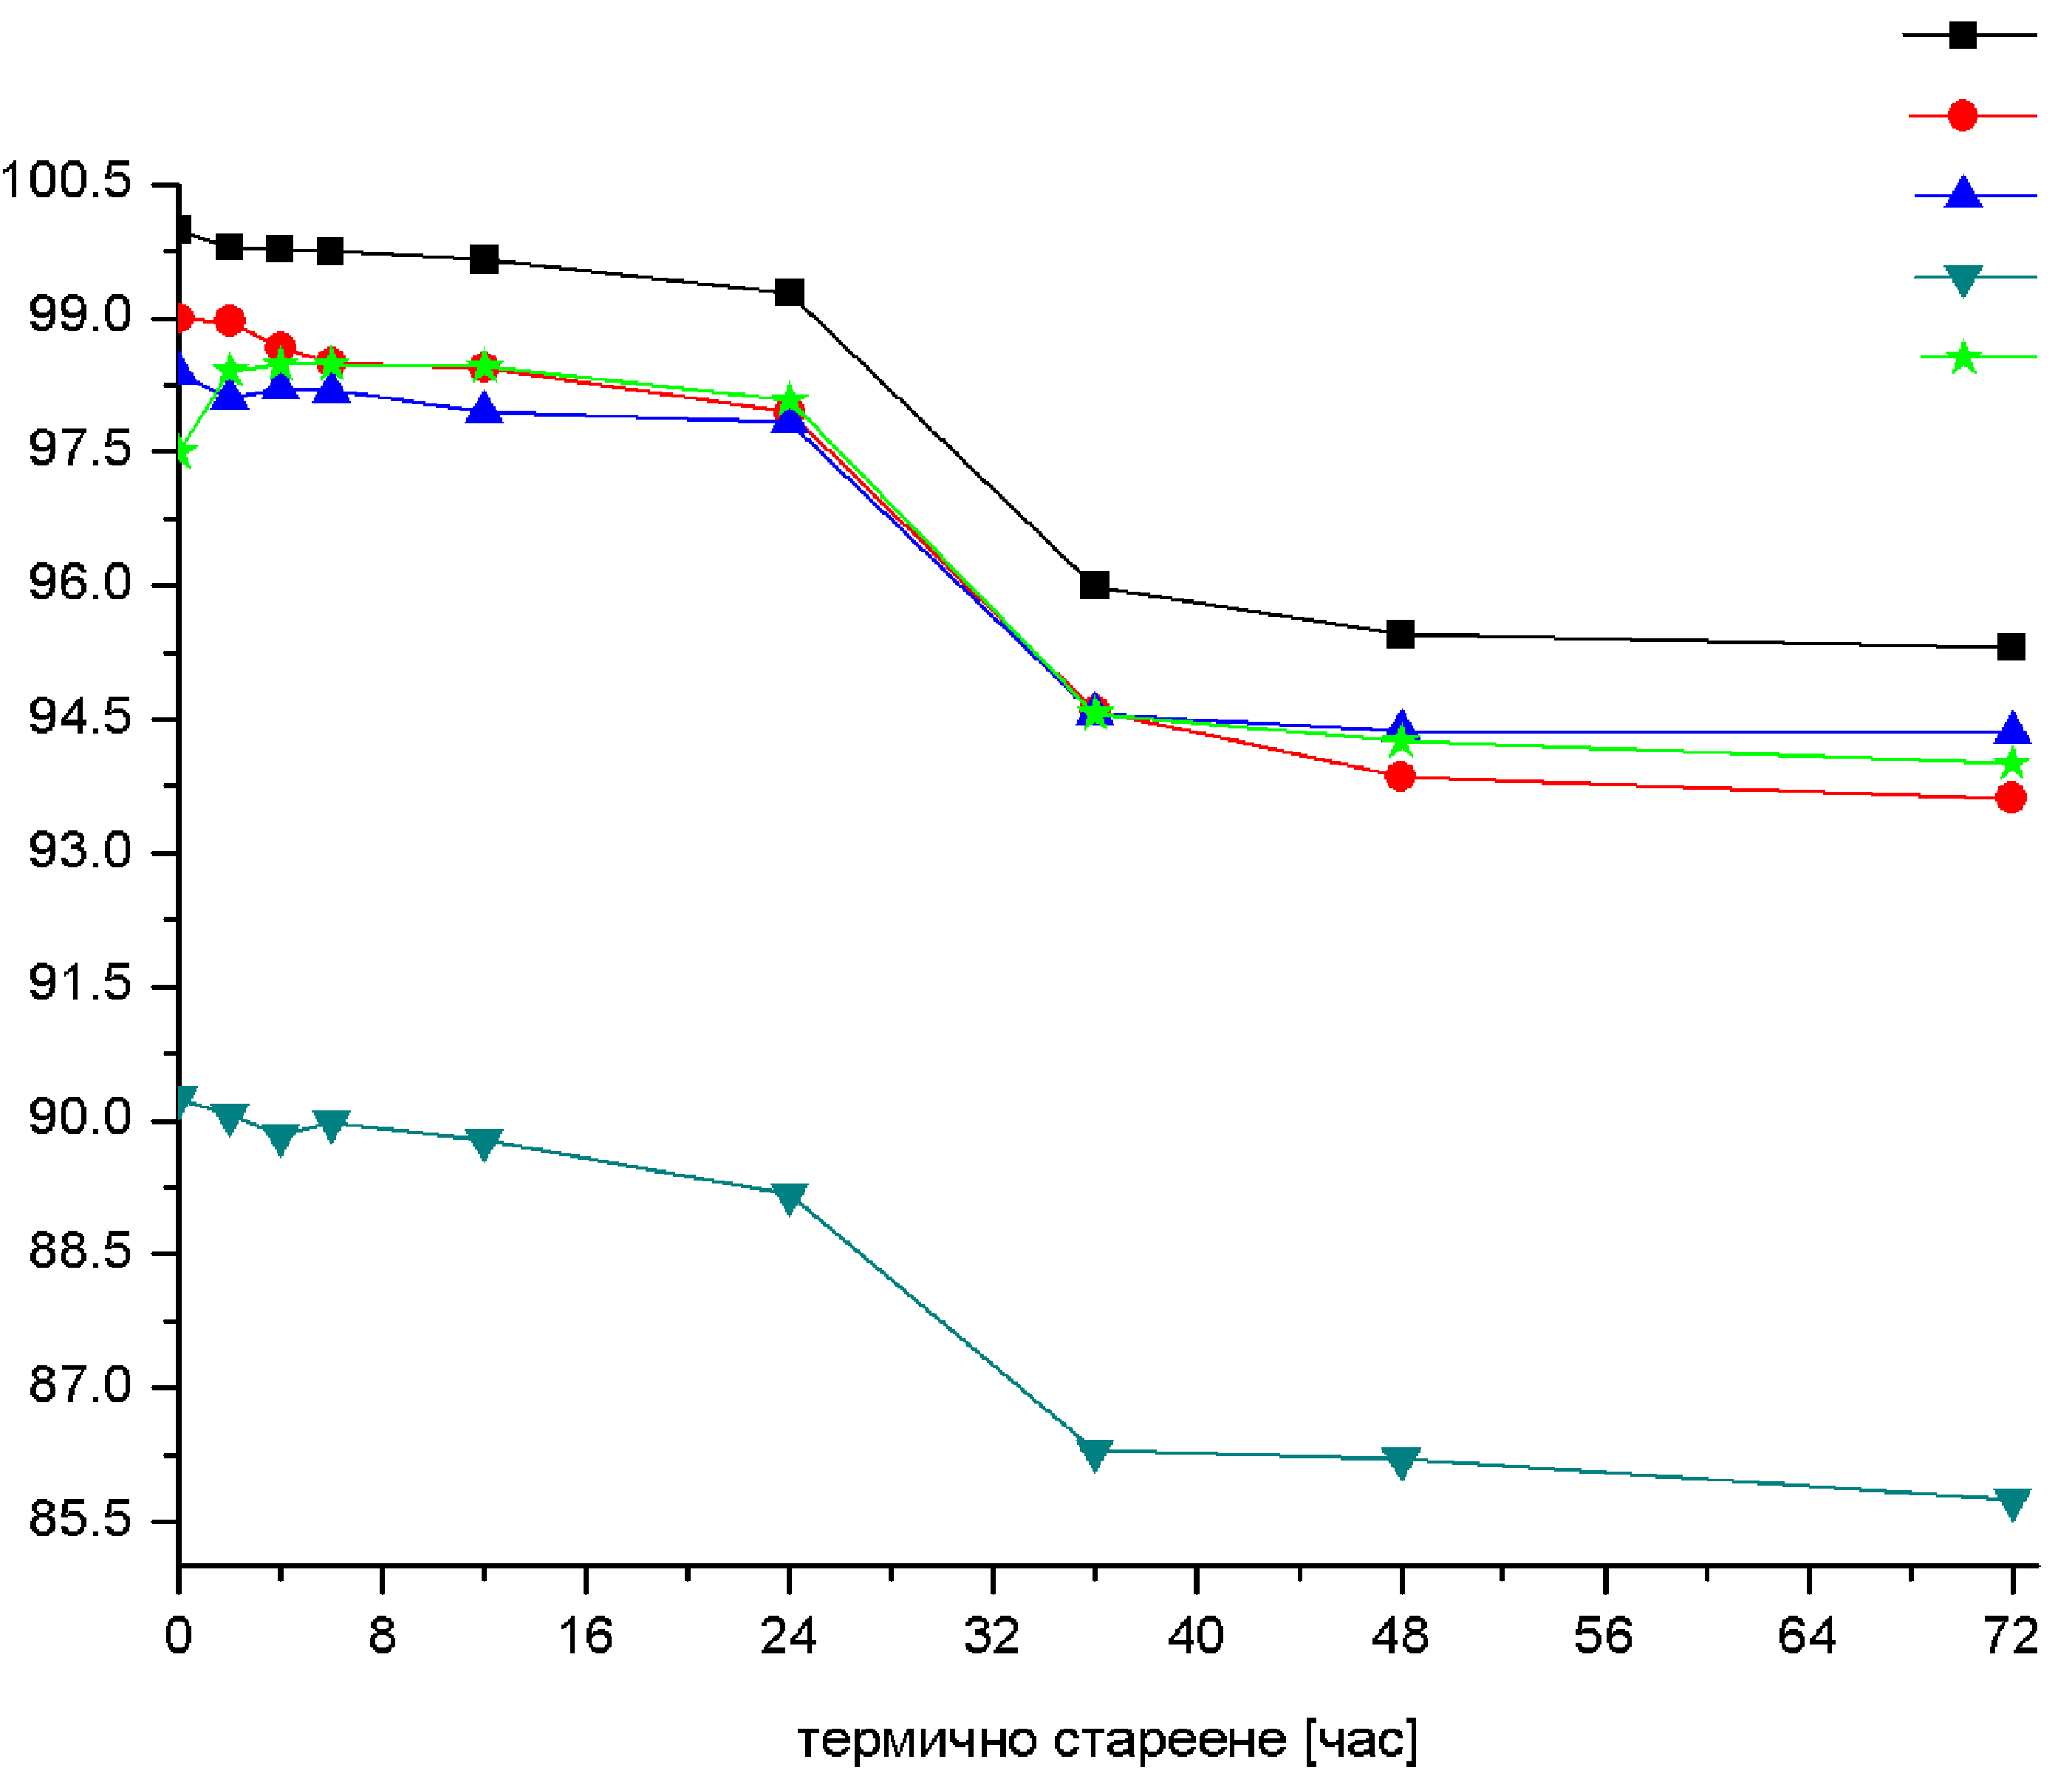  Thermal ageing (hour) | Coated paper –glossy  Coated paper –mat  Offset paper  Newspaper  LWC paper
Fig.1. Depending of CIEL* of papers on the thermal ageing

CIE а* | 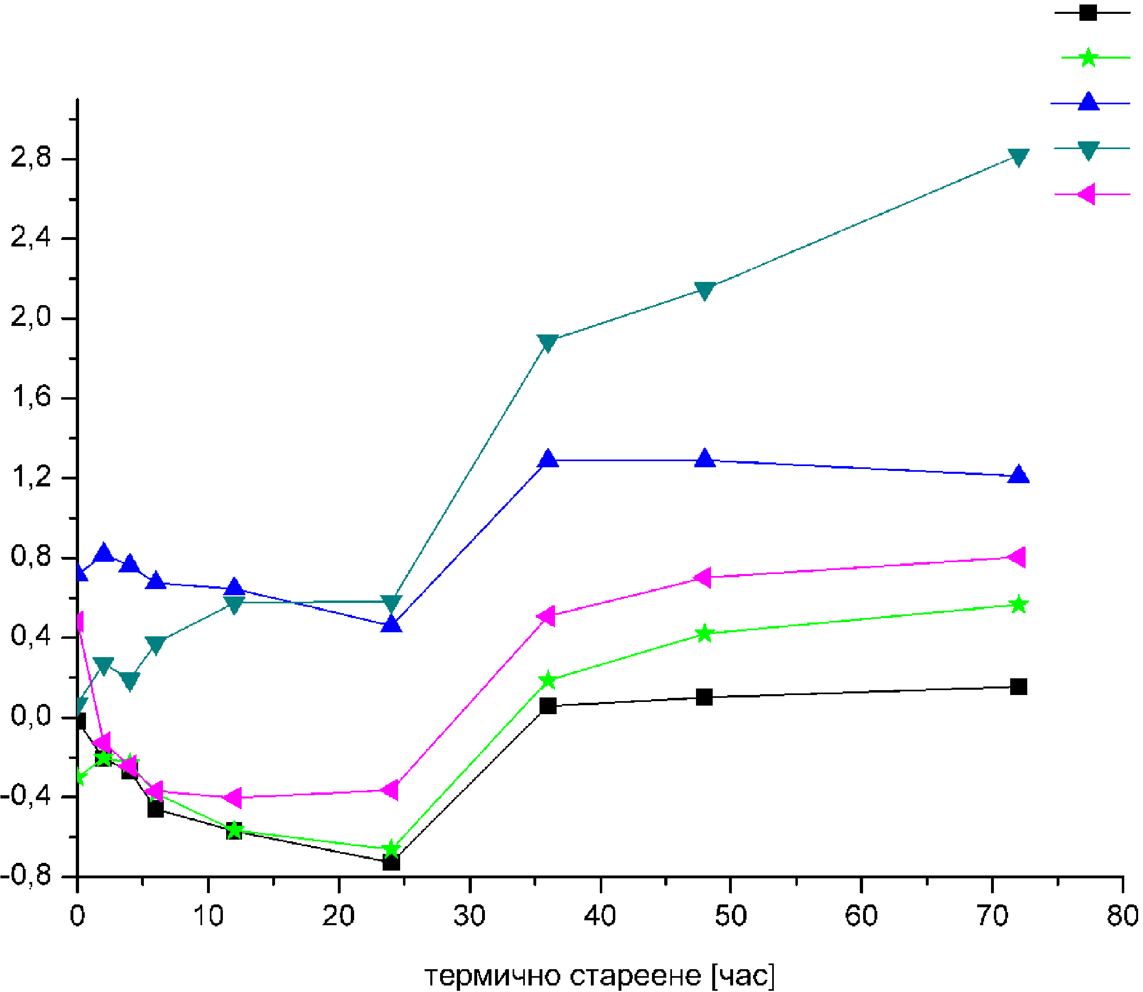  Thermal ageing (hour) (hour)  Coated paper –glossy  Coated paper –mat  Offset paper  Newspaper  LWC paper
Fig.2. Depending of CIEa* of papers on the thermal ageing.

CIEb* | 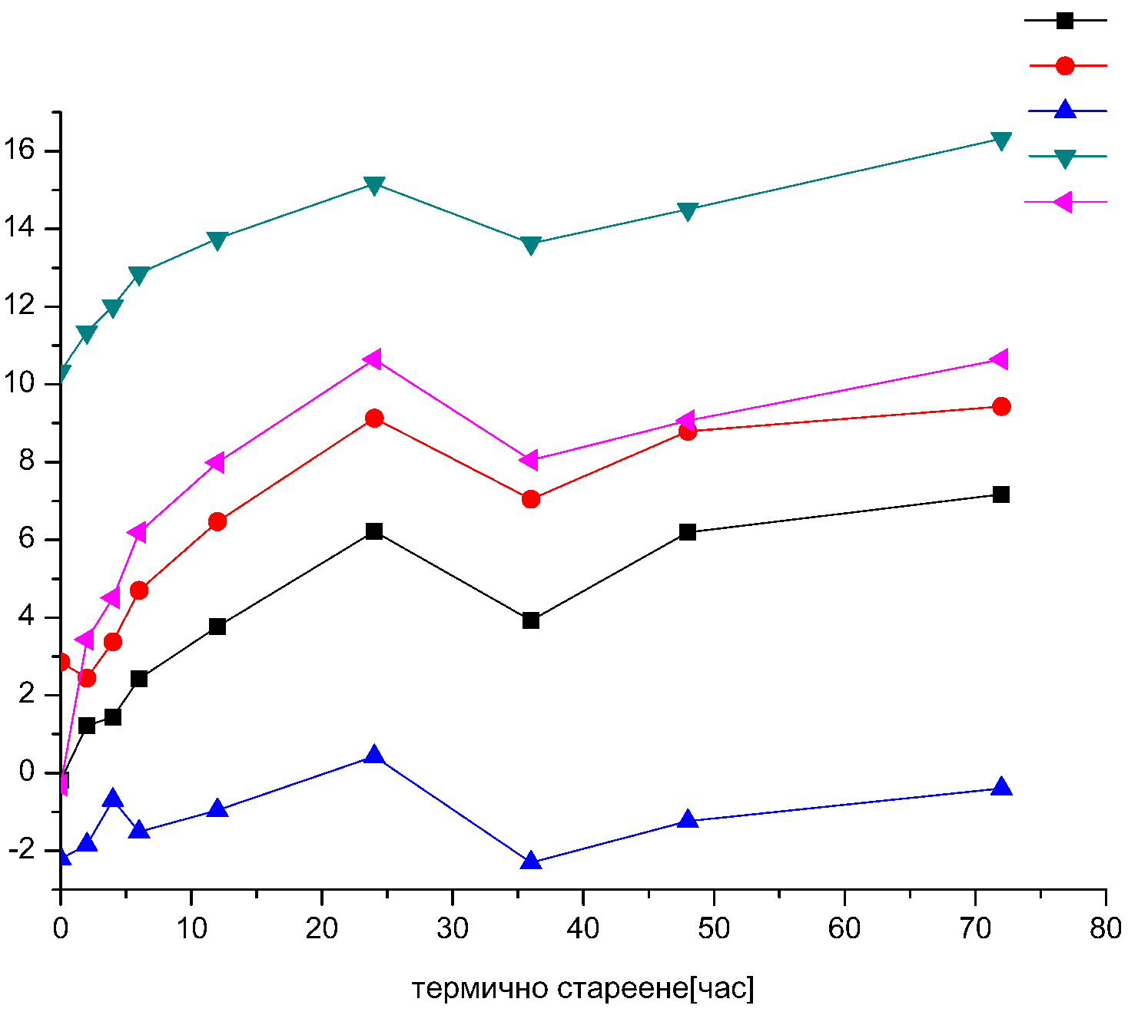  Thermal ageing (hour) | Coated paper –glossy  Coated paper –mat  Offset paper  Newspaper  LWC paper
Fig.3. CIE b* of papers depending of duration of the thermal ageing

ΔE_{ab} _{average} | 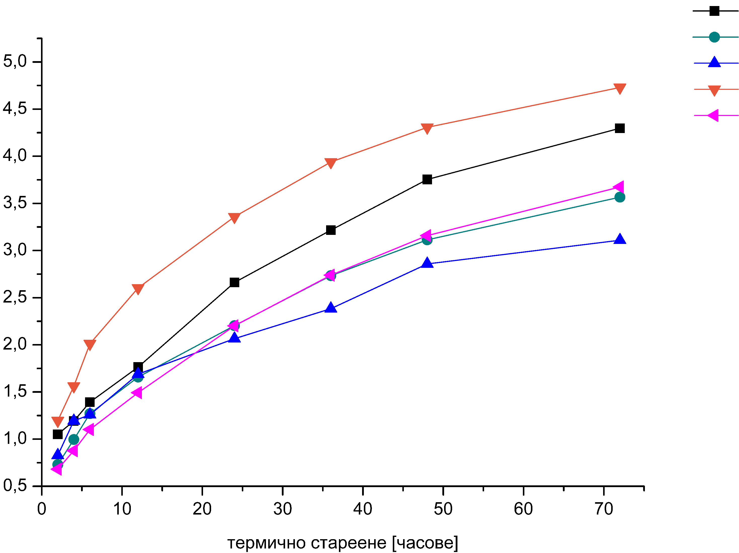  Thermal ageing (hour) (hour) |  | Coated paper –glossy  Coated paper –mat  Offset paper  Newspaper  LWC paper
Fig.4. Depending of duration of the thermal ageing on average color difference

- Study of the change in 3D color range from different point of view depending of time of artificial thermal ageing
Visualization of 3D color ranges of specific printing combination - ink - paper - printing technology is the most valuable method for estimation of color changes during some kind of process. Evaluation of changes in different color areas of 3D body of color range clearly shows the influence of thermal ageing on color zones =- green, blue, yellow etc. the crossovers of the CIE L* axis shows the influence of ageing on light, midle and dark tones.
The evaluation of changes of 3D color range for offset printed images in dependence of ageing time is innovative methodology developed by authors of this research. [11]
It is done a comparison of the color ranges from different point of view before and after exposing the paper 72 hours artificial thermal aging.
On Fig. 5 are presented 3D color ranges from different point of view before and after exposing for 72 hours artificial thermal ageing for glossy coated paper.

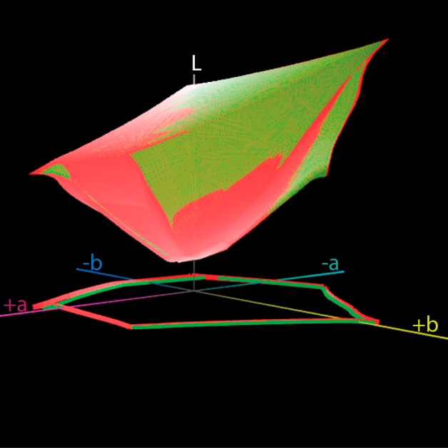 | 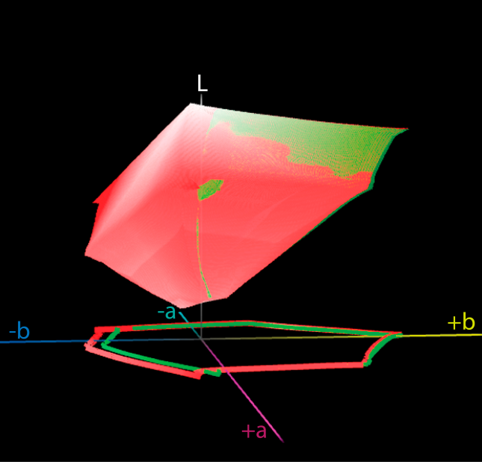
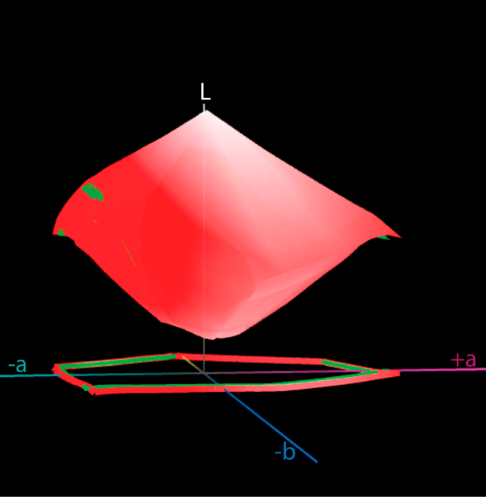
Fig. 5. 3D color range before (red) and after exposure (green) on 72 hours artificial thermal ageing on glossy coated paper.

The 3D color ranges shows relatively big changes for all colors after 72 hours of thermal ageing. For dark tones (L=18) smaller change is for yellow color, for some of the dark (L=25) and midle tones (L=50) the biger change after thermal ageing is for blue and blue-violet colors. In light tones (L=63, L=90) color range before artificial thermal ageing is biggеr for bluе-violet, green and yellow colors compare to color range after ageing.
On Fig. 6 is presented 3D color ranges for coated paper – mat. For coated paper – mat in dark tones (L=13 to L=25) color range before artificial thermal ageing is bigger compare to color range after 72 hours thermal ageing on 105⁰C for all colors. In dark tones (L=36), middle tones (L=50) and light (L=70) the biger change of color range after thermal ageing is for green, blue-green and blue-violet colors. In light tones (L=82) and (L=90) 3D color ranges shows relatively big changes for all colors exception is for yellow-red colors. On Fig. 7 is presented 3D color ranges for offset uncoated paper.

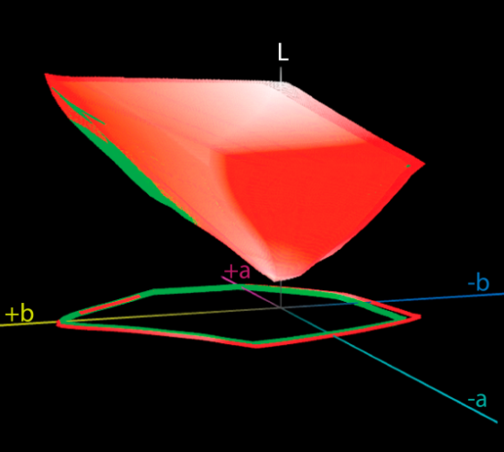 | 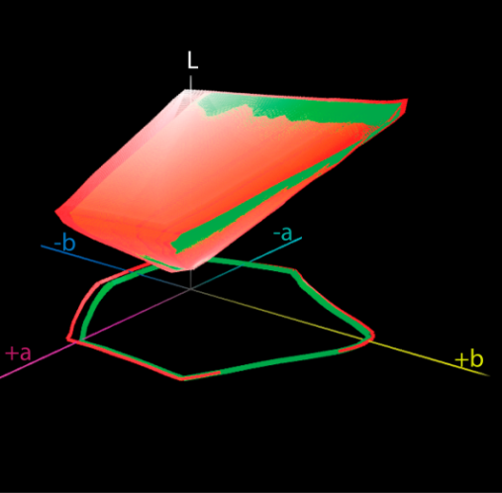
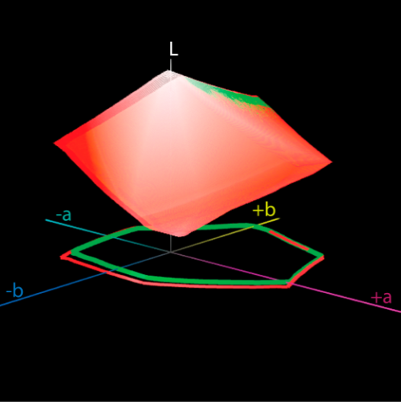
Fig. 6. 3D color range before (red) and after exposure (green) on 72 hours artificial thermal ageing for coated paper – mat.

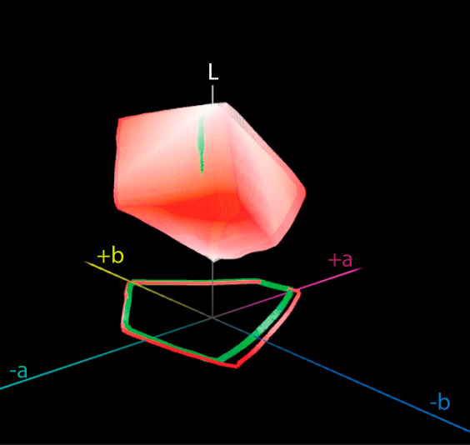 | 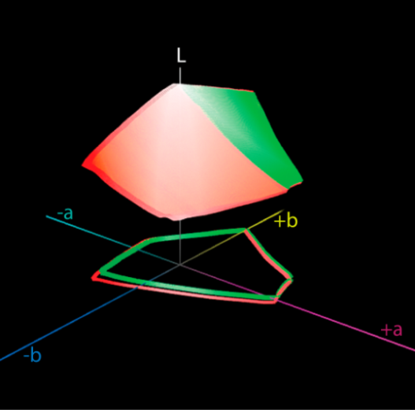
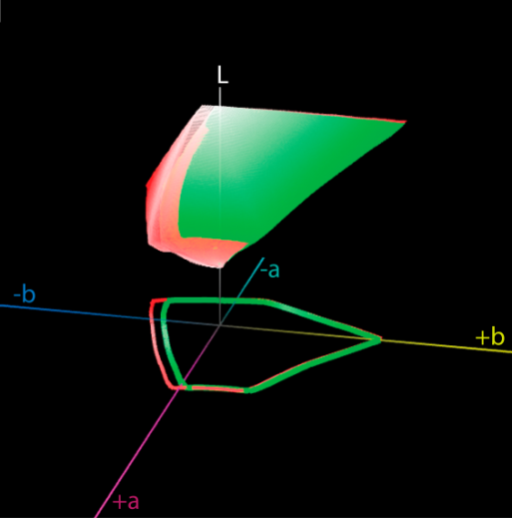

Fig. 7. 3D color range before (red) and after exposure (green) on 72 hours artificial thermal ageing for offset uncoated paper.

For offset uncoated paper for dark tones (L=29) the biger change in color range before thermal ageing compare to color range after 72 hours thermal ageing is for blue and blue violet colors. In dark tones (L=36) the change in color range is smaller for yellow color. In middle and lights tones the bigger change for color range is for blue-green and blue-violet colors.
On Fig. 8 is presented 3D color ranges for LWC paper.

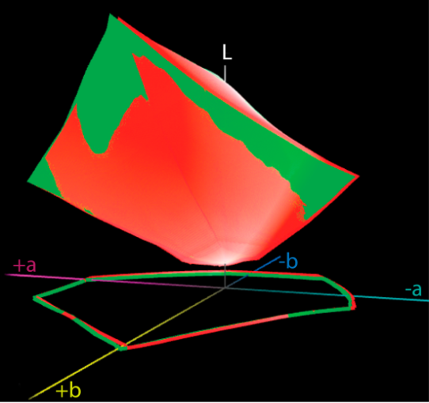 | 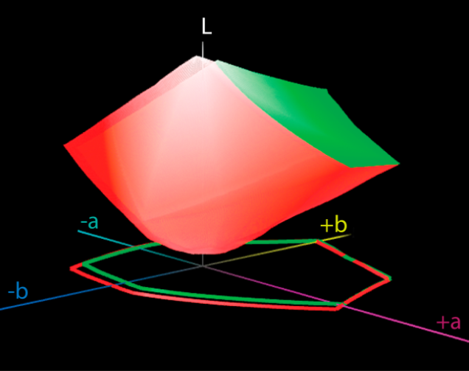
Fig. 8. 3D color range before (red) and after exposure (green) on 72 hours artificial thermal ageing for LWC paper.

For LWC paper in dark tones (L=13) and (L=25) color range before artificial thermal ageing is bigger compare to color range after 72 hours thermal ageing on 105⁰C for all colors. In some dark tones (L=36) in middle tones (L=50) and lights tones to (L=70 shows relatively big changes in color range for blue-violet color, and in tones (L=83 to L=90) the change in color range is for yellow color.
On next Fig. 9 is presented 3D color ranges for news paper.
For newspaper dark tones (L=27) color range before artificial thermal ageing is bigger for blue-violet color compare to color range after 72 hours thermal ageing on 105⁰C. In dark tones (L=36) and middle tones (L=50) there is change in color range for all color exception for yellow color. In light tones (L=63, L=70, L=83) the bigger change in color range is for green-blue and blue-violet colors

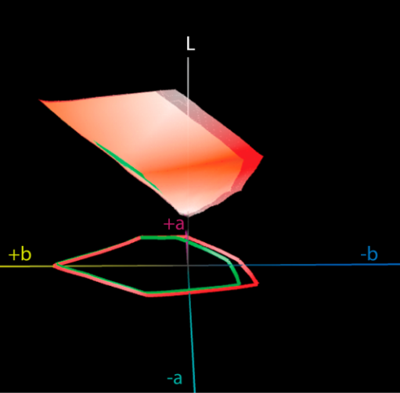 | 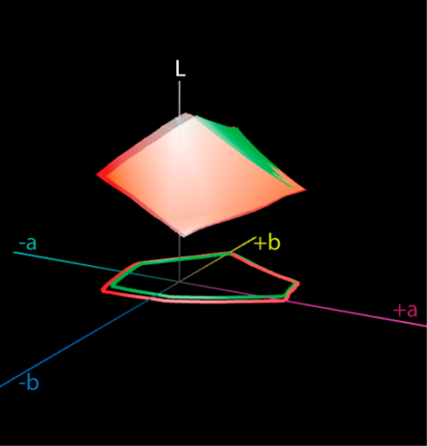
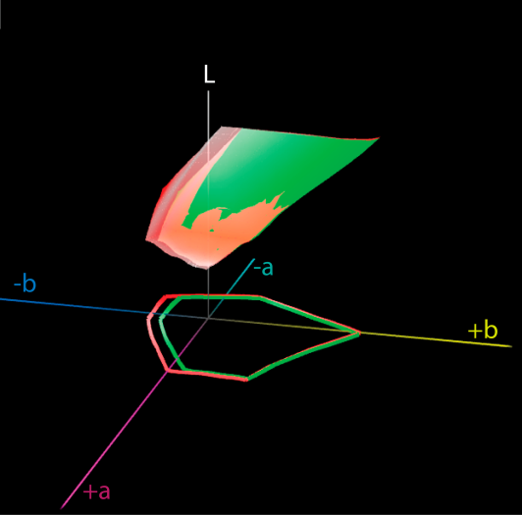

Fig. 9. 3D color range before (red) and after exposure (green) on 72 hours artificial thermal ageing for newspaper.

4.CONCLUSIONS
In this research for a first time was created and implemented a methodology for ageing of colors and brightness and experimental in real printing condition for mostly used and certified by ISO main types of papers – coated paper – glossy and mat, offset paper, LWC paper and newspaper.
From this research found that with increase a time of exposure of artificial thermal ageing after 72 hours on 105⁰C for five types of papers brightness decreased.
The CIE L* value is decreasing between 3,5 to 4,5 units after thermal ageing for all types of papers. The bigger difference of CIE L* is between 24 to 36 hours for all types of papers. The value of CIE a* increase between 24 and 36 hours for all types of papers, and value of CIE b* is increase for all types of paper to 24 hour, and then between 24 and 36 hour decreased and after 36 hour increase. With increased the time of exposure to artificial thermal ageing color difference for all types of papers increase. The color difference for coated papers – glossy and mat and LWC paper, color difference on 36 hour is smaller compare to this between 24 and 48 hour of artificial thermal ageing.
In result of exposure on thermal ageing average color difference (ΔE*_{ab, average)} increase for all types of papers.
The 3D color ranges shows relatively big changes in all colors after 72 hours of thermal ageing. The lights, middle and dark tones of color range before artificial thermal ageing is bigger compare to color range after 72 hours thermal ageing on 105⁰C for blue-violet color.

After comparing color range of five types of papers before and after 72 hours exposure on artificial thermal aging at 105⁰C have been observed the following influence on color shifting during the ageing process:
In yellow-red color the small difference on color range was in offset paper and bigger for coated paper – mat and LWC paper.
For blue-red color the smallest color range have newspaper, and bigger coated paper – glossy. For green-blue colors bigger color range have LWC paper and smallest newspaper.
REFERENCES
1. G. Saikova, Base methods for restoration and conservation of paper, NHM, Sofia, 1990
2. ISO 12647-2:2004, Graphic technology – Process control for the production of half-tone color separations, proof and productions prints, Part 2: Offset lithographic processes.
3. N. Kachin, I. Spiridonov, Cellulose Chemistry and Technology, 39, 255 (2004).
4. N. Kachin, I. Spiridonov, Printing Processes, Part 1, Theoretical bases, Pleiada, Sofia, 2000
5. Gretag Mackbeth, Обзорнийпроспект технических и программньх средств контроля цвета, Легион
группа, Москва 2000.

6. ISO 13656:2000, Graphic technology – Application of reflection densitometry and colorimetry to
process control or evaluation of prints and proofs.
7. H. Kipphan, Handbook of Print Media Technologies and Production Methods, Berlin Spinger, 2001.
235
8. К. Schläpfer, Farbmetrik in der Reproduktionstechnik und im Mehrfarbendruck, 2. Auflage. UGRA. St.
Gallen 1993.
9. H. Kipphan, Color Measurement Methods and Systems in Printing, Technology and Graphic Arts
Proceeding, SPIE,Vol. 1912 (Color Hardcopy and Graphic Arts II).The Societyfor Optical Engineering (SPIE), Bellingham (WA), 278-298, 1993.
10. ISO 2470:2002, Paper, board and pulps - Measurement of diffuse blue reflectance factor (ISO brightness)
11. E. Petkova, I. Spiridonov, I. Lozanova-Doncheva, R. Boeva-Spiridonova, Proc. 5th International GRID symposium, Novi Sad, Serbia, p. 39-44, 2010.

ИЗСЛЕДВАНЕ НА ПРОМЕНИТЕ В ЦВЕТОВИТЕ ХАРАКТЕРИСТИКИ НА ПЕЧАТНИТЕ ИЗОБРАЖЕНИЯ ПРИ ИЗКУСТВЕНО СТАРЕЕНЕ НА РАЗЛИЧНИ ХАРТИИ
И. Спиридонов¹*, Р. Боева¹, И. Лозанова-Дончева¹, Т. Божкова¹,
Ж. Павлович², Г. Владич ², Н. Кашикович², М. Станчич², Б. Тачева¹
1 Химикотехнологичен и металургичен университет, Катедра „Целулоза, хартия и полиграфия“, България
2 Университет на Нови Сад, Технически факултет, Катедра по графично инженерство и дизайн, Сърбия
Постъпила на 28 ноември, 2016 г.; Приета за печат на 8 май, 2017 г.
(Резюме)
В настоящата разработка е извършено е подробно изследване на промените в цветовите характеристики на офсетовите печатни изображения в процеса на изкуствено термично стареене. За целта е моделирана, експонирана и отпечатана специална тестова форма съдържаща голям брой различни контролни скали и елементи. Измерени са оптичните (денситометрични) и цветови характеристики на различните комбинации от мастило-хартия-печатна машина преди стареенето и след подлагане на стареене през различни времеви периоди. Основната задача на изследването е установяване и оценка в реални производствени условия на стареенето на различните комбинации от мастила и хартии за печат.
Ключови думи: цветови характеристики, офсетов печат, цветови разлики, качество на печата, стареене на материалите

