Effect of LXR agonist T0901317 and miR-33inhibitor on SIRT1-AMPK and circulating HDL-C levels
A. Mohammadi^{1,2}, H. Fallah¹, B. Shahouzehi¹*, H. Najafipour³
¹Department of Clinical Biochemistry, Afzalipour School of Medicine & Physiology Research Center, Kerman University of Medical Sciences, Kerman, Iran
²Sirjan School of Medical Sciences, Sirjan, Iran
³Department of Physiology, Afzalipour School of Medicine & Physiology Research Center, Kerman University of Medical Sciences, Kerman, Iran
Received July 26, 2017; Accepted October 31, 2017
Cardiovascular diseases (CVD) are still the leading cause of mortality and morbidity worldwide. Liver X receptors (LXRs) and sterol regulatory element binding proteins (SREBPs) play an important role in lipid homeostasis. LXRs affect SREBPs and promote lipid synthesis and reverse cholesterol transport (RCT). MicroRNA-33 down regulates AMPK, ABCA1 and CPT1 mRNA. Sirt1 also affects LXR and SREBP activity through deacetylation. We assessed the effect of LXR agonist and miR-33 inhibitor on Srebp-2, Sirt1, AMPK expression, and lipid profile. Twenty four mice were divided into four groups (n=6) and the study duration was 7 days. Group I, the control group, did not receive any treatment, group II received 30 mg/kg/48 h LXR agonist (T0901317) through i.p. injection, group III received 1 mg/kg/48 h antagomiR-33 by i.p. injection and group IV received a combination of T0901317 and antagomiR-33. miR-33, AMPK, Sirt1, Srebf-2 and Srebf1c gene expression were quantified by real time PCR, and AMPK, Sirt1 and Srebp-2 protein expression by western blotting. T0901317 administration increased miR-33 and srebf-2 expression. Co-administration of T0901317 and antagomiR-33 reduced srebf-2 and miR-33 levels and increased HDL-c levels. AMPK was reduced in those groups which received T0901317. Sirt1 gene and protein expression remained unchanged. In spite of progress in drug discovery for atherosclerosis and metabolic diseases, these disorders are not fully controlled. It seems that there is a synergistic effect between T0901317 and antagomiR-33 which reduce intracellular sterol levels and increase cholesterol transport to hepatocytes, therefore this can be considered as a therapeutic alternative in atherosclerosis and cardiovascular diseases.
Key words: LXR agonist, miR-33, T0901317, AMP-activated protein kinase

INTRODUCTION
Lipid homeostasis imbalance results in complications such as atherosclerosis, diabetes mellitus and metabolic syndrome [1, 2]. There are networks of genes which orchestrate lipid metabolism; including Sterol Regulatory Element-Binding Factor (SREBF) family, Liver X receptor (LXRs), AMP-activated Protein Kinase (AMPK). Recently, microRNA-33 (miR-33) family also was linked to lipid metabolism regulation [3-6].
MicroRNAs are short, endogenous, non-coding RNAs which emerged as regulators of gene expression and are implicated in many biological processes [7, 8]. MiRNAs bind to their specific mRNA targets in 3' UTR (untranslating region) and cause mRNA degradation or translational inhibition [2]. MicroRNA-33 is located in the intronic region of SREBF family genes. In humans, there are two isoforms of miR-33, miR-33a and miR-33b. miR-33a is located in intron 16 of the SREBF-2 gene and miR-33b is located in intron 17 of the SREBF-1 gene. However there is only one miR-33 isoform in mice which is located within intron 15 of the mouse Srebf-2 gene. MiR-33 is highly conserved and seed sequence of miR-33 family is identical in human and mouse [9-11]. The SREBPs are DNA binding transcription factors and there are two SREBPs, designated as SREBP-1 and SREBP-2. Also, there are two different isoforms of SREBP-1, SREBP-1a and 1c [9, 11]. SREBPs are the regulators of sterol and lipid homeostasis [2]. SREBPs act via regulating the expression of many genes involved in cholesterol, lipid and phospholipid metabolism [2, 8]. LXRs consist of two subtypes, LXR-α and LXR-β which are encoded by two separate genes. LXRs are a superfamily of nuclear receptors which control metabolism of glucose, lipid and cholesterol. LXR-α is expressed in tissues such as liver, intestine, kidney, adipose tissue and certain immune cells, while LXR-β is expressed in all tissues [6, 12]. Some of the target genes for LXRs target genes consist of SREBF-1c, SREBF-2, ABCA1, ABCG1, ABCG5 and CYP7A1 (CYP enzyme cholesterol 7α-hydroxylase) [13-17]. LXRs ability to promote SREBP-1c gene expression resulted in FAS activation and lipogenesis [6]. Also, LXRs are known as cholesterol sensors and are involved in cholesterol transport and metabolism. T0901317 up-regulates SREBP-1c expression, however, data on its effects on SREBP-2 are controversial. LXR activation also affects reverse cholesterol transport (RCT) by elevation of ABCA1 gene expression [6, 17].
*) To whom all correspondence should be sent:
E-mail: bshahouzehi@yahoo.com
© 2018 Bulgarian Academy of Sciences, Union of Chemists in Bulgaria
Silent mating type information regulation 2 homolog 1 (sirtuin1; SIRT1) is a member of NAD⁺ dependent histone deacetylase family which regulates the targets by deacetylation. SIRT1 targets include LXRs, SREBP-1c and peroxisome-proliferated activated receptor c co-activator (PGC)-1 α [5, 18]. SIRT1 activates LXR by deacetylation and subsequently LXR promotes SREBF-1c gene expression and elevated lipid synthesis. But SIRT1 also deacetylates the SREBP-1c protein, reduces its activity and inhibits lipogenesis [5]. AMPK enhances NAD⁺ levels which activates SIRT1 resulting in modulation of downstream SIRT1 targets [4, 5]. AMPK can suppress SREBP-1c gene expression by LXR suppression. SIRT-1 and AMPK signaling increase fatty acid oxidation and suppress lipogenesis. Therefore, SIRT1 and AMPK are intriguing therapeutic targets in treatment of metabolic disease [4].
MiR-33 inhibits HDL synthesis and controls lipids metabolism by targeting AMPK, ABCA1, and ABCG1 [3, 19, 20]. Rayner et al. evaluated miR-33 inhibition therapeutic effects on atherosclerosis [21]. Data about LXRs effect on SREBP-2 and co-expression of miR-33 are rudimentary [10, 22-27]. It has been reported that LXR deficient mice showed higher expression of SREBP-2 while other study showed that T0901317, LXR agonist, caused elevation of SREBP-2 expression [23]. In this study, the therapeutic activation of LXR along with inhibition of miR-33 and their impact on SIRT1-AMPK and some other genes and proteins involved in lipid and cholesterol metabolism were assessed.
MATERIALS AND METHODS
Materials
LXR synthetic agonist T0901317 was purchased from Cayman Chemical (71810, Ann Arbor, MI, United States), in vivo LNA™ miR-33 inhibitor was purchased from Exiqon (Woburn, MA, United States), miRCURY RNA isolation kit-tissue (300111-Exiqon),miRCURY LNA universal cDNA synthesis kit (203301, Exiqon), LNA PCR primer set for miR-33 (205690, Exiqon), LNA PCR primer set for U6 (203907, Exiqon), ExiLENT SYBR green master mix (203403, Exiqon), EZ-10 Spin column total RNA mini-prep super kit (BS584, Bio Basic Inc., Ontario, Canada), Prime script RT reagent kit (RR037A, Takara Bio Inc., Otsu, Japan), SYBR premix EX taq II Tli RNaseH plus (RR820L, Takara, Otsu, Japan). All antibodies were purchased from Santa Cruz.
Materials description and preparation: LXR agonist T0901317 is hardly soluble in aqueous buffers; therefore, it was dissolved in DMSO and diluted with PBS (pH 7.2) according to the manufacturer’s instruction. The in vivo LNA™ microRNA inhibitors are designed as short (14-16mer) sequences which easily are taken up with fully modified PS backbone to minimize toxicity. The in vivo LNA™ microRNAs-33 inhibitor was dissolved in PBS according to supplier’s instruction. Both LXR agonist and the in vivo LNA™ microRNA inhibitor were prepared daily and administered by intraperitoneal injection to mice every two days.
Animals: Twenty four male mice weighing 22±2 g were obtained from Kerman Physiology Research Center’s Animal Care Center and were fed with standard diet and water ad libitum. Mice were housed at a temperature of 22°C, with 12 h light/12 h darkness cycle and allowed 7 days for acclimatization. Mice were randomly divided in 4 groups (n=6) as follows: Group I (control, received chow diet), Group II (LXR agonist, received 30mg/kg T0901317), Group III (anti miR-33, received 1mg/kg LNA miR-33 inhibitor), Group IV (received LXR agonist & LNA miR-33 inhibitor). Mice received 3 intraperitoneal injections of T0901317 or in vivo miR-33 LNA inhibitor according to their designated groups every two days in a six-day period (days 1, 3 and 6). At the end of the treatment period (day seventh) and after 10 hours fasting overnight, mice were sacrificed, blood samples were collected and serum was separated. Liver tissue was excised and washed with cold saline and was immediately frozen in liquid nitrogen. Finally, serum and tissues were moved to a -80°C freezer till further examination. All procedures were approved by the Animal Research Ethics Committee of Kerman University of Medical Sciences (Ethic committee permission No IR.KMU.REC. 1394.319).
MicroRNA-33 quantification: In order to quantify miR-33 according to microRNA extraction protocol, about 15 mg of liver tissue was excised and total RNA (including small RNA <200 nt) was extracted by miRCURY RNA isolation kit. First-strand cDNA for microRNAs were synthesized by miRCURY LNA universal cDNA synthesis kit. Synthesized cDNA was diluted 1:80 and 5 µl/reaction were used for real time-PCR as follows: 95°C for 10 min, then 40 cycles of 95°C for 10 s and 60°C for 1 min using ExiLENT SYBR green master mix (Exiqon) by ABI step one plus instrument. Real-time PCR reaction was performed in triplicate. U6 was used as housekeeping gene and values were normalized to U6 [13, 28].
Real-time PCR: about 75 mg of liver tissue was removed from storage and total RNA was extracted using EZ-10 spin column total RNA mini preps super kit (Bio Basic). 250 ng of total RNA was transcribed and cDNA synthesized by Prime Script RT reagent kit for real-time PCR (Takara) using oligo dT primer and random 6mer according to the kit instructions. Real-time PCR reaction (20 µl) contained 2X SYBR Premix Ex Taq II RNaseH plus (Takara), ROX, primers of the target gene, sterile water and cDNA template (100 ng cDNA). Real time PCR was performed on ABI Step One Plus instrument as follows: stage 1 denaturation, 95°C for 10 min, then 40 cycles of 95°C for 20 s and 60°C for 30 s. A melt curve analysis was performed which started from 60°C and increased by 0.3°C increments up to 95°C. Real-time PCR reactions were performed in duplicate. Amplicons of each target gene were examined by agarose gel electrophoresis (2% agarose gel, 90V) in order to confirm the presence of a specific band. Specific primers for target genes were purchased from MACROGEN (MACROGEN Inc., Seoul, South Korea) as listed in Table 1. The expression level was determined by the 2^{-∆∆Ct} method [23, 24].
Western blotting: liver tissue (50 mg) was homogenized on ice-cold protein extraction RIPA buffer (containing protease inhibitor cocktail, 1 mM phenylmethylsulfonyl fluoride [PMSF] and 1 mM sodium orthovanadate, pH 7.4). The homogenate was centrifuged at 15,000 rpm at 4 °C for 20 min and the supernatant was removed for further study. Total protein concentration was determined by the Bradford method. An equal volume of 2× sample buffer was added to each sample and incubated at 95°C for 5 min. 100 µg of proteins were loaded on a 12.5 % SDS-PAGE gel and the separated proteins (120 volts, 80 min) were transferred to a polyvinylidene difluoride (PVDF) membrane. Blocking was performed by overnight incubation of the membrane at 4°C with 5 % skim milk in tris-buffered saline and Tween 20. The membrane was incubated with primary antibodies (Santa Cruz) in TBST buffer for 1 h, and then washed 4 times for 5 min in TBS-T, followed by incubation with goat-anti-rabbit secondary antibody for 1 h at room temperature. All antibodies were diluted with 2% blocking buffer prepared by TBS-T. The PVDF membrane was incubated with a substrate (Western Lightening Plus ECL, Perkin-Elmer) for 1 min. Antibody–antigen complex was detected using an enhanced chemiluminescence detection film in a dark room. After development, the band densities were analyzed by the ImageJ software. β-Actin immunoblotting was used as a control for loading [29].
Lipid profile: In order to evaluate the lipid profile of mice, total cholesterol, high-density lipoprotein (HDL-c) and triglyceride (TG) levels were measured.

Statistical analysis: Data from real time-PCR, western blotting and serum parameters were expressed as mean ± SEM. Data were analyzed by SPSS v.16 (SPSS Inc., Chicago, IL). In order to compare groups, one-way ANOVA was used and for pair-wise comparison the post hoc Tukey’s test was used. P-values ≤ 0.05 were considered as statistically significant.

RESULTS
Real time-PCR analysis showed that miR-33 expression is up-regulated following T0901317 administration (p=0.047). AntagomiR-33 reduced miR-33 and this reduction was attenuated by T0901317 (Fig. 1).
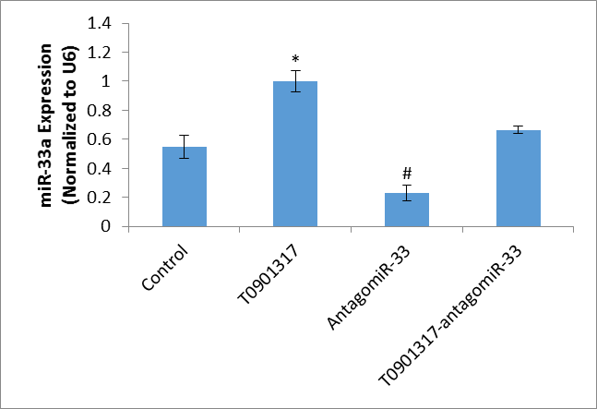
Fig 1. Evaluation of miR-33 expression shown by real-time PCR in liver tissue of 4 groups of mice, I. untreated control group, II. LXR agonist (T0901317), III. antagomiR-33 (miR-33 inhibitor), and IV. combination of T0901317 and antagomiR-33. All data are expressed as mean ± SEM (n = 6 mice/group). * statistically significant compared to the control group, # statistically significant compared to the T0901317 group (p < 0.05 considered as significant).

Table 1. Sequences of real-time PCR primers
Genes name | Forward primer 5' to 3' | Reverse primer 5' to 3' | Product size (bp)
Ampk | CTCAGTTCCTGGAGAAAGATGG | CTGCCGGTTGAGTATCTTCAC | 174
Beta-actin | CAACGAGCGGTTCCGATG | GCCACAGGATTCCATACCCA | 90
Sirt1 | GCAGGTTGCAGGAATCCAA | GGCAAGATGCTGTTGCAAA | 80
Srebf-1c | GGAGCCATGGATTGCACATT | GCTTCCAGAGAGGAGGCCAG | 190
Srebf-2 | CCAAAGAAGGAGAGAGGCGG | CGCCAGACTTGTGCATCTTG | 130

Gene expression experiment revealed that T0901317 causes up regulation of Srebf-2, Srebf-1c and sirt1, of those, sirt1 elevation was not significant. Inhibition of miR-33 significantly up regulates AMPK. Interestingly, co-administration of antagomiR-33 and LXR agonist down regulated Srebf-2 expression (Fig. 2). Srebp2 protein levels were reduced by antagomiR-33 and combination of antagomiR-33 and T0901317. AMPK protein levels were upregulated by antagomiR-33 and combination of antagomiR-33 and T0901317 (Fig. 3). T0901317 significantly increased TG levels compared to control group. HDL-c increased in the three other groups compared to control (p=0.01) (Table 2).

DISCUSSION

Cardiometabolic diseases such as atherosclerosis and associated cardiac complications are considered as major public health problems and cardiovascular diseases (CVD) are the leading cause of mortality worldwide.

Even with drugs such as statins, beta blockers, and other medications, the risk of cardiometabolic diseases is still increasing [1, 2]. Therefore, the major goal is finding strategies to reduce the risk of cardiometabolic diseases.

For this reason, the focus is on HDL elevation and improvement of RCT. MiR-33 is located in introne of SREBFs gene family and affects mRNA of target genes [3]. It was documented that miR-33 inhibits Abca1 and AMPK, and as a result potentially reduces serum HDL levels and also RCT [3, 30]. Thus, it seems that miR-33 is a good potential therapeutic target for finding new approaches in order to reduce risk of cardiometabolic diseases. LXR agonists activate LXR and SREBPs as downstream targets of LXRs [23, 31], so they have beneficial effects on lipid metabolism and showed some advantageous effects such as HDL elevation, promotion of RCT and increase cholesterol excretion as bile salts.

It has been reported that miR-33 is co-expressed with SREBF family of transcription factors [26]. There is however a controversy over co-expression of Srebf-2 and miR-33 following LXR agonists’ administration. Previously, some studies have confirmed co-expression of Srebf-2 and miR-33 [6, 19, 28] while some other studies have reported that there is no relationship between Srebf-2 and miR-33 expression under different conditions [15, 23, 24, 26, 27].
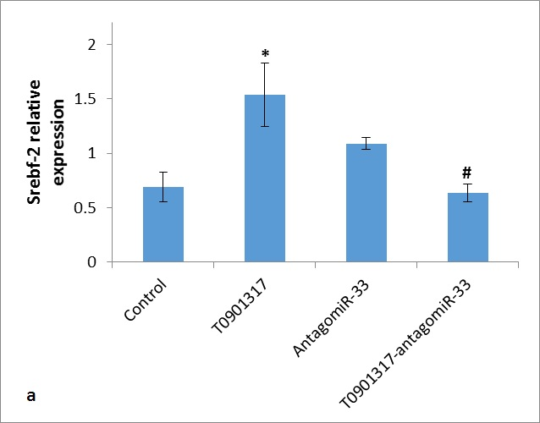
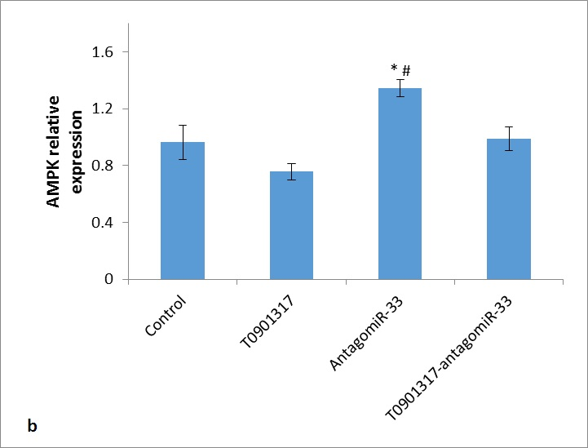
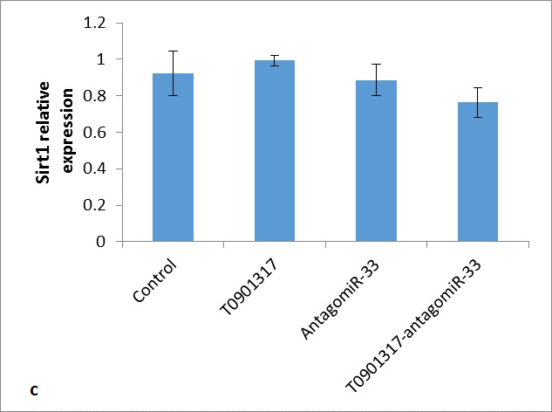
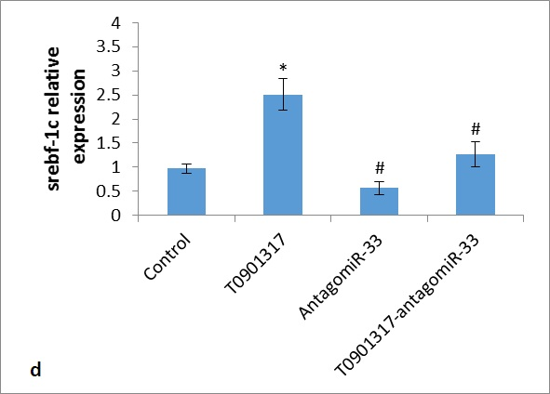
Fig 2. Evaluation of Srebf-2 (a), AMPK (b), Sirt1 (c) and Srebf1c (d) expression shown by real-time PCR in liver tissue of 4 groups of mice, I. untreated control group, II. LXR agonist (T0901317), III. AntagomiR-33 (miR-33 inhibitor), and IV. combination of T0901317 and AntagomiR-33. All data are expressed as mean ± SEM (n = 6 mice/group). *statistically significant compared to control group, # statistically significant compared to T0901317 group (p < 0.05 considered as significant).
SREBR-2
Actin 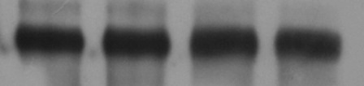
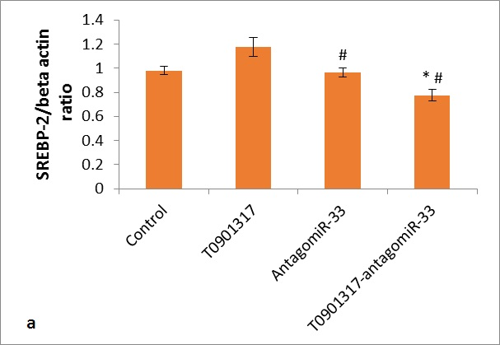
AMPK 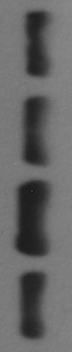
Actin
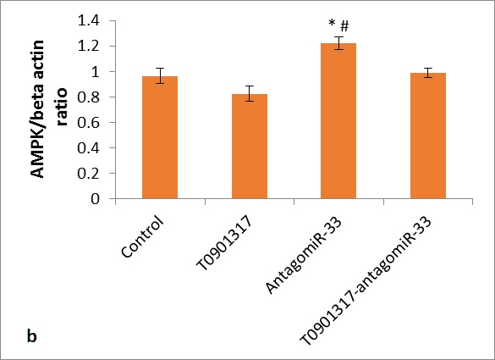
Sirt1
Actin
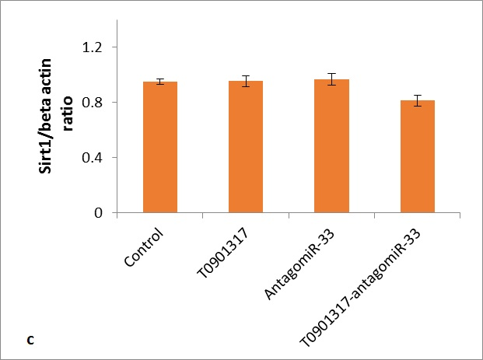

Fig 3. Western blotting of SREBP-2 (a), AMPK (b), Sirt1 (c) expressed in liver tissue of 4 groups of mice, I. untreated control group, II. LXR agonist (T0901317), III. AntagomiR-33 (miR-33 inhibitor), and IV. Combination of T0901317 and AntagomiR-33. Data are expressed as mean ± SEM (n = 6 mice/group). * statistically significant compared to control group, # statistically significant compared to T0901317 group (p < 0.05 considered as significant)

Also, there are disagreements about T0901317 effects on Srebf-2 expression. It has been reported that treatment with T0901317 for 4 days showed no effect on SREBP-2 levels [19]. Horie et al. proved that T0901317 has no effect on miR-33a and srebf-2 in HepG2 cell line [28]. Also, Schultz et al. showed that T0901317 administration increased SREBF-1c but had no effect on SREBF-2 [6]. Furthermore, Kostopoulou et al., found that SREBP-2 gene and miR-33a as intronic microRNA in osteoarthritic chondrocytes compared with normal chondrocytes were significantly elevated [24]. MiR-33 and Srebf-2 expression were down-regulated by high cholesterol diet in mouse peritoneal macrophages indicating that Srebf-2 and miR-33 are transcribed simultaneously [26]. It showed that T0901317 in goose hepatocytes increased SREBP-2 and HMGCR expression [23]. Other studies also have reported that T0901317 increased SREBP-2 [15, 27]. In spite of this inconsistency about LXR activation and its agonist’s effect on SREBF-2 gene expression, here we showed that T0901317 increases miR-33, SREBP-2 and Srebf-2 levels in mice liver after seven days. These findings are consistent with studies which showed that T0901317 increased Srebf-2 and miR-33 expression or studies which reported that Srebf-2 and miR-33 are co-transcribed [6, 19, 28].

AMPK is a sensor of energy in the cells where it inhibits synthetic and energy consuming pathways such as lipogenesis and cholesterol biosynthesis. On the other hand, it activates catabolic pathways to increase intracellular energy levels [5, 31]. AMPK is a known target of miR-33 and there are many studies which have reported that miR-33 reduces AMPK levels and anti-miR-33 increases AMPK [2, 3, 20, 30]. In contrast to these findings, Horie et al. reported that in miR-33b knock-in mice, SREBP-1 and ABCA1 proteins were reduced in liver, but AMPK was unaffected by miR-33b over expression [28]. We found that administration of antagomiR-33 in mice increased hepatic AMPK levels, which is consistent with most studies [2, 3, 20, 30] and in contrast to Horie et al. [28], who reported no effect of miR-33 overexpression over AMPK. Also, we showed that T0901317 affected AMPK levels, but this reduction was not

Table 2. Serum lipid profile. All data are expressed as mean ± SD (n = 6 mice/group)
Groups | Triglyceride (mg/dL) | Cholesterol (mg/dL) | HDL-c (mg/dL)
Control | 102.5 ±5.6 | 107.50±8.7 | 91.8±3.1
T0901317 | 180.8±16ª | 127.51±8.8 | 104±0.9ª
AntimiR-33 | 106.5±6.4^{b} | 124.0±24.7 | 106.8±1.8ª
T090+AntimiR-33 | 110.8±9.3^{b} | 114.33±7.1 | 111.2±1.1ª
ª Significant compared to control group; ^{b} Significant compared to T0901317 group; (p < 0.05 considered as significant)

significant. It has been reported that AMPK activation reverses hepatic fat accumulation and reduces serum TG and cholesterol [32]. Also it has been shown that Licochalcone by activation of AMPK/Sirt1 pathway is capable of suppressing the LXR-a dependent lipogenic gene expression in the liver [31]. Lee et al. [33] reported that AMPK activation affects LXR-Srebf1c signaling pathway, suppresses it and reduces TG levels. We found that anti-miR-33 treatment reduced TG levels, and it could be associated with increased liver AMPK contents, because AMPK activation suppresses Srebf-1c and its upstream activator, LXR-α [33, 34].

There is a crosstalk between AMPK and sirt1 and they affect each other’s activity [4, 5]. Sirt1 activates LXR but inhibits SREBF-1c activity. Therefore, Sirt1 is capable of elevating Abca1 by LXR activation and reducing lipogenesis by inhibition of SREBF-1c [5, 31]. Walker et al., [18] described that SIRT1 suppresses SREBP-1 and SREBP-2 target genes; however, we found no remarkable effect due to Sirt1 treatment in our study because there was no significant change in Sirt1 gene and protein levels. Escola-Gil et al. [14] found that Resveratrol administration (a Sirt1 agonist) and overexpression of SIRT1 showed no effect on liver LXR-target genes. This is consistent with our finding that Sirt1 did not show any significant change, thus Sirt1 has no potential downstream role after miR-33 manipulation by anti-miR-33 and LXR activation by T0901317. Unlike Sirt1, AMPK showed significant changes in our study and it seems that SREBF-1c suppression could be related to inhibitory effect of AMPK on srebf-1c and its activator, LXR. T0901317 lowers AMPK levels insignificantly, but anti-miR-33 treatment significantly increased AMPK in mice liver. Combination of T0901317 and anti-miR-33 showed that anti-miR-33 treatment attenuates the ablative effect of T0901317 on AMPK levels. Elevation of AMPK and reduction of srebf-2 gene and protein expression in this group (co-administration of T0901317 plus anti-miR-33) explains reduced serum TG levels and increased HDL in this group. Previous studies have shown that T0901317 and anti-miR-33 cause elevation of Abca1 which is directly related to HDL augmentation [3, 6, 14, 25, 35]. On the other hand, by elevation of HDL there is a flow of cholesterol from peripheral tissues to the liver, known as RCT which results in high levels of sterols in the cells [2]. High cholesterol contents cause down regulation of srebf-2 which justifys Srebf-2 reduction at gene and protein expression level. Therefore, AMPK could be considered responsible for changes observed in lipid homeostasis in this study.

SREBP-2 activates HMGCR and increase cellular cholesterol levels, but Wong et al, also showed that SREBP-2 increase oxysterol production which is a known ligand for LXR [16, 17, 25]. So SREBP-2 can up regulate LXR activity and increase HDL levels by helping LXR dependent Abca1 expression [16]. We showed that anti-miR-33 and T0901317 co-administration significantly increased HDL levels and also reduced SREBP-2. Previous studies have shown that anti-miR-33 and T0901317 increase HDL levels through different mechanisms [6, 20, 28, 35]. We showed that co-administration of anti-miR-33 and T0901317 increased HDL levels significantly compared to control group. Hence it seems that SREBP-2 has no role in HDL elevation in this group. Co-administration of T0901317 and AntimiR-33 therapy reduced srebf-2 levels significantly. It seems that there is a synergic effect of antimiR-33 and T0901317 on cholesterol entrance to hepatocytes in mice which cause significant reduction in srebf-2 levels that is under control of sterol levels in cells.

Other study showed that anti-miR-33 therapy reduced srebf-1c expression [21]. T0901317 activates LXR and result in Srebf-1c activation which in turn activates lipogenesis and increases serum TG [6]. We showed that co-administration of anti-miR-33 and T0901317 reduce srebf-1c gene expression compared to T0901317 (activator of Srebf-1c) group (p=0.004). Then, co-administration of anti-miR-33 and LXR agonist proposes a potent therapeutic effect against atherosclerosis and other cardiometabolic diseases in which lipid imbalance exist. Horie and colleagues showed that LXR stimulation by T0901317 was not affected SREBF-2 and miR-33 levels which are absolutely in contrast with our finding that T0901317 up regulated miR-33, Srebf-2 and Srebf-1c [28]. T0901317 cause severe elevation of serum TG levels which executed from LXRa-Srebf-1c pathway as mentioned above. And this high level of serum TG was reduced by anti-miR-33 therapy in group that received both anti-miR-33 and T0901317. It is probable that AMPK can be a potent factor for this phenomenon which is because of AMPK decreasing effects on Srebf-1c gene expression [4, 5]. Rayner et al, [21] showed that anti-miR-33 therapy reduced srebf1 and FAS which confirm our observation which anti-miR-33 therapy attenuated TG levels in group that received T0901317 plus anti-miR-33.

CONCLUSIONS

It has been reported that LXR activation promotes RCT and elevate HDL-c, and Anti-miR-33 therapy increase HDL-c, AMPK and ABCA1 levels. Also it was documented that SREBP-2 increase HMGCR activity and intracellular cholesterol levels. We showed that co- administration of LXR agonist and miR-33 inhibition significantly (p<0.001) increase serum HDL-c and reduce SREBP-2 expression in mice liver. Also, co-administration of T0901317 and anti-miR-33 compared to T0901317 alone, significantly reduced serum TG levels. Thus LXR activation and miR-33 antagonism is a valuable therapeutic alternative for cardiovascular disorders. But there is a necessity of more evaluation about co-administration of LXR agonists and anti-miR-33 treatments.
Acknowledgements: This research was financially supported by Kerman University Research Council (Grant no. 94.401). We would also like to thank Dr. Rohollah Nikooie, Mr. Yaser Masoumi-Ardakani and Mr. Soheil Aminizadeh for their kind help and support.
Conflict of interest: The authors declare that there is no conflict of interest.

REFERENCES
- T. Horie, O. Baba, Y. Kuwabara, Y. Chujo, S. Watanabe, M. Kinoshita, M. Horiguchi, T. Nakamura, K. Chonabayashi, M. Hishizawa, K. Hasegawa, N. Kume, M. Yokode, T. Kita, T. Kimura, K. Ono, J. Am. Heart Assoc., 1, e003376 (2012).
- V. Rottiers, A. M. Naar, Nature Reviews Molecular Cell Biology, 13, 239 (2012).
- H. Najafi-Shoushtari, F. Kristo, Y. Li, Science, 18, 328 (2010).
- N.B. Ruderman, X.J. Xu, L. Nelson, J.M. Cacicedo, A. K. Saha, F. Lan, Y. Ido, Am. J. Physiol. Endocrinol. Metab., 298, E751 (2010)
- M. Fulco, V. Sartorelli, Cell Cycle, 7, 3669 (2008)
- J.R. Schultz, H. Tu, A. Luk, J.J. Repa, J.C. Medina, L. Li, S. Schwendner, S. Wang, M. Thoolen, D.J. Mangelsdorf, K.D. Lustig, B. Shan, Genes & Development, 14, 2831 (2000).
- O.A. Alrob, S. Khatib, S.A. Naser, J Physiol. Biochem., 73, 307 (2017).
- K. Ono, T. Horie, T. Nishino, O. Baba, Y. Kuwabara, M. Yokode, T. Kita, T. Kimura, Circulation Journal, 79, 278 (2015).
- G.T. Bommer, O.A. MacDougald, Cell Metab., 13, 241 (2011)
- T. Horie, T. Nishino, O. Baba, Y. Kuwabara, T. Nakao, M. Nishiga, S. Usami, M. Izuhara, N. Sowa, N. Yahagi, H. Shimano, S. Matsumura, K. Inoue, H. Marusawa, T. Nakamura, K. Hasegawa, N. Kume, M. Yokode, T. Kita, T. Kimura, K. Ono. Nat. Commun., 4, 2883 (2013).
- H. Najafi-Shoushtari, Curr Atheroscler. Rep., 13, 202 (2011).
- J. Laurencikiene, M. Ryden, International Journal of Obesity. 36, 1494 (2012).
- R.M. Allen, T.J. Marquart, C.J. Albert, F.J. Suchy, D. Q.-H. Wang, M. Ananthanarayanan, D.A. Ford, A. Baldan, EMBO Mol. Med., 4, 882 (2012).
- J.C. Escola-Gil, J. Julve, G. Llaverias, Transl. Res., 161, 110 (2013).
- J.C. Larkin, S.B. Sears, Y. Sadovsky, Placenta, 35, 919 (2014).
- S. Rong, V.A. Cortes, S. Rashid, N.N. Anderson, J. G. McDonald, G. Liang, Y.-A. Moon, R.E. Hammer, J.D. Horton, Human Biology and Medicine, 6, e25015 (2017).
- J. Wong, C.M. Quinn, A.J. Brown, Biochem. J., 400, 485 (2006).
- A.K. Walker, F. Yang, K. Jiang, J.–Y. Ji, J.L. Watts, A. Purushotham, O. Boss, M.L. Hirsch, S. Ribich, J.J. Smith, K. Israelian, C.H. Westphal, J.T. Roders, T. Shioda, S.L. Elson, P. Mulligan, H. Najafi-Shoushtari, J.C. Black, J.K. Thakur, L.C. Kadyk, J. R. Whetsteine, R. Mostoslavsky, P. Puigserver, X. Li, N.J. Dyson, A.C. Hart, A.M. Naar. Genes & Development., 24, 1403 (2010).
- A. Davalos, L. Goedeke, P. Smibert, C.M. Ramirez, N.P. Warrier, U. Andreo, D. Cirea-Salinas, K. Rayner, U. Suresh, J.C. Pastor-Pareja, E. Esplugues, E.A. Fisher, L.O. F. Penalva, K.J. Moore, Y. Suarez, E.C. Lai, C. Fernandez-Hernando, PNAS, 108, 9232 (2011).
- L. Goedeke, A. Salerno, C. M. Ramirez, EMBO Molecular Medicine, 6, 1133 (2014).
- K.J. Rayner, C.C. Esau, F.N. Hussain, A.L. McDaniel, S.M. Marshal, J.M. Van Gils, T.D. Ray, F.J. Sheedy, L. Goedeke, X. Liu, O.G. Khatsenko, V. Kaimal, C.J. Lees, C. Fernandez-Hernando, E.A. Fisher, R. E. Temel, K. J. Moore, Nature, 478, 404 (2012).
- I. Gerin, L.A. Clerbaux, O. Haumont, N. Lanthier, A.K. Das, C.F. Burant, I.A. Leclercq, O.A. MacDougald, G.T. Bommer, J. Biol. Chem., 285, 33652 (2010)
- F. He, C. Han, D. Liu, H. Wan, J. Wang, H. Liu, L. Li, H. Xu, H. He, Ital J Anim Sci., 13, 2979 (2014).
- F. Kostopoulou, K.N. Malizos, I. Papathanasiou, A. Tsezou, Arthritis Research & Therapy, 17, 42 (2015).
- T.J. Marquart, R.M. Allen, D.S. Ory, A. Baldan, PNAS, 107, 12228 (2010)
- K.J. Rayner, Y. Suárez, A. Dávalos, S. Parathath, M.L. Fitzgerald, N. Tamehiro, E.A. Fisher, K.J. Moore, C. Fernandez-Hernando. Science., 328, 1570 (2010).
- K. Sato, T. Kamada, Comparative Biochemistry and Physiology, 158, 201 (2011).
- T. Horie, T. Nishino, O. Baba, Y. Kuwabara, T. Nakao, M. Nishiga, S. Usami, M. Izuhara, F. Nakazeki, Y. Ide, S. Koyama, N. Sowa, N. Yahagi, H. Shimano, T. Nakamura, K. Hasegawa, N. Kume, M. Yokode, T. Kita, T. Kimura, K. Ono, Sci. Rep., 4, 5312 (2014).
- H. Najafipour, A. Vakili, B. Shahouzehi, A. S. Hekmat, Y. Masoomi, M. Yeganeh Hajahmadi, S. Esmaeli-Mahani, J Physiol Biochem., 71, 165 (2015).
- K.J. Rayner, C. Fernandez-Hernando, K. J. Moore, Thrombosis and Haemostasis, 107, 642 (2012b).
- J.Y. Han, S.H. Park, J.H. Yang, Toxicol Res., 30, 19 (2014).
- M. Gao, D. Liu, The AAPS Journal, 15, 744 (2013).
- J. Lee, S.–W. Hong, S.E. Park, E.J. Rhee, C.Y. Park, K.W. Oh, S.W. Park, W.Y. Lee, Molecular and Cellular Endocrinology, 414, 148 (2015).
- Y. Li, S. Xu, M. Mihaylova, B. Zheng, X. Hou, B. Jiang, O. Park, Z. Lou, E. Lefai, J.Y.J. Shyy, B. Gao, M. Wierzbicki, T.J. Verbeuren, R.J. Shaw, R.A. Cohen, M. Zang, Cell Metab., 13, 376 (2011).
- T. Horie, K. Ono, M. Horiguchi, H. Nishi, T. Nakamura, K. Nagao, M. Kinoshita, Y. Kuwabara, H. Marusawa, Y. Iwanaga, K. Hasegawa, M. Yokode, T. Kimura, T. Kita, PNAS, 107, 17321 (2010).

ВЛИЯНИЕ НА LXR АГОНИСТ T0901317 И miR-33ИНХИБИТОР НА SIRT1-AMPK И ЦИРКУЛИРАЩИ HDL-C НИВА
A. Мохаммади^{1,2}, Х. Фаллах¹, Б. Шахузехи¹*, Х. Наджафипур¹
¹ Департамент по клинична биохимия, Изследователски център към Училището по медицина и физиология на Афзалипур, Кермански Университет по медицински науки, Керман, Иран
² Училище по медицински науки, Сирджан, Иран
Постъпила на 26 юли, 2017 г.; Приета на 31 октомври, 2017 г.
(Резюме)
Сърдечносъдовите заболявания са все още основната причина за заболеваемостта и смъртността в световен мащаб. Чернодробните X рецептори (LXR) и стерол-регулиращите елемент-свързващи протеини (SREBP) играят важна роля в липидната хомеостаза. LXR влияят върху SREBP и подпомагат липидния синтез и обратния холестеролов транспорт. МикроRNA-33 регулира надолу AMPK, ABCA1 и CPT1 mRNA. Sirt1 също влияе върху активността на LXR и SREBP посредством деацетилиране. Ние оценихме влиянието на LXR агонист и miR-33 инхибитор върху Srebp-2, Sirt1, AMPK експресия и липидния профил. 24 мишки бяха разделени на 4 групи (n=6) и изследването траеше 7 дни. Група I (контролна група) не получаваше лечение; група II получаваше 30 mg/kg/48 h LXR агонист (T0901317) чрез интраперитонеална (и.п.) инжекция; група III получаваше 1 mg/kg/48 h antagomiR-33 чрез и.п. инжекция и група IV получаваше комбинация от T0901317 и antagomiR-33. МiR-33, AMPK, Sirt1, Srebf-2 and Srebf1c генни експресии са определени количествено чрез полимеразна верижна реакция в реално време, а AMPK, Sirt1 и Srebp-2 протеинови експресии чрез western blotting тест. Прилагането на T0901317 повишава miR-33 и srebf-2 експресии. Съвместното прилагане на T0901317 и antagomiR-33 понижава нивата на srebf-2 и miR-33 и повишава нивата на HDL-c. AMPK намалява в групите, получаващи T0901317. Генът Sirt1 и протеиновата експресия остават непроменени. Независимо от прогреса в откриването на нови лекарства срещу атеросклероза и метаболитни заболявания, тези болести не са напълно контолирани. Вероятно има синергичен ефект между T0901317 и antagomiR-33, които понижават вътреклетъчните нива на стерол и повишават транспорта на холестерол към хепатоцитите, което може да се счита като терапевтична алтернатива при атеросклероза и сърдечносъдови заболявания.

