Kinetic and equilibrium modeling of the removal of Cr (VI) ions by chemically treated Zea mays (Corn) cob from aqueous solutions

A. R. Abbas¹*, Misbah^{1,2}, M. Riaz¹*, M. A. Hanif ², M. Suleman³, Y. Gull⁴
¹Department of Chemistry, University of Sargodha, Women Campus Faisalabad, Pakistan
²Department of Chemistry, University of Agriculture, Faisalabad-38040, Pakistan
³Department of Chemistry, Women University of Azad Jammu & Kashmir, Bagh, Pakistan
⁴Department of Chemistry, University of Sargodha, Sub-Campus Bhakkar, Bhakkar 30000, Pakistan
Received September 27, 2016; Revised November 12, 2017
In the present study, biosorption of Cr (VI) from aqueous solutions was conducted using chemically treated Zea mays (corn) cob. The effect of various parameters like biosorbent size and dose, pH, contact time and initial metal concentration necessary for establishment of equilibrium biosorption of Cr (VI) ion using chemically treated Zea mays (corn) cob was studied. Biosorbent was treated with different chemicals such as NaOH, acetone and HCl for surface modification. The biosorbent dose providing maximum percentage removal (23.7 %) was 0.3 g, while with 0.5 g maximum metal uptake (14.2 mg/g) was observed. The Zea mays (corn) cob biosorbent shows maximum adsorption capacity for different pretreated and untreated samples. For estimation of the removal of metal, Cr (VI) concentration was analysed before and after the biosorption process by atomic absorption spectrophotometry (AAS). SEM and EDX analysis provided information on the biosorption of Cr (VI) on the biosorbent surface. The data obtained were analyzed using Langmuir isotherm and Freundlich isotherm models, pseudo first- and pseudo second-order kinetic models. From the result it followed that Langmuir isotherm and pseudo second-order kinetic model best fitted the experimental data having higher R² value. Finally, the results were analyzed statistically.

Keywords: Biosorption, Cr (VI), corn cob, Langmuir isotherm, Freundlich isotherm

INTRODUCTION
The world is facing a major environmental problem of water pollution with heavy metals. For the control of environmental pollution from industrial waste water, the removal of toxic heavy metals is essential. Heavy metals such as Cr, Cu, Cd, Zn, etc., are released by many industries in wastewater. Human beings are suffering from heavy metals which cause many diseases such as brain damage. Their removal from waste water is necessary as they cannot be easily degraded. Various physical and chemical methods are available to remove toxic metals present in industrial wastewater. However, they are energy consuming and expensive. Low-cost treatment systems suitable for our environment are needed. Assessing the hazard of chemical contaminants in water, one of the pathways is the uptake of pollutants from water by plants [1].
Biosorption process has major advantages; the use of low-cost biosorbent materials is helpful in minimizing the concentrations of heavy metals. [2]. Research on biosorption indicated that the metallic species are deposited through different sorption processes on solid biosorbents, and these sorption processes are complex phenomena such as chelation, complexation, ion exchange, etc. Toxic metal ions removal from polluted water by biosorbents is of importance because the latter have a high area-to-volume ratio and provide a large contact area for metal binding [3]. The Zea mays (corn) cob was used as a biosorbent, due to its abundance and cost effectiveness. Its availability in most developing countries makes it a strong candidate for biosorption. Corn cob was considered to be a waste material and was used as a biosorbent for pollutants removal from aqueous solutions [4]. However, corn cob would be practical, economical and useful as a metal biosorbent by direct utilization [5].
* To whom all correspondence should be sent.
E-mail: amtur_rehman@yahoo.com and riaz_453@yahoo.com
© 2018 Bulgarian Academy of Sciences, Union of Chemists in Bulgaria
As per earlier reports Zea mays (corn) cob contains protein, lignin, hemicelluloses and cellulose groups. They contain carboxyl and hydroxyl groups present on cell surface of Zea mays (corn) cob biosorbent and are specified for metal binding, differing in affinity due to their negative charge which binds with the positive charge of the metal [6].
Cr (VI) is a toxic metal ion which is being extensively used in processing and manufacturing plants and it is present in high concentrations in the industrial wastewater of metal finishing plants, electroplating, petroleum refineries, textiles, welding, varnishes, dyes, pulp manufacture facilities and chemical industries. Chromium metal is toxic to humans and is generated by textile industry tanning and electroplating [7]. The

conventional processes generally used for the removal of chromium include precipitation as Cr (OH)₂, membrane filtration, reverse osmosis, ion exchange and adsorption on activated carbon. These treatments are not completely effective and are very expensive [8,9]. The main aim and objective of this study was the removal of Cr (VI) from aqueous solution and the characterization of the Zea mays (corn) cob.
EXPERIMENTAL
Sample preparation
Zea mays (corn) cob biosorbent used in this work was collected from local areas of Okara Pakistan. The cobs were washed comprehensively with tap and distilled water to make the surface clean from dust. After this the whole biosorbent was sun-dried and ground for further application. The ground biosorbent was sieved using various mesh size sieves (0.50, 1.00, 1.40, 1.70 mm) for optimization of the particle size in order to achieve maximum removal of metal ions by the biosorbent. Finally, the biosorbent was obtained in the form of powder.
Preparation of chromium stock solution
Potassium dichromate (K₂Cr₂O₇) was used for preparing the chromium stock solution. For obtaining 1000 ppm Cr (VI) stock solution, potassium dichromate K₂Cr₂O₇ (2.835 g) was dissolved in distilled water in a 1.0 L volumetric flask. Analytical grade reagents were used for stock solution preparation.
Chemical treatments
The biosorbent was treated with chemicals: 0.1M NaOH, acetone and HCl, for surface modification. After treatment with chemicals the biosorbent was used for further experiments [10].
Batch mode adsorption studies
The effects of various parameters: biosorbent size and dose, initial metal concentration, pH, and kinetics were studied. For biosorption studies all experiments were conducted in batch mode. Biosorbent was not chemically treated for optimization of biosorbent size and dose. The effects of other parameters like initial metal concentration, pH, and kinetics on the biosorption of metal ions using chemically treated Zea mays (corn) cob biosorbent were investigated.
In order to achieve maximum removal of metal ions, optimization of the biosorbent particle size (0.5, 1.00, 1.40, 1.70 mm) and dose of biosorbent (0.05, 0.10, 0.15, 0.20, 0.25, 0.30, 0.35 g) was performed. For optimization of pH, the values were adjusted to 1.0, 2.0, 0, 3.0, 4.0, 5.0 and 7.0. The pH experiments were conducted by using a buffer solution of 0.1 M HCl & NaOH [11]. Initial metal concentrations in the range of 25, 50, 100, 200, 400, 600, 800, 1000 ppm were used [12]. The contact time was varied in the range of 15, 30, 60, 120, 180, 240 min and 24 h. The quantitative uptake of metal ions showed the potential of the biosorbent for removal of heavy metals. Biosorbent samples were dipped in a 100 ppm stock solution separately for 24 h with stirring at 200 rpm. Solutions were filtered with Whatman filter paper (0.011mm) and after 10-fold dilution the filtrate was analyzed for the metal ions by AAS.
Removal efficiency of metal ion
The chromium removal percentage (R %) was determined by using the equation:
Removal efficiency (R %) = (C_{i}-C_{e})/Ci × 100 (1)
where C_{e} and C_{i} are equilibrium and initial concentration of Cr (VI) metal (ppm).
Adsorption capacity of metal ion
By using equation (1) the metal ion uptake was calculated. This equation is as follows:
q = V (C_{i}-C_{e})/m×1000 (2)
where q is metal uptake or adsorption capacity of metal ion (mg/g), V is the sample volume (mL), m is the dose or mass of dry biosorbent (g), C_{i}, C_{e} are initial and equilibrium metal concentrations (ppm).
Atomic absorption spectrophotometric (AAS) analysis
Atomic absorption spectrophotometry (AAS) was used for determination of metal ion concentration.
Scanning electron microscopy (SEM) analysis
By scanning electron microscopy images of Zea mays (corn) cob biosorbent were recorded by using electron through electron gun. Scanning electron microscopy was also used to analyze the complex surface morphology of the biosorbent. SEM provides high resolution and magnification of field [13].
Energy dispersive X-ray (EDX) analysis
Energy dispersive X-ray (EDX) analysis is an advanced technique used for elemental and chemical characterization of the biosorbent. The energy-dispersive X-ray spectrometer measured X-rays energy emitted from a biosorbent sample in the form of graph peaks and measured the biosorbent elemental composition [14].
RESULTS AND DISCUSSION
Effect of biosorbent size
The metal uptake (mg/g) against size (mm) of Zea mays (corn) cob biosorbent is shown in Fig. 1. Different biosorbent sizes (0.50-1.70 mm) were used in the experiment. The maximum uptake of Cr (VI) was observed at 0.5 mm. It was evident that by decreasing size down to 0.5 mm biosorption increased due to increased surface area and number of active sites [15]. The increase in size from 1.0 to 1.70 mm resulted in reduction of biosorbent active sites and adsorption capacity of metal uptake decreased [16,17].
Effect of biosorbent dose
Biosorbent dose had a very important effect on the removal of Cr (VI) in the batch mode adsorption studies. Adsorption experiments were carried out by varying biosorbent dose (0.05-0.35 g/100 ml). The Cr (VI) removal from Zea mays (corn) cob as a function of biosorbent dose is presented in Fig. 2. The optimum dose and mesh size of the Zea mays (corn) cob biosorbent for Cr (VI) removal were 0.3 g and 0.50 mm, respectively. From the results it followed that, by increasing biosorbent dose from 0.05 to 0.30 g the Cr (VI) percentage removal increased due to complexation of Cr (VI) ions with the biosorbent. More binding sites became available and increased the rate of percentage removal of the metal ion. However, with 0.35 g biosorbent dose slow increase in removal and slow attainment of equilibrium between biosorbent and adsorbate was noted [18]. With further increase in dose after 0.30 g, the removal of metal decreased due to the interference by the dense outer layer of cells or screening effect of the biosorbent [19].

Fig. 1. Effect of size on Cr (VI) biosorption by Zea mays (corn) cob biosorbent
Fig. 2. Effect of dose on Cr (VI) biosorption by Zea mays (corn) cob biosorbent

Effect of biosorbent pH
The effect of biosorbent pH on Cr (VI) adsorption by Zea mays (corn) cob was studied at different pH values from 1.0 to 7.0 (Fig. 3). Cr (VI) adsorption capacity increased by increasing pH from 1.0 to 2.0, then it decreased from pH 3.0 to 7.0. Cr (VI) adsorption capacity was maximum at pH 2. At pH 1 the adsorption capacity of the metal ion was lower as compared to pH 2 due to the acidic nature of chromium solution, because more protonation caused less adsorption. The effect of pH can be interpreted on the basis of the chromium specification and Cr (VI) adsorption by the biosorbent. At lower pH, the solution of chromium ions contains a smaller number of hydrogen chromate ions and a larger number of dichromate (Cr₂O₇²⁻) ions. According to the overall equilibrium, the dichromate (Cr₂O₇²⁻) ions were shifted by equilibrium in the range of pH 3 to 7. Furthermore, the biosorbent surface at pH 2 may be positively charged. At pH 2, HCrO⁻₄ ion from chromium solution binds to the acidic functional groups on the biosorbent surface through electrostatic attraction and adsorption of Cr (VI) onto biosorbent. On further pH from 3.0 to 7.0, biosorption decreased because carboxylate groups exist in alkali conditions in deprotonated form and surface charge on the biosorbent became negative. As per earlier reports on other biosorbent same trend was observed [20,21].
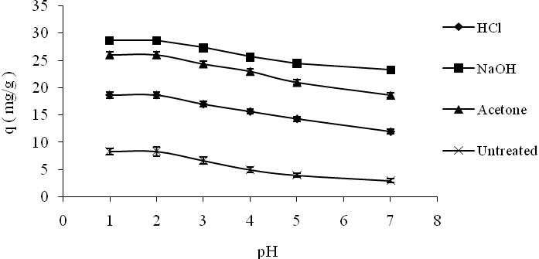
Fig. 3. pH effect on Cr (VI) by Zea mays (corn) cob biosorbent
Effect of chemical treatment
The chemical treatments of Zea mays (corn) cob may reduce or enhance the adsorption capacity of the biosorbent. It may change the biosorbent surface either by exposure of greater metal binding sites and masking or removing the functional groups in the biosorbent. All three chemically treated and untreated samples exhibited different biosorption capabilities in the following order: NaOH > acetone > HCl > untreated sample. Maximum increase in Cr (VI) biosorption was shown by NaOH treated Zea mays (corn) cob biosorbent as shown in Fig. 4. Treatment with NaOH of biosorbent lignocellulose materials caused a decrease in polymerization degree, crystallinity, leading, swelling and increase in internal surface area, separation or disruption of biosorbent structural linkages between carbohydrates and lignin [22]. Treatment of the biosorbent with acetone caused a slight increase in the Cr (VI) adsorption capacity of Zea mays (corn) cob biosorbent. Treatment with acetone removed the lipid and protein fractions from the biosorbent surface. Hence, this treatment improved the adsorption capacity and exposure of more metal binding sites of biosorbent [23]. HCl was used to treat the lignocellulose materials of the biosorbent. After HCl treatment, binding of H⁺ ions to the biosorbent caused a lower adsorption of Cr (VI). This result indicated that HCl may covalently bind to the biosorbent adsorbing surface and destroy the H⁺ ions of their adsorbing groups. Thus, biosorbent electronegativity may change due to H⁺ ions of HCl resulting in a decrease in adsorption capacity of the biosorbent [24].
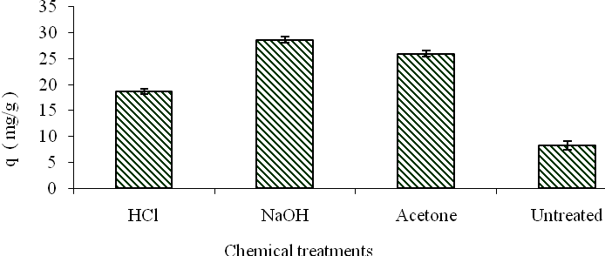
Fig. 4. Effect of treatment of Zea mays (corn) cob biosorbent
Effect of biosorbent initial metal concentration
By increasing initial metal ion concentration from 25 to 800 ppm the adsorption capacity/metal uptake of the biosorbent increased. Saturation of the biosorbent at 800 to 1000 ppm was done by further increase in initial metal ion concentration. Different metal ion concentrations from 25-1000 ppm were used as shown in Fig. 5. Initial metal concentration from 25 to 200 ppm showed greater adsorption as compared to 200-800 ppm. Concentration ranges from 25 to 200 ppm, increased the metal uptake by NaOH treated sample (5.33 to 38.75 mg/g), acetone treated sample (4.33 to 33.33 mg/g), HCl treated sample (3.67 to 30.33 mg/g) and untreated sample (3.00 to 25.00 mg/g) and minor increase in adsorption was observed from 200 to 800 ppm while concentration ranges from 800 to 1000 ppm seem to be saturated. Adsorption capacity of the metal ion increased at higher concentrations because, through intraparticle diffusion the metal diffused to the biosorbent surface. However, the metal occupies the biosorbent adsorption sites more rapidly at low concentrations [25].
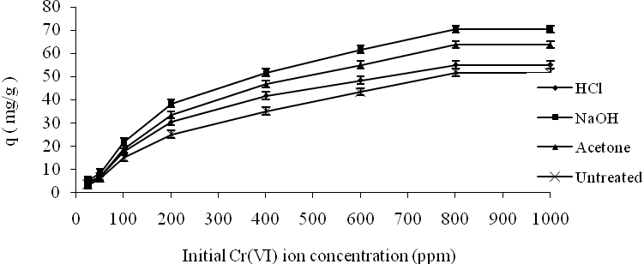
Fig. 5. Effect of initial Cr (VI) concentrations by Zea mays (corn) cob biosorbent
Isotherms for biosorption of chromium
The Freundlich and Langmuir isotherm adsorption models were applied to the equilibrium data of Zea mays (corn) cob biosorption of Cr (VI) [26].
Langmuir isotherm for biosorption of chromium
The Langmuir isotherm equation for biosorption of Cr (VI) was chosen for the estimation on the biosorbent surface of complete mono layer coverage and maximum adsorption capacity of metal ion on the biosorbent surface as shown in Fig. 6. The Langmuir related parameters are shown in Table 1. Equilibrium data were used to correlate the data with the help of Langmuir equation by using the equation [27]:
Ce/qe = 1/q_{max} K_{L}+ (1/q_{max}) Ce (3)
where K_{L} is Langmuir isotherm constant (ppm), Ce is equilibrium adsorption of metal concentration (ppm),

Table 1. Langmuir and Freundlich isotherms for Cr (VI) biosorption on Zea mays (corn) cob biosorbent
Treatment of biosorbent | Experimental | Langmuir isotherm constants |  |  | Freundlich isotherm constants
Treatment of biosorbent | q _{max} (mg/g) | X_{m} (mg/g) | K_{L} (L/mg) | R² | qe (mg/g) | K_{F} (mg/g) | 1/n | R²
Untreated | 63.66 | 79.36 | 0.0022 | 0.9049 | 4124.4 | 2.2977 | 0.7337 | 0.9672
HCl | 55.00 | 68.96 | 0.0050 | 0.9763 | 2445.1 | 1.0480 | 0.6424 | 0.9085
Acetone | 51.66 | 82.64 | 0.0050 | 0.9606 | 2379.8 | 1.1102 | 0.6393 | 0.9012
NaOH | 70.33 | 79.36 | 0.0071 | 0.9833 | 1411.6 | 1.8902 | 0.5771 | 0.9091

q_{max.} is maximum biosorbent monolayer adsorption capacity (mg/g).
The graph, (Ce/qe) vs. Ce was drawn. By applying Langmuir equation, intercept K_{L} and slope (1/q_{max}) were calculated. The Langmuir isotherm model as compared to Freundlich isotherm model fitted better to the experimental data as shown from the value of its constants. R² and q_{max} values of each pretreated or untreated sample were found: NaOH (0.9809, 70.33 mg/g), acetone (0.9595, 51.66 mg/g), HCl (0.9738, 55.00 mg/g) and untreated sample (0.9678, 63.66 mg/g).
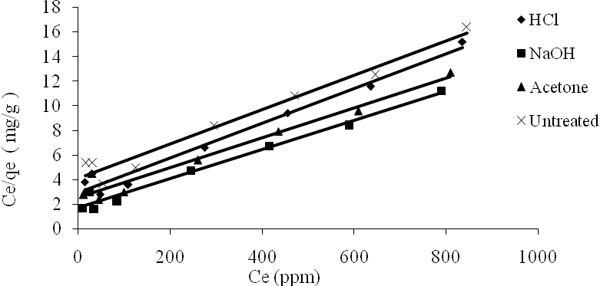
Fig. 6. Langmuir isotherm for Cr (VI) biosorption by Zea mays (corn) cob biosorbent
Freundlich isotherm for biosorption of chromium
At a given temperature it presents the equilibrium relationship between the concentrations of metal in the adsorbent and in the fluid phase. Freundlich isotherm can be applied in case of intermediate and low concentration ranges or it can be presented as isotherm equation of empirical adsorption [28]:
lnq_{e}= lnK_{f}+ n ln Ce (4)
where n and K_{f} are the Freundlich constants, Ce is concentration of metal at equilibrium (ppm), qe is adsorption capacity of biosorbent at equilibrium (mg/g). The Freundlich isotherm graph, log qe vs. log Ce is presented in Fig. 7.
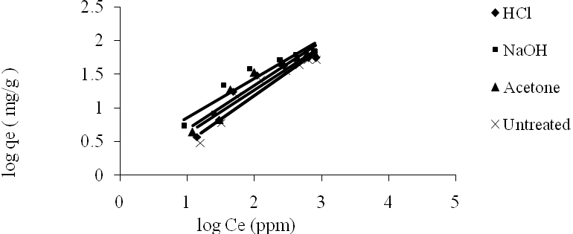
Fig. 7. Freundlich isotherm for Cr (VI) biosorption by Zea mays (corn) cob biosorbent
Separation factor (R_{L})
In a batch adsorption process, the separation factor can be used to calculate unfavorable or favorable adsorption system. The graph of initial metal concentration vs. separation factor (R_{L}) of adsorption of Cr (VI) on Zea mays (corn) cob is presented in Fig. 8. R_{L} values between 1 and 0 show the favorable isotherm. From the Langmuir isotherm based equation R_{L} was calculated [29]:
R_{L} = 1/ (1 + K_{L} C_{i}) (5)
where C_{i} is initial Cr (VI) concentration (ppm), K_{L} is Langmuir constant, R_{L} parameter presents the shape of the isotherm and nature of the sorption process: R_{L} = 1 = linear isotherm, R_{L} > 1 = unfavorable isotherm, R_{L} = 0 = irreversible isotherm, 0 < R_{L} <1 = favorable isotherm.
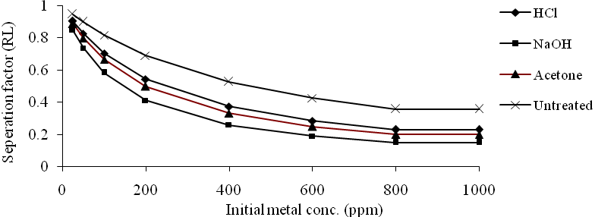
Fig. 8. Separation factor against initial metal concentration for biosorption of Cr (VI) by Zea mays (Corn) cob biosorbent
Surface coverage (θ)
By using Langmuir type equation the part of biosorbent surface covered by Cr (VI) was studied (Eq. (6) and Fig. 9).
θ = K_{L} C_{i} (1-θ) (6)
Where Ci is initial Cr (VI) concentration (ppm), K_{L} is Langmuir adsorption coefficient. The surface coverage increased and the surface was almost completely covered with monolayer by increase in initial Cr (VI) concentration from 25 to 800 ppm. The rate of adsorption became independent if Cr (VI) concentration was higher than 800 ppm. This is because at higher levels of concentration of Cr (VI) the surface coverage decreased extensively [30].
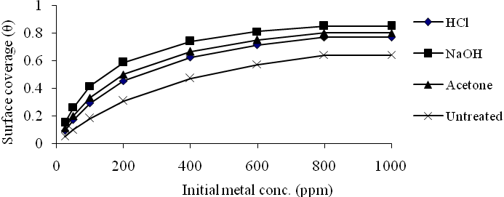
Fig. 9. Surface coverage (θ) vs. initial Cr (VI) concentration (ppm) for Zea mays (corn) cob biosorbent
Effect of kinetics
The kinetics of Cr (VI) adsorption is shown in Fig. 10. After the first 15 min the adsorption capacity of Cr (VI) was found to be fast and indicating an equilibration point after 180 min. Cr (VI) adsorption capacity was found to increase slowly until saturation level was attained. Most favorable time observed was 180 min at which metal adsorption capacity was 82.9 (0.30 g, 0.50 mm) for Zea mays (corn) cob biosorbent. The adsorption process of Cr (VI) took place in two stages. The first stage was more rapid than the second stage, because in the first 120 min 70% adsorption was completed. In the second stage 30% progressive adsorption was observed. The rapid initial biosorption may be attributed to accumulation of metal on biosorbent surface and the large surface area of the biosorbent. In the second stage a slower occupation of biosorbent sites was noted. The reason for the slower process after the saturated level is that initially deposited metal ions enter to the inside through intra-particle dispersion of the biosorbent. Other similar studies are in accordance with these observations [31]. In case of Zea mays (corn) cob the contact time increased with the increase in Cr (VI) adsorption capacity of biosorbent. Fast adsorption occurred from 15 to 120 min, accelerated biosorption was observed later on, because of the availability of vacant surface sites in a large number of initially biosorbent for adsorption and after some time due to repulsive forces the remaining vacant surface sites may be exhausted between the bulk and solid phase of molecules of biosorbent [32].
Adsorption kinetic studies
The adsorption kinetic studies of Zea mays (corn) cob biosorbent describe the rate of Cr (VI) ion uptake which controls the equilibrium time. These adsorption kinetic models integrated first- and second-order equations.
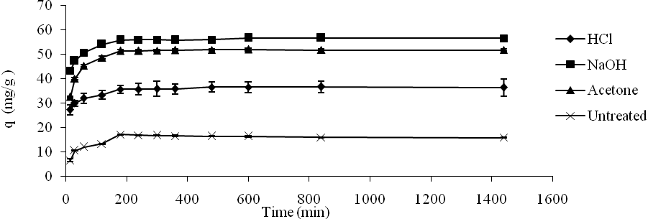
Fig. 10. Effect of kinetics on Cr (VI) biosorption by Zea mays (corn) cob biosorbent
Pseudo first-order model
The pseudo first-order rate equation is described as:
log (q_{e}-q_{t}) = log (q_{e}) –(k₁/2.303)t (7)
where qe is Cr (VI) metal ion concentration adsorbed by the biosorbent mass at equilibrium (mg/g), qt is Cr adsorbed by the biosorbent measured in (mg/g), k₁ is rate constant (min⁻¹) [33]. A graph plot of time vs. log (q_{e}-q_{t}) presents a straight line of intercept of log (qe).and slope (k1/2.303) as shown in Fig. 11.
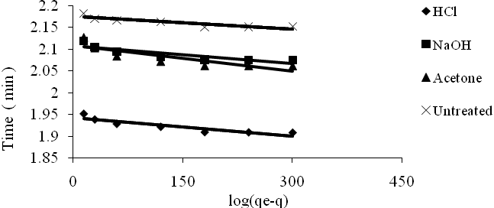
Fig. 11. Kinetic modeling of the biosorption of Cr (VI) by Zea mays (corn) cob pseudo first-order model
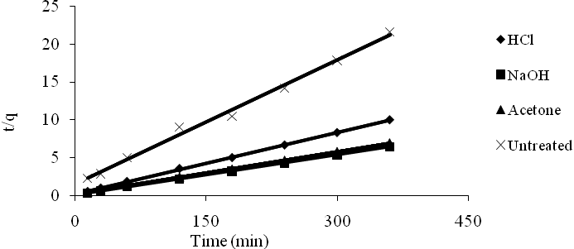
Fig. 12. Kinetic modeling by Cr (VI) Zea mays (corn) cob pseudo second order model.
Pseudo second-order model
Adsorption data of this model are given by an equation:
t/q_{t} = 1/K₂(qe)² +(1/qe)t (8)
where q_{t} and q_{e} are the adsorption capacities at time t and at equilibrium, K₂ is the equilibrium rate constant (g/mg min). The graph of time vs. t/q has a slope (1/qe) and intercept of 1/k₂ (qe)² as shown in Fig. 12. From the result it is obtained that R² and q_{e} values of each treated or untreated sample (see Table 2) are: NaOH (0.9999, 56.81 mg/g), acetone (0.9999, 53.19 mg/g), HCl (0.9997, 36.63 mg/g) and untreated sample (0.9938, 18.24 mg/g). Hence, pseudo second-order is the most favorable isotherm for Zea mays (corn) cob biosorbent [34].
Scanning electron microscopy
The scanning electron micrographs of Zea mays (corn) cob biosorbent before and after Cr (VI) adsorption are shown in Figs. 13 and 14 respectively.

Table 2. Pseudo first- and pseudo second-order kinetic models for Cr (VI) biosorition on Zea mays (corn) cob biosorbent
Treatment of biosorbent |  | Experimental |  | Pseudo first-order constants |  |  |  |  |  | Pseudo second-order constants
 |  | q _{max}(mg/g) |  | qe(mg/g) |  | k₁(min⁻¹) |  | R² |  | qe(mg/g) |  | k₂(g/mg min) |  |  | R²
Untreated |  | 15.933 |  | 149.86 |  | 2.30×10⁻⁴ |  | 0.8005 |  | 18.24 |  | 2.06×10⁻³ |  |  | 0.9938
HCl |  | 36.466667 |  | 87.72 |  | 2.30×10⁻⁴ |  | 0.8234 |  | 36.63 |  | 3.78×10⁻³ |  |  | 0.9997
Acetone |  | 51.733 |  | 128.43 |  | 4.60×10⁻⁴ |  | 0.7199 |  | 53.19 |  | 1.95×10⁻² |  |  | 0.9999
NaOH |  | 15.933 |  | 128.43 |  | 2.30×10⁻⁴ |  | 0.7623 |  | 56.81 |  | 3.13×10⁻³ |  |  | 0.9999

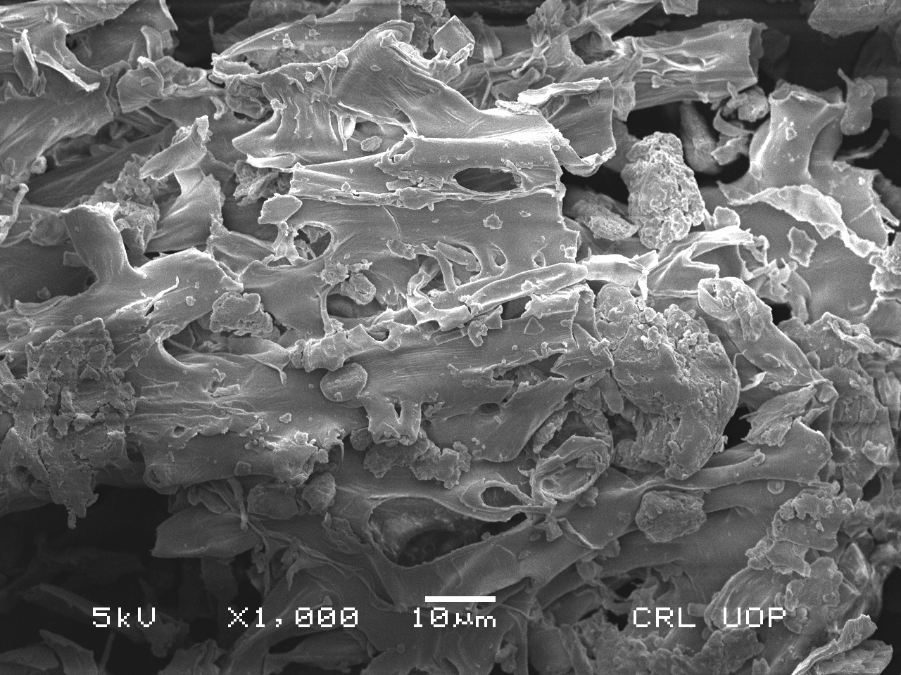
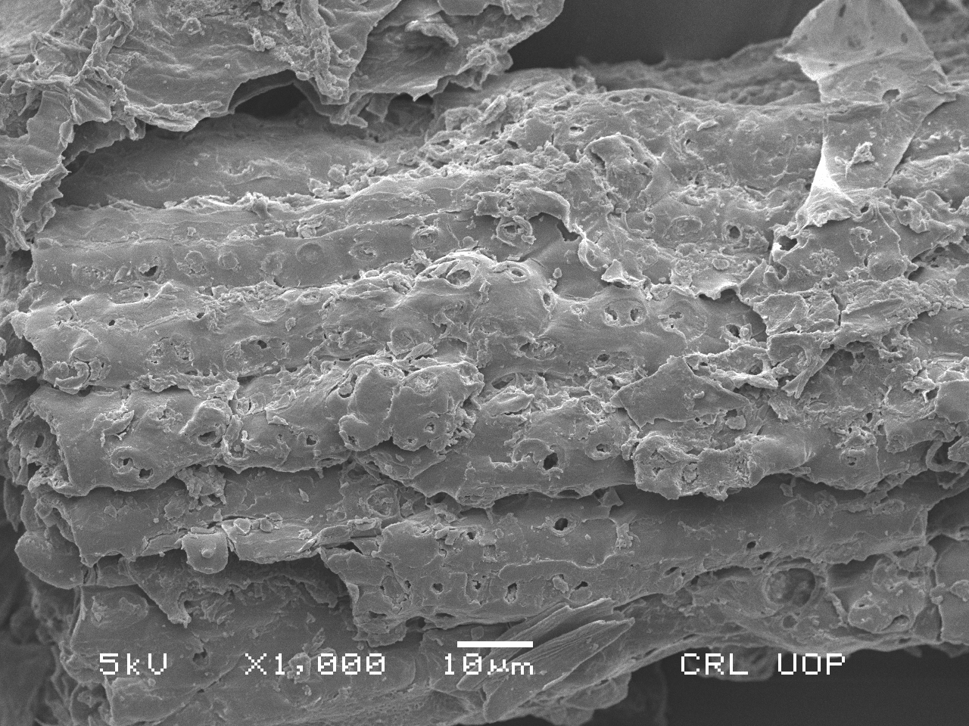
Fig. 13. SEM image of Zea mays (corn) Fig.14.SEM image of Zea mays (corn) cob
cob biosorbent before Cr (VI) adsorption biosorbent after Cr (VI) adsorption
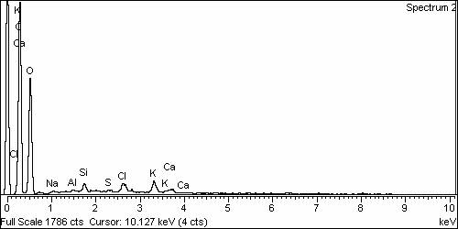
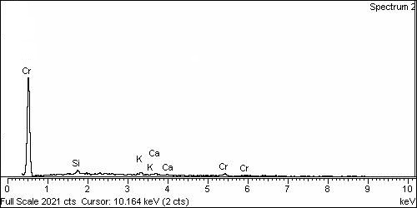
Fig. 15. EDX spectra of Zea mays (corn) cob Fig. 16. EDX spectra of Zea mays (corn) cob
before Cr (VI) adsorption after Cr (VI) adsorption

The surface morphology of different parts of both biosorbent materials would facilitate the adsorption of metal ions and the surface was found to be porous and irregular. The SEM micrographs of the biosorbent showed that pores with different shapes and different sizes existed on the external surface of Zea mays (corn) cob. The SEM micrograph of Zea mays (corn) cob before Cr (VI) adsorption showed larger surface area, pore space, pore volume and number of pores available (Fig. 13) while after Cr (VI) adsorption there was reduction of surface area, pore space and number of pores available (Fig. 14) due to binding of positive sites of Cr (VI) with negative sites of biosorbent. Hence, metal adsorption was found to be maximum [12].
Energy dispersive X-ray analysis
The energy dispersive X-ray (EDX) spectra of Zea mays (corn) cob biosorbent before and after Cr (VI) adsorption are shown in Figs. 15 and 16, respectively. The EDX peaks for Cr (VI) were observed and this technique was used qualitatively. The EDX spectra show absence of Cr (VI) peak before biosorption and appearance of Cr (VI) adsorption peak after biosorption. Appearance of Cr (VI) peaks means that the biosorbent adsorbed the Cr (VI) metal ion because biosorbent surface has active groups such as oxygen, carbon and nitrogen groups which bind the metal ion [35].
CONCLUSIONS
The present work shows that the dried biosorbent of Zea mays (corn) cob has ability to remove heavy metals like Cr (VI) from aqueous solutions. In batch mode adsorption studies different parameters were optimized, like biosorbent size and dose, initial metal concentration, pH, and contact time.
Effect of biosorbent size and dose: Effect of biosorbent size and dose was optimized without pretreatment of biosorbent with chemicals. Optimum size was found to be 0.5 mm. Higher adsorption was observed for biosorbents chemically pretreated with sodium hydroxide, acetone and hydrochloric acid. Biosorbent treated with chemicals showed adsorption capacity in the following order: NaOH > acetone > HCl > untreated sample. The optimum biosorbent dose was 0.3 g, and the optimum size was 0.5 mm.
Effect of pH, initial concentration and contact time: The Zea mays (corn) cob biosorbent showed maximum adsorption capacity for different pretreated (NaOH, acetone, HCl) and untreated samples. The effect of pH, initial metal concentration and contact time for treated and untreated samples was studied and maximum adsorption was observed at pH 2, 800 ppm and 180 min, respectively.
Kinetic isotherm model and surface characterization: Kinetic isotherm models such as pseudo second-order and Langmuir isotherm adsorption model were also studied for removal of Cr (VI). Biosorbent samples were analyzed before and after biosorption by SEM for surface morphology of biosorbent and EDX. The presence of metal ion peak confirmed that the biosorbent adsorbs Cr (VI) metal ions. It can be concluded from the present study that chemically treated Zea mays (corn) cob powder could be employed as an eco-friendly and cost-effective biosorbent for removal of heavy metal from aqueous solution.
Acknowledgements: We are highly thankful to acknowledge the Department of Chemistry, University of Sargodha Faisalabad Pakistan in providing the facilities for this research work.
REFERENCES
- S. Yapoga, Y. B. Ossey, V. Kouame, Int. J. Conserv. Sci. 4, 81 (2013).
- . F. Ekmekyapar, A. Aslan, Y. K. Bayhan, A. Cakici, J. Hazard. Mater. 137, 293 (2006).
- S. Pandiyan, D. Mahendradas, Eur. J. Sci. Res 52, 345 (2011).
- W. Tsai, C. Chang, S. Wang, C. Chang, S. Chien, H. Sun, Res. Coserv. Rec. 32, 43 (2001).
- J.-L. Lin, H. M. Keener, R. H. Essenhigh, Combust. Flame 100, 271 (1995).
- B. Barl, C. G. Biliaderis, E. D. Murray, A. W. Macgregor, J. Sci. Food Agri. 56, 195 (1991).
- M. Saifuddin, P. Kumaran, Electron. J. Biotechnol. 8, 43 (2005).
- G. Rojas, J. Silva, J. A. Flores, A. Rodriguez, M. Ly, H. Maldonado, Sep. Purif. Technol. 44, 31 (2005).
- Y. Sag, Y. Aktay, Process Biochem. 36, 157 (2000).
- R. De Carvalho, K. H. Chong, B. Volesky, Biotechnol. Prog. 11, 39 (1995).
- G. M. Matei, J. K. Kiptoo, N. K. Oyaro, A. O. Onditi, Facta Univ. Phys. Chem. Technol. 12, 1 (2014).
- D. Krishna, R. P. Sree, Int. J. Appl. Sci. Eng. 11, 171 (2013).
- S. Renganathan, J. Kalpana, M. Dharmendira Kumar, M. Velan, CLEAN–Soil, Air, Water 37, 901 (2009).
- J. Goldstein, D. E. Newbury, P. Echlin, D. C. Joy, A. D. Romig Jr, C. E. Lyman, C. Fiori, E. Lifshin, Scanning electron microscopy and X-ray microanalysis: a text for biologists, materials scientists, and geologists, 2nd Edition ed. Springer Science & Business Media, New York, 2012.
- G. Agarwal, H. K. Bhuptawat, S. Chaudhari, Bioresour. Technol. 97, 949 (2006).
- V. K. Gupta, I. Ali, J. Colloid Interface Sci. 271, 321 (2004).
- V. Sarin, K. K. Pant, Bioresour. Technol. 97, 15 (2006).
- M. Rao, A. Parvate, A. Bhole, Indian J. Environ. Prot. 22, 17 (2002).
- N. R. Bishnoi, A. Pant, P. Garima, J. Sci. Ind. Res. 63, 813 (2004).
- D. Park, Y.-S. Yun, J. M. Park, Chemosphere 60, 1356 (2005).
- A. J. Priya, S. R. Gajulapalli, K. Abburi, V. M. Boddu, Bioremediat. J. 12, 145 (2008).
- Y. Sun, J. Cheng, Bioresour. Technol. 83, 1 (2002).
- R. Ashkenazy, L. Gottlieb, S. Yannai, Biotechnol. Bioeng. 55, 1 (1997).
- F. Bux, H. Kasan, Water S. A. 20, 73 (1994).
- S. Bai, T. E. Abraham, Bioresour. Technol. 79, 73 (2001).
- U. Freundlich, Z. Phys. Chem 57, 387 (1906).
- M. A. Hussain, A. Salleh, P. Milow, Am. J. Biochem. Biotechnol. 5, 75 (2009).
- M. Temkin, V. Pyzhev, Acta Physio. Chim. 12, 217 (1940).
- M. A. Hanif, R. Nadeem, H. N. Bhatti, N. R. Ahmad, T. M. Ansari, J. Hazard. Mater. 139, 345 (2007).
- M. Riaz, R. Nadeem, M. A. Hanif, T. M. Ansari, J. Hazard. Mater. 161, 88 (2009).
- M. R. Sangi, A. Shahmoradi, J. Zolgharnein, G. H. Azimi, M. Ghorbandoost, J. Hazard. Mater. 155, 513 (2008).
- S. Qaiser, A. R. Saleemi, M. Umar, J. Hazard. Mater. 166, 998 (2009).
- G. Donmez, Z. Aksu, Process Biochem. 38, 751 (2002).
- Y. Sag, Y. Aktay, Biochem. Eng. J. 12, 143 (2002).
- M. Figueira, B. Volesky, H. Mathieu, Environ. Sci. Technol. 33, 1840 (1999).

КИНЕТИЧНО И РАВНОВЕСНО МОДЕЛИРАНЕ НА СОРБЦИЯТА НА CR (VI) ВЪРХУ ХИМИЧНО МОДИФИЦИРАНИ КОЧАНИ ОТ ЦАРЕВИЦА (ZEA MAYS) ВЪВ ВОДЕН РАЗТВОР

A. Р. Aбас¹*, Мисбах^{1,2} , M. Риаз¹*, А. Ханиф¹, M. Сулеман³, И. Гул⁴
¹Департамент по химия, Университет на Саргода, Женски кампус, Файзалабад, Пакистан
² Департамент по химия, Селскостопански университет, Файзалабад 38040, Пакистан
³Департамент по химия, Женски университет на Азад Джаму и Кашмир, Баг, Пакистан
⁴ Департамент по химия, Университет на Саргода, кампус Бхакар, Бхакар 30000, Пакистан

Постъпила на 27 септември, 2016 г.; Коригирана на 12 ноември, 2017 г.
(Резюме)
В настоящата статия е изследвана биосорбцията на Cr (VI) върху химично обработени кочани от царевица (Zea mays). Изследвано е влиянието на различни параметри като размер на частиците и количество на биосорбента, рН, време за контакт и първоначална концентрация на металния йон върху достигането на сорбционно равновесие. Биосорбентът е обработен предварително с различни реагенти като NaOH, ацетон и HCl за модифициране на повърхността му. Количеството биосорбент, осигуряващо максимално извличане (23.7 %) е 0.3 g, докато с 0.5 g извличането е 14.2 mg/g. За оценка на степента на сорбция, концентрацията на Cr (VI) е определяна преди и след биосорбцията чрез AAS анализ. Чрез SEM и EDX анализ е получена информация за биосорбцията на Cr (VI) върху повърхността на сорбента. Получените данни са анализирани с помощта на изотермите на Langmuir и Freundlich и с кинетични модели от псевдопърви и псевдовтори порядък. От резултатите следва, че изотермата на Langmuir и кинетичният модел от псевдовтори порядък съответстват най-добре на експерименталните данни (най-високи стойности на R²). Резултатите са обработени статистически.

