Rose oil isolated from oil-bearing Rosa damascena Mill. as a protector against ionizing radiation-induced oxidative disorders
Y.D. Karamalakova¹, M.K. Adhikari³, N.D. Kovacheva², V.A. Ivanov⁴, G.D. Nikolova^{1*},
V.G. Gadjeva¹
¹Department of Chemistry and Biochemistry, Medical Faculty, Trakia University, 11 Armeiska Str., 6000 Stara Zagora, Bulgaria
²Institute for Roses, Medicinal and Aromatic Plants, 49 Osvobozhdenie str., 6100 Kazanlak, Bulgaria
³Institute of Nuclear Medicine and Allied Sciences, Defence Research and Development Organization (DRDO), Brig S. K. Mazumdar Marg, Delhi-110054, India
⁴Department of Neurology, Psychiatry and Disaster Medicine, Section of Disaster Medicine, Medical Faculty, Trakia University, 6000, Stara Zagora, Bulgaria
Received September 28, 2017, Revised November 30, 2018
Essential oils are derived from different natural plant materials such as leaves and flowers. They are commercially important and have been widely used in cosmetics, household products and medicines because of pharmacologically active components. Essential oil as antioxidant is able to prevent oxidative processes and to inhibit the oxidation reaction effect caused by radiation-induced oxygen/nitrogen free radicals. Ionizing radiation is a recognized method of maintaining the quality of aromatic herbs, spices and vegetables for a long time. The present study focused on identifying the radioprotective efficacy of rose oil against oxidative damage of molecules by ionizing radiation in in vitro models.
Keywords: Rosa damascena Mill., DPPH scavenger, Radiomodulation

INTRODUCTION
The available data indicate that the effect of ionizing radiation leads to changes in biological systems and to an increase in the level of free radicals [1, 2]. Consequently, the evaluation of the pharmacological effect of essential oils after ultraviolet (UV) and gamma (γ) radiation is of considerable interest because of their supposed antioxidant and therapeutic effect, as well as the overall composition. Essential oils as antioxidants are able to prevent oxidative processes [3] and to inhibit the oxidation reaction effect caused by radiation-induced oxygen/nitrogen free radicals [4]. Ionizing radiation is a recognized method of maintaining the quality of aromatic herbs, spices and vegetables for a long time [5]. Increased antioxidant activity was observed in oils obtained from previously irradiated leaves and fruits [6, 7]. In vitro and in vivo systems serve as models for preliminary observations in assessing pharmacological activity, changes in chemical composition and various forms of the spectrum versus time and T°C [7, 8] oils as protective antioxidants that can effectively involve radiation-induced oxidative changes [9, 10]. The Western European Rose Damascus Mill. (R. damascena) as a plant species of Europe was used in homeopathic and pharmaceutical preparations [11]. Rose oil was characterized by antibacterial, neuropharmacological, anti-inflammatory and stable antioxidant action [12-15]. More than 300 components referring to terpenic and non-terpenic hydrocarbons, glycosides, flavonoids, citronellol, geraniol, farnesol, alcohols, nerol, linalool and esters, have been recognized in the oil structure [16, 17]. The present study focused on identifying the radioprotective efficacy of rose oil against oxidative damage of molecules by ionizing radiation in in vitro models.
* To whom all correspondence should be sent:
E-mail: gnikolova@mf.uni-sz.bg
© 2018 Bulgarian Academy of Sciences, Union of Chemists in Bulgaria
EXPERIMENTAL
Isolation and characterization of Bulgarian rose oil
Rose flowers (stage IV-V) were collected on May 26, 2009, between 6 and 10 am at a relative humidity of 86-93% and temperature of 13.5-14.8ºC from 2 plantations located at IREMC, Kazanlak, Bulgaria. Isolation and characterization of the main components of rose oil were carried out using Clevenger water vapor distillation and gas chromatography (GC) (chromatograms obtained for the determination of the representative and distinctive ingredients given in BS ISO 9842-2004), as described in previous reports [19, 20]. The quality of the Bulgarian rose oil corresponds to the standard [21] for rose concrete and rose absolute grown from dry leaves [17].
Irradiation
Experimental samples (in a de-aerated capillary) were exposed to UV-B (UV-vis Transilluminator- 4000, Bulgaria; 290-320 nm; two lamps; 220V ~ 50 Hz; microwave power 7.70VA; for 2 h rate; humidity- 40 %) and to ⁶⁰Co radiation at doses of 2.5, 5, 10, 20, 30, 50 Gy using γ- chamber Gamma Cell 5000 (dose rate of 1.4 Gy/h, Board of Radiation and Isotope Technology, India). Dosimetry was carried out using Baldwin Farmer’s secondary dosimeter and Fricke’s chemical method and all the radiation safety measures were strictly followed during experimentation.
Electron donation potential estimation assay
The electron donation potential of UV and γ-irradiated samples and oil alone, was determined by the Oyaizu [22] method. A range of concentrations (1 - 500 μg/ml) before and after gamma irradiation (2.5 Gy) was firstly tested to determine the concentration at which oil exhibited maximal donation potential. Further, this concentration (50 μg/ml) was UV and γ- irradiated with doses ranging from 5 Gy to 50 Gy and the electron potential was determined both immediately and 24 h post irradiation. The reaction mixture was left for 10 min at room temperature and the absorbance was measured at 700 nm. An increased absorbance of the reaction mixture indicates increased reducing power:
% Inhibition = [(OD_{control} – OD_{test} ) /OD_{control}] × 100
2,2-Diphenyl-1-picrylhydrazyl (DPPH) radical- scavenging activity
Radical scavenging activity of γ-irradiated samples and oil alone against the stable DPPH radical was determined according to Cuendet et al. [23]. Briefly, 1.0 ml of DPPH (100 µM) was added to 500 µl of different volume concentrations of the studied samples. Mixtures were incubated in the dark for 10 min and their absorbance at 517 nm was measured. Quercetin was used as a positive control. The percentage of DPPH radicals scavenged was calculated according to the equation:
% Inhibition = (A_{control} – A_{test} ) /A_{control} × 100
2,2-Azinobis (3-ethylbenzothiazoline–6–sulfonic acid) (ABTS^{•+}) radical-scavenging assay
ABTS^{•+} radical scavenging assay of γ- irradiated samples and oil alone was performed according to Re et al. [24] with slight modifications. The reaction mixtures were incubated at 24⁰C for 30 min and the intensity of chromogen was measured at 734 nm. Antiradical activity of the examined sample was presented as the percentage of ABTS^{•+} radical scavenging and calculated according to the equation:
% Inhibition = (A_{control} – A_{test} ) /A_{control} × 10
Nitric oxide (NO⁻) ion scavenging assay
The NO⁻ potential of γ-irradiated samples and oil alone samples (0.1–250 μg/ml) was determined according to the method described by Shirwaikar et al. [25]. The scavenging potential was evaluated as the decrease in percent absorbance of the chromogen formed by diazotisation of nitrite with sulfanilamide and subsequent coupling with naphthyl ethylenediamine recorded at 546 nm.
Protection of membrane against radiation damage (membrane protection index)
Soya lecithin and cholesterol (1:1 molar ratio) were suspended in an appropriate amount of chloroform. A thin film was developed by complete evaporation of chloroform in a rotary evaporator (Buchi, Newcastle, USA) at 40ºC. The film was subjected to hydration in (0.1 M, pH 7.4) PBS and was incubated in a water bath (40ºC) for 4 h. The stock solution was diluted with PBS to the final concentration in terms of phospholipid content, cf. Lasic&Papahadjopoulous [26]. Different treated oil samples, liposome only (untreated), radiation only (2.5Gy), liposome + rose oil and liposome + rose oil+2.5 Gy were evaluated for the levels of malondialdehyde, the final product of membrane degeneration. A radiation dose of 2.5 Gy at a dose rate of1.4 kGy/h was used and after exposure the samples were immediately incubated for 1 h at 37ºC. 10 % TCA and 0.5% thiobarbituric acid, 1:1 ratio and 0.025 M NaOH were added. The mixture was heated in a water bath (80ºC) for 1 h and absorbance was measured at 535 nm [27].
Statistical analysis
Statistical analysis was performed with Statistica 6.1, StaSoft Inc., and results were expressed as means ± standard error (SE). Statistical significance was determined by Student’s t-test. Value of p < 0.05 was considered statistically significant.
RESULTS AND DISCUSSION
Ionizing radiation (IR) induces oxidative disturbances by the accumulation of reactive oxygen species (ROS) as singlet oxygen (¹O₂), nitrogen oxide (NO•), hydrogen peroxide (H₂O₂), macromolecular degradation and lipid peroxidation [28, 29]. Oxidation of lipids and other vital macromolecules leads to persistent oxidative disturbances and obstruction of intracellular processes. Therefore, in order to protect biological macromolecules from free radicals of ionizing radiation, it is necessary to shield them by an effective radiation-protective agent.
Thus, the oils of the bearing plants and plant extracts were evaluated for stable antioxidant activity in vitro and in vivo, scavenging of ROS / RNS and radiation protection property [30-32]. Donation potential is usually associated with the presence of reducing agents that exert an antioxidant effect by breaking down the radical chains by donating a hydrogen atom [33]. The maximum reduction ability for non-irradiated oil (Fig. 1a) and 2.5 Gy samples (Fig. 1b) with respect to the Fe³⁺ complex was observed at a concentration of 50 μg / ml. Two hours after UV irradiation, the oil samples showed a greater donation potential compared to non-irradiated oil (0.664 ± 0.016 vs. 0.472 ± 0.005). R. damascena displayed a good restoring ability to the complex of Fe³⁺ after UV in both treatment groups up to 5Gy (Fig. 1).
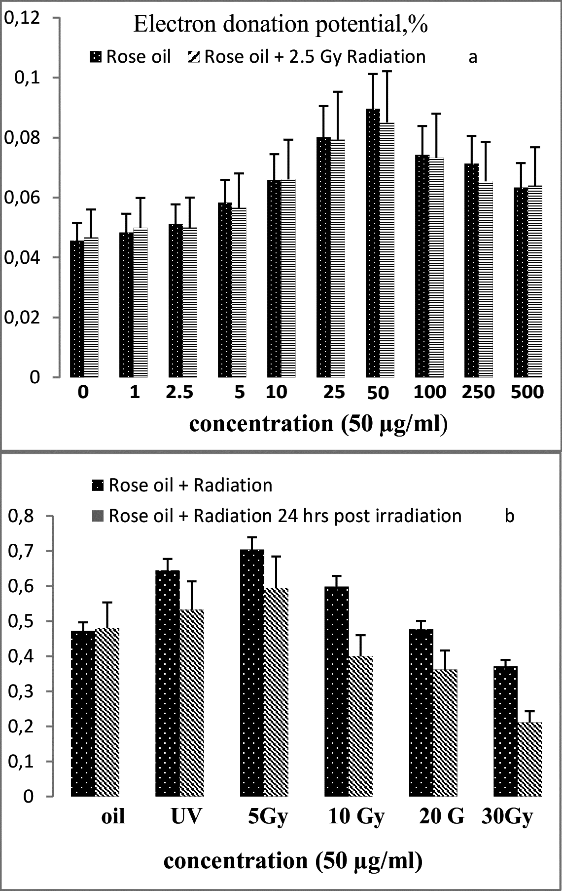
Fig. 1. Electron donation potential estimation of 50 µg/ml oil alone/ after 2.5Gy irradiation (a) /after UV and γ-irradiation (immediately and 24 h post irradiation, (b)).
Donation potential of the oil was tested at different time intervals, immediately and 24 h after treatment. Therefore, the results of this study clearly indicate that the samples after irradiation showed a significant reduction in the donor potential in comparison with non-irradiated oil and with those that were measured immediately after irradiation, but with the same dependence. Radiation exposure increases the load of iron in the cellular environment and leads to hemolysis [34]. It can be assumed that the reduction of Fe³⁺ to the less dangerous Fe²⁺ is a possible mode of action of R. damascena, which showed antioxidant protection to overcome oxidative disorders caused by radiation in vivo.
The efficiency of DPPH scavenging activity of R. damascena, non-irradiated and γ-irradiated (2.5 Gy) oil is shown in Fig. 2. The maximum DPPH -scavenging activity of 2.5 Gy oil (74.4 ± 0.97%) was detected at 50 μg / ml compared to non-irradiated oil (63.4 ± 1.12%, 500 μg / ml). In two ranges of increasing concentrations, namely 2.5 to 25 μg / ml and 50 to 500 μg / ml, a statistically insignificant increase in the DPPH scavenging activity was observed in both non-irradiated oil and γ-irradiated samples.
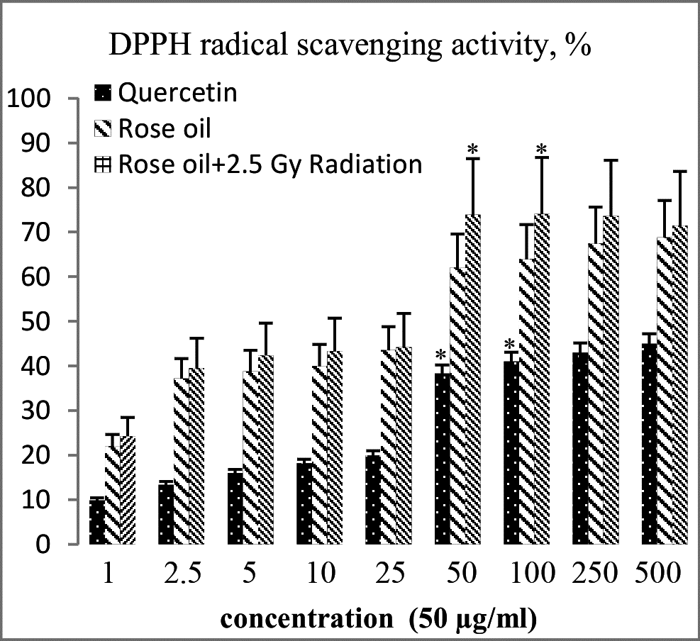
Fig. 2. Determination of DPPH radical scavenging activity of γ-irradiated (2.5 Gy) and oil alone. Quercetin was used as a standard.
For the same concentration ranges, an insignificant increase in DPPH activity of the γ-irradiated sample was also observed in comparison with the non-irradiated oil. It should be noted that irradiated and non-irradiated oil in all studied concentrations demonstrates a statistically higher ability of DPPH scavenging compared to quercetin used as a positive control. The efficacy in the scavenging abilities of the stable DPPH radicals of geraniol [35] and citronellol and the good inhibitory effect on UV irradiation [36] are consistent with our results. A significant reduction in the radical scavenging ability of oil at higher doses (> 5 Gy) of IR irradiation can be explained by the significant structural changes of some constituents in the form of geraniol, citronellol and eugenol, which probably determined its antioxidant activity.
The ABTS analysis is excellent for determining the total antioxidant activity of hydrogen-donating antioxidants (scavenging aqueous-phase radicals) and chain breaking antioxidants (scavenging lipid-peroxyl radicals) [37]. The present study used an improved ABTS^{•+} decolorization assay [24], which is applicable to lipophilic and hydrophilic antioxidants. In the range of 10-500 μg/ml, both γ-irradiated and non-irradiated oil samples (Fig. 3) demonstrated an increase in scavenging abilities towards ABTS^{•+} in a concentration-dependent manner. As indicated at 500 μg/ml, the ABTS^{•+} scavenging ability percentage was 70.36 ± 1.91% for non-irradiated oil and 72.38 ± 1.08% for 2.5 Gy samples. Only at 25 μg/ml and 50 μg/ ml was a statistically significant increase in ABTS^{•+} activity of 2.5 Gy oil compared to non-irradiated oil. With the exception of 500 μg/ml, all other oils alone and 2.5 Gy irradiated concentrations showed better ABTS^{•+} scavenging activity than the standard.
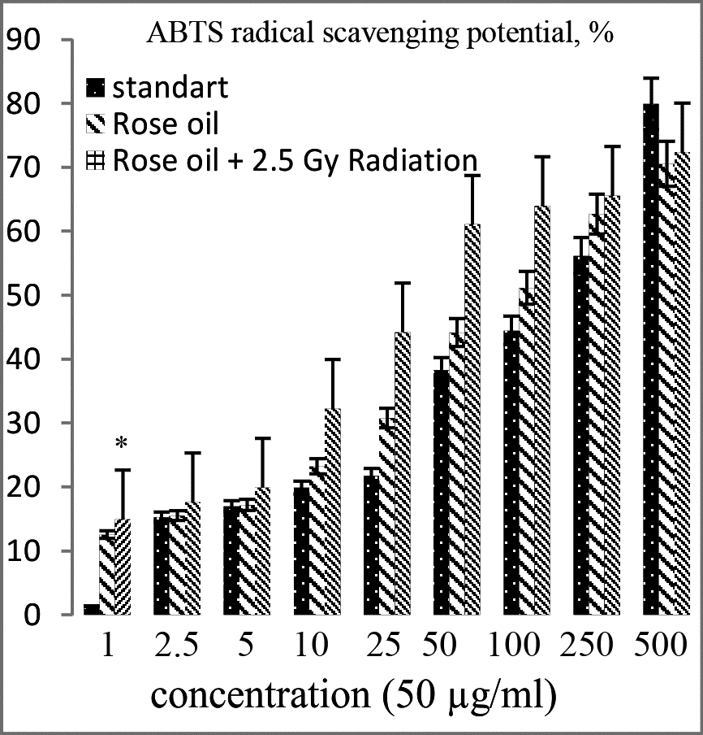
Fig. 3. ABTS radical scavenging potential of γ- irradiated (2.5 Gy) and oil alone in concentration range (1 – 500 μg/ml).
Nitric oxide (NO•) is an important messenger in a variety of normal physiological processes. In addition to its physiological actions, the overload of NO• can lead to cell damage by changing the function of the protein by nitrosylation, promote glutamate exutotoxicity, inhibit mitochondrial respiratory complexes, participate in fragmentation of organelles and mobilize zinc from internal stores [38]. Oxidative stress induced by IR generates NO• and plays a critical role in the initiation and progression of oxidative damage [39], the function and dysfunction of the nervous system, [38]. The scavenging ability of NO• (Fig. 4) increases with an increase in the concentration of 2.5 Gy and samples with non-irradiated oil. At 250 µg/ml maximum NO• scavenging activities were 34.07± 1.1% and 32.2 ± 3.01%, respectively.
In in vitro non-irradiated oil samples and ionizing radiation samples, NO• production was markedly reduced, indicating that the oil contains hydrophilic antioxidants that have NO• scavenging ability. In addition, for each test concentration of 2.5 Gy of oil, a higher scavenging activity was shown compared to non-irradiated oil, suggesting that additional structures are involved in reducing NO• levels. Pathologically, NO• radicals reacted with O₂^{•-} anion to peroxynitrite (ONOO‾) and led to serious toxic reactions with proteins and lipids [40, 41]. In view of the fact that R. damascene exhibits a pronounced scavenging activity against NO•, as before/after IR makes the oil a potential antioxidant, it can be used in IR-induced pathological situations associated with excessive production of NO•[41]. Moreover, γ-irradiation induces changes in fatty acids of membrane phospholipids forming unstable and highly reactive peroxy radicals that decompose into alcohols, ketones and malondialdehyde [42]. The artificial membrane system (liposomes) was used to assess the ability of rose oil to protect the lipids of 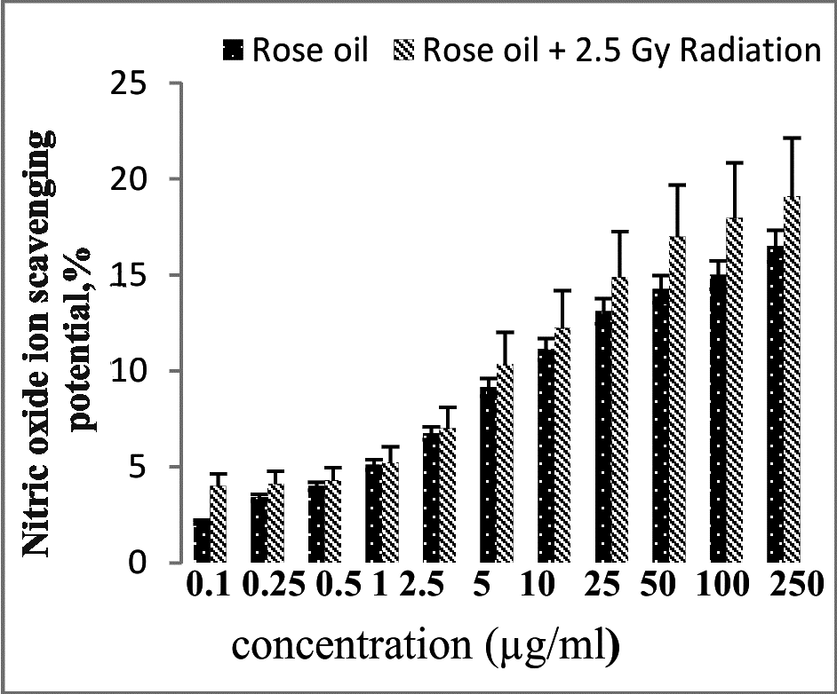
Fig. 4. Nitric oxide scavenging potential of γ- irradiated (2.5 Gy) and oil alone in the concentration range (0.1 – 250 μg/ml).
liposomes against lipid peroxidation 2.5 Gy (dose rate = 1.24 KGy / h). The most effective dose for inhibition of peroxidation in the tested liposome system was 100 µg/ml. Rose oil exhibited significantly higher membrane protection at 150 μg/ml (0.062 ± 1.04%; p<0.05). Maximal activity of 2.5 Gy was at 100-150 μl/ml (Fig. 5). The samples with 2.5 Gy indicated two times higher anti-lipid peroxidation, compared to oil alone. It might be assumed that the higher membrane protection of the 2.5Gy samples was due to chelation of transition metal ions [43] by filling the aqua-coordination sites of the hydrophilic rose oil substances exhibiting radical scavenging abilities, which indirectly demonstrated protective properties and possible reduction of pathophysiological consequences [44]. Good ability of geraniol to inhibit lipid peroxidation in egg-liposomal suspension is in agreement with our reported results [35].
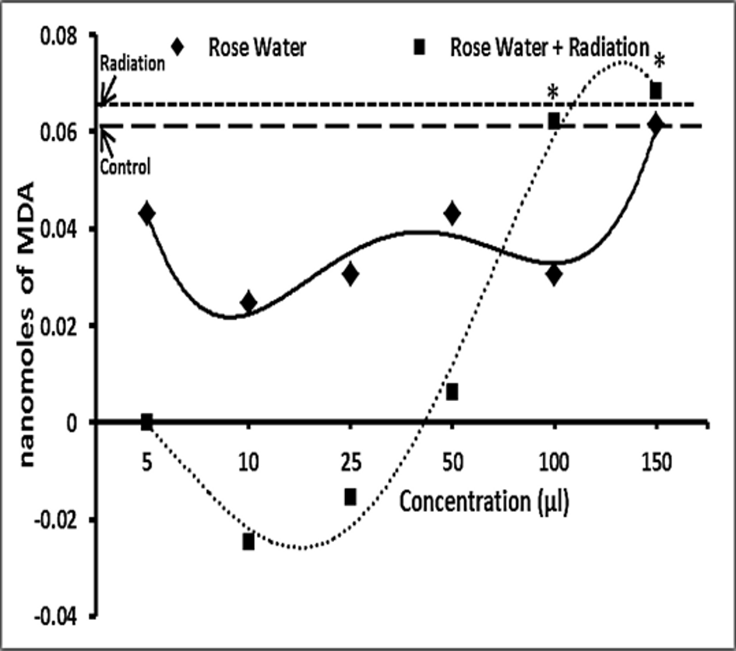
Fig.5. Analysis of the membrane-protecting ability of non-irradiated and γ- irradiated (2.5 Gy) rose oil utilizing an artificial membrane system (liposome). A significant (p < 0.05) decrease in the formation of malondialdehyde (MDA) with increasing concentration of γ- irradiated oil (50 – 150 μg/ml) was recorded. Effect of different concentrations of non-irradiated and γ- irradiated (2.5 Gy) rose oil on radiation (1.24KGy/h)- mediated lipid peroxidation evaluated in erythrocytes. Each experiment was performed in triplicate. The lipid peroxidation activity is expressed as nanomoles of MDA formed.
CONCLUSION
Rose oil after irradiation showed a significant reduction in the donor potential in comparison with non-irradiated oil and with those that were measured immediately after irradiation, but with the same dependence. Moreover, irradiated and non-irradiated oil in all studied concentrations demonstrates a statistically higher ability of DPPH compared to quercetin used as a positive control.
Acknowledgements: This study was supported by a grant of the Ministry of Education, Youth and Science – Indo-Bulgarian collaborative project (BIn-7/2008), PIRSES-GA-2012-316067/ 2013-2016 and scientific projects № 21/2014; № 35/2014. The authors gratefully acknowledge the following people for their assistance with this project-work: Jyoti Sharma, and Poonam Malhotra.

Conflict of interest: The authors declared no potential conflicts of interest with respect to the research, authorship, and/or publication of this article.
REFERENCES
- G.C. Jagetia, J. Clin. Biochem. Nutrition, 40, 74 (2007).
- A. Wei, T. Shibamoto, J. Agric. Food Chem., 58(12),7218 (2010).
- F. Liu, Q. Xu, R. Dai, Y. Ni, Acta Sci. Pol. Technol. Aliment. 14, 37 (2015).
- B. Poljsak, D. Šuput, I. Milisav, Oxidat. Med. and Cell. Long., 29, 11 (2013).
- European Directive 1999/3/EC of the Europ. Parliam. and of the Council of 22 Febr. 1999 on the Establishment of a Community list of foods and food ingredients treated with ionizing radiation, Offic. J. Europ Comm. L66, 13.3., 1999, p. 24.
- M. Suhaj, J. Horvathova, J. Food and Nutrition Res., 46(3), 112 (2008).
- Y. Karamalakova, J. Sharma, G. Nikolova, S. Stanev, R. Arora, V. Gadjeva, A. Zheleva, Biotechnol. & Biotechnolog. Equipm., 27(3), 3861 (2013).
- G. J. Troup, L. Navarini, F. S. Liverani, S.C. Drew, PloS ONE, 10, e0122834 (2015).
- R. Arora, CABI Publishing, Wallingford, Oxon, UK, 2008, p. 332.
- P. Paul, K. Unnikrishnan, N. Nagappa, Ind. J. Nat. Prod. Res.., 2, 137 (2011).
- P. T. Beales, W. Cairns, W. Duncan, K. Grant, P. Grapes, K. Harkness, J. H. Mattock, D. Ruston, Randomhouse Australia Pty. Ltd., Sydney, 1998.
- E. Basim, H. Basim, Fitoterapia, 74, 394 (2003).
- M. A. B. Nyeem, M. A. Alam, M. A. Awal, M. Mostofa, S. J. Uddin, N. Islam, R. Rouf, Iran. J. Pharmaceut. Res., 5, 171 (2007).
- O. Sagdiç, G. Özkan, N.G. Baydar, H. Baydar, Revista de Agroquimica y Tecnologia de Alimentos, 10(4), 277 (2004).
- V. Hajhashemi, A. Ghannadi, M. Hajiloo, Iran. J. Pharm.Res. 9, 163 (2010).
- N. Kumar, B. Singh, V. K. Kaul, Nat. Prod. Comm., 1(8), 623 (2006).
- K. Rusanov, N. Kovacheva, A. Atanassov, I. Atanassov, Floricult. Ornament. Biotech.. 3, 14 (2009).
- M. H. Boskabady, M. N. Shafei, Z. Saberi, S. Amini, Iran J. Basic Med. Sci., 14(4), 295 (2011).
- G. Diakov, A. Balinova, Rastenievudni nauki. Plant Science. Bulgaria, 1975.
- ISO 9842:2003. Oil of rose (Rosa × damascena Miller). 2003. International Standards for Business, Government and Society. Available online: <www.iso.org>.
- N. Kovacheva, K. Rusanov, I. Atanassov, Direct and Chall., 24, 2, (2010).
- M.Oyaizu, Jap. J. Nutr., 44: 307 (1986).
- M. Cuendet, K. Hostettmann, O. Potterat, W. Dyatmiko, Helvet. Chim. Acta, 80, 1144 (1997).
- R. Re, N. Pellegrini, A. Proteggente, A. Pannala, M. Yang, C. Rice-Evans, Free Radical Biology and Medicine, 26(9), 1231 (1999).
- A. Shirwaikar, K. Prabhu, R. Punitha, Ind. J. Experim. Biol., 44, 993 (2006).
- D.D. Lasic, D. Papahadjopoulos, editors. Medical applications of liposomes, Elsevier (1998).
- H. Ohkawa, N. Ohishi, K. Yagi, Anal. Biochem. 95, 351 (1979).
- B.D. Lawenda, K.M. Kelly, E.J. Ladas, S.M. Sagar, A. Vickers, J.B. Blumberg, J of the Nat. Cancer Inst. 100(11), 773 (2008).
- G. Barrera, Oncology, 2012, 137289 (2012).
- D.M. Maestri, V. Nepote, A.L. Lamarque, J.A. Zygadlo, Res. Signopost, Kerala, India. 105 (2006).
- M.S. Baliga, S. Rao, J. Cancer Research and Therapeutics, 6, 255 (2010).
- M.G. Miguel, Molecules, 15, 9252 (2010).
- Rahman, M.M., Islam, M.B., Biswas, M., Alam, A.H.K. BMC Research Notes. 8, 621. (2015).
- L. Giambarresi, A. Jacobs, J. Acad. Press, London, 1987, p. 265.
- S. Cavar, M. Maksimovic, Food Contr. 23(1): 263 (2012).
- M. Mileva, I. Nikolova, N. Nikolova, Acta Microbiol. Bulg., 31, 48 (2015).
- S. Kaviarasan, H. Naik, R. Gangabhagirathi, V. Anuradha, I. Priyadarsini, Food Chem., 103, 31 (2007).
- A.B. Knott, E. Bossy-Wetzel, Antioxid. Redox. Sign. 11(3), 541 (2010).
- A. Bhattacharyya, R. Chattopadhyay, S. Mitra, S.E. Crowe, Physiol. Rev., 94, 329 (2014).
- V. Yermilov, J. Rubio, M. Becchi, M.D. Friesen, B. Pig-Natelli, H. Ohshima, Carcinogenesis, 16, 2045 (1995).
- A. Rahal, A. Kumar, V. Singh, B. Yadav, R. Tiwari, S. Chakraborty, K. Dhama, BioMed
Res. Int. Article ID 761264, 19 pages (2014). Doi:10.1155/2014/761264
- R. Kumar, D. D. Bansal, D. D. Patel, S. Mishra, Y. Karamalakova, A. Zheleva, V. Gadjeva, R. K. Sharma, Mol. and Cell. Bioch. 349(1-2), 57 (2011).
- P.I. Kumar, H.C. Goel, Ind. J. Exp. Biol., 38, 1003 (2000).
- R.M. Samarth, M. Samarth, Y. Matsumoto, Drug Design, Devel. and Ther., 9, 5355 (2015).

РОЗОВО МАСЛО, ИЗОЛИРАНО ОТ МАСЛОДАЙНАТА Rosa damascena MILL. КАТО ЗАЩИТНО СРЕДСТВО СРЕЩУ РАДИАЦИОННО ПРЕДИЗВИКАНИ ОКСИДАТИВНИ НАРУШЕНИЯ
Я. Д. Карамалакова¹, M. K. Aдхикари³, Н. Д. Koвачева², В. A. Иванов⁴, Г. Д. Николова^{1*}, В. Г. Гаджевa¹
¹Катедра "Химия и биохимия", Медицински факултет, Тракийски университет, ул. Армейска 11, 6000 Стара Загора, България
² Институт по розата, медицински и ароматни растения, ул. Освобождение 49, 6100 Казанлък, България
³ Институт по ядрена медицина и природни науки, Организация за изследване и развитие на отбраната (DRDO), Бриг С. К. Масумдар Марг, Делхи-110054, Индия
⁴ Катедра по неврология, психиатрия и МБС, Секция по МБС, Медицински факултет, Тракийски университет, ул. Армейска 11, 6000 Стара Загора, България
Постъпила на 28 септември, 2017 г.; коригирана на 30 ноември, 2017 г.
(Резюме)
Eсенциални масла се извличат от различни природни растителни материали като листа и цветове. Те са важни от търговска гледна точка и се използват широко в козметиката, домакинските продукти и лекарствата поради фармакологично активните си компоненти. Като антиоксиданти есенциалните масла могат да предотвратят окислителни процеси и да подтиснат влиянието на окислителната реакция, предизвикана от радиационно-индуцирани свободни радикали на кислород/азот. Йонизиращата радиация е признат метод за запазване качеството на ароматни билки, подправки и зеленчуци за дълго време. Целта на настоящото изследване е да се идентифицира радиозащитната ефективност на розовото масло срещу оксидативни нарушения на молекулите, дължащи се на йонизиращото лъчение, с използване на in vitro модели.

