Oxidative stress and related diseases. Part 1: Bronchial asthma
G.D. Nikolova¹, V. Ilieva², Y.D. Karamalakova¹, V. A. Ivanov³, A. M. Zheleva¹, V. G. Gadjeva*¹
¹ Department of Chemistry and Biochemistry, Medical Faculty, Trakia University, 11 Armeiska Str. 6000 Stara Zagora, Bulgaria
² Department of Internal Medicine, University Hospital, Medical Faculty, Trakia University, 6000 Stara Zagora, Bulgaria
³ Department of Neurology, Psychiatry and Disaster Medicine, Section of Disaster Medicine, Medical Faculty, Trakia University, 6000 Stara Zagora, Bulgaria
Received, Revised,
Oxidative stress (OS) plays a significant role in the pathogenesis of a number of human diseases such as ischemia/reperfusion injury, atherosclerosis, cancer, neurodegenerative diseases, allergy, etc. Bronchial asthma (BA) is a chronic inflammatory disease of the lungs, resulting in a restriction of airflow, hyperactivity, and airway remodeling. Clinical and experimental data in recent years show that increased OS and destructive effects of free radical oxidation can be an important cause of chronic pathological processes in the lungs. The aim of the present study was to investigate and compare the level of oxidative stress in blood of asthmatic patients that differ in the degree of disease control. In the study were included 30 patients with BA and 24 age-matched healthy volunteers. Patients were diagnosed with BA with allergic component longer than one year. For this purpose, the ROS and RNS products, the final products of lipid and protein were explored, the relationship between oxidative stress parameters and C-reactive protein (CRP) as a marker of inflammation degree was also studied. By using the EPR spin trapping technique, ongoing real time oxidative processes were confirmed in blood samples isolated from asthmatic patients differing in the degree of disease control. Moreover, positive correlation was found between the levels of studied OS biomarkers and CRP as a marker of inflammation degree. In BA patients, oxidative processes in real time were demonstrated. The results of correlation analysis confirmed that the development and maintenance of inflammatory processes in respiratory tract are associated with the oxidative and nitrosative stress.
Keywords: ROS, RNS, Bronchial asthma, CRP, MDA

INTRODUCTION
Bronchial asthma (BA) is a chronic inflammatory disease of the lungs, leading to the limitation of airflow, hyperactivity and airway remodeling. This disease is a global medical and social problem [1]. The problems of diagnosis and treatment of asthma are associated with complex clinical disease polymorphism [2,3]. Characteristic because of poor prognosis is severe therapy of resistant asthma, which is associated with uncontrolled inflammation. Clinical and experimental data in recent years show that chronic inflammation of the respiratory tract and oxidative stress (OS) play a key role in respiratory diseases [4]. Increased OS and destructive effects of free radical oxidation can be an important cause of chronic pathological process in the lungs. OS can cause hyperreactivity of the respiratory tract, and free radicals can remove stimulating signals as a critical intracellular second messenger, occurring in the modulation of immune responses [5]. OS is a major feature of asthma, so one of the goals of therapy is to fight the disease by preventing, reducing pulmonary insufficiency and the risks associated with it. According to Taylor [6], achieving control and progression of the disease generally affects the decision to treat. Similarly, the degree of asthma symptoms that are eliminated or reduced by treatment is called "asthma control". The most recent studies have shown [7] that reactive species of nitrogen (RNS) are critical for the progress of asthma. It is known that the molecule of nitric oxide (NO•) participates in the development of asthma by the direct and indirect contribution of allergic inflammation. Nitrosative stress is one of the leading mechanisms of inflammation of the allergic respiratory tract in asthma.
Our goal was to study and compare the OS in the blood of patients with asthma, which differ in the degree of disease control. To achieve this goal, we studied: 1) the levels of some products of ROS and RNS as parameters of OS in real time; 2) levels of end products of oxidation of lipids and proteins, measured as the content of MDA and carbonyl protein (PCC), respectively; 3) the relationship between C-reactive protein (CRP) as a marker of the degree of inflammation and levels of OS parameters.
EXPERIMENTAL
In this study, 46 patients with asthma from the “Stoyan Kirkovich” University Hospital, Stara Zagora, Bulgaria and 24 age-appropriate healthy volunteers were included. All procedures performed in studies involving human participants were in accordance with the ethical standards of the institutional and/or national research committee and with the 1964 Helsinki declaration and its later amendments or comparable ethical standards. Patients were diagnosed with BA with an allergic component for more than one year. The diagnosis BA was made in accordance with GINA [1] with positive bronchodilator performed between 15 and 30 min after inhalation of 400 μg Ventolin pMDI without a spacer. The spirometry test was performed on the Master Screen spirometer, eRT, Germany, using ATS/ERS standards 2006. The control of the disease was assessed with thr questionnaire Asthma Control Test. Result of 25 points is considered as well-controlled asthma, partially controlled - 20-24 points; uncontrolled less than 20 points. Patients were divided into three groups depending on the control of asthma: well-controlled (n = 15), partially controlled (n = 14) and uncontrolled (n = 17) asthma, according to GINA [8]. All groups were treated with inhaled corticosteroid (ICS) and/or without leukotriene receptor antagonists (LTRA). The control group consisted of people without a family history of asthma.
Fasting samples of venous blood were collected in the morning from 8.00 to 10.00. Blood to determine lipid peroxidation was collected in tubes containing 10% EDTA (ethylenediaminetetraacetic acid). To measure ROS products, NO• and PCC, whole blood was collected in a closed test tube (no anticoagulant). All samples from each subject were separated and executed in triplicate.
Determination of products of lipid peroxidation
The total number of lipid peroxidation products in plasma was assessed using thiobarbituric acid (TBARs) [9], by measuring reactive malondialdehyde products (MDA) at 532 nm, and the results were expressed in μmol/L.
Electron paramagnetic resonance (EPR)
EPR measurements were carried out on an X-band EMX^{micro}, Bruker spectrometer, Germany, equipped with a standard resonator. The spectral processing was performed using the programs Bruker WIN-EPR and Sinfonia.
EPR ex vivo estimates of serum ROS levels
The ROS levels were determined according to Shi et al. [10] with some modification. Experimental spectroscopy of erythrocytes with EPR expression using N-tert-Butyl-α-phenylnitrone (PBN) spin-trap was used to study real-time formation of active forms of oxygen (ROS) in the serum of asthmatic patients and controls.
Evaluation of EPR ex vivo levels of NO•
Based on the methods published by Yoshioka et al. [11] and Yokoyama et al. [12], we developed and adapted the EPR method to estimate the levels of NO• radicals in serum.
The content of carbonic protein (PCC)
The PCC was measured using a commercial OxiSelect™ Protein Carbonyl ELISA Kit (Cell biolabs, incorporation) kit in accordance with the manufacturer's instructions.
CRP measurement
CRPs were measured by immunoturbidimetric
method (Tina-quant CRP detection method; Roche Diagnostics) performed on an automated Hitachi 717 analyser with a detection limit of 0.1 mg / L and an extended measurement range of 0.1-240 mg / L (with repeats). CV between analyses was 2.6% at 4.65 mg / L CRP [13].
Statistical analysis
Unpaired t-test was used to compare the results of healthy control subjects with the results of patients with asthma. Biochemical parameters were compared in patients with different disease control using one-way ANOVA. The relationship between the various parameters of the study and the degree of airway obstruction was assessed according to Student's t-test. The value of p ≤ 0.05 was considered statistically significant.
RESULTS
Determination of lipid peroxidation products
Plasma levels of lipid peroxidation products measured as MDA (Fig. 1), in all asthma groups compared to control subjects, were statistically significantly increased: for well-controlled group 2.45 ± 0.05 μmol/l vs 1.85 ±0.1μmol/l, р <0.003, t-test; for partially controlled 2.61 ± 0.1 μmol/l vs 1.85±0.1μmol/l, р <0.000, t-test; and for uncontrolled BA 2.99±0.1μmol/l vs 1.85±0.1 μmol/l, р <0.000, t-test. There was no statistically significant difference between asthma groups.

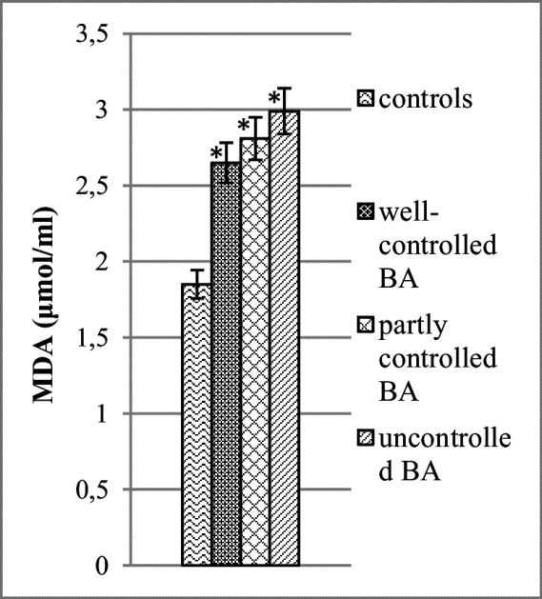
Fig. 1. Lipid peroxidation in plasma, expressed as micromoles of TBARS per litter in controls, well-controlled asthma group, partly controlled and uncontrolled asthma, p < 0.0001 (*) statistically significant compared to controls.
Protein carbonyl content (PCC)
PCC (Fig. 2) measured in serum was statistically significant increased in all groups compare with healthy controls: for well-controlled group mean 10.11 ± 2.3 nmol/mg, vs mean 1.72 ± 0.2 nmol/mg, p = 0.000, t-test; for partially controlled mean 7.61 ± 0.8 nmol/mg, vs mean 1.72 ± 0.2 nmol/mg, p = 0.000, t-test; for uncontrolled mean 9.11 ± 0.9 nmol/mg, vs mean 1.72 ± 0.2 nmol/mg, p = 0.000, t-test. There was no statistically significant difference between asthma groups, p = 0.3, t-test.
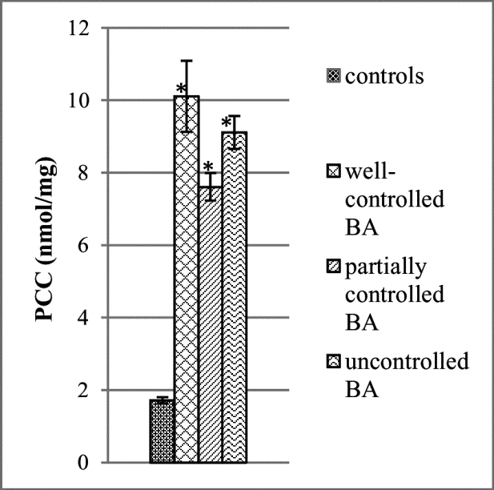
Fig. 2. Protein carbonyl content measured in nanomoles per milligram of protein, (*) p <0.000 statistically significant compared to controls. (**) p < 0.000 statistically significant compared to uncontrolled asthma.
ROS levels measurement
ROS levels (Fig. 3) measured in serum of patients with uncontrolled asthma were statistically significantly higher than the control subjects (mean 2.77 ± 0.3 vs mean 0.33 ± 0.1, р <0.000, t-test). In patients with well-asthma control (mean 1.35 ± 0.3 vs mean 0.33 ± 0.1, р <0.000, t-test) and partially controlled asthma (mean 1.07 ± 0.4 vs mean 0.33 ± 0.1, р <0.04, t-test), the ROS levels were also statistically significant higher compared to the controls. Statistically significant difference were observed between the ROS levels in well-controlled and uncontrolled BA group, (p ≥ 0.06), also statistically significant difference were shown in partly controlled asthma group vs uncontrolled, (p ≥ 0.00).
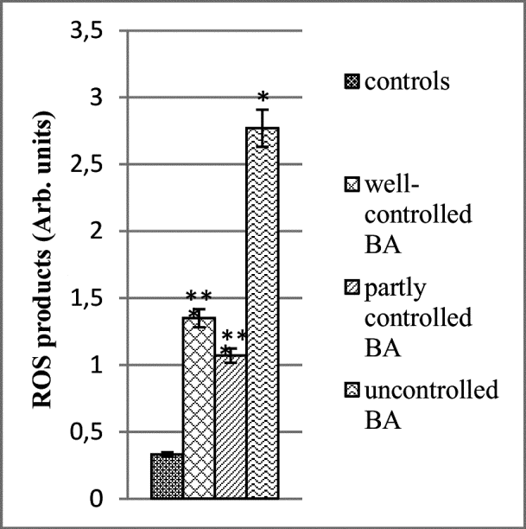
Fig. 3. The ROS levels are expressed in arbitrary units in controls, well-controlled asthma group, partly controlled and uncontrolled asthma, (*) p <0.000 statistically significant compared to controls. (**) p <0.000 statistically significant.
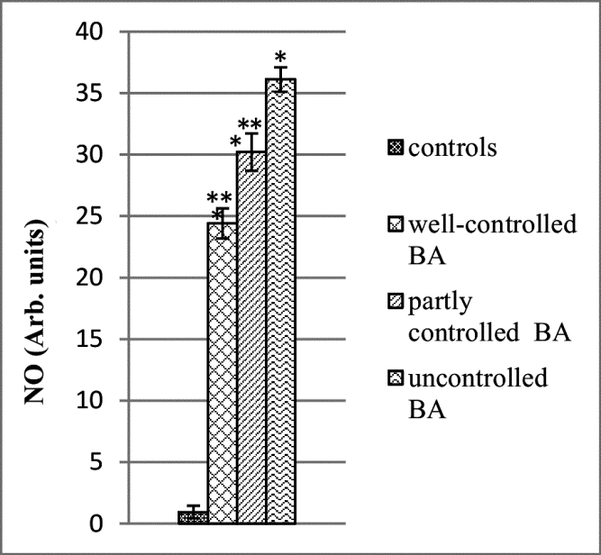
Fig. 4. The NO• radicals measured in arb. units in serum of healthy controls, well-controlled asthma group, partly controlled and uncontrolled asthma, (*) p <0.000 statistically significant compared to controls. (**) p <0.000 statistically.
Ex vivo evaluation the NO• levels
The levels of NO• radicals (Fig. 4) in patients with uncontrolled asthma were statistically significant increased compare to the healthy controls (mean 36.1 ± 1.1, vs mean 0.95 ± 0.1, р > 0.00, t-test). The similar increase was observed in the well-controlled group compared to the controls (mean 24.4 ± 2.7, vs mean 0.95 ± 0.1, р ≥ 0.00, t-test), and partially controlled group (mean 30.2 ± 1.63, vs mean 0.95±0.1, р ≥ 0.00, t-test). Statistically significant difference in NO• levels was also observed in both asthma groups, with well-controlled and partially controlled, compared to uncontrolled patients (p ≥ 0.00).
Correlations between levels of CRP and OS parameters
MDA plasma levels showed positive correlation with reactive C protein (MDA vs CRP r = 0.29; p = 0.056). PCC in serum samples showed very high positive correlation with reactive C protein (PCC vs CRP r= 0.59; p=0.00). NO• levels significantly correlated with reactive C protein (NO• vs CRP, r = 0.54, p = 0.000). ROS levels showed positive correlation with reactive C protein (r= 0.39, p = 0.006).
Positive correlation and statistically significant difference were also observed between biochemical parameters, MDA vs NO• r = 0.74, P = 0.000; MDA vs ROS products r = 0.53, P = 0.000; MDA vs PCC r = 0.56, P = 0.000; ROS vs PCC r = 0.42; P = 0.003.
DISCUSSION
At this stage, numerous studies have found that the OS and in particular lipid peroxidation contributes to the pathophysiology of asthma. However, still systematic and comprehensive characterization of OS of asthmatics has not been conducted primarily due to the lack of suitable OS biomarkers [14]. In the current research using different techniques we have investigated and compared levels of ROS and NO• measured in real time, MDA and PCC measured as end products of lipids and proteins oxidation and CRP in blood of asthmatic patients divided in three groups differing in the degree of disease control - well-controlled disease, partially controlled and uncontrolled disease. Chronic airway inflammation and OS play a key role in the pathogenesis and progression of respiratory diseases including asthma [14] and may be a final common pathway leading to tissue damage. Inflammatory cells after activation respond with a “respiratory burst”, which involves the uptake of oxygen and subsequent release of ROS into surrounding cells. During “respiratory burst”, the inflammatory cells generate high concentrations of •O₂⁻, •OH, HOCl, and H₂O₂ that may penetrate into surrounding cells causing increased quantities of free radicals in airway tissues. Moreover, the inflammatory cells of asthmatics possess an increased ability to generate free radicals in comparison with controls, which further contributes to elevation of ROS concentrations [15, 16]. Asthmatics may also produce an excess of reactive nitrogen species (RNS) such as NO• [17, 18]. The latter can react with •O₂⁻, to form peroxynitrite that has many damaging effects, including lipid oxidation [19]. On the other hand, NO• can be converted to nitrite which can oxidise proteins. Thus, excess amounts of ROS and RNS accumulated in asthmatics can overcome the body's antioxidant defenses and cause OS. Since ROS and RNS are extremely unstable structures they can be measured only by EPR spectroscopy [20]. PBN was selected as a spin trap to evaluate the levels of ROS products in serum of asthmatics and healthy controls. Whether the radical trapped by PBN was oxygen-centered (PBN/•OR) or carbon-centered (PBN/•R) it can be determined by calculating the values of the hyperfine splitting constants aN and aH_{β} from the EPR spectrum of the registered spin adduct. According to literature data about the values of both splitting constants (aN = 13.88 G and aHβ = 2.35 G) the radical species trapped were identified as secondary oxygen centered alkoxy radicals (PBN/•OR), which resulted from the attack of the primary oxygen-centered radicals to membrane phospholipids [21]. Statistically higher levels of ROS products observed in the three groups of patients in comparison with the controls, means that oxidative processes are realized in all asthmatics at the time of the study. Moreover, the fact that both groups of partially and well-controlled asthmatics expressed significantly lower levels of ROS compared with uncontrolled group, shows that in those two groups the oxidative processes are partially reduced, which is apparently due to the successfully implemented therapy. Increased ROS production found in all asthmatics was also additionally confirmed with the increased levels of MDA registered in their plasma (see Fig. 1). Due to the highest production of ROS in the uncontrolled group the highest level of MDA was observed. It is well-known that lipid peroxidation is induced by ROS and a good correlation exists between the degree of ongoing lipid peroxidation processes and the amount of formed MDA reactive substances which are considered as a specific biomarker of OS [14]. The lipid peroxidation and the breakage of lipids with the formation of reactive substances can lead to changes in the permeability and fluidity of the membrane lipid bilayer and can dramatically alter cell integrity [21, 22]. LPO products are characterized by carbohydrate chains of different length, reactive aldehyde groups and double bonds, which make these molecules reactive to nucleic acids, proteins and cellular thiols. Modifications of proteins with LPO products may regulate cellular processes like apoptosis, cell signaling and senescence [23]. On the other hand, ROS can promote protein carbonylation - a process by which reactive aldehydes or ketones are incorporated into proteins by oxidation [24]. Protein carbonylation is a result of the direct metal-catalyzed oxidation of amino acid side chains (primary protein carbonylation) or the addition of reactive aldehydes to amino acid side chains (secondary protein carbonylation) [25]. Oxidative modifications of proteins by reactive species, especially ROS are implicated in etiology or progression of a wide range of disorders and diseases. The level of oxidatively modified proteins can be quantified by measuring the PCC [26].
In the current study statistically significant increased levels of PCC found in all groups comparing to healthy controls were in accordance with elevated ROS established for the three groups of asthmatic patients. It was interesting that protein carbonyls levels in the well-controlled group were higher than those of the other two groups while the level of ROS products of the uncontrolled group was significantly higher than the well-controlled and partially controlled asthmatics. Based on this finding we assume that PCC registered in well-and partially controlled groups is mainly a result of the direct oxidation by ROS (primary protein carbonylation) while in the uncontrolled group predominates indirect oxidation by reaction with secondary by-products (reactive aldehydes) of OS (secondary protein carbonylation). This assumption is additionally supported by the highest level of malondialdehyde end products of lipid peroxidation found in uncontrolled asthmatics comparing to the other two groups.
The development and maintenance of allergic inflammation in the respiratory tract with bronchial asthma is associated with the implementation of oxidative and nitrosative stress. Nitrosative stress is characterized by an increase in the levels of NO• radicals and ROS products measured in serum. OS is characterized by an increase in the MDA level and protein carbonyl content, depending on the control of the disease. The intensity of lipid peroxidation, proteins oxidation and levels of generated free radicals in our study positively correlate with the level of reactive C protein.
CONCLUSION
For the first time using the EPR spin trapping method, oxidative processes in real time were demonstrated in patients with asthma. It is important to emphasize that the group with uncontrolled asthma showed the highest level of oxidative stress, which was confirmed by both higher levels of real-time OS parameters and higher levels of the end products of oxidation of lipids and proteins compared to the other two groups of asthmatics. The results of correlation analysis confirm that the development and maintenance of inflammatory processes in the respiratory tract is associated with the oxidative and nitrosative stress present in asthmatic patients.
Funding: This study was funded by University scientific project № 19/2015 of Medical faculty, Trakia University, Stara Zagora, Bulgaria.
REFERENCES Please fill in page numbers
- Global Initiative for Asthma (GINA) (2006) revision www.ginasthma.com
- D. Dimov, T. Tacheva, V. Ilieva, A. Koychev, G. Prakova, Z. Andreev, Allergy, Asthma and Immunophys.: From Basic Sc. to Clin. Manag., 17, 4 (2013).
- D. Dimov, M. Kurzawski, T. Tacheva, V. Ilieva, A. Koychev, G. Prakova, M. Kurzawski. V. Dimitrov, M. Drozdzik, T.Vlaykova, Allergy, Asthma and Immunophys.: From Basic Sc. to Clin. Manag., 17, 3 (2013).
- A.M. Cantin, D. Hartl, M.W. Konstan, J.F. Chmiel, J. Cystic Fibr.,14, 419 (2015).
- Y.S. Cho, H.B. Moon, Allergy, Asthma and Imm. Res., 2(3), 183 (2010).
- D.R. Taylor, Thieme Med Publish., 33, 620 (2012)
- A. Nadeem, S.K. Chhabra, A Masood, J Allergy and Clin.Immunol., 111, 72 (2003)
- Global Initiative for Asthma Global Strategy for Asthma Management and Prevention. Vancouver, WA, USA:GINA, (2014) www.ginasthma.org
- Z.A. Plaser, L.L. Cushman, B.C. Jonson, Anal. Biochem., 16, 359 (1966).
- H. Shi, Y. Sui, X. Wang, Yi. Luo, L. Ji, Comp. Biochem. and Physiol. Part C: Toxicol. & Pharmacol., 140, 115 (2005).
- T. Yoshioka, N. Iwamoto, K. Lto, J. Am. Soci. Nephrol., 7, 961 (1996).
- K. Yokoyama, K. Hashiba, H. Wakabayashi, Anticanc. Res., 24, 3971 (2004).
- N. Khuseyinova, A. Imhof, G, Trischler, Clin. Chem., 49(10), 1691 (2003).
- L.G. Wood, P.G. Gibson, M.L. Garg, Eur. Respir. J., 21, 177 (2003),
- L. Zuo, N.P. Otenbaker, B.A. Rose, K.S. Salisbury, Molec. Immunol., 56, 57 (2013).
- P. Kirkham, I. Rahman, Pharmacol. Ther., 11 (2006).
- S.A. Kharitonov, D. Yates, R.A. Robbins, R. Logan-Sinclair, E.A. Shinebourne, P.J. Barnes, Lancet, 343, 133 (1994).
- L. Zuo, M.S. Koozechian, L.L. Chen, Ann. Allergy Asthma Immunol., 112, 18 (2014).
- I. Spasojević, M. Mojović, A. Ignjatović, G. Bačić, J. Serb. Chem. Soc., 76, 647 (2011).
- B. Halliwell, J.M. Gutteridge, Oxford Univ. Press, USA, 2015.
- T.A. Dix, J. Aikens, Chem. Res. in Toxicol., 6, 2 (1993).
- G. Barrera, Review Article. Intern Scholarly Res Network ISRN Oncology, Article ID 137289, 21pages doi:10.5402/2012/137289 (2012).
- A. Winczura, B. Tudek, Free Rad. Res., 46, 442 (2012).
- Y.J. Suzuki, M. Carini, D.A. Butterfield, Antioxid. Redox Signal, 12, 620 (2010).
- Ch.M. Wong, G. Bansal, L. Marcocci, Y.J. Suzuki, Redox. Rep., 17, 90 (2012).
- E.R. Stadtman, R.L. Levine, Ann. N.Y. Acad. Sci., 899, 191 (2000).

ОКСИДАТИВЕН СТРEС И СВЪРЗАНИ С НЕГО БОЛЕСТИ. Част 1: Бронхиална астма
Г.Д. Николова¹, В. Илиевa², Я.Д. Карамалакова¹, В. A. Иванов³, A. M. Желева¹, В.Г. Гаджева¹*
¹¹ Катедра по химия и биохимия, Медицински факултет, Тракийски университет, ул. Армейска 11, 6000 Стара Загора, България
² Катедра по вътрешна медицина, Медицински факултет, Университетска болница, Тракийски университет, ул. Армейска 11, 6000 Стара Загора, България
³ Катедра по неврология, психиатрия и медицина ня бедствията, Медицински факултет, Тракийски университет, ул. Армейска 11, 6000 Стара Загора, България
Постъпила на коригирана на
(Резюме)
Оксидативният стрес (OS) играе важна роля в патогенезата на голям брой болести при човека, като исхемична болест/реперфузионно увреждане, атеросклероза, рак, невродегенеративни болести, алергии и др. Бронхиалната астма (BA) е хронично възпалително заболяване на дробовете, което ограничава притока на въздух, води до хиперактивност и ремоделиране на дихателните пътища. Клинични и експериментални данни от последните години показват, че повишеният OS и деструктивните ефекти от окислението на свободните радикали може да са важни причини за хроничен патологичен процес в дробовете. Целта на настоящата работа е да се изследва и сравни нивото на оксидативния стрес в кръвта на пациенти с астма, които се различават по степента на контрола на заболяването. В изследването са включени 30 пациенти с ВА и 24 подходящи по възраст здрави доброволци. Пациентите са диагностицирани с ВА с алергичен компонент по-дълго от една година. За целта са изследвани продуктите на ROS и RNS, крайните продукти на липидите и протеините, проследена е и връзката между параметрите на оксидативния стрес и С-реактивния протеин (CRP) като маркер на степента на възпаление. С помощта на EPR спин-улавяща техника са потвърдени протичащите в реално време процеси в кръвни проби, изолирани от астматични пациенти с различен контрол на заболяването. Установена е позитивна корелация между нивата на изследваните OS биомаркери и CRP като маркер на степента на възпаление. Оксидативните процеси в реално време са демонстрирани при пациентите с ВА. Резултатите от корелационния анализ потвърждават, че развитието и поддържането на възпалителните процеси в дихателния тракт са свързани с оксидативния и нитрозативния стрес.

